**Shu Lian 8694385**

**2. ERD Modelling**

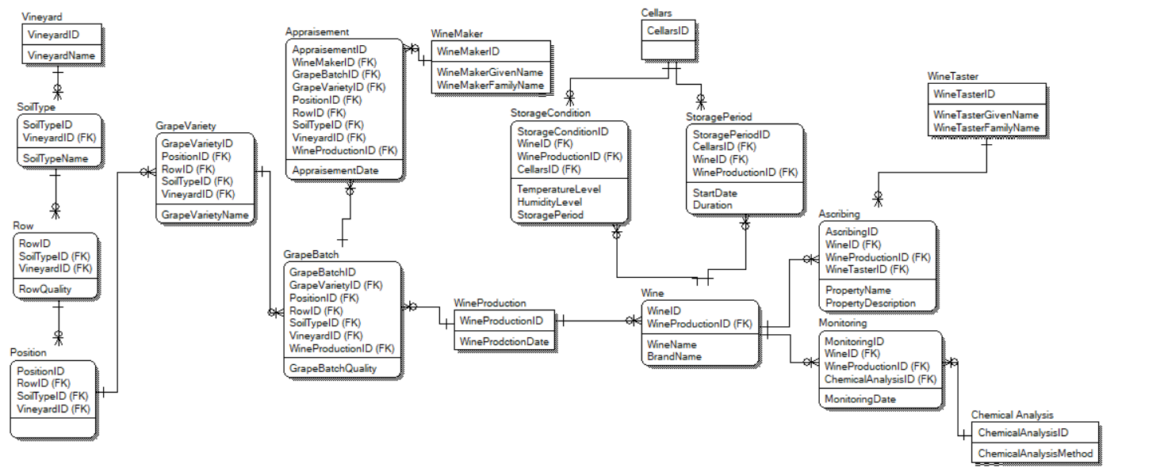

**3. HoloLens Design Guidance**

*Select row/object and display its properties*

I will use Object Collection to lay out imported 3D objects.

In the scene, I will be able to find various combinations scripts. You can combine different types of scripts and find them under the path: WineProduction\Scene\Scripts\Objects. It is designed to support various types of Interactable Object in flexible way.

To display its properties, I can go either click into the script and check ‘public’ functions,

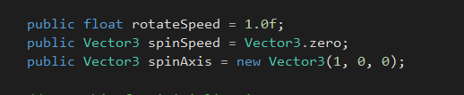

or simply select object and then check Inspector Board.

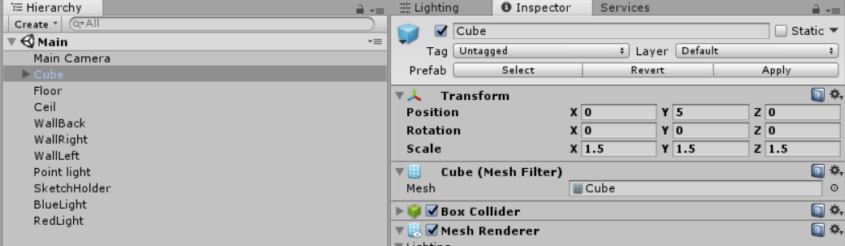

*How to draw user’s attention to something happening behind, and displaying a relevant set of information to them*

I will attract user’s attention by adding sounds and voice control functions.

When user is walking over the vineyard, they can hear the background music and with alarm sound. When they hear the sound, they would like to turn around and see a billboard, which will move with user’s horizons.

Then it shows that they can use voice command find new information they just missed.

The information will be displayed by Billboarding and tag-along.

For example, when user is walking too fast, the alarm will be on; then when he/she looks behind, the billboard will be displaying that user is missing the information: (with a list), to go detail with information, user can use voice command like: ‘check row quality’, ’show overall mapping’ to know the details.

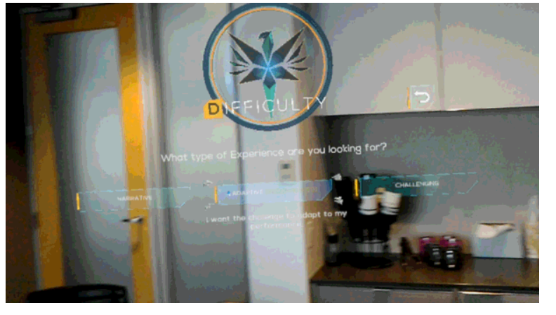

**4. Create Object as a Sphere**

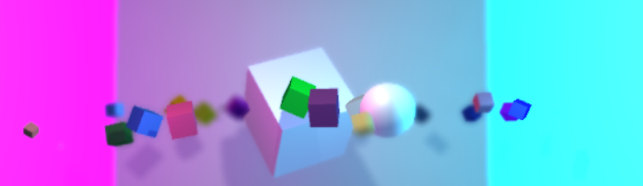

**5. Change the color of one cube every second in the order they were created**

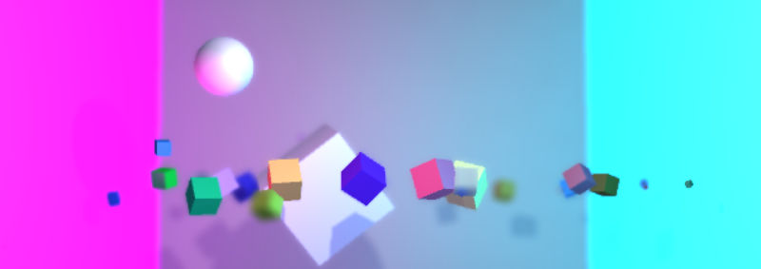

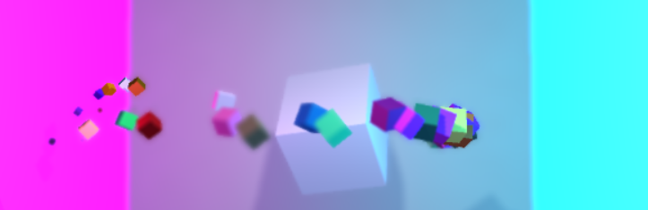

**6. Place the cube you create at one Y position and the sphere at another.**

**7. GitHub URL**

https://github.com/slia356/LabTest1