

**CMC Foundations of Data Science for Human Cognition: PSYC166**

Final Report for

**Liaison’s Name Here**

Liaison’s Institution here

**Your Title goes here**

Month, day, 2024

**Team Members**

Team Member A

Team Member B

Team Member C

Team Member D

**Faculty Advisor**

Professor Gabriel I. Cook

**Liaison** Professor Name and Title

Table of Contents

1 Abstract 3

2 Acknowledgments 5

3 Introduction 6

4 Problem Statement 6

5 Data 6

6 Findings 6

7 Discussion 6

8 Conclusion 6

# 1 Abstract

**Contents**

Move the table of contents to this page.

# 2 Acknowledgments

# 3 Introduction

# 4 Problem Statement

# 5 Data

## 5.1 *Description*

## 5.2 *Cleaning*

## 5.3 *Preprocessing*

# 6 Findings

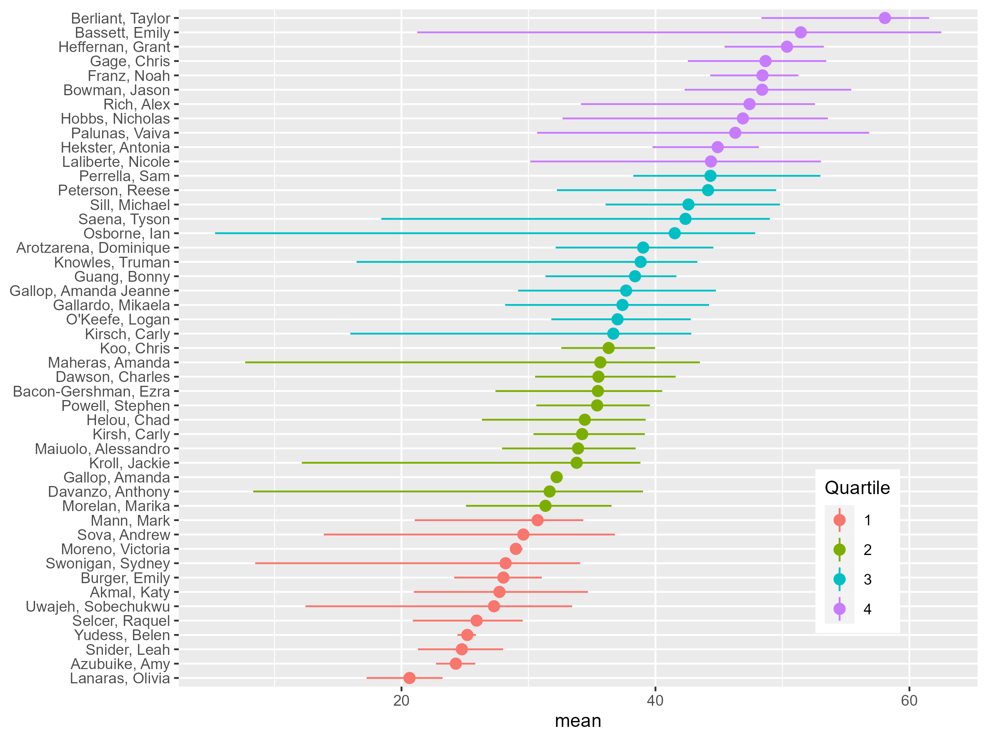

# 7 Discussion

# 8 Conclusion