1. Create github.com account
2. Create github repo on account
3. …
   1. Got to clone/download - get the url ending in .git
4. Install git for computer
5. In RStudio, go to **Tools -> Global Options -> Git/SVN**

@ **Git executable**: **Browse** to the install directory and find the git.exe location (likely in git/bin/) and apply changes.

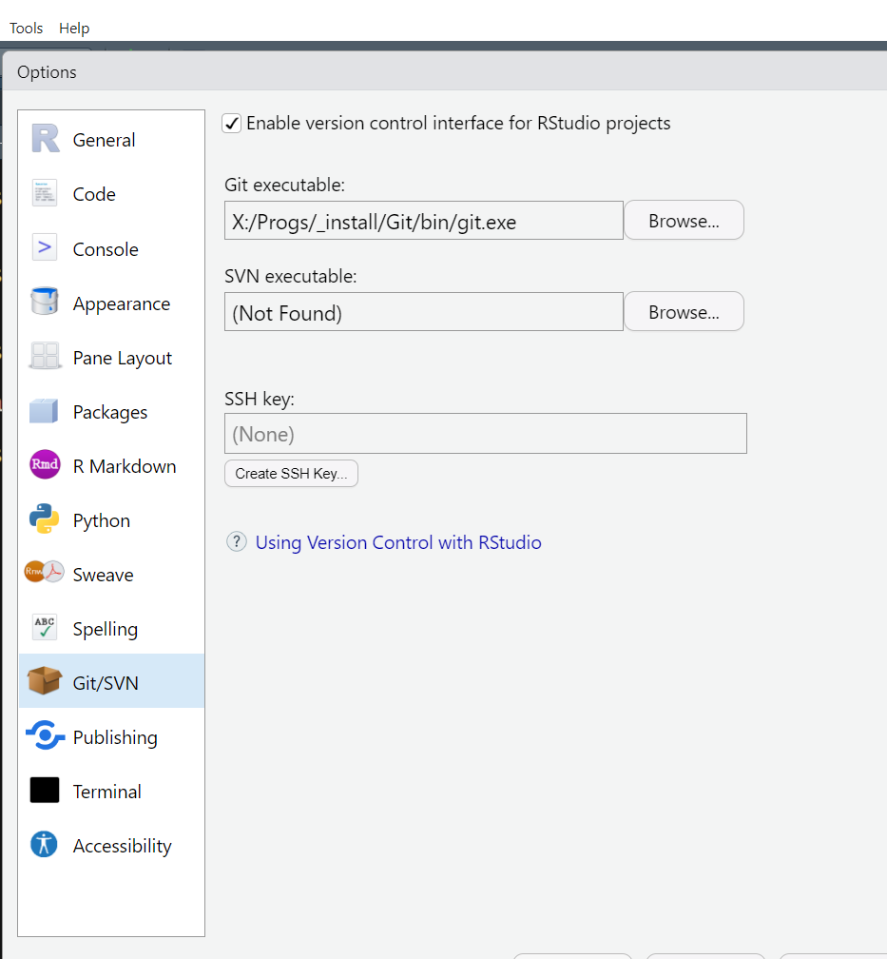

1. In RStudio, go to **Tools -> Global Options -> Terminal**

@ “**New terminals open with**:” select **Git Bash** option if available

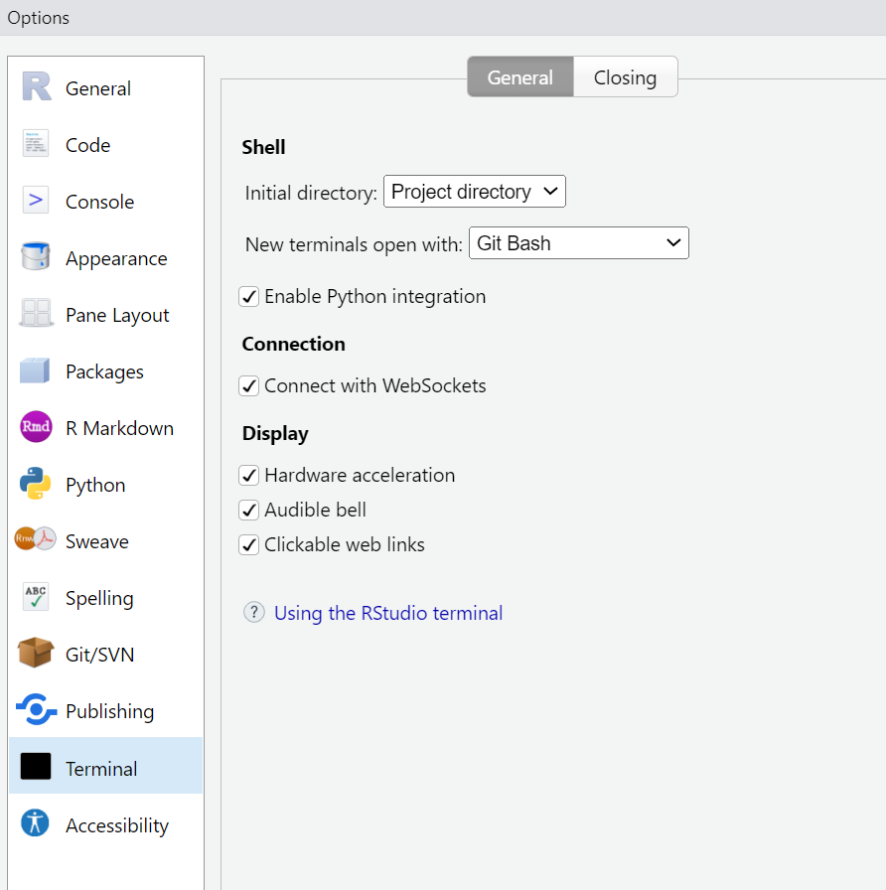

1. In RStudio, go to **File -> New Project -> Version Control -> Git**

@ Repository url: paste the *.git link from the clone/download step

@ Project directory name: add a project name if not autopopulated

@ Create project as subdirectory of: browse to where you want the project createed

1. Get a Website Theme

Go to <https://themes.gohugo.io/>

Select a theme, click on “download” or “” to find the github url to the theme

<https://github.com/wowchemy/starter-hugo-academic>

make note of the username and theme name, e.g., wowchemy/starter-hugo-academic

1. In RStudio, coding console:

install.packages("blogdown")

# install hugo for themes

blogdown::install_hugo()

Hugo has been installed to "C:\Users\gcook\AppData\Roaming\Hugo\0.113.0". You are recommended to set options(blogdown.hugo.version = "0.113.0") in the .Rprofile file in your website project. See the blogdown book for more info on .Rprofile: https://bookdown.org/yihui/blogdown/global-options.html

# create a new site

blogdown::new_site(theme = “wowchemy/starter-hugo-academic”)

If you get an error message:

The directory '.' is not empty. Create the site anyway? (y/n)

Proceed with y

Wait for downloading of contents.

The directory '.' is not empty. Create the site anyway? (y/n) y

1. RStudio will open the website project and you will see the opened file: **index.en.Rmd**

And in the console, you will see information about a netlify.toml file, the .Rprofile, and you can see the content in a browser if you want.

Adding the sample post to content/post/2020-12-01-r-rmarkdown/index.en.Rmd

| Converting all metadata to the YAML format

| Adding netlify.toml in case you want to deploy the site to Netlify

| Adding .Rprofile to set options() for blogdown

― The new site is ready

○ To start a local preview: use blogdown::serve_site(), or the RStudio add-in "Serve Site"

○ To stop a local preview: use blogdown::stop_server(), or restart your R session

► Want to serve and preview the site now? (y/n) y

1. You will see a reference to a local host: e.g., http://localhost:4321

You can open in the browser.

1. dd