# CISPROG1: Final Project

### Image result for panther chaffeyTotal Points: 250

#### ASSIGMEMNT OVERVIEW

In this project, you are asked to develop a point of sale and reservation system for Chaffey College’s new Airline. The system keeps track of the information in a 2D list/array and gives the reservation attendant 5 options

1. make a new first class reservation
   1. Only 8 seats are available at $500
2. Make a new coach class reservation a
   1. Only 40 seats are available at $199
3. change an existing reservation
4. print the listing of seats
5. quit

In the print option, the system will print in an orderly manner all the seats available in each compartment and the list of seats that are taken with the individual that has reserved the seat. If all seats are taken a message is displayed stating, no new reservations can be made. If the person’s name is longer than 12 characters you will only display the first 12 characters. Note: the entire name should be in the array, you only to reduce the length of text during the print function for neatness.

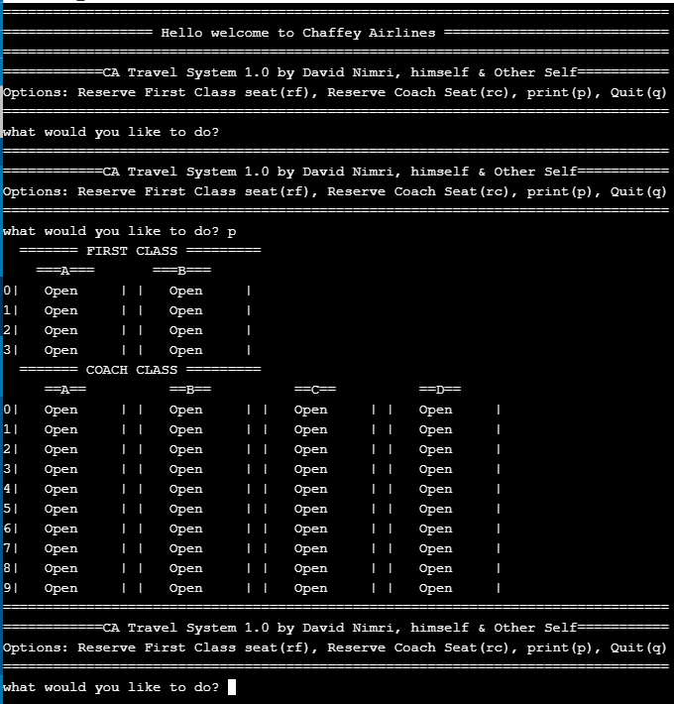

If the reservation attendant picks first class or coach reservation, he/she should then enter the location of the desired seat & the name of the person taking the flight. If not available, it will be refused



However, if a seat is available, the program calculates the cost for each item plus the amount of sales tax, and asks for that amount to be provided. The fare for Chaffey Airlines is calculated as $500 for first class and $199 for coach class. If the passenger is under 7 or 65 or older, they get a 20% discount. If the user doesn’t have enough money, he/she is not booked a ticket. If the user does provide an amount equal to or greater than the required amount the user is ticketed and provided the change amount if applicable.

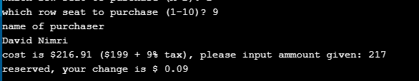

The program then takes amount of change to be rendered and computes the denominations ($100 bills, $20 bills, $5 bills, $1 bills, quarters, dimes, nickels, and pennies) for the attendant. The following is example of such a program output:

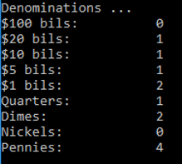

In the next print you should see the reservation made:

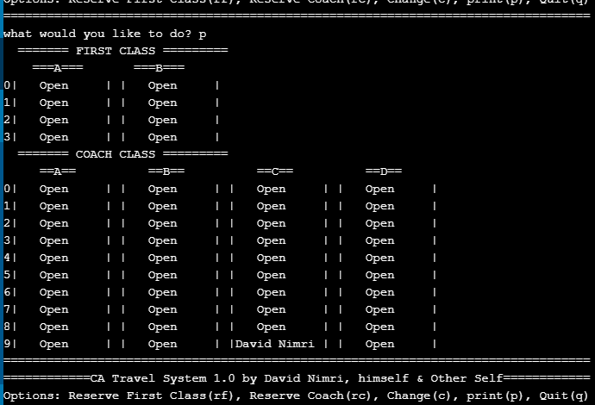

If the attendant selects change reservation option, he/she should be prompted for what seat to change, the seat is set to open, and the attendant can rebook the person to a different seat. There are no refunds at Chaffey Airlines.

Those are the minimum requirements and will earn 100% if satisfied. However, you can earn up to an addition 25% extra credit for new features you add! Be sure to present these in class!

#### What you need to submit for the project:

* Submit your py file or link to your code online in Canvas
* You must partner up with another person. Teams greater than 2 are not allowed unless there is an odd number in the class.
* Submit to canvas a report in Microsoft Word containing the following items:
  + Title page, with your name
  + Pseudocode & flowchart
  + Sample screenshot (use the [Alt+Prt Scr] buttons on your keyboard to capture a screenshot of your program running with representative inputs, such as the examples shown on the previous pages). Screen shots must show at a minimum what is listed above and there should be 4 First class and 10 coach class passengers shown on the print out.
  + A brief discussion of your project experience
    - Did you enjoy this project? What problems did you encounter?
    - What did you get out from the project?
    - How did you find the project (too easy, easy, just right, difficult, too difficult)?
    - What type of help/references did you use in your project (e.g. book, web sites, classmates, tutors)?

#### Grading Criteria

* Satisfaction of project requirements (100 points)
* Report (50 points)
* Coding style (50 points)
  + Provide comments about your program in appropriate places.
  + You must use the program template provided on canvas that has a program comment block containing filename, description, author, class, and date.
  + Use descriptive identifiers.
  + Array & function use
  + Use proper spacing and indentation (refer to the textbook’s program style).
* Class Presentation (required to complete the assignment. An incomplete assignment will earn a maximum grade of 50%)
* Extra (up to 5 bonus points)