**Coding Report Outline**

Due April 24, 2017

Team 1 MangoWEB

Julian Bertini, Collin Epstein, Caleb Warren

1. First, create a list of all of the code files and their names that have been written by the team (do not include files that may have been generated by a tool or the infrastructure).  For each file, identify the hardware device on which it runs (e.g., handheld device, server, PC).  This list should represent your project as of sometime on 4/24/2017 before class.

* CameraController.cs
  + Script that controls movement of camera in the game world.
  + Runs on mobile device/personal computer.
* PositionReset.cs
  + Resets object to its initial position on designated button press.
  + Runs on mobile device/personal computer.
* Rotator.cs
  + Continually rotates object about its local axes.
  + Runs on mobile device/personal computer.

Most other game functions are accomplished using provided assets from the Unity game engine.

2. Next, please create a snapshot of the code listed under question 1 above.  This should consist of a printed copy of each code file written by the team.  I would prefer that the code be printed with line numbers, if possible.  You should submit a single document containing your responses to these questions. Of course, I expect that the code will follow the coding guidelines shown in my Software Coding presentation. I realize that your project is not yet finished, so I understand the source code may not be complete and correct.

CameraController.cs

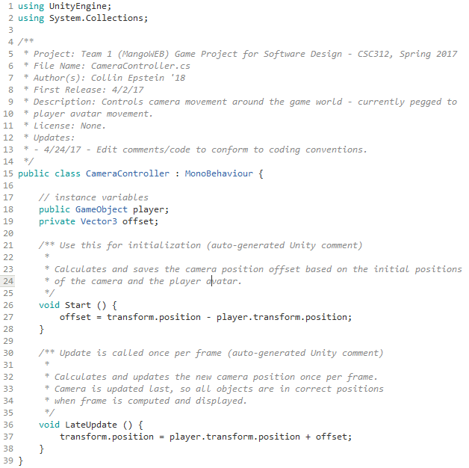

PositionReset.cs

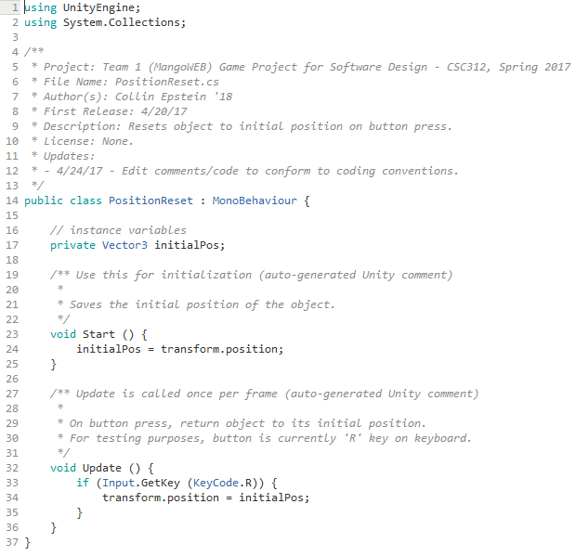

Rotator.cs

