
Faculty of Information Technology

Swift Customs: Customs Clearance Accounting System

Graduation Project (1) Report
Prepared by:
Student ID | Student Name
202220424 | Osama Ibrahim
202220623 | Abdalrahman Saeed

Supervised By:
Dr. Hani Al-Bloush

Declaration
We, the undersigned, hereby declare that the work presented in this report is entirely our own, produced independently under the supervision of our designated supervisor. All ideas, text, data, figures, tables, and other content drawn from external sources have been clearly identified in the text and fully attributed in the reference list at the end of this document.
We confirm that this report has not been submitted in whole or in part to any other institution or for any other qualification. We are aware that any form of academic dishonesty including plagiarism, data fabrication, unauthorized use of artificial intelligence generation tools without proper disclosure, or misrepresentation of contributions constitutes a violation of the university's academic integrity policy and may be subject to disciplinary action.
We further undertake to notify the Supervisor, and the Graduation Projects Committee of any material change to the project scope, team composition, or methodology within two weeks of such a change occurring.

Student ID | Students Name | Signature | Date
202220424 | Osama Ibrahim
202220623 | Abdalrahman Saeed

Supervisor Approval موافقة المشرف
APPROVAL FOR SUBMISSION

I certify that this project report entitled “Swift Customs: Custom Clearance Accounting System” was prepared by OSAMA AND ABDULRAHMAN has met the required standard for submission in partial fulfillment of the requirements for the degree of Bachelor of Science in Computer Science at MEU.

Approved by

Signature: ……...…….………………………..................
Supervisor: Dr. Hani Al-Bloush
Date: …………….………………………………………

Abstract
Swift Customs is a customs clearance accounting system developed using Oracle APEX to support the digital transformation of customs operations in Jordan. The system addresses key challenges in the traditional customs clearance process, including manual paperwork, slow transaction handling, high operational costs, calculation errors, and the lack of integration with national financial platforms such as JoFotara. These issues create delays, reduce accuracy, and increase the workload for customs brokers, clearing agents, and clients.
The proposed system automates the management of import and export declarations, duty and tax calculations, receipt generation, and financial record keeping through a secure and accessible web-based platform. By integrating with the JoFotara API, Swift Customs enables real-time data exchange and generates authenticated QR-coded receipts that allow clients to verify the legitimacy of transactions. The system also supports compliance with Jordan Customs Authority regulations while improving transparency, accuracy, and efficiency.
Overall, Swift Customs provides a modern, reliable, and scalable solution for customs clearance accounting in Jordan. It reduces manual effort, minimizes human error, improves financial documentation, and strengthens the connection between customs operations and Jordan’s digital financial infrastructure.

Abstract (Arabic) المستخلص (عربى)
"Swift Customs"
نظام محاسبة للتخليص الجمركي مبني على Oracle APEX

نظام محاسبي للتخليص الجمركي، تم تطويره باستخدام منصة أوراكل أبيكس لدعم التحول الرقمي للعمليات الجمركية في الأردن. يعالج النظام التحديات الرئيسية في عملية التخليص الجمركي التقليدية، بما في ذلك الأعمال الورقية اليدوية، وبطء معالجة المعاملات، وارتفاع التكاليف التشغيلية، وأخطاء الحساب، وعدم التكامل مع المنصات المالية الوطنية مثل جوفوتارا. تُسبب هذه المشكلات تأخيرات، وتُقلل من الدقة، وتزيد من عبء العمل على سماسرة الجمارك، ووكلاء التخليص، والعملاء.

يُؤتمت النظام المقترح إدارة بيانات الاستيراد والتصدير، وحسابات الرسوم والضرائب، وإصدار الإيصالات، وحفظ السجلات المالية من خلال منصة إلكترونية آمنة وسهلة الاستخدام. من خلال التكامل مع واجهة برمجة تطبيقات جوفوتارا، يُتيح نظام سويفت للجمارك تبادل البيانات في الوقت الفعلي، ويُصدر إيصالات موثقة برمز الاستجابة السريعة (QR) تُمكّن العملاء من التحقق من صحة المعاملات. كما يدعم النظام الامتثال للوائح هيئة الجمارك الأردنية، مع تحسين الشفافية والدقة والكفاءة.

بشكل عام، يُقدم نظام سويفت للجمارك حلاً عصرياً وموثوقاً وقابلاً للتطوير لمحاسبة التخليص الجمركي في الأردن. فهو يقلل من الجهد اليدوي، ويقلل من الخطأ البشري، ويحسن الوثائق المالية، ويعزز الصلة بين العمليات الجمركية والبنية التحتية المالية الرقمية للأردن.

Table of Contents
List of Figure 8
List of Tables 9
Terminologies 11
Chapter 1: Introduction 14
1.1 Background and Context 14
1.2 Problem Statement 15
1.3 Description of the Suggested Solution 16
1.4 Literature Review (Related work) 18
1.5 Technology and tools to be used 21
Chapter 2: Project Plan 25
2.1 Project Objectives 25
2.2 Project Scope 25
2.3 Software Process Model 27
2.4 Work Breakdown Structure (WBS) 29
2.5 Project Schedule 33
2.6 Project Schedule Chart(s) (Gannt Chart) & Team Structure 35
Chapter 3: Requirements and Analysis 40
3.1 Functional Requirements 41
3.2 Non-Functional Requirements 59
Chapter 4: Architecture and Design 66
4.1 Architecture 66
4.2 Use Case Diagram 70
4.3 Use Case Description 71
4.4 Activity Diagram 84
4.5 ERD Diagram 91
Chapter 5: Conclusion & Future Work 103
5.1 Conclusion 103
5.2 Future Work 105
References 107
Appendix 109
Appendix A: System Prototype 109
A.2 Dashboard 110
A.3 Clients (list) 110
A.4 New Declaration 111
A.5 Invoice 111
A.6 Record Payment 112
A.7 Reports 112

List of Figure
Figure 1: Core Features of Swift Customs 17
Figure 2: Waterfall Software Development Life Cycle 28
Figure 3:Work Breakdown Structure (WBS) of the Swift Customs System. 32
Figure 4: Requirements Gathering & Analysis Gantt Chart 36
Figure 5:Design Gantt Chart 37
Figure 6:Implementation Gantt Chart 37
Figure 7:Testing Gantt Chart 38
Figure 8:Full project Gantt Chart 39
Figure 9: Layered Architecture of the Swift Customs System 67
Figure 10: Use Case Diagram for the Swift Customs System 70
Figure 11: Login Activity Diagram 85
Figure 12:Create Declaration Activity Diagram 86
Figure 13:Issue Invoice & Receipt Activity Diagram 87
Figure 14:Record Payment Activity Diagram 88
Figure 15:Manage Clients Activity Diagram 89
Figure 16:Create Staff Account Activity Diagram 90
Figure 17:Entity Relationship Diagram (ERD) of the Swift Customs System 92
Figure 18: Login screen 109
Figure 19: Dashboard 110
Figure 20:Clients List 110
Figure 21:New Declaration 111
Figure 22:Invoice 111
Figure 23:Record Payment 112
Figure 24:Records 112

List of Tables
Table 1: Glossary of Technical and Domain-Specific Terms 11
Table 2:Comparison of Customs Clearance and Accounting Systems 20
Table 3: Team Structure and Roles 35
Table 4:FR1 - User Authentication 41
Table 5:FR2 - Staff Account Management 41
Table 6: FR3 - Role-Based Access Control 42
Table 7: FR4 - Password Policy Enforcement 42
Table 8:FR5 - Account Lockout Management 43
Table 9:FR6 - Session Timeout Management 43
Table 10:FR7 - Client Registration 44
Table 11:FR8 - Client Account Management 44
Table 12:FR9 - Client Search and Filtering 45
Table 13:FR10 - Tariff and Duty Rate Management 45
Table 14:FR11 - Tax and Fee Configuration 46
Table 15:FR12 - Create Clearance Declaration 46
Table 16:FR13 - Declaration Data Validation 47
Table 17:FR14-Edit Clearance Declaration 47
Table 18:FR15 - View, Search, and Filter Declarations 48
Table 19:FR16 - Declaration Reference Number Generation 48
Table 20:FR17 - Automated Duty and Tax Calculation 49
Table 21:FR18 - Manual Adjustment of Calculated Amounts 49
Table 22: FR19 - Invoice/Receipt Generation 50
Table 23:FR20 - JoFotara E-Invoice Submission 50
Table 24:FR21 - QR Code Retrieval and Embedding 51
Table 25:FR22 - Receipt PDF Generation 51
Table 26: FR23 - JoFotara Submission Failure Handling 52
Table 27:FR24 - Receipt Authenticity Verification 52
Table 28:FR25 - Record Payment 53
Table 29: FR26 - Client Balance Tracking 53
Table 30:FR27 - Outstanding Payments Management 54
Table 31:FR28 - Transactions Report 54
Table 32:FR29 - Tax and Duty Summary Report 55
Table 33:FR30 - Client Account Statement 55
Table 34:FR31 - Revenue Report 56
Table 35:FR32 - Company Profile Management 56
Table 36:FR33 - Activity Logging and Audit Trail 57
Table 37:FR34 - Data Validation and Integrity Checks 57
Table 38:FR35 - System Error Handling 58
Table 39:NFR-SEC01 - Secure Authentication 59
Table 40:NFR-SEC02 - Secure Data Transmission 60
Table 41:NFR-SEC03 - Role-Based Access Control 60
Table 42:NFR-PERF01 - Fast Response Time 61
Table 43:NFR-PERF02 - Concurrent User Support 61
Table 44:NFR-REL01 - System Reliability 62
Table 45:NFR-SCAL01 - System Scalability 62
Table 46:NFR-USAB01 - User-Friendly Interface 63
Table 47:NFR-MAINT01 - System Maintainability 63
Table 48:NFR-COMP01 - Regulatory and JoFotara Compliance 64
Table 49:NFR-LOG01 - Logging and Auditing 65
Table 50:UC01 - Log In / Authenticate 71
Table 51:UC02 - Manage Staff Accounts 72
Table 52:UC03 - Manage Company Profile 73
Table 53:UC04 - Manage Tariff & Tax Rates 74
Table 54:UC05 - Manage Clients 75
Table 55:UC06 - Create & Manage Declaration 76
Table 56:UC07 - Calculate Duty & Tax 77
Table 57:UC08 - Issue Invoice & Receipt 78
Table 58:UC09 - Submit E-Invoice to JoFotara 79
Table 59:UC10 - Record Payment 80
Table 60:UC11 - Track Balances & Outstanding Payments 81
Table 61:UC12 - Generate Reports 82
Table 62:UC13 - View Audit Logs 83
Table 63: COMPANY_PROFILE Table 93
Table 64: USER_ACCOUNT Table 94
Table 65: CLIENT Table 95
Table 66: DECLARATION Table 96
Table 67: DECLARATION_ITEM Table 97
Table 68: TARIFF Table 98
Table 69: TAX_RATE Table 98
Table 70: INVOICE Table 99
Table 71: INVOICE_TAX Table 100
Table 72: PAYMENT Table 100
Table 73: JOFOTARA_SUBMISSION Table 101
Table 74: AUDIT_LOG Table 102

Terminologies
The following table defines the key technical and domain-specific terms used throughout this report.
Table 1: Glossary of Technical and Domain-Specific Terms
Term | Meaning / Purpose
Customs Broker (Clearing Agent) | A licensed professional or firm authorized to prepare and submit customs declarations and handle clearance procedures on behalf of importers and exporters.
Customs Clearance | The official process of passing goods through customs so they can legally enter or leave a country, including declaration, inspection, and payment of duties and taxes.
Customs Declaration | A formal statement submitted to the customs authority describing the goods, their value, origin, and classification; in Jordan it is filed as the Single Administrative Document (SAD).
HS Code (Harmonized System Code) | An internationally standardized numbering system used to classify traded products and determine the applicable customs duty and tax rates.
Tariff | A schedule of duty rates applied to imported or exported goods, typically based on their HS classification and customs value.
Customs Duty | A tax imposed on goods when they are transported across international borders, calculated from the goods’ value, quantity, or weight.
Sales Tax (General Sales Tax) | An indirect tax applied to the sale of goods and services that, in the customs context, is calculated on cleared goods in addition to customs duty.
CIF Value | The combined Cost, Insurance, and Freight value of imported goods, commonly used as the basis for calculating customs duties and taxes.
JoFotara | Jordan’s national electronic invoicing system, operated by the Income and Sales Tax Department, which validates invoices and returns an authenticated QR code so receipts can be verified as legitimate.
ISTD (Income and Sales Tax Department) | The Jordanian government authority responsible for tax administration and for operating the national JoFotara e-invoicing platform.
QR Code | A machine-readable code embedded on an authenticated receipt that allows a client to instantly verify the legitimacy of the transaction.
Oracle APEX | Oracle Application Express, a low-code development platform built on the Oracle Database, used to build the Swift Customs web application.
Oracle Database | The relational database management system used to securely store all clearance, accounting, and transaction data in Swift Customs.
PL/SQL | Oracle’s procedural extension of SQL, used in Swift Customs to implement duty and tax calculation logic and other business rules inside the database.
ORDS (Oracle REST Data Services) | An Oracle middleware component that exposes database logic as RESTful web services, enabling integration between Swift Customs and external platforms such as JoFotara.
ASYCUDA World | The Automated System for Customs Data developed by UNCTAD and operated by Jordan Customs for the electronic submission and processing of customs declarations.
Audit Log | A chronological record of system actions and user activity maintained for accountability, traceability, and security review.
Role-Based Access Control (RBAC) | A security model that restricts system access and permitted actions according to each user’s assigned role, such as Broker Admin or Staff.
Entity Relationship Diagram (ERD) | A diagram that models the system data as entities, their attributes, and the relationships between them; used to design the relational database.
Entity | A real-world object or concept about which data is stored, represented as a table in the relational database (e.g. Client, Declaration, Invoice).
Attribute | A property or field that describes an entity, corresponding to a column in a database table.
Primary Key (PK) | An attribute (or set of attributes) that uniquely identifies each record in a table.
Foreign Key (FK) | An attribute that references the primary key of another table, establishing a relationship between them.
Cardinality | The numerical nature of a relationship between entities: one-to-one (1:1), one-to-many (1:N), or many-to-many (M:N).
Participation (Total / Partial) | Whether every instance of an entity must take part in a relationship (total) or may optionally take part (partial).
Data Dictionary | A detailed description of each database table, listing its attributes, data types, keys, and constraints.
Derived Attribute | An attribute whose value is calculated from other stored data rather than stored directly (e.g. total payable).
Multivalued Attribute | An attribute that can hold more than one value for a single entity (e.g. a client with multiple phone numbers).

Chapter 1: Introduction

Background and Context

Customs clearance inefficiency and financial inaccuracy have become a widespread challenge in global trade, contributing to significant revenue losses and delays in the movement of goods [1]. The complexity of duty and tax calculations, combined with the rising volume of import and export transactions, creates an environment that is difficult to manage manually [2]. This inefficient ecosystem not only increases operational costs but also erodes trust between customs brokers, clients, and regulatory bodies [3]. The increasing reliance on manual customs procedures has become a critical challenge in the trade sector, raising concerns about the accuracy and reliability of clearance transactions. Traditional methods such as physical paperwork, manual duty calculations, and in-person visits to customs offices are often slow, error-prone, and susceptible to mistakes or manipulation, making it difficult for brokers and authorities to process and authenticate transactions reliably. As a result, there is a growing interest in digital platforms and system integration as a solution to enhance the speed, accuracy, and transparency of customs clearance operations. Integrated digital systems provide automated, real-time mechanisms, ensuring the accuracy and credibility of financial records across brokers, clients, and government entities [4]. The rising volume of trade has made manual paper-based processes vulnerable to errors, undermining the credibility of the customs system [5]. Clients and authorities are increasingly demanding more robust and verifiable methods to ensure the legitimacy of clearance transactions. Additionally, the administrative burden on the Jordan Customs Authority and customs brokers continues to grow as the volume of trade increases annually. Modern technologies such as Oracle APEX and national integration through "JoFotara" have emerged as promising solutions for digital customs accounting, offering automation, transparency, and reliability. Several countries and institutions worldwide have begun adopting digital and integrated systems for trade and customs operations, demonstrating the technology's potential to transform how clearance transactions are processed, recorded, and verified. The traditional system, despite its established nature, presents major challenges in the modern digital era, sometimes leading to inefficiency and vulnerabilities that threaten the credibility of the customs system, and this traditional approach has become unsuitable in the digital age, where speed, accuracy, and accessibility are much more important.

Problem Statement
The traditional approach to managing customs clearance and accounting in Jordan has been confirmed to be slow, error-prone, and inefficient. Consequently, the root issue we are planning to address in this study can be briefly stated as: "The absence of a dedicated, integrated system for managing and verifying customs clearance accounting in Jordan." Currently, customs brokers must handle large volumes of physical paperwork, perform manual duty and tax calculations, and process receipts without proper integration with national platforms. This challenge became especially pressing after the government mandated that all brokers in Jordan issue their receipts electronically through "JoFotara" — both to ensure taxes are calculated correctly on brokers and clients, and to generate authenticated QR codes so clients can verify that each receipt is legitimate. Without a dedicated system to handle this, brokers face significant delays and administrative burden, while their clients are left uncertain about the accuracy and legitimacy of their transactions. This process can take hours, sometimes days, creating costly delays and raising serious concerns about the reliability of customs accounting across Jordan's trade ecosystem.
To overcome these challenges, we propose Swift Customs (an Oracle APEX-Based Customs Clearance Accounting System), a comprehensive, accurate, secure, and interoperable system for managing customs clearance and financial records. Swift Customs is designed to enhance trust, accuracy, compliance, and efficiency in customs accounting processes, while ensuring fast, reliable, and fully integrated operation with Jordan's national infrastructure.

Description of the Suggested Solution

The proposed project addresses this critical need by introducing a digital, secure, and integrated system for customs clearance accounting. By leveraging the reliability and automation capabilities of Oracle APEX, combined with direct integration into Jordan's national invoicing platform, the system aims to transform the current slow and error-prone process into an instantaneous and accurate digital workflow. This transformation is designed to benefit all parties involved: the customs brokers who operate the system, their clients, and the Jordan Customs Authority. The core components of the solution are:

- Oracle APEX Web Application: A full-featured web portal built entirely in Oracle APEX provides the interface through which customs brokers manage declarations, perform accounting tasks, and handle their clearance transactions efficiently from anywhere.
- Oracle Database: Used to store all clearance and accounting data, ensuring a reliable, structured, and secure record of every transaction, calculation, and receipt issued through the system.
- JoFotara Integration: The system integrates directly with the national "JoFotara" platform to enable real-time invoice submission, accurate tax and duty calculation, and the generation and authentication of a QR code for each receipt — ensuring taxes are calculated correctly and allowing clients to verify the legitimacy of their receipts.
- Automated Calculation & Verification: The system automates duty and tax calculations, eliminating manual errors, while the authenticated QR code mechanism allows clients to instantly confirm that each receipt is legitimate and officially recorded.

This approach prevents errors and fraud, reduces costs and processing time, and empowers customs brokers with an accurate, compliant, and fully integrated digital workflow for managing their clearance accounting [6].
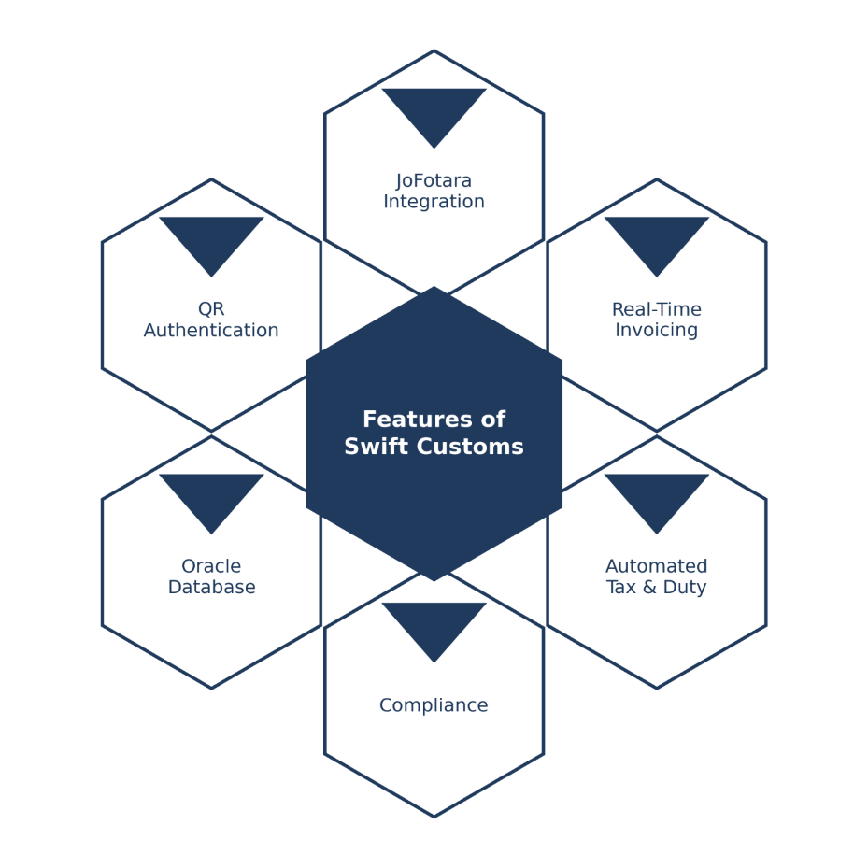
Figure 1: Core Features of Swift Customs

Literature Review (Related work)

In this section, we present several related works in this domain to illustrate the current state of customs clearance, accounting, and e-invoicing systems relevant to Jordan. Following this, we provide background research that is relevant to our study and clarify the gap that Swift Customs is designed to fill.
Several comprehensive systems already exist for accounting and electronic invoicing, some of which support Jordan's national e-invoicing platform, "JoFotara". For example, “Daftra” is a cloud-based, all-in-one ERP solution that combines accounting, invoicing, inventory, human resources, point-of-sale, and customer management, and it provides electronic invoicing compliant with the requirements of tax authorities in several countries, including Jordan [7]. While “Daftra” is powerful and fully implemented for real-world use, it is a large and complex platform designed to serve more than fifty different industries, which makes it heavy for a specialized workflow and generally requires solid accounting expertise to operate properly. It is not tailored to the specific needs of customs brokers. Similarly, Odoo is a widely used modular ERP system that offers JoFotara integration through its Jordanian localization package and dedicated add-on modules, enabling real-time invoice submission, automated tax calculation, QR code generation, digital signatures, and invoice validation directly within the system [8]. Although Odoo is flexible and capable, it remains a general-purpose enterprise platform rather than a focused solution for the customs clearance domain and configuring it for a broker's particular needs adds considerable complexity and overhead.
On the other hand, when it comes to the customs clearance process itself, Jordan Customs operates the ASYCUDA World system, an electronic customs management platform developed under UNCTAD and customized for national use [9]. ASYCUDA World allows importers and their representatives (customs brokers) to electronically submit and process customs declarations using the Single Administrative Document (SAD), validating entries and routing them through inspection channels. It is fully implemented, owned nationally, and widely adopted by the thousands of approved customs brokers operating in Jordan. However, ASYCUDA focuses on the declaration and clearance relationship between the broker and the Customs Department; it does not manage the broker's own accounting toward their clients, nor does it issue JoFotara-compliant electronic receipts with authenticated QR codes for the services the broker provides.
There have been several other commercial and governmental solutions developed to support accounting, taxation, and trade facilitation. Due to the recent government mandate requiring brokers in Jordan to issue their receipts electronically through JoFotara, businesses are increasingly investing in tools that automate invoicing and ensure tax compliance. When it comes to the daily work of a customs broker, however, the main concern is having a focused system that connects clearance-related accounting directly to JoFotara without the burden of a massive ERP. Most of the assessed related works fall into one of two categories: large general-purpose ERPs (such as Daftra and Odoo) that are powerful but heavy, complex, and not designed for the customs broker workflow, or national clearance systems (such as ASYCUDA) that handle declarations but not the broker's client-facing accounting and e-invoicing. This leaves a clear gap between the two.
As a result, a lightweight, purpose-built system that is specifically designed for customs brokers, that does not require deep accounting expertise, and that integrates directly with JoFotara to generate accurate, tax-compliant receipts with authenticated QR codes, best suits our use case. This is precisely the gap that Swift Customs, built on Oracle APEX, is designed to fill.

Table 2:Comparison of Customs Clearance and Accounting Systems
System | JoFotara Integration | QR Receipt Authentication | Automated Tax & Duty Calc | Customs-Broker Focused | Easy to Use (No Accounting Expertise) | Cost Efficient/ Lightweight | Jordan Compliance
Manual Process (Current) | ✗ | ✗ | ✗ | ~ | ✗ | ✗ | ~
Daftara | ✓ | ✓ | ~ | ✗ | ✗ | ✗ | ✓
Odoo | ✓ | ✓ | ~ | ✗ | ✗ | ~ | ✓
ASYCUDA World | ✗ | ✗ | ✓ | ✓ | ~ | ~ | ✓
Swift Customs | ✓ | ✓ | ✓ | ✓ | ✓ | ✓ | ✓

Technology and tools to be used

- Oracle APEX Stack Components
  - Oracle Database [10] Purpose: Main database for all application and accounting data.
Why Oracle Database:
- Enterprise-grade reliability and data integrity.
- Powerful transaction handling (ACID compliance).
- Strong security and access control.
- Native integration with Oracle APEX and PL/SQL.
- Built-in support for storing documents and receipts (BLOB storage).
  - Oracle APEX (Application Express) Purpose: Low-code framework for building web applications and user interface. Capabilities:
- Browser-based development runs directly inside the Oracle Database.
- Rapid creation of forms, reports, and interactive dashboards.
- Built-in authentication and authorization schemes.
- Responsive UI components out of the box. Why Oracle APEX:
- Fast development with minimal boilerplate code.
- Tight integration with Oracle Database and PL/SQL.
- Secure by design with built-in session and access management.
- Ideal for a focused, single-purpose system like Swift Customs.
- We are familiar with it.
  - PL/SQL Purpose [11]: Backend procedural language for implementing business logic.
Responsibilities:
- Tax and duty calculation logic.
- Receipt and declaration processing.
- Data validation and integrity checks.
- Building and handling REST calls to the JoFotara API.
- Error handling and transaction control. Why PL/SQL:
- Runs natively inside the Oracle Database for high performance.
- Tight coupling with application data reduces latency.
- Robust exception handling and transaction management.
- Seamless integration with both APEX and ORDS.
  - Oracle REST Data Services (ORDS) Purpose [12]: REST API layer connecting Swift Customs to external services. Key Features:
- Exposes and consumes RESTful web services.
- Enables direct communication with the JoFotara API.
- Secure, scalable middle tier for the Oracle Database.
- JSON request and response handling. Why ORDS:
- Allows direct REST API calls to JoFotara from APEX/ORDS without third-party middleware.
- Native Oracle technology with full APEX compatibility.
- Lightweight and easy to configure.
- JoFotara (National E-Invoicing Platform) Purpose [13] : Jordan's official national e-invoicing system, integrated as the core compliance and verification engine. Key Features:
- Real-time electronic invoice submission to the Income and Sales Tax Department (ISTD).
- Automated tax validation against national requirements.
- QR code generation and authentication for each issued receipt.
- Standardized, government-compliant invoice records. Why JoFotara:
- Mandatory for customs brokers in Jordan by government regulation.
- Ensure taxes are calculated and reported correctly.
- The authenticated QR code lets clients confirm that each receipt is legitimate.
- Accessed directly through a REST API call from Swift Customs.

- Oracle Cloud Infrastructure (Deployment Platform) Purpose: Managed infrastructure for hosting the Oracle APEX application and database. Key Features:
- Oracle Autonomous Database with built-in APEX support.
- Automatic backups, patching, and scaling.
- Secure, cloud-based access from anywhere.
- Integrated monitoring and high availability. Why Oracle Cloud:
- Removes complex infrastructure setup and maintenance.
- Reduces development and operational overhead.
- Enterprise-grade reliability and security.
- can also be deployed in a local Oracle environment if required.
- Document and Receipt Handling Purpose: Generating and storing customs receipts and clearance documents. Key Features:
- PDF generation directly from APEX reports.
- Embedding the JoFotara-authenticated QR code into receipts.
- Secure document storage within the Oracle Database (BLOB).
- Consistent, professional receipt templates. Why this approach:
- Keeps documents and data in one secure, integrated system.
- No single point of failure or external storage dependency.
- Ensures receipt integrity and easy retrieval.
- Supporting Technologies

  - PL/SQL Business Logic
- Language: PL/SQL
- Purpose: Implements the core system logic such as issuing receipts, calculating duties and taxes, and managing clearance records.
  - QR Code Authentication
    - Source: Generated and authenticated by JoFotara
    - Swift Customs receives the QR code via the API and displays/embeds it on the receipt for client verification.
  - Authentication
    - Oracle APEX built-in Authentication Schemes for secure login.
    - APEX Authorization Schemes for role-based access control.
  - PDF Handling
    - Oracle APEX native report printing / PDF generation.
    - Used for producing receipts and embedding the QR code.
  - API Documentation
    - ORDS auto-generated OpenAPI (Swagger) documentation for REST endpoints.
  - Development Tools
    - Oracle APEX App Builder
    - Oracle SQL Developer
    - Git and GitHub
    - Postman (for testing the JoFotara API integration)
  - Deployment Infrastructure
    - Oracle Cloud (Autonomous Database) or local Oracle server.

Chapter 2: Project Plan

2.1 Project Objectives

Design and implement a prototype Customs Clearance Accounting System based on Oracle APEX in Jordan that allows customs brokers to securely manage clearance accounting, calculate duties and taxes, and issue tamper-resistant, government-compliant receipts. To achieve this, the objectives of this research project are:
- To review and analyze existing platforms that support customs clearance accounting and electronic invoicing.
- To design and develop the Customs Clearance Accounting System Based on Oracle APEX in Jordan "Swift Customs".
- To integrate the system with the national "JoFotara" e-invoicing platform for real-time invoice submission and QR-based receipt authentication.
- To verify and validate the newly developed system mentioned in objective 2.

2.2 Project Scope
The main purpose of Swift Customs is to deliver a full Oracle APEX web application that enables a customs broker to manage their clearance accounting through a secure, integrated platform. The system will support core accounting processes by allowing the broker to create and manage customs clearance records, automatically calculate duties and taxes, and record client payments and outstanding balances. It will integrate directly with Jordan's national "JoFotara" e-invoicing platform through a REST API call to submit invoices in real time, validate them against national tax requirements, and receive an authenticated QR code for each issued receipt. In addition, Swift Customs will generate professional receipts with the embedded JoFotara QR code to ensure fast, reliable, and tamper-resistant verification, allowing clients to confirm that each receipt is legitimate.
For this project, several items are considered out of scope due to limitations in time, cost, and required technical expertise. Direct integration with ASYCUDA, the national customs declaration system operated by Jordan Customs, is excluded because it requires official access, real institutional APIs, data agreements, and significant coordination that is beyond the scope of a prototype. Migration of historical records from brokers' existing or legacy accounting methods is also excluded, as it would require extensive data mapping, cleaning, and validation effort that does not contribute to demonstrating the core functionality. Mobile application development is not included, since the focus of this version is on a web-based platform only. Finally, the system is designed for a single customs broker (one user/company) in this version rather than a multi-broker or multi-tenant environment, to keep the prototype focused and manageable within the available timeframe.

2.3 Software Process Model

Since our team is small and we are not experts in software development (especially in applying Agile practices), we selected the Waterfall model as the most suitable software process for this project. In the Waterfall approach, each phase is completed and documented before moving to the next phase, which helps us stay organized and avoid confusion later.

2.3.1 Analysis Phase (Data Gathering and Analysis)

In this phase, we used a combination of traditional and modern requirement-gathering techniques to ensure the application meets the real needs of users and stakeholders, and to understand the current customs clearance accounting process.
- Market research and related existing system analysis: We analyzed similar systems such as the current manual process, Daftra, Odoo, and ASYCUDA World to identify their strengths, weaknesses, and gaps based on their documentation and user feedback.
- Brainstorming session: We conducted several team brainstorming discussions to generate ideas for system features and user flows. This encourages open sharing of ideas and feedback.
- Document analysis and related work review: Documents and procedures related to the customs clearance process and the JoFotara e-invoicing requirements were reviewed, along with documentation from related research works, academic papers, and existing studies in digital accounting and e-invoicing systems. This analysis helped identify current limitations, best practices, and research gaps, ensuring the proposed system aligns with both practical requirements and established research findings.
2.3.2 Design Phase

After the analysis phase, we designed the full system architecture, including how the Oracle Database will be structured, how the PL/SQL business logic will be configured, how the system will integrate with the JoFotara API through ORDS, and how everything will come together within the Oracle APEX web application. The design phase serves as a clear blueprint and guide for implementation.

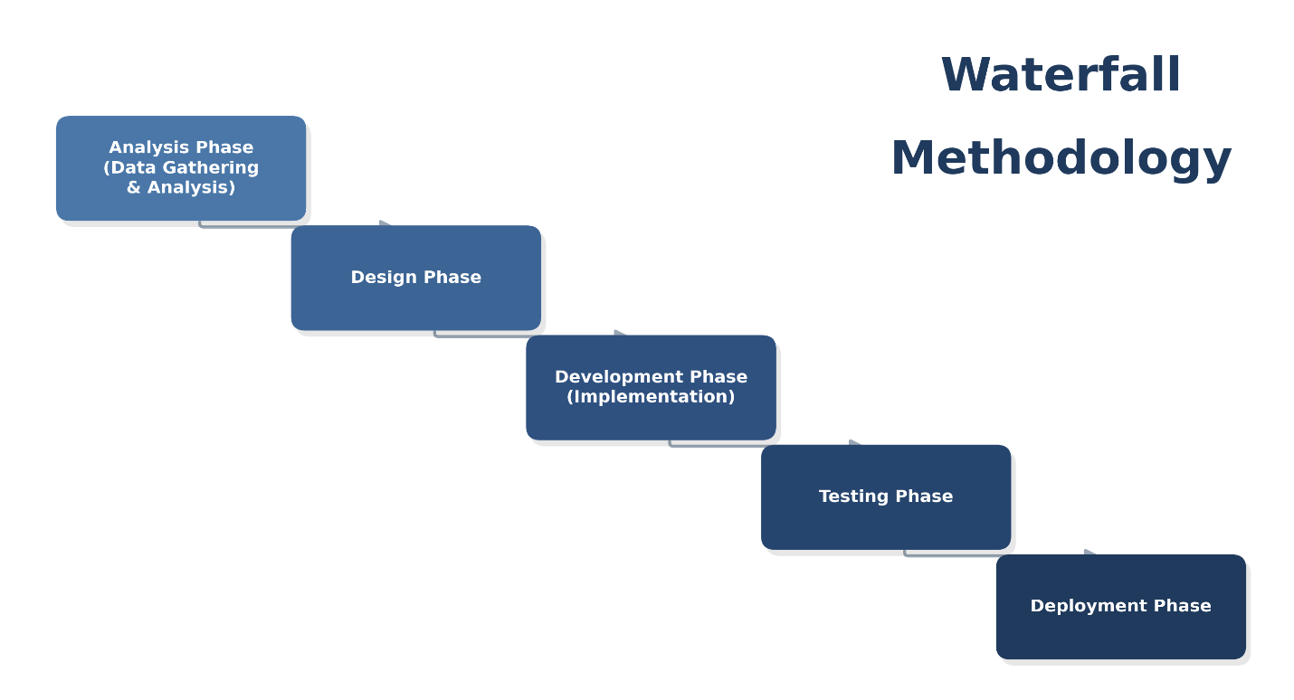
Figure 2: Waterfall Software Development Life Cycle

2.3.3 Development Phase (Implementation)

In this phase, the system will be developed following the planned sequence without moving ahead to later steps. Core functions such as creating clearance records, calculating duties and taxes, submitting invoices to JoFotara, recording receipts with authenticated QR codes, and the broker dashboard will be implemented step by step, where each stage starts only after the previous one is completed.

2.3.4 Testing Phase

After development, testing will be done to make sure the system works correctly before deployment. The testing will include unit testing, integration testing, end-to-end testing, security testing (SQL injection, XSS, CSRF), and performance testing.

2.3.5 Deployment Phase

Finally, the system will be deployed and made accessible to the customs broker to use the clearance accounting and JoFotara verification services in a real environment.

2.4 Work Breakdown Structure (WBS)

The Work Breakdown Structure (WBS) decomposes the Swift Customs project into manageable phases and work packages, providing a hierarchical view of all the work required to deliver the system. Organized around the Waterfall phases adopted for this project, the WBS clarifies the scope of each stage, supports accurate scheduling and task allocation among the team, and ensures that no deliverable is overlooked from initial planning through to deployment and documentation.
1.0 Swift Customs – Customs Clearance Accounting System
1.1 Project Management
1.1.1 Project Planning & Scope Definition
1.1.2 Scheduling (Gantt Chart)
1.1.3 Team Structure & Role Assignment
1.1.4 Supervisor Meetings & Milestone Reviews
1.1.5 Risk Management
1.2 Requirements & Analysis
1.2.1 Existing Systems Study (Daftra, Odoo, ASYCUDA)
1.2.2 Stakeholder Requirement Gathering
1.2.3 Functional Requirements Specification
1.2.4 Non-Functional Requirements Specification
1.2.5 Requirements Analysis & SRS Documentation
1.3 System Design
1.3.1 System Architecture (3-Layer)
1.3.2 Database Design (ERD / Oracle Schema)
1.3.3 Use Case Diagrams & Descriptions
1.3.4 Activity Diagrams
1.3.5 Class Diagram
1.3.6 UI/UX Design (APEX Pages)
1.3.7 JoFotara Integration Design
1.4 Development (Implementation)
1.4.1 Oracle Database Setup & Schema Creation
1.4.2 PL/SQL Duty & Tax Calculation Logic
1.4.3 APEX Application Pages (Clients, Declarations, Tariffs, Invoices, Payments, Reports)
1.4.4 Authentication & Role-Based Access Control
1.4.5 JoFotara Integration (ORDS / REST – Authentication & QR)
1.4.6 Audit Logging
1.5 Testing
1.5.1 Unit Testing
1.5.2 Integration Testing
1.5.3 System Testing
1.5.4 User Acceptance Testing (UAT)
1.5.5 Security Testing
1.6 Deployment
1.6.1 Environment Setup & Hosting
1.6.2 Data Configuration (Tariffs & Tax Rates)
1.6.3 Deployment & Go-Live
1.6.4 User Training & Handover
1.7 Documentation
1.7.1 GP(1) Report
1.7.2 GP(2) Final Report
1.7.3 User Manual
1.7.4 Technical Documentation
1.7.5 Final Presentation & Poster

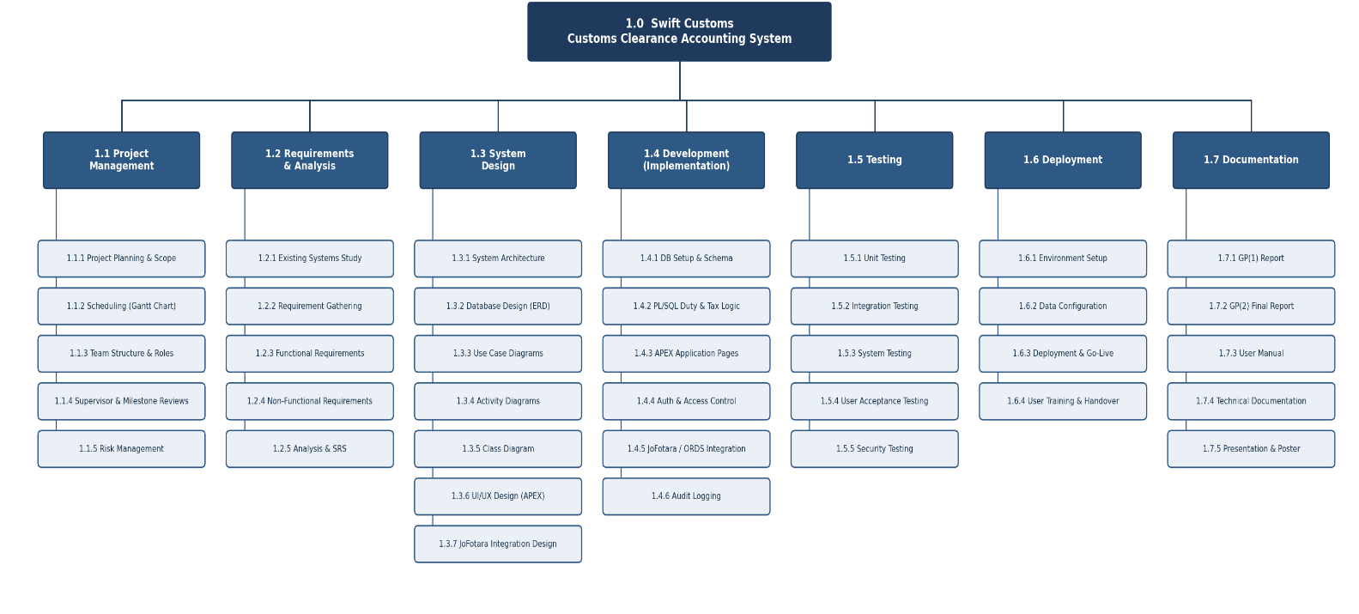
Figure 3:Work Breakdown Structure (WBS) of the Swift Customs System.

2.5 Project Schedule

The development of our project will navigate a meticulously crafted course, adhering to the structured guidance of the Waterfall model. This established approach ensures each phase is traversed efficiently, minimizing surprises and maximizing control. To visualize progress and maintain transparency, we will leverage a detailed Gantt chart, serving as a roadmap to success.
The Waterfall model forms the backbone of our schedule, meticulously dividing the project into distinct, sequential phases:
- Requirements Gathering (Weeks 1-4): This cornerstone stage focuses on the systematic and thorough collection of needs from the key stakeholder (the customs broker), along with an understanding of the JoFotara e-invoicing requirements and Jordan Customs regulations. By analyzing the existing manual clearance process and current digital solutions, we will establish a comprehensive and documented foundation for system design.

- Analysis (Weeks 5-7): With a clear understanding of the accounting and clearance requirements, we will move to a rigorous analysis phase. Deconstructing these requirements involves defining the data the system must store, the duty and tax calculation rules, and the workflows for receipt issuance and JoFotara integration.

- Design (Weeks 8-14): Building upon the insights gleaned from analysis, we will delve into the intricate details of the system architecture. This stage translates our vision into tangible blueprints by designing and drawing comprehensive UML and data diagrams — including use case diagrams, use case descriptions, activity diagrams, and the Entity Relationship Diagram (ERD) to visualize the flow between the user, the application, the Oracle Database, and the JoFotara API. We will specifically define the database schema, structure the PL/SQL business logic, and map out the user interface elements for the broker's dashboard and receipt-issuing screens.

- Implementation (Weeks 15-22): Guided by the detailed design roadmap, we will commence the construction phase. The development will cover building the Oracle APEX application, structuring the Oracle Database, coding the PL/SQL business logic for duty and tax calculations, and developing the JoFotara API integration layer. Each module will be meticulously built with high-quality code, adhering to security best practices and undergoing rigorous unit testing to ensure robust functionality.

- Integration and Testing (Weeks 23-26): With individual modules (APEX application, Oracle Database, PL/SQL logic, and JoFotara API layer) complete, we will seamlessly integrate them to form a cohesive web application. This phase emphasizes comprehensive testing, employing integration testing and user acceptance testing protocols to guarantee the platform ensures data accuracy and meets the receipt processing and verification expectations.

- Deployment and Maintenance (Weeks 27-28): Finally, the system will be launched to improve customs clearance accounting for brokers in Jordan. However, our work does not end with the launch. We will continue to maintain the application and update the business logic and JoFotara integration regularly. This will ensure the system performs well and remains secure.

2.6 Project Schedule Chart(s) (Gannt Chart) & Team Structure

Table 3: Team Structure and Roles
Team Member | Role | Responsibilities
Osama Ahmad Fouad Ibrahim | Oracle APEX Developer & Database Designer | - Requirements gathering  - Oracle Database schema design (ERD)  - PL/SQL business logic development  - Duty & tax calculation logic  - JoFotara API integration (ORDS/REST)  - APEX application development  - Documentation
Abdalrahman Rateb Saeed | Oracle APEX Developer & System Analyst | - Requirements gathering  - System analysis  - APEX application development  - UI/UX design  - PL/SQL development  - Receipt generation & QR display  - Testing  - Documentation
Dr. Hani Al-Bloush | Project Supervisor | - Technical guidance  - Academic oversight  - Milestone review

By strictly following this structured project plan and continuously tracking progress through the Gantt chart, we are confident in delivering Swift Customs, the Customs Clearance Accounting System, within the planned timeframe and to a high standard of quality. This disciplined scheduling approach ensures that each development phase is completed efficiently, risks are minimized, and project objectives are consistently met. Through careful planning, clear milestones, and effective coordination, this project schedule lays a strong foundation for a successful system deployment and long-term positive impact on customs brokers and Jordan's trade ecosystem.

- Requirements Gathering & Analysis: The Requirements tasks and schedules are shown in Figure 3.
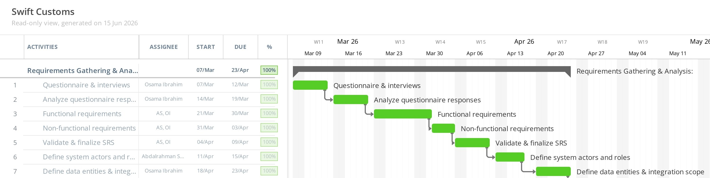
Figure 4: Requirements Gathering & Analysis Gantt Chart

- Design: Design tasks, times, and schedules are shown in Figure 4
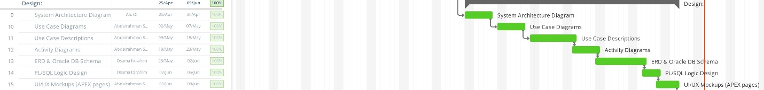
Figure 5:Design Gantt Chart
- Implementation: The Implementation tasks, times, and schedules are shown in Figure 5.
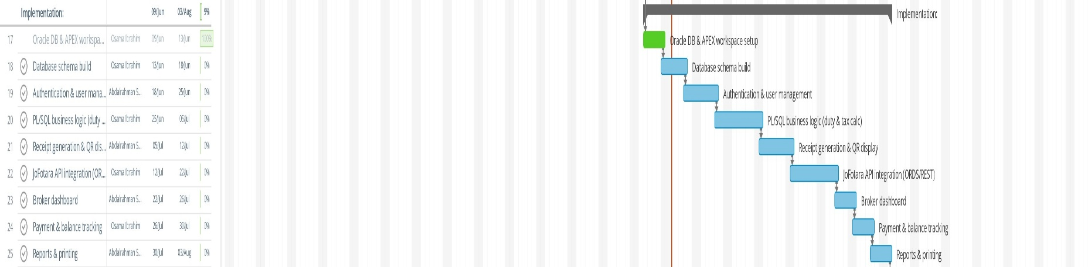
Figure 6:Implementation Gantt Chart

- Testing: The Testing tasks, times, and schedules are shown in Figure 6.

Figure 7:Testing Gantt Chart

- Full Gantt Chart: The project tasks and schedule are shown in Figure 7.
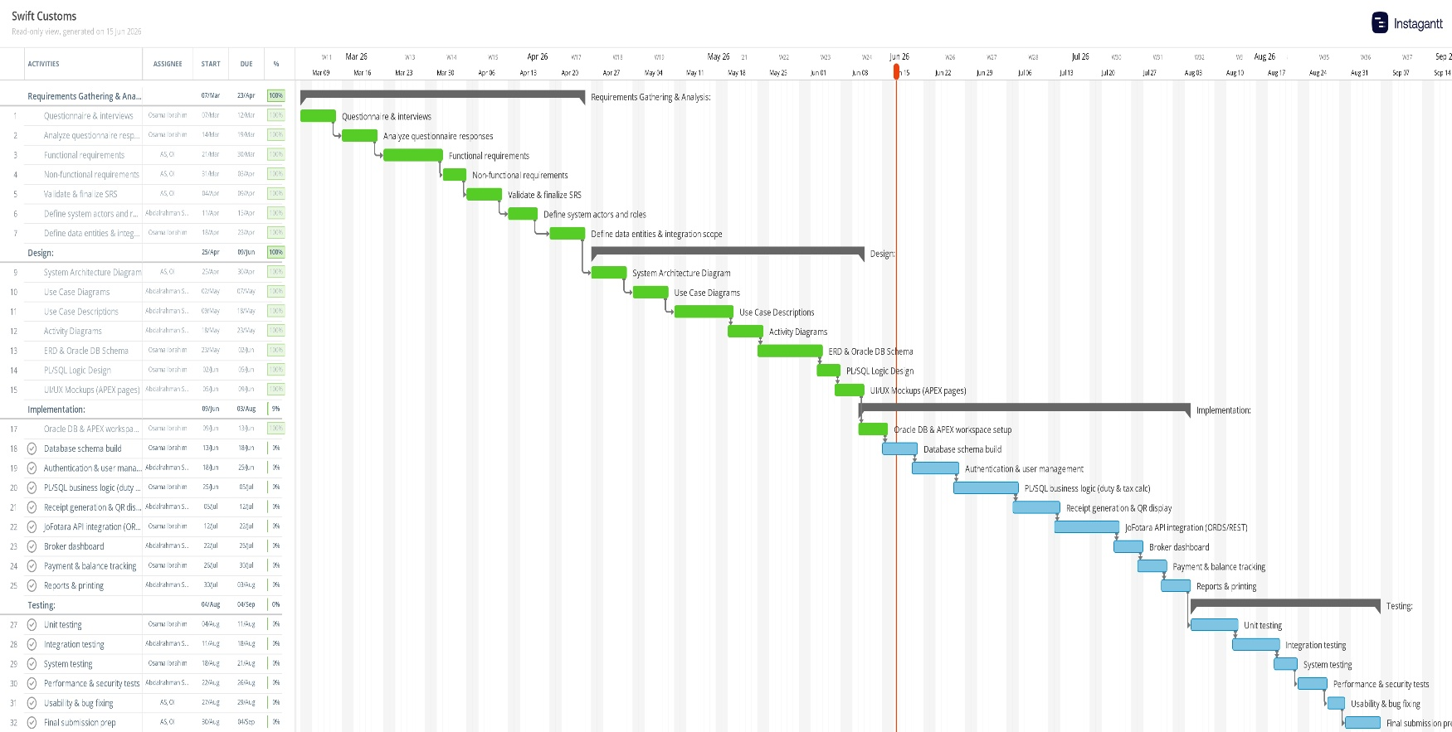
Figure 8:Full project Gantt Chart

Chapter 3: Requirements and Analysis

In this chapter, the system requirements are identified and documented using a Software Requirements Specification (SRS) template. The template used in this project is based on IEEE Std 830-1998 – IEEE Recommended Practice for Software Requirements Specifications and ISO/IEC/IEEE 29148:2018 – International Standard for Software and Systems Requirements Engineering. These standards were selected because they provide clear guidelines for writing well-structured, understandable, and testable software requirements.
Each functional requirement in this chapter is written using a consistent format that includes the requirement ID, name, priority, description, business rationale, dependencies, and exception scenarios. Using this standardized approach helps ensure clarity, consistency, and traceability of requirements, and makes it easier to understand the system behavior and validate the requirements during the design, implementation, and testing phases.

3.1 Functional Requirements

Table 4:FR1 - User Authentication
Requirement ID | FR1
Requirement name | User Authentication
Priority | High
Description | The system allows registered users (Broker Admin and Staff) to log in using their username and password through Oracle APEX authentication. Upon successful authentication, the user shall be directed to their authorized dashboard based on their assigned role.
Business Rationale | Ensures secure access control and prevents unauthorized access to sensitive accounting, client, and transaction data.
Dependency | FR2 (Staff accounts must exist), FR3 (Role-Based Access Control).
Exception scenario | 1. If the username or password is incorrect, display: "Invalid username or password."  2. After 5 failed login attempts, the account shall be temporarily locked for 15 minutes.

Table 5:FR2 - Staff Account Management
Requirement ID | FR2
Requirement name | Staff Account Management
Priority | High
Description | The system shall allow Broker Admin to create, update, and deactivate staff accounts within the company, assigning each account a role and the appropriate access permissions.
Business Rationale | Enables controlled delegation of work to employees while keeping the Broker Admin in full control of access.
Dependency | FR1 (Broker Admin authenticated), FR3 (Role-Based Access Control).
Exception scenario | 1. If the username already exists, display: "A user with this username already exists."  2. If account creation fails, display: "Unable to create staff account."

Table 6: FR3 - Role-Based Access Control
Requirement ID | FR3
Requirement name | Role-Based Access Control
Priority | High
Description | The system shall enforce role-based access control distinguishing the Broker Admin (full access to all functions) from Staff (restricted access to assigned functions such as declaration entry and invoicing).
Business Rationale | Prevents unauthorized actions and enforces least privilege access across the system.
Dependency | FR1 (User authentication).
Exception scenario | 1. If an unauthorized action is attempted, display: "Access denied."

Table 7: FR4 - Password Policy Enforcement
Requirement ID | FR4
Requirement name | Password Policy Enforcement
Priority | Medium
Description | The system shall enforce strong password policies, including minimum length and complexity requirements, when accounts are created or passwords are changed.
Business Rationale | Enhances system security and reduces the risk of credential compromise.
Dependency | FR2 (Staff Account Management).
Exception scenario | 1. If the password does not meet policy, display: "Password does not meet security requirements."

Table 8:FR5 - Account Lockout Management
Requirement ID | FR5
Requirement name | Account Lockout Management
Priority | Medium
Description | The system shall temporarily lock a user account after a defined number of consecutive failed login attempts and automatically unlock it after a set time.
Business Rationale | Protects account against brute-force login attacks.
Dependency | FR1 (User authentication).
Exception scenario | 1. If the account is locked, display: "Account temporarily locked. Please try again later."

Table 9:FR6 - Session Timeout Management
Requirement ID | FR6
Requirement name | Session Timeout Management
Priority | Medium
Description | The system shall automatically end inactive user sessions after a predefined timeout period and require the user to re-authenticate.
Business Rationale | Reduces security risks arising from unattended active sessions.
Dependency | FR1 (User authentication).
Exception scenario | 1. If the session expires, the user shall be redirected to the login page on the next action.

Table 10:FR7 - Client Registration
Requirement ID | FR7
Requirement name | Client Registration
Priority | High
Description | The system shall allow the Broker Admin and authorized Staff to register new clients (importers/exporters) by entering details such as name, national ID or company registration number, tax number, contact information, and address.
Business Rationale | Maintains an accurate client database that can be linked to declarations, invoices, and payments.
Dependency | FR1 (Authentication), FR3 (Role-Based Access Control).
Exception scenario | 1. If a client with the same tax/registration number exists, display: "This client is already registered."  2. If required fields are missing, display: "Please complete all required client details."

Table 11:FR8 - Client Account Management
Requirement ID | FR8
Requirement name | Client Account Management
Priority | Medium
Description | The system shall allow authorized users to view, update, and deactivate existing client records while preserving their historical transactions.
Business Rationale | Keeps client information current without losing past declarations and payment history.
Dependency | FR7 (Client Registration).
Exception scenario | 1. If a client has linked transactions, the system shall deactivate rather than delete the record.  2. If the update fails, display: "Unable to update client record."

Table 12:FR9 - Client Search and Filtering
Requirement ID | FR9
Requirement name | Client Search and Filtering
Priority | Medium
Description | The system shall allow users to search for clients by name, tax number, or registration number and filter the client list accordingly.
Business Rationale | Improve efficiency when handling many clients.
Dependency | FR7 (Client Registration).
Exception scenario | 1. If no matching client is found, display: "No matching clients found."

Table 13:FR10 - Tariff and Duty Rate Management
Requirement ID | FR10
Requirement name | Tariff and Duty Rate Management
Priority | High
Description | The system allows the Broker Admin to maintain a tariff table that maps HS codes to their corresponding customs duty rates, enabling automated duty calculation during declaration entry.
Business Rationale | Ensures duty calculations are based on accurate, up-to-date rates and reduces manual errors.
Dependency | FR1 (Authentication), FR3 (Role-Based Access Control).
Exception scenario | 1. If a duplicate HS code is entered, display: "This HS code already exists."  2. If an invalid rate is entered, display: "Please enter a valid duty rate."

Table 14:FR11 - Tax and Fee Configuration
Requirement ID | FR11
Requirement name | Tax and Fee Configuration
Priority | High
Description | The system shall allow Broker Admin to configure applicable tax rates (such as General Sales Tax) and additional fees used in calculating clearance charges.
Business Rationale | Allows the system to reflect current tax regulations and apply them consistently.
Dependency | FR1 (Authentication), FR3 (Role-Based Access Control).
Exception scenario | 1. If an invalid value is entered, display: "Please enter a valid tax or fee value."

Table 15:FR12 - Create Clearance Declaration
Requirement ID | FR12
Requirement name | Create Clearance Declaration
Priority | High
Description | The system shall allow authorized users to create a new clearance declaration by selecting a client and entering shipment details, including goods description, HS code, country of origin, customs value (CIF), and a system-generated reference number and date.
Business Rationale | Captures all information required to process a clearance transaction and calculate charges.
Dependency | FR7 (Client Registration), FR10 (Tariff Management).
Exception scenario | 1. If required fields are missing, display: "Please complete all required declaration details."  2. If the selected HS code has no defined duty rate, display: "No duty rate defined for the selected HS code."

Table 16:FR13 - Declaration Data Validation
Requirement ID | FR13
Requirement name | Declaration Data Validation
Priority | High
Description | The system shall validate all declaration fields (such as customs value, HS code, and country of origin) for completeness and correct format before saving the declaration.
Business Rationale | Prevents incorrect or incomplete data from affecting duty and tax calculations.
Dependency | FR12 (Create Clearance Declaration).
Exception scenario | 1. If validation fails, display: "Invalid declaration data. Please review the highlighted fields."

Table 17:FR14-Edit Clearance Declaration
Requirement ID | FR14
Requirement name | Edit Clearance Declaration
Priority | Medium
Description | The system shall allow authorized users to edit a declaration's details before an invoice has been issued, after which the declaration becomes read-only.
Business Rationale | Allows corrections during preparation while protecting the integrity of issued invoices.
Dependency | FR12 (Create Clearance Declaration).
Exception scenario | 1. If the declaration already has an issued invoice, display: "This declaration cannot be edited after invoicing."

Table 18:FR15 - View, Search, and Filter Declarations
Requirement ID | FR15
Requirement name | View, Search, and Filter Declarations
Priority | Medium
Description | The system shall allow users to view a list of declarations and search or filter them by client, date range, reference number, or status.
Business Rationale | Provides quick access to and management of clearance records.
Dependency | FR12 (Create Clearance Declaration).
Exception scenario | 1. If no matching declarations are found, display: "No matching declarations found."

Table 19:FR16 - Declaration Reference Number Generation
Requirement ID | FR16
Requirement name | Declaration Reference Number Generation
Priority | Medium
Description | The system shall automatically generate a unique reference number for each clearance declaration upon creation.
Business Rationale | Ensure every declaration can be uniquely identified and traced.
Dependency | FR12 (Create Clearance Declaration).
Exception scenario | 1. If reference generation fails, the system shall prevent saving and display: "Unable to generate declaration reference number."

Table 20:FR17 - Automated Duty and Tax Calculation
Requirement ID | FR17
Requirement name | Automated Duty and Tax Calculation
Priority | High
Description | The system shall automatically calculate the customs duty, applicable taxes, and total clearance charges for a declaration based on the customs value (CIF), the duty rate associated with the HS code, and the configured tax and fee rates.
Business Rationale | Eliminates manual calculation errors and ensures accurate, consistent charges.
Dependency | FR10 (Tariff Management), FR11 (Tax Configuration), FR12 (Create Clearance Declaration).
Exception scenario | 1. If required calculation data is missing, display: "Cannot calculate charges. Please verify declaration and rate data."

Table 21:FR18 - Manual Adjustment of Calculated Amounts
Requirement ID | FR18
Requirement name | Manual Adjustment of Calculated Amounts
Priority | Medium
Description | The system shall allow authorized users to manually adjust calculated amounts before issuing an invoice, while recording the original calculated values for traceability.
Business Rationale | Provides flexibility for special cases while maintaining an audit trail of changes.
Dependency | FR17 (Automated Duty and Tax Calculation).
Exception scenario | 1. If an invalid adjustment value is entered, display: "Please enter a valid amount."

Table 22: FR19 - Invoice/Receipt Generation
Requirement ID | FR19
Requirement name | Invoice/Receipt Generation
Priority | High
Description | The system shall generate an invoice/receipt for a declaration containing the client details, itemized charges (duty, taxes, fees), total amount, and the declaration reference.
Business Rationale | Provides the client with a clear, itemized record of clearance charges.
Dependency | FR17 (Automated Duty and Tax Calculation).
Exception scenario | 1. If invoice generation fails, display: "Unable to generate invoice. Please try again."

Table 23:FR20 - JoFotara E-Invoice Submission
Requirement ID | FR20
Requirement name | JoFotara E-Invoice Submission
Priority | High
Description | The system shall submit each issued invoice to the national JoFotara platform in real time through a REST API call and await confirmation before completing the issuance.
Business Rationale | Ensures compliance with the national e-invoicing mandate and correct tax reporting.
Dependency | FR19 (Invoice/Receipt Generation).
Exception scenario | 1. If the JoFotara API is unavailable, display: "JoFotara service unavailable. Invoice submission failed."  2. If the submission is rejected, display the returned validation error.

Table 24:FR21 - QR Code Retrieval and Embedding
Requirement ID | FR21
Requirement name | QR Code Retrieval and Embedding
Priority | High
Description | The system shall retrieve the authenticated QR code returned by JoFotara for each submitted invoice and embed it into the generated receipt.
Business Rationale | Enables clients to verify the legitimacy of their receipts.
Dependency | FR20 (JoFotara E-Invoice Submission).
Exception scenario | 1. If the QR code is not returned, display: "Invoice submitted but QR code unavailable."

Table 25:FR22 - Receipt PDF Generation
Requirement ID | FR22
Requirement name | Receipt PDF Generation
Priority | High
Description | The system should produce a printable PDF receipt that includes the itemized charges and the embedded JoFotara QR code, available for download or printing.
Business Rationale | Provides clients with an official, verifiable document.
Dependency | FR21 (QR Code Retrieval and Embedding).
Exception scenario | 1. If PDF generation fails, display: "Unable to generate receipt PDF."

Table 26: FR23 - JoFotara Submission Failure Handling
Requirement ID | FR23
Requirement name | JoFotara Submission Failure Handling
Priority | High
Description | The system shall handle JoFotara submission failures gracefully by preventing receipt finalization, preserving the invoice data, and allowing the user to retry submission.
Business Rationale | Prevents inconsistent records and ensures no receipt is issued without valid authentication.
Dependency | FR20 (JoFotara E-Invoice Submission).
Exception scenario | 1. If retry fails repeatedly, the system shall save the invoice as "Pending" and notify the user.

Table 27:FR24 - Receipt Authenticity Verification
Requirement ID | FR24
Requirement name | Receipt Authenticity Verification
Priority | Medium
Description | The system shall support client verification of receipts by ensuring the embedded JoFotara QR code links to the official verification record, allowing clients to confirm the receipt is legitimate.
Business Rationale | Builds client trust and confirms that issued receipts are officially registered.
Dependency | FR21 (QR Code Retrieval and Embedding).
Exception scenario | 1. If the QR code is invalid or tampered with, verification through JoFotara will fail, indicating the receipt is not legitimate.

Table 28:FR25 - Record Payment
Requirement ID | FR25
Requirement name | Record Payment
Priority | High
Description | The system shall allow authorized users to record full or partial payments made by clients against their issued invoices, including the amount, date, and payment method.
Business Rationale | Keeps accurate financial records of amounts received.
Dependency | FR19 (Invoice/Receipt Generation).
Exception scenario | 1. If the payment amount exceeds the outstanding balance, display: "Payment exceeds the outstanding balance."

Table 29: FR26 - Client Balance Tracking
Requirement ID | FR26
Requirement name | Client Balance Tracking
Priority | High
Description | The system shall automatically calculate and maintain each client's outstanding balance based on issued invoices and recorded payments.
Business Rationale | Provides an accurate, real-time view of what each client owes.
Dependency | FR25 (Record Payment).
Exception scenario | 1. If balance calculation fails, display: "Unable to update client balance."

Table 30:FR27 - Outstanding Payments Management
Requirement ID | FR27
Requirement name | Outstanding Payments Management
Priority | Medium
Description | The system will allow users to view all invoices with outstanding balances and filter them by client or date.
Business Rationale | Help the broker follow up on unpaid invoices and manage cash flow.
Dependency | FR26 (Client Balance Tracking).
Exception scenario | 1. If there are no outstanding payments, display: "No outstanding payments found."

Table 31:FR28 - Transactions Report
Requirement ID | FR28
Requirement name | Transactions Report
Priority | Medium
Description | The system shall generate a report of clearance transactions over a selected period, showing declarations, charges, and status.
Business Rationale | Gives the broker an overview of activity and supports record-keeping.
Dependency | FR12 (Create Clearance Declaration).
Exception scenario | 1. If no transactions exist for the period, display: "No transactions found for the selected period."

Table 32:FR29 - Tax and Duty Summary Report
Requirement ID | FR29
Requirement name | Tax and Duty Summary Report
Priority | Medium
Description | The system shall generate a summary report of the duties and taxes calculated and collected over a selected period.
Business Rationale | Supports tax reporting and reconciliation.
Dependency | FR17 (Automated Duty and Tax Calculation).
Exception scenario | 1. If no data exists, display: "No tax or duty data found for the selected period."

Table 33:FR30 - Client Account Statement
Requirement ID | FR30
Requirement name | Client Account Statement
Priority | Medium
Description | The system shall generate a statement for a selected client showing their invoices, payments, and outstanding balance over a period.
Business Rationale | Provides clients and the broker with a clear account history.
Dependency | FR26 (Client Balance Tracking).
Exception scenario | 1. If the client has no activity, display: "No account activity found for this client."

Table 34:FR31 - Revenue Report
Requirement ID | FR31
Requirement name | Revenue Report
Priority | Low
Description | The system shall generate a report summarizing the broker's revenue (service charges and collected amounts) over a selected period.
Business Rationale | Helps the broker monitor business performance.
Dependency | FR25 (Record Payment).
Exception scenario | 1. If no revenue data exists, display: "No revenue data found for the selected period."

Table 35:FR32 - Company Profile Management
Requirement ID | FR32
Requirement name | Company Profile Management
Priority | Medium
Description | The system shall allow the Broker Admin to manage the company profile, including company name, tax number, contact details, and JoFotara integration credentials.
Business Rationale | Ensures accurate company information on invoices and a correct connection to JoFotara.
Dependency | FR1 (Authentication), FR3 (Role-Based Access Control).
Exception scenario | 1. If required profile fields are missing, display: "Please complete all required company details."

Table 36:FR33 - Activity Logging and Audit Trail
Requirement ID | FR33
Requirement name | Activity Logging and Audit Trail
Priority | Medium
Description | The system shall log critical actions — including declaration creation, invoice issuance, payment recording, and user management — capturing the timestamp and the user who performed the action.
Business Rationale | Ensures accountability and traceability of all important operations.
Dependency | FR1 (Authentication).
Exception scenario | 1. If logging fails, the system shall still complete the primary action and flag the log failure.

Table 37:FR34 - Data Validation and Integrity Checks
Requirement ID | FR34
Requirement name | Data Validation and Integrity Checks
Priority | High
Description | The system shall validate all input data and maintain consistency between declarations, invoices, payments, and client balances.
Business Rationale | Prevents data corruption and ensures financial accuracy.
Dependency | FR12 (Create Clearance Declaration), FR19 (Invoice Generation), FR25 (Record Payment).
Exception scenario | 1. If an integrity check fails, the system shall block the operation and display: "Data validation error."

Table 38:FR35 - System Error Handling
Requirement ID | FR35
Requirement name | System Error Handling
Priority | High
Description | The system shall gracefully handle application, database, and network errors and present user-friendly error messages.
Business Rationale | Improves system stability and user trust.
Dependency | None.
Exception scenario | 1. On an unexpected error, display: "An unexpected error occurred. Please try again later."

3.2 Non-Functional Requirements
Non-functional requirements specify how the system should perform. They address quality attributes, constraints, and system characteristics rather than specific features.

Table 39:NFR-SEC01 - Secure Authentication
Non-functional requirement ID | NFR-SEC01
NFR category | Security
Requirement Title | Secure Authentication
Requirement Description | The system should protect user accounts using securely hashed passwords and the authentication mechanisms provided by Oracle APEX.
Acceptance Criteria | Passwords are stored using hashing; invalid access attempts are blocked.
Priority | High
Rationale | Prevents unauthorized access to sensitive accounting and client data.
Related Functional Requirements | FR1, FR4, FR5

Table 40:NFR-SEC02 - Secure Data Transmission
Non-functional requirement ID | NFR-SEC02
NFR category | Security
Requirement Title | Secure Data Transmission
Requirement Description | All data exchanged between users and the system, and between the system and the JoFotara API, shall be encrypted.
Acceptance Criteria | HTTPS enabled all requests; API calls use secure connections.
Priority | High
Rationale | Protects data from interception, especially invoice and tax data sent to JoFotara.
Related Functional Requirements | FR20, FR34

Table 41:NFR-SEC03 - Role-Based Access Control
Non-functional requirement ID | NFR-SEC03
NFR category | Security
Requirement Title | Role-Based Access Control
Requirement Description | Users shall only access the features permitted by their assigned role (Broker Admin or Staff).
Acceptance Criteria | Unauthorized actions are blocked.
Priority | High
Rationale | Ensures least-privilege access across the system.
Related Functional Requirements | FR3

Table 42:NFR-PERF01 - Fast Response Time
Non-functional requirement ID | NFR-PERF01
NFR category | Performance
Requirement Title | Fast Response Time
Requirement Description | The system shall respond to common operations such as saving a declaration or generating an invoice within a few seconds under normal load.
Acceptance Criteria | 95% of standard operations respond within 3 seconds (excluding external JoFotara response time).
Priority | High
Rationale | Keeps the broker's daily workflow fast and efficient.
Related Functional Requirements | FR12, FR19

Table 43:NFR-PERF02 - Concurrent User Support
Non-functional requirement ID | NFR-PERF02
NFR category | Performance
Requirement Title | Concurrent User Handling
Requirement Description | The system shall support the broker office's staff using the system simultaneously without performance degradation.
Acceptance Criteria | No degradation with the expected number of concurrent office users.
Priority | Medium
Rationale | Ensure smooth operation for all staff working at the same time.
Related Functional Requirements | FR1, FR12

Table 44:NFR-REL01 - System Reliability
Non-functional requirement ID | NFR-REL01
NFR category | Reliability
Requirement Title | Reliable Operations
Requirement Description | The system shall respond to common operations such as saving a declaration or generating an invoice within a few seconds under normal load.
Acceptance Criteria | 95% of standard operations respond within 3 seconds (excluding external JoFotara response time).
Priority | High
Rationale | Keeps the broker's daily workflow fast and efficient.
Related Functional Requirements | FR12, FR19

Table 45:NFR-SCAL01 - System Scalability
Non-functional requirement ID | NFR-SCAL01
NFR category | Scalability
Requirement Title | Support Future Growth
Requirement Description | The system shall handle a growing number of clients, declarations, and transactions over time without requiring redesign.
Acceptance Criteria | Increased data volume is handled without architectural changes.
Priority | Medium
Rationale | The broker's client base and records grow over time.
Related Functional Requirements | FR7, FR12

Table 46:NFR-USAB01 - User-Friendly Interface
Non-functional requirement ID | NFR-USAB01
NFR category | Usability
Requirement Title | User-Friendly Interface
Requirement Description | The system should provide a clear, simple interface that non-technical broker staff can use with minimal training.
Acceptance Criteria | Users complete core tasks with little or no training.
Priority | Medium
Rationale | Improves adoption and reduces the accounting expertise needed — a key advantage over heavy, complex ERPs.
Related Functional Requirements | FR12, FR19

Table 47:NFR-MAINT01 - System Maintainability
Non-functional requirement ID | NFR-MAINT01
NFR category | Maintainability
Requirement Title | Easy Maintenance
Requirement Description | The system should be modular and well-documented, with business logic organized in PL/SQL for ease of update.
Acceptance Criteria | Code changes (e.g. updating tax rates or logic) do not break existing features.
Priority | Medium
Rationale | Supports future updates such as changes in tax law or duty rates.
Related Functional Requirements | FR10, FR11, FR32

Table 48:NFR-COMP01 - Regulatory and JoFotara Compliance
Non-functional requirement ID | NFR-COMP01
NFR category | Compliance
Requirement Title | Regulatory Compliance
Requirement Description | The system shall comply with Jordanian tax regulations and the JoFotara e-invoicing requirements.
Acceptance Criteria | Invoices are accepted by JoFotara; audit logs and access controls are enabled.
Priority | High
Rationale | Mandatory for the legal operation of customs brokers in Jordan.
Related Functional Requirements | FR20, FR21, FR33

Table 49:NFR-LOG01 - Logging and Auditing
Non-functional requirement ID | NFR-LOG01
NFR category | Auditability
Requirement Title | System Activity Logging
Requirement Description | All critical actions shall be logged with a timestamp and user ID.
Acceptance Criteria | Logs are available for review.
Priority | High
Rationale | Ensures accountability and traceability.
Related Functional Requirements | FR33

Chapter 4: Architecture and Design

4.1 Architecture

Since Swift Customs is being developed as a web-based project, the architecture will follow a layered architecture, as it is the most suitable choice for our system. The layered architecture consists of the Presentation Layer, the Application/Business Logic Layer, and the Data Layer, with the national JoFotara e-invoicing platform integrated as an external service. Each layer has a specific role and responsibility within the system, and one of the strongest advantages of this architecture is the separation of concerns. This means that components in each layer only handle the logic related to that layer, which makes the system more organized and easier to manage. This clear classification of components helps in building effective roles and responsibilities within the architecture and makes the system easier to develop, test, govern, and maintain because each layer has well-defined interfaces and a limited scope. In Swift Customs, the Front-End represents the Presentation Layer, developed using Oracle APEX, which renders the user interface in the browser using HTML, CSS, and JavaScript. The Application/Business Logic Layer is implemented using the Oracle APEX engine together with PL/SQL and Oracle REST Data Services (ORDS) to manage requests, apply business rules such as duty and tax calculation, and communicate with the external JoFotara service. Finally, the Data Layer is responsible for storing and managing the system data using the Oracle Database, including relational tables for clients, declarations, invoices, and payments, as well as BLOB storage for receipt PDFs.

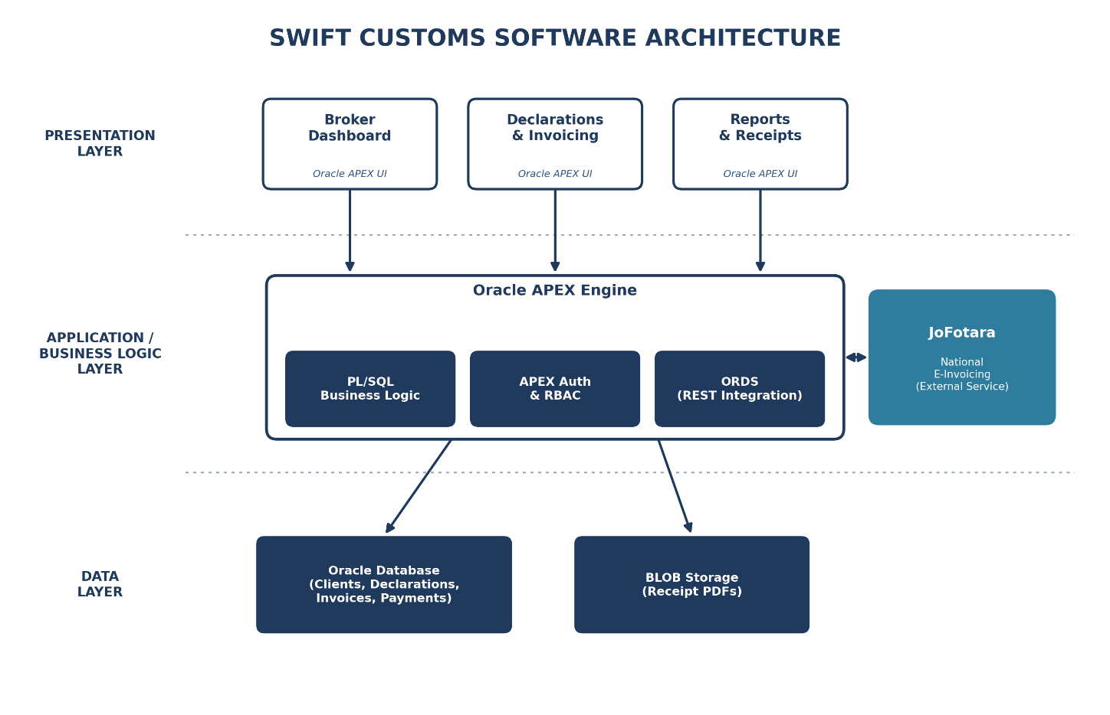
Figure 9: Layered Architecture of the Swift Customs System

For Swift Customs, we will use a 3-layer (layered) architecture because it fits web-based systems and ensures separation of concerns, making the system easier to develop, test, maintain, and secure.

- First Layer (Presentation Layer): his is the topmost layer responsible for handling the user interface and user input. It includes UI components such as pages, forms, reports, and dashboards. In Swift Customs, this layer is implemented using Oracle APEX, which renders these components in the browser to provide the interface used by the broker and staff.

- Second Layer (Application/Business Logic Layer): This is the server-side layer that manages requests and provides system services. It includes the Oracle APEX engine, PL/SQL business logic, and Oracle REST Data Services (ORDS). It is responsible for request handling, input validation, authentication and authorization, role-based access control, and coordinating workflows such as declaration entry, duty and tax calculation, invoice issuance, and payment recording. It also acts as the mediator between the presentation layer and the external JoFotara service, submitting invoices and retrieving the authenticated QR code.

- Third Layer (Data/Storage Layer): This layer is responsible for storing and managing data. In Swift Customs, it uses the Oracle Database to store all application data — including clients, declarations, invoices, payments, tariff rates, and audit logs — as well as the generated receipt PDFs stored as BLOBs.

- External Service (JoFotara): The national e-invoicing platform is integrated as an external service rather than a layer of application. The Application/Business Logic Layer communicates with it through a secure REST API call to submit invoices in real time and retrieve the authenticated QR code that is embedded into each receipt.

This architecture improves security because the client does not directly access the database or the JoFotara service; all access goes through the application layer where validation and access control are enforced. It also improves maintainability because the business logic is centralized in PL/SQL, and it improves data integrity because all updates follow controlled backend workflows before being stored in the Oracle Database.

4.2 Use Case Diagram
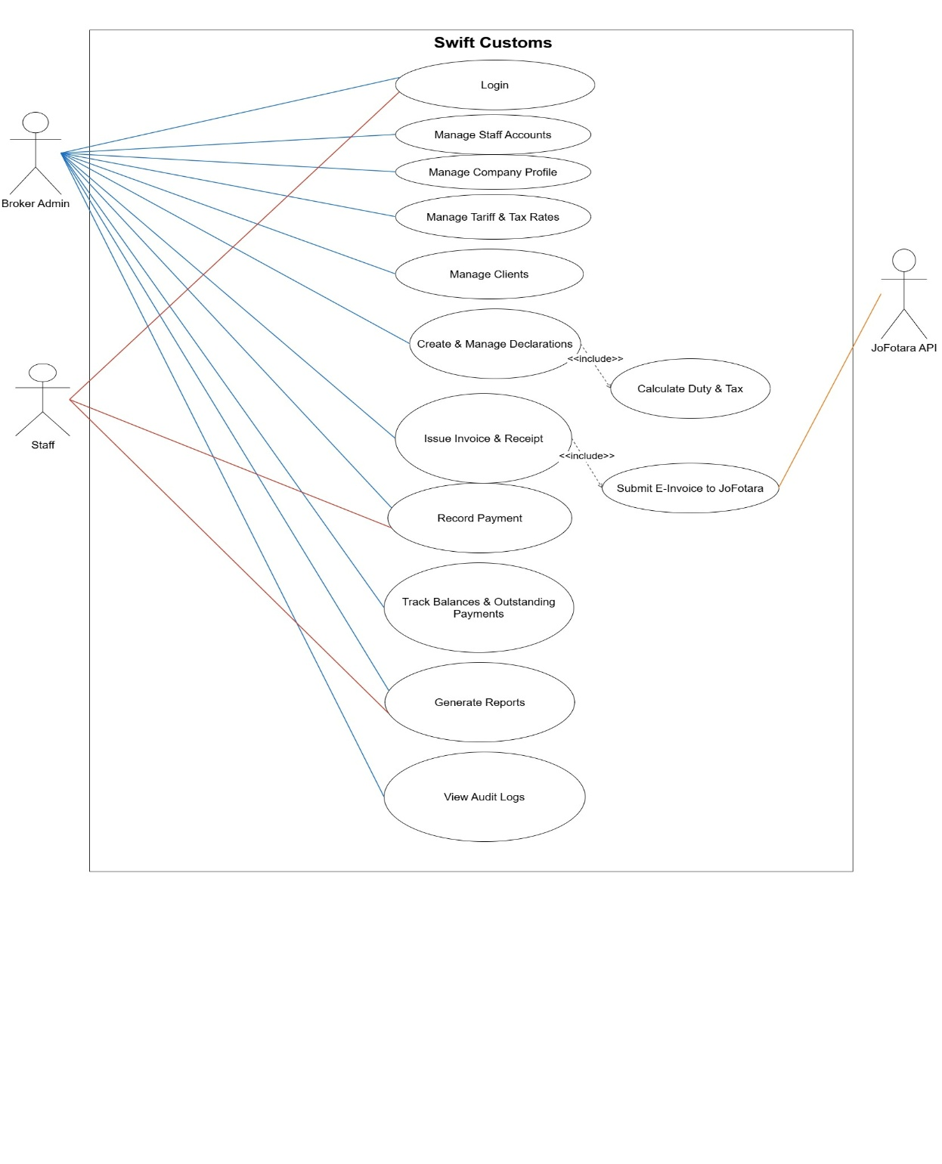
Figure 10: Use Case Diagram for the Swift Customs System

4.3 Use Case Description

Table 50:UC01 - Log In / Authenticate
USE CASE NAME | Log In / Authenticate
USE CASE ID | UC-SC-01
DESCRIPTION | Allows registered users (Broker Admin and Staff) to access Swift Customs using their credentials and routes them to the dashboard appropriate to their role.
PRIMARY ACTOR | Broker Admin / Staff
SECONDARY ACTOR | ----
PRE-CONDITION | User account exists.
POST-CONDITION | A user session is created, and the user is directed to their authorized dashboard.
MAIN FLOWS | 1. User opens the Swift Customs login page.  2. User enters username and password.  3. System validates the credentials.  4. System creates a session and applies the user's role.  5. System redirects the user to the appropriate dashboard.
ALTERNATIVE FLOWS | - Invalid username/password: system displays "Invalid username or password."  - After 5 failed attempts: account is temporarily locked.

Table 51:UC02 - Manage Staff Accounts
USE CASE NAME | Manage Staff Accounts
USE CASE ID | UC-SC-02
DESCRIPTION | Broker Admin creates, updates, and deactivates staff accounts and assigns their roles and permissions.
PRIMARY ACTOR | Broker Admin
SECONDARY ACTOR | ----
PRE-CONDITION | Broker Admin is authenticated.
POST-CONDITION | Staff accounts are created/updated/deactivated with the appropriate permissions.
MAIN FLOWS | 1. Broker Admin opens "Staff Management."  2. Broker Admin chooses to add, edit, or deactivate a staff account.  3. Broker Admin enters or updates the staff details and role.  4. System validates the input.  5. System saves the changes and records the action in the audit log.
ALTERNATIVE FLOWS | - Duplicate username: system displays "A user with this username already exists."  - Creation fails: system displays "Unable to create staff account."

Table 52:UC03 - Manage Company Profile
USE CASE NAME | Manage Company Profile
USE CASE ID | UC-SC-03
DESCRIPTION | Broker Admin manages the company profile, including company details, tax number, and JoFotara integration credentials.
PRIMARY ACTOR | Broker Admin
SECONDARY ACTOR | ----
PRE-CONDITION | Broker Admin is authenticated.
POST-CONDITION | Company profile is updated and used across the system (e.g., on invoices and JoFotara submissions).
MAIN FLOWS | 1. Broker Admin opens "Company Profile."  2. System displays the current company details.  3. Broker Admin updates the details and/or JoFotara credentials.  4. System validates and saves the changes.
ALTERNATIVE FLOWS | - Required fields missing: system displays "Please complete all required company details."

Table 53:UC04 - Manage Tariff & Tax Rates
USE CASE NAME | Manage Tariff & Tax Rates
USE CASE ID | UC-SC-04
DESCRIPTION | Broker Admin maintains the tariff table (HS codes and duty rates) and configures the tax and fee rates used in calculations.
PRIMARY ACTOR | Broker Admin
SECONDARY ACTOR | ----
PRE-CONDITION | Broker Admin is authenticated.
POST-CONDITION | Tariff and tax rates are saved and applied in duty/tax calculations.
MAIN FLOWS | 1. Broker Admin opens "Tariff & Tax Rates."  2. Broker Admin adds or updates an HS code with its duty rate, or a tax/fee rate.  3. System validates the entry.  4. System saves the rate.
ALTERNATIVE FLOWS | - Duplicate HS code: system displays "This HS code already exists."  - Invalid value: system displays "Please enter a valid rate."

Table 54:UC05 - Manage Clients
USE CASE NAME | Manage Clients
USE CASE ID | UC-SC-05
DESCRIPTION | Broker Admin registers, views, updates, and deactivates client (importer/exporter) records and links them to declarations.
PRIMARY ACTOR | Broker Admin
SECONDARY ACTOR | ----
PRE-CONDITION | Broker Admin is authenticated.
POST-CONDITION | Client records are created/updated and available to link to declarations and invoices.
MAIN FLOWS | 1. Broker Admin opens "Clients."  2. Broker Admin adds a new client or selects an existing one to edit.  3. Broker Admin enters client details (name, tax/registration number, contact, address).  4. System checks for duplicates and validates the data.  5. System saves the client record.
ALTERNATIVE FLOWS | - Duplicate client: system displays "This client is already registered."  - Missing required data: system prompts to complete the fields.

Table 55:UC06 - Create & Manage Declaration
USE CASE NAME | Create & Manage Declarations
USE CASE ID | UC-SC-06
DESCRIPTION | Broker Admin creates and manages customs clearance declarations by entering shipment details; the system calculates duty and tax as part of the process.
PRIMARY ACTOR | Broker Admin
SECONDARY ACTOR | ----
PRE-CONDITION | Broker Admin is authenticated; client and tariff rates exist.
POST-CONDITION | A declaration is saved with a unique reference number and calculated charges.
MAIN FLOWS | 1. Broker Admin opens "Declarations" and selects "Create Declaration."  2. Broker Admin selects a client and enters shipment details (goods description, HS code, country of origin, customs value).  3. System generates a unique declaration reference number.  4. System calculates the duty and tax (include: Calculate Duty & Tax).  5. System validates and saves the declaration.
ALTERNATIVE FLOWS | - Missing required fields: system displays "Please complete all required declaration details."  - No duty rate for HS code: system displays "No duty rate defined for the selected HS code."

Table 56:UC07 - Calculate Duty & Tax
USE CASE NAME | Calculate Duty & Tax
USE CASE ID | UC-SC-07
DESCRIPTION | The system calculates the customs duty, applicable taxes, and total charges for a declaration based on the customs value, the HS code's duty rate, and the configured tax/fee rates. (Included by Create & Manage Declarations.)
PRIMARY ACTOR | Swift Customs System (triggered by Create & Manage Declarations)
SECONDARY ACTOR | ----
PRE-CONDITION | Declaration data and applicable rates are available.
POST-CONDITION | Calculated duty, tax, and total charges are returned and stored with the declaration.
MAIN FLOWS | 1. System retrieves the customs value and the duty rate for the HS code.  2. System applies the configured tax and fee rates.  3. System computes the total clearance charges.  4. System returns the calculated amounts to the declaration.
ALTERNATIVE FLOWS | - Missing rate/data: system displays "Cannot calculate charges. Please verify declaration and rate data."

Table 57:UC08 - Issue Invoice & Receipt
USE CASE NAME | Issue Invoice & Receipt
USE CASE ID | UC-SC-08
DESCRIPTION | Broker Admin issues an invoice/receipt for a declaration; the system submits it to JoFotara, retrieves the authenticated QR code, and produces the receipt.
PRIMARY ACTOR | Broker Admin
SECONDARY ACTOR | JoFotara API
PRE-CONDITION | A declaration with calculated charges exists.
POST-CONDITION | A receipt is generated with the JoFotara-authenticated QR code embedded.
MAIN FLOWS | 1. Broker Admin selects a declaration and chooses "Issue Invoice."  2. System generates the invoice with itemized charges.  3. System submits the invoice to JoFotara (include: Submit E-Invoice to JoFotara).  4. System receives the authenticated QR code and embeds it into the receipt.  5. System produces the receipt PDF and confirms issuance.
ALTERNATIVE FLOWS | - Invoice generation fails: system displays "Unable to generate invoice."  - JoFotara submission fails: issuance is halted and the invoice is kept for retry.

Table 58:UC09 - Submit E-Invoice to JoFotara
USE CASE NAME | Submit E-Invoice to JoFotara
USE CASE ID | UC-SC-09
DESCRIPTION | The system submits an issued invoice to the JoFotara platform via REST API for authentication and retrieves the QR code. (Included by Issue Invoice & Receipt.)
PRIMARY ACTOR | Swift Customs System (triggered by Issue Invoice & Receipt)
SECONDARY ACTOR | JoFotara API
PRE-CONDITION | An invoice has been generated and is ready for submission.
POST-CONDITION | The invoice is registered with JoFotara and an authenticated QR code is returned.
MAIN FLOWS | 1. System sends the invoice data to the JoFotara API.  2. JoFotara validates and registers the invoice.  3. JoFotara returns the authenticated QR code.  4. System stores the QR code and submission reference.
ALTERNATIVE FLOWS | - JoFotara unavailable: system displays "JoFotara service unavailable. Submission failed."  - Submission rejected: system displays the returned validation error.

Table 59:UC10 - Record Payment
USE CASE NAME | Record Payment
USE CASE ID | UC-SC-10
DESCRIPTION | Broker Admin or Staff records full or partial payments made by clients against issued invoices.
PRIMARY ACTOR | Broker Admin / Staff
SECONDARY ACTOR | ----
PRE-CONDITION | An issued invoice with an outstanding balance exists.
POST-CONDITION | The payment is recorded and the client's balance is updated.
MAIN FLOWS | 1. User opens the invoice or client record.  2. User selects "Record Payment."  3. User enters the amount, date, and payment method.  4. System validates the payment against the outstanding balance.  5. System records the payment and updates the balance.
ALTERNATIVE FLOWS | - Payment exceeds balance: system displays "Payment exceeds the outstanding balance."

Table 60:UC11 - Track Balances & Outstanding Payments
USE CASE NAME | Track Balances & Outstanding Payments
USE CASE ID | UC-SC-11
DESCRIPTION | Broker Admin views clients' outstanding balances and the list of unpaid invoices.
PRIMARY ACTOR | Broker Admin
SECONDARY ACTOR | ----
PRE-CONDITION | Broker Admin is authenticated; invoices and payments exist.
POST-CONDITION | Outstanding balances and unpaid invoices are displayed.
MAIN FLOWS | 1. Broker Admin opens "Balances / Outstanding Payments."  2. System calculates each client's balance from invoices and payments.  3. System displays balances and unpaid invoices, with filters by client or date.
ALTERNATIVE FLOWS | - No outstanding payments: system displays "No outstanding payments found."

Table 61:UC12 - Generate Reports
USE CASE NAME | Generate Reports
USE CASE ID | UC-SC-12
DESCRIPTION | Broker Admin or Staff generates reports such as transactions, tax & duty summaries, client statements, and revenue over a selected period.
PRIMARY ACTOR | Broker Admin / Staff
SECONDARY ACTOR | ----
PRE-CONDITION | User is authenticated; relevant data exists.
POST-CONDITION | The requested report is generated and displayed/exported.
MAIN FLOWS | 1. User opens "Reports."  2. User selects the report type and period.  3. System retrieves and aggregates the data.  4. System displays the report and allows export.
ALTERNATIVE FLOWS | - No data for the period: system displays "No data found for the selected period."

Table 62:UC13 - View Audit Logs
USE CASE NAME | View Audit Logs
USE CASE ID | UC-SC-13
DESCRIPTION | Broker Admin reviews the audit trail of critical actions (declarations, invoicing, payments, user management) for accountability.
PRIMARY ACTOR | Broker Admin / Staff
SECONDARY ACTOR | ----
PRE-CONDITION | Broker Admin is authenticated.
POST-CONDITION | Audit log entries are displayed and can be reviewed/filtered.
MAIN FLOWS | 1. Broker Admin opens "Audit Logs."  2. System displays logged actions with timestamp and user.  3. Broker Admin filters or searches the entries.
ALTERNATIVE FLOWS | - No matching log entries: system displays "No matching log entries found."

4.4 Activity Diagram

This section presents the activity diagrams for the Swift Customs system, illustrating the procedural flow of the project's core business processes. These diagrams provide a visual step-by-step representation of the dynamic behavior and interactions between the system's actors — such as the Broker Admin and Staff — and the system's technical components, including the Oracle APEX application, the PL/SQL business logic, and the external JoFotara e-invoicing platform. By modeling the logic of primary workflows such as user authentication, clearance declaration creation, invoice issuance with JoFotara authentication, and payment recording, these diagrams ensure a clear understanding of how data moves through the layered architecture.
4.4.1 Login / Authentication
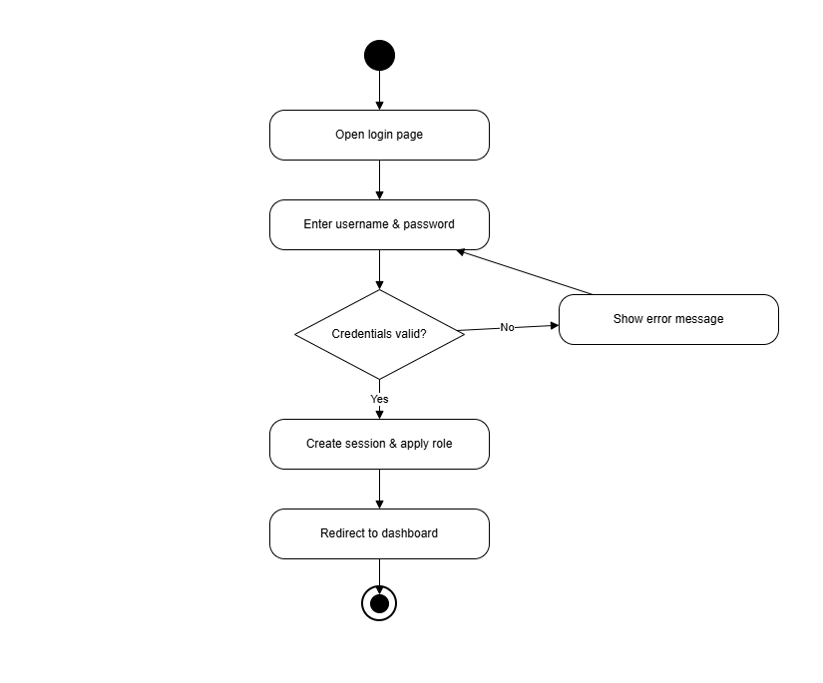
Figure 11: Login Activity Diagram

4.4.2 Create Declaration
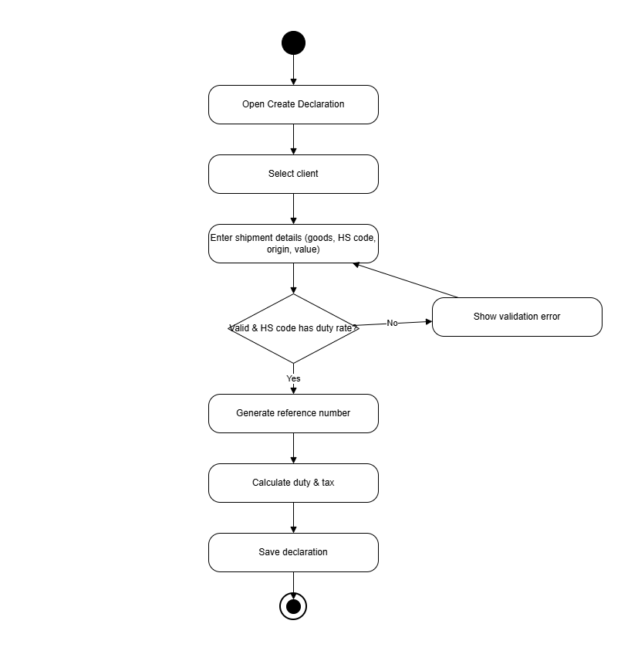
Figure 12:Create Declaration Activity Diagram

4.4.3 Issue Invoice & Receipt
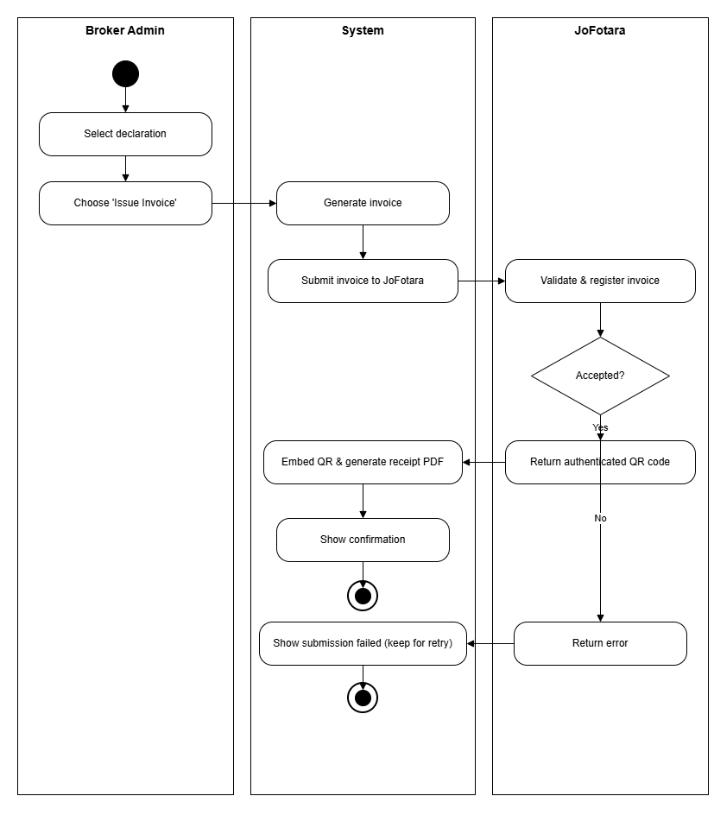
Figure 13:Issue Invoice & Receipt Activity Diagram

4.4.4 Record Payment
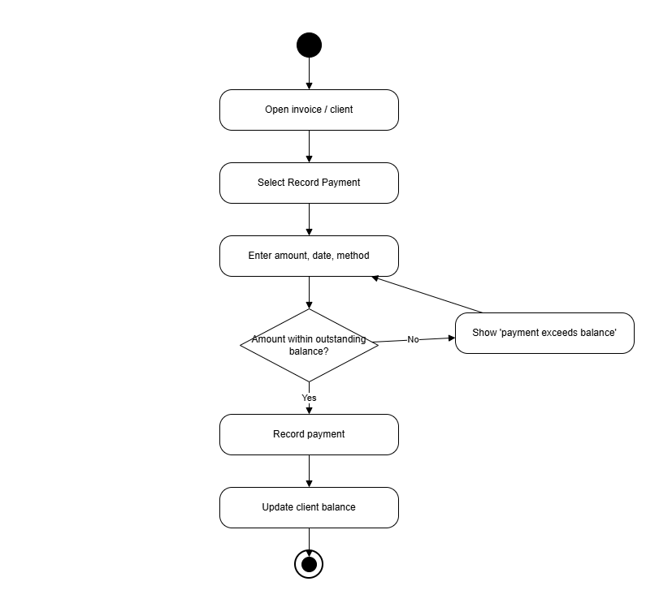
Figure 14:Record Payment Activity Diagram

4.4.5 Manage Clients
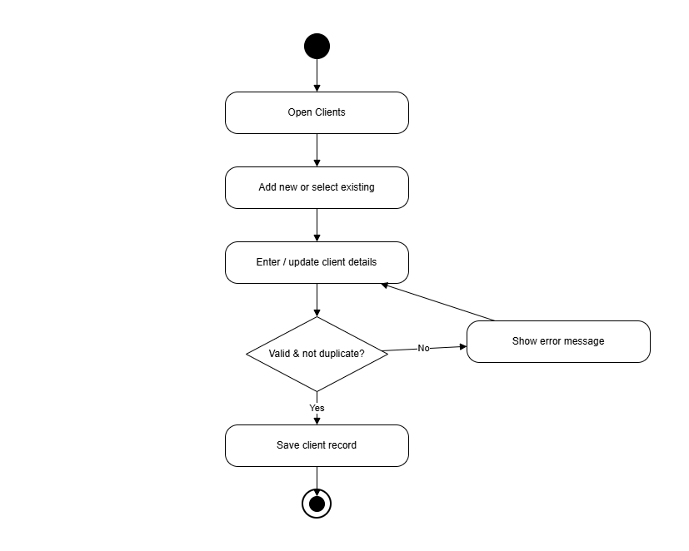
Figure 15:Manage Clients Activity Diagram

    - Create Staff Account

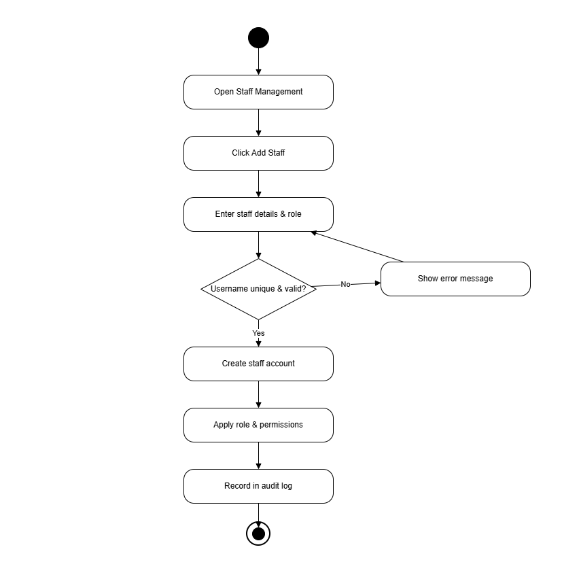
Figure 16:Create Staff Account Activity Diagram

4.5 ERD Diagram

Since Swift Customs is built on a relational database (Oracle Database), the data architecture is represented using an Entity Relationship Diagram (ERD), the standard modeling technique for relational systems. Unlike document-oriented models, the relational model organizes data into structured entities (tables) linked through primary and foreign keys, which makes it well suited to the financial and transactional nature of customs clearance accounting, where data integrity and consistency are critical.
The diagram below is presented using Chen notation, where rectangles represent entities, ellipses represent attributes (primary keys are underlined, multivalued attributes are shown as double ellipses, and derived attributes as dashed ellipses), and diamonds represent the relationships between entities. The cardinality (1:1, 1:N) and the participation (partial or total) of each relationship are indicated on the connecting lines. Tariffdel is normalized to reduce redundancy and preserve integrity; for example, the many-to-many relationships between declarations and tariff codes, and between invoices and tax rates, are resolved through the associative entities DECLARATION_ITEM and INVOICE_TAX respectively.

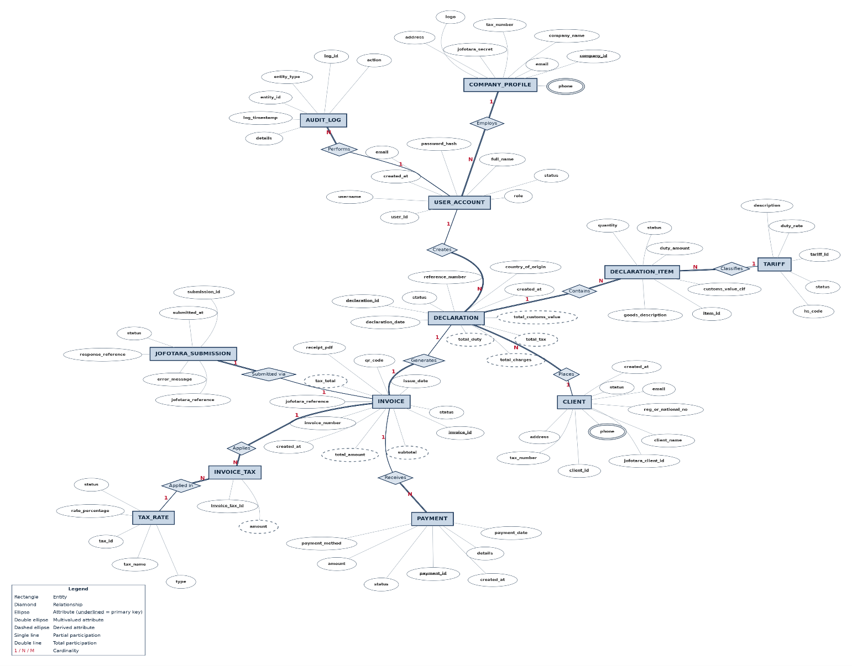
Figure 17:Entity Relationship Diagram (ERD) of the Swift Customs System

Data Dictionary
The following data dictionary describes each table in the Swift Customs database, listing its attributes, data types, keys, and constraints. Together with the entity-relationship diagram above, it defines the complete database design.

Stores the brokerage company profile and its JoFotara integration credentials.

Table 63: COMPANY_PROFILE Table
Attribute | Data Type | Key / Constraints | Description
company_id | NUMBER | PK | Unique identifier of the brokerage company
company_name | VARCHAR2(150) | NOT NULL | Registered name of the customs brokerage
tax_number | VARCHAR2(50) | NOT NULL, UNIQUE | National tax registration number
email | VARCHAR2(120) | - | Contact email address
phone | VARCHAR2(30) | Multivalued | Contact phone number(s)
logo | BLOB | - | Company logo shown on invoices
address | VARCHAR2(250) | - | Registered address
jofotara_secret | VARCHAR2(255) | - | Credential used to authenticate with JoFotara

System users (Broker Admin and Staff) who operate the system.

Table 64: USER_ACCOUNT Table
Attribute | Data Type | Key / Constraints | Description
user_id | NUMBER | PK | Unique identifier of the user
company_id | NUMBER | FK to COMPANY_PROFILE | Brokerage the user belongs to
username | VARCHAR2(60) | NOT NULL, UNIQUE | Login name
password_hash | VARCHAR2(255) | NOT NULL | Hashed account password
full_name | VARCHAR2(120) | - | Display name of the user
email | VARCHAR2(120) | - | User email address
role | VARCHAR2(20) | NOT NULL | Access role: Broker Admin or Staff
status | VARCHAR2(15) | - | Account status (Active/Inactive)
created_at | TIMESTAMP | - | Account creation timestamp

Importers/clients on whose behalf declarations are filed.

Table 65: CLIENT Table
Attribute | Data Type | Key / Constraints | Description
client_id | NUMBER | PK | Unique identifier of the client
company_id | NUMBER | FK to COMPANY_PROFILE | Owning brokerage
client_name | VARCHAR2(150) | NOT NULL | Client / importer name
email | VARCHAR2(120) | - | Client email
phone | VARCHAR2(30) | Multivalued | Client phone number(s)
tax_number | VARCHAR2(50) | - | Client tax registration number
address | VARCHAR2(250) | - | Client address
reg_or_national_no | VARCHAR2(50) | - | Commercial registration or national ID number
jofotara_client_id | VARCHAR2(80) | - | Client identifier used in JoFotara
status | VARCHAR2(15) | - | Client status
created_at | TIMESTAMP | - | Record creation timestamp

Customs declarations submitted for clearance.

Table 66: DECLARATION Table
Attribute | Data Type | Key / Constraints | Description
declaration_id | NUMBER | PK | Unique identifier of the declaration
client_id | NUMBER | FK to CLIENT | Client the declaration is filed for
user_id | NUMBER | FK to USER_ACCOUNT | Staff member who prepared it
declaration_date | DATE | NOT NULL | Date the declaration was filed
country_of_origin | VARCHAR2(80) | - | Country goods were shipped from
reference_number | VARCHAR2(50) | UNIQUE | External / customs reference number
status | VARCHAR2(20) | - | Lifecycle status (Pending/Cleared)
total_customs_value | NUMBER(14,3) | Derived | Sum of item CIF values
total_duty | NUMBER(14,3) | Derived | Total customs duty calculated
total_tax | NUMBER(14,3) | Derived | Total sales tax calculated
total_charges | NUMBER(14,3) | Derived | Total payable (duty + tax)
created_at | TIMESTAMP | - | Record creation timestamp

Individual goods line items within a declaration.

Table 67: DECLARATION_ITEM Table
Attribute | Data Type | Key / Constraints | Description
item_id | NUMBER | PK | Unique identifier of the line item
declaration_id | NUMBER | FK to DECLARATION | Parent declaration
tariff_id | NUMBER | FK to TARIFF | Tariff / HS classification applied
goods_description | VARCHAR2(250) | - | Description of the goods
quantity | NUMBER(12,2) | - | Quantity of goods
customs_value_cif | NUMBER(14,3) | NOT NULL | CIF value of the item
duty_amount | NUMBER(14,3) | - | Duty calculated for the item
status | VARCHAR2(15) | - | Item status

Tariff / HS-code classifications and their duty rates.

Table 68: TARIFF Table
Attribute | Data Type | Key / Constraints | Description
tariff_id | NUMBER | PK | Unique identifier of the tariff
hs_code | VARCHAR2(20) | NOT NULL, UNIQUE | Harmonized System code
description | VARCHAR2(250) | - | Tariff description
duty_rate | NUMBER(5,2) | NOT NULL | Duty rate percentage
status | VARCHAR2(15) | - | Active / Inactive

Configurable tax rates applied to invoices (e.g. 16% GST).

Table 69: TAX_RATE Table
Attribute | Data Type | Key / Constraints | Description
tax_id | NUMBER | PK | Unique identifier of the tax rate
tax_name | VARCHAR2(60) | NOT NULL | Name of the tax
rate_percentage | NUMBER(5,2) | NOT NULL | Tax rate percentage (e.g. 16)
type | VARCHAR2(40) | - | Tax type (e.g. General Sales Tax)
status | VARCHAR2(15) | - | Active / Inactive

Invoices generated from cleared declarations.

Table 70: INVOICE Table
Attribute | Data Type | Key / Constraints | Description
invoice_id | NUMBER | PK | Unique identifier of the invoice
declaration_id | NUMBER | FK to DECLARATION | Declaration being invoiced
invoice_number | VARCHAR2(40) | NOT NULL, UNIQUE | Human-readable invoice number
issue_date | DATE | NOT NULL | Date issued
status | VARCHAR2(15) | - | Payment status (Unpaid/Paid)
subtotal | NUMBER(14,3) | Derived | Duty subtotal before tax
tax_total | NUMBER(14,3) | Derived | Total tax on the invoice
total_amount | NUMBER(14,3) | Derived | Total payable amount
qr_code | CLOB | - | JoFotara QR payload embedded on the receipt
receipt_pdf | BLOB | - | Generated PDF receipt
jofotara_reference | VARCHAR2(80) | - | Reference returned by JoFotara
created_at | TIMESTAMP | - | Record creation timestamp

Tax lines linking an invoice to the tax rates applied.

Table 71: INVOICE_TAX Table
Attribute | Data Type | Key / Constraints | Description
invoice_tax_id | NUMBER | PK | Unique identifier of the invoice-tax line
invoice_id | NUMBER | FK to INVOICE | Parent invoice
tax_id | NUMBER | FK to TAX_RATE | Tax rate applied
amount | NUMBER(14,3) | Derived | Tax amount computed for the invoice

Payments recorded against invoices.
Table 72: PAYMENT Table
Attribute | Data Type | Key / Constraints | Description
payment_id | NUMBER | PK | Unique identifier of the payment
invoice_id | NUMBER | FK to INVOICE | Invoice being settled
amount | NUMBER(14,3) | NOT NULL | Amount paid
payment_date | DATE | NOT NULL | Date of payment
payment_method | VARCHAR2(30) | - | Cash / Bank Transfer / Cheque / Card
status | VARCHAR2(15) | - | Payment status
details | VARCHAR2(250) | - | Reference / notes
created_at | TIMESTAMP | - | Record creation timestamp

Records of invoice authentication submissions to JoFotara / ISTD.

Table 73: JOFOTARA_SUBMISSION Table
Attribute | Data Type | Key / Constraints | Description
submission_id | NUMBER | PK | Unique identifier of the submission
invoice_id | NUMBER | FK to INVOICE | Invoice submitted for authentication
status | VARCHAR2(20) | - | Submitted / Authenticated / Failed
submitted_at | TIMESTAMP | - | Submission timestamp
error_message | VARCHAR2(500) | - | Error returned on failure
response_reference | VARCHAR2(120) | - | Response reference from ISTD
jofotara_reference | VARCHAR2(80) | - | Authentication UUID / QR reference

Audit trail of user actions performed in the system.

Table 74: AUDIT_LOG Table
Attribute | Data Type | Key / Constraints | Description
log_id | NUMBER | PK | Unique identifier of the log entry
user_id | NUMBER | FK to USER_ACCOUNT | User who performed the action
log_timestamp | TIMESTAMP | NOT NULL | When the action occurred
action | VARCHAR2(60) | - | Action performed (Create/Update/Revoke)
entity_type | VARCHAR2(60) | - | Affected entity type
entity_id | NUMBER | - | Affected record identifier
details | VARCHAR2(500) | - | Additional details

Chapter 5: Conclusion & Future Work

5.1 Conclusion
This project presented the design and analysis of Swift Customs; a customs clearance accounting system tailored to the work of customs brokers and clearing agents in Jordan. The proposed solution addresses critical limitations in the traditional, manual approach to customs clearance accounting, including time-consuming paperwork, repeated in-person visits, error-prone manual calculation of duties and taxes, the absence of organized digital records, and the difficulty clients face in confirming the legitimacy of the receipts they receive.
By building the system on Oracle APEX together with an Oracle Database, PL/SQL, and ORDS, the project delivers a secure, web-based platform with strong role-based access control and centralized governance under the broker's administration. The business logic implemented in PL/SQL automates the calculation of customs duties and taxes using configurable tariff (HS code) and tax-rate reference tables, while still allowing the broker to review and adjust the figures before an invoice is issued, ensuring both speed and accuracy throughout the declaration lifecycle.
Rather than handling sensitive financial records on paper, Swift Customs stores all declarations, invoices, and payments in a structured relational database, which improves consistency, traceability, and reporting. The integration with JoFotara, Jordan's national e-invoicing platform, registers each issued invoice with the tax authority and returns an authenticated QR code that is embedded on the receipt, allowing clients to instantly verify the legitimacy of their documents.
The system architecture follows a layered (three-tier) design in which each layer has a specific role and responsibility, and one of the strongest advantages of this architecture is the separation of concerns. The Oracle APEX presentation layer provides intuitive portals for the broker administrator and staff, the application layer encapsulates the business logic and enforces access control, and the data layer manages all stored records and mediates the interaction with the external JoFotara service. This separation of concerns simplifies maintenance and future enhancement.
A comprehensive requirement analysis, supported by functional and non-functional requirements, use case diagrams, activity diagrams, an entity relationship diagram, and a class diagram, ensured that the system's behavior is well defined and that both functional and quality requirements are satisfied.
In conclusion, the proposed system demonstrates that a focused, database-driven Oracle APEX solution can deliver fast, accurate, and transparent customs clearance accounting without imposing technical complexity on its users. The project establishes a solid foundation that can be extended in the future to serve multiple brokerage firms, integrate directly with national customs systems, and reach clients through dedicated applications. Overall, this work modernizes and streamlines the customs clearance accounting process for brokers in Jordan.

5.2 Future Work

The Swift Customs system has been designed with scalability and extensibility in mind. While the current implementation focuses on the core functionalities of client management, declaration handling, duty and tax calculation, invoicing with JoFotara verification, and payment tracking, several promising areas have been identified for future development and enhancement.
Mobile Application Development represents a key future enhancement of the system. Native mobile applications for iOS and Android platforms would be developed to serve both brokers and their clients. The broker application would allow staff to create declarations, calculate duties, and issue invoices on the go, while the client application would let clients securely view, download, and share their receipts directly from their mobile devices, eliminating the need for desktop access. It would also integrate QR-code scanning functionality so clients can instantly confirm the legitimacy of a receipt through JoFotara. Both applications would adhere to the same security standards and authentication mechanisms implemented in the web platform to ensure data integrity and user privacy.
Multi-Broker (Multi-Tenant) Expansion is another important future direction. The current version operates as a single-broker system, but it could be extended into a multi-tenant platform that serves several brokerage firms from a shared deployment, with each firm's data securely isolated from the others. By opening the system to multiple firms, this expansion would broaden its reach across the customs brokerage sector in Jordan, while centralized maintenance and updates would reduce operational overhead and promote consistent practices across firms.
Client Self-Service Portal would extend the system by giving clients their own authenticated access. Rather than only receiving a receipt, clients would be able to log in to track the status of their declarations, view their invoices and payment history, and download verified receipts at any time. This extension would broaden the system's applicability, improve transparency for clients, and reduce the volume of routine status enquiries handled by broker staff.
External System Integration will focus on developing standardized API endpoints for integration with external services. This includes establishing secure connections with national customs systems such as ASYCUDA World, government and tax-authority databases, and banking or electronic payment gateways, to streamline data exchange, automate parts of the clearance process, and speed up duty payment and reconciliation while preserving data integrity.

References

[1] | A. Ellard, "Trade Facilitation Agreement: Eight Years of Cutting Trade Costs and Boosting Growth for All Members," World Trade Organization, 26 Feb 2025. [Online]. Available: https://www.wto.org/english/blogs_e/ddg_angela_ellard_e/blog_ae_26feb25_e.htm.
[2] | World Trade Organization, "Agreement on Trade Facilitation (Legal Text)," 2017. [Online]. Available: https://www.wto.org/english/docs_e/legal_e/tfa_e.htm.
[3] | World Trade Organization, "WTO Trade Facilitation Agreement Enters into Force," 31 Jan 2017. [Online]. Available: https://www.wto.org/english/news_e/news17_e/fac_31jan17_e.htm.
[4] | World Trade Organization, "Trade Facilitation and the Use of Technology," World Trade Organization, [Online]. Available: https://www.wto.org/english/tratop_e/dtt_e/dtt-tradfa_e.htm.
[5] | United Nations Conference on Trade and Development (UNCTAD), "Customs Automation – ASYCUDA," UNCTAD, [Online]. Available: https://unctad.org/topic/transport-and-trade-logistics/customs-automation-ASYCUDA.
[6] | Oracle Corporation, "Oracle APEX – Low-Code Application Development Platform," Oracle, [Online]. Available: https://www.oracle.com/application-development/apex/.
[7] | Daftra, "All-Inclusive Online Accounting and Invoicing Software," Daftra, [Online]. Available: https://www.daftra.com/en/.
[8] | Odoo S.A., "Odoo: Open Source ERP and CRM," Odoo, [Online]. Available: https://www.odoo.com/.
[9] | UNCTAD, "ASYCUDA – About the Automated System for Customs Data," ASYCUDA, [Online]. Available: https://asycuda.org/en/about/.
[10] | Oracle Corporation, "Oracle Database," Oracle, [Online]. Available: https://www.oracle.com/database/.
[11] | Oracle Corporation, "Oracle Database PL/SQL Technology," Oracle, [Online]. Available: https://www.oracle.com/database/technologies/application-development-pl/sql.html.
[12] | Oracle Corporation, "Oracle REST Data Services (ORDS)," Oracle, [Online]. Available: https://www.oracle.com/database/technologies/appdev/rest.html.
[13] | EDICOM, "Electronic Invoicing in Jordan: The JoFotara System," EDICOM Global, [Online]. Available: https://edicomgroup.com/electronic-invoicing/jordan.

Appendix

Appendix A: System Prototype

A.2 Login Screen
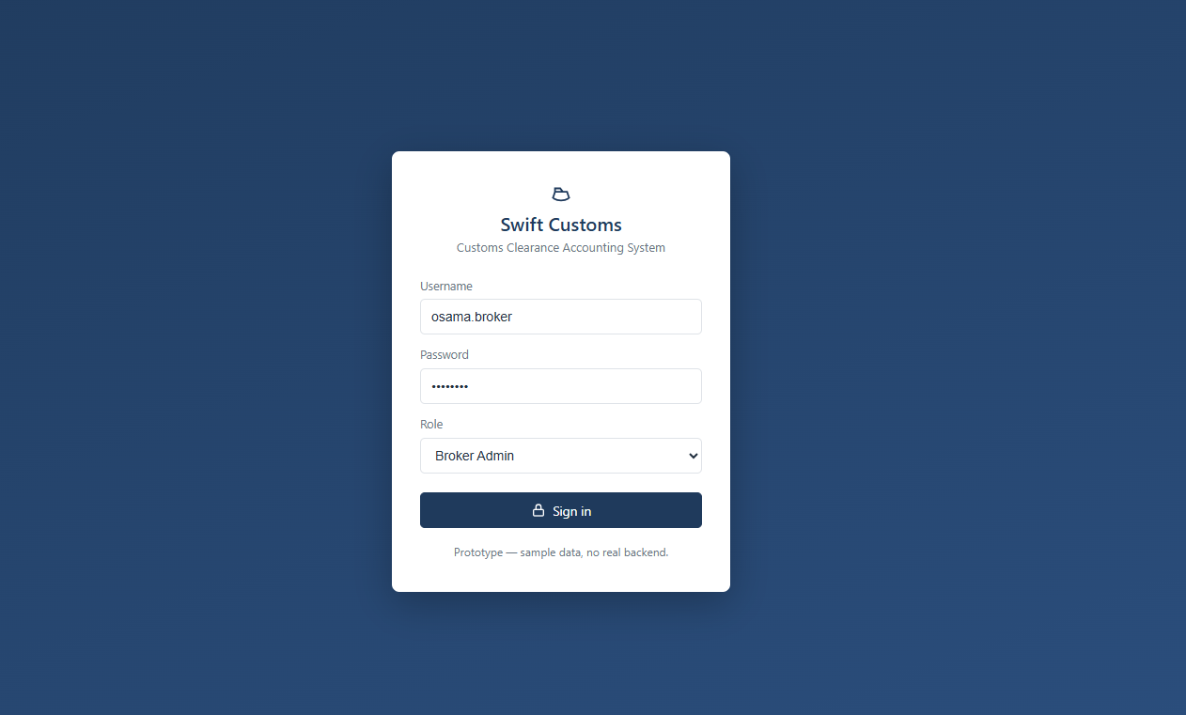
Figure 18: Login screen

A.2 Dashboard
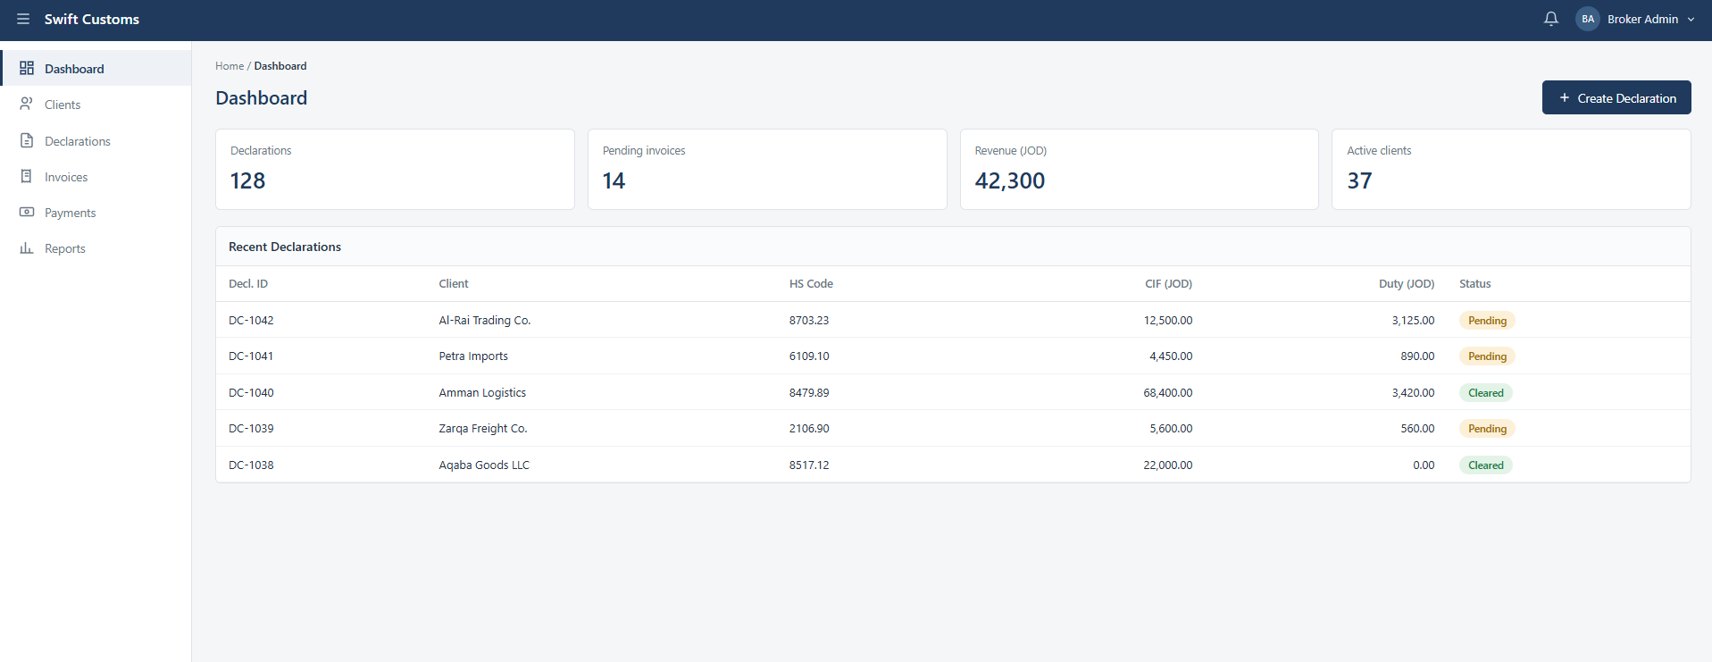
Figure 19: Dashboard

A.3 Clients (list)
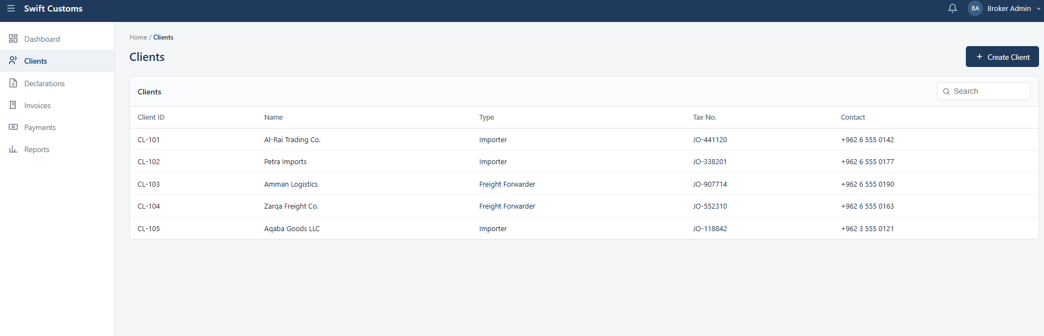
Figure 20:Clients List

A.4 New Declaration
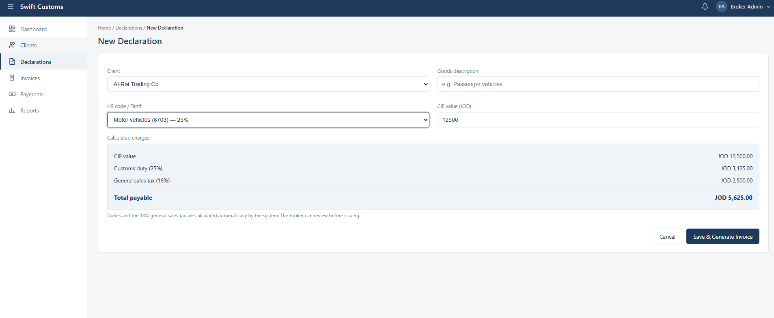
Figure 21:New Declaration

A.5 Invoice
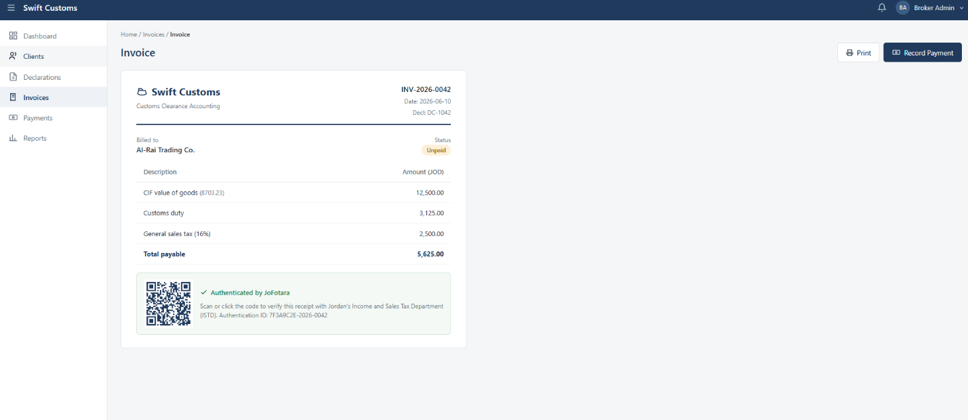
Figure 22:Invoice

A.6 Record Payment
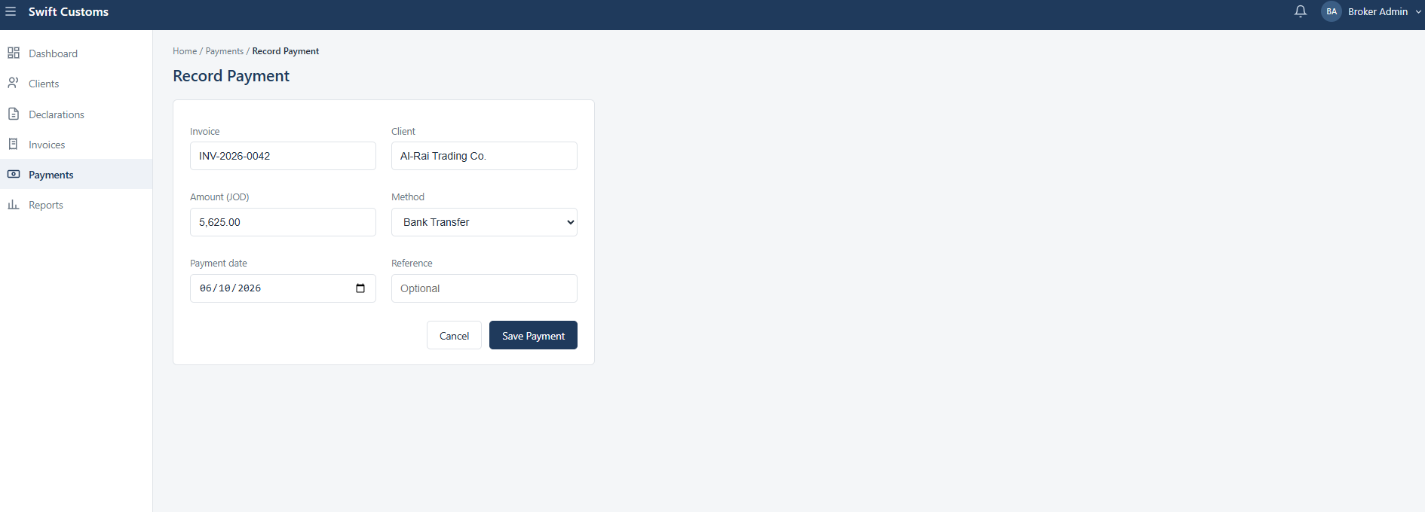
Figure 23:Record Payment

A.7 Reports
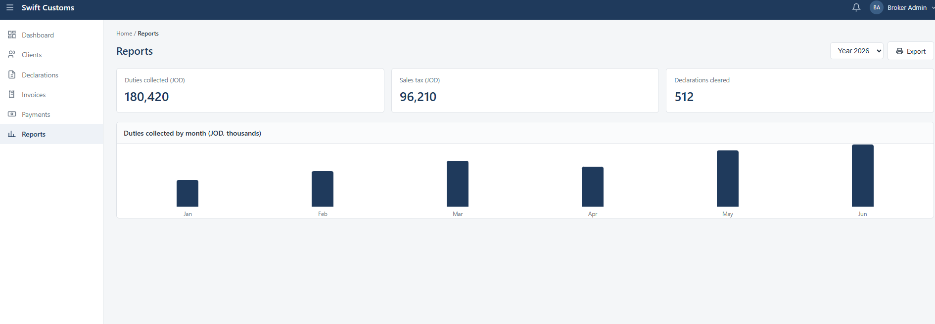
Figure 24:Records

