K-Mean and Mean-Shift algorithms in Machine Learning Model for Efficient Malware Categorization
Keshava Srinivas, Rahul Trivedi, Dharmik Patel, Kakelli Anil Kumar *
School of Computer Science and Engineering,
Vellore Institute of Technology, Vellore-632014, TN, India
Email: keshavjagadish26@gmail.com,
Email: rahulj.trivedi2017@vitstudent.ac.in,
Email: patel.dharmik2017@vitstudent.ac.in,
Email: johnbrightkakelli@gmail.com
*Corresponding author

Abstract: Malware can cause havoc not only in the personal devices of individuals but also in multinational organizations on their data handling capabilities. So, it is paramount to classify whether a file is malware or not, and classifying based on its behavior is highly essential for efficient malware analysis. This paper proposes a new technique with the help of based on machine learning (ML) to classify and categorize malware (PE32 files). We have extracted various features from the PE32 file from its subsections and applied the dimension reductionality techniques like Principal Component Analysis (PCA) and Non-negative matrix factorization (NMF) to reduce the number of features that have highly preferable to use by the machine learning model. Our proposed technique has been implemented using K-mean and Mean-Shift algorithms for better accuracy in malware detection and classification concerning the behavior.
Keywords: Static analysis, Clustering, K-means, Mean-Shift, Principal Component Analysis, Non-Matrix Factorization, Elbow method, Silhouette measure
Reference to this paper should be made as follows: Keshava Srinivas, Rahul Trivedi, Dharmik Patel and Kumar, K.A. (xxxx) ‘K-Mean and Mean-Shift algorithms in Machine Learning Model for Efficient Malware Categorization’, Int. J. Internet Technology and Secured Transactions, Vol. X, No. Y, pp.xxx–xxx.
Biographical notes:
Keshava Srinivas received his B. Tech in Computer Science and Engineering specializing in Information security from Vellore Institute of Technology in 2021. He is currently doing his MSc in Information Technology - Information Security at Carnegie Mellon University, USA.

Rahul Trivedi received his B. Tech in Computer Science and Engineering specializing in Information security from Vellore Institute of Technology in 2021. He is currently doing business in marble industry in Gujarat and preparing to go for Masters in USA.

Dharmik Patel received his BTech in Computer Science and Engineering with specialization in information security from Vellore Institute of Technology Vellore in 2021.

Kakelli Anil Kumar is an Associate Professor of School of Computer Science and Engineering in Vellore Institute of Technology (VIT), Vellore, TN, India. He earned his PhD in Computer Science and Engineering from Jawaharlal Nehru Technological University (JNTUH) Hyderabad in 2017, and graduated in 2009 and under-graduated in 2003 from the same university. He started his teaching career in 2004 and worked as an Assistant Professor, and Associate Professor and HOD in various reputed engineering institutions of India. His current research includes the wireless sensor networks, internet of things (IoT), digital forensics, cyber security, Malware analysis, block-chain and crypto-currency. He has published over 45 research articles in reputed peer reviewed international journals and conferences.

1 Introduction
The most imminent threat to any organization that gives importance and relies on their data for their smooth functioning and profit, is malware. Malware comes in various forms and can prevaricate users into thinking it is legitimate software. Many organizations have suffered immense losses due to such malware that is hard to be classified as malware due to obfuscation. Emotet trojan is one of the most destructive and dangerous malwares, with many damages one being the Consorcio Bank, with a loss of 2 million USD. Another ransomware WannaCry, which affected many corporations like FedEx, Nissan and Renault. Also, studies (Ethan et al., 2016) show that around 94% of all malware attacks have been performed on the Windows platform. This shows that companies having Windows-based systems and home PC users are at great risk. They also show that there is a huge gap in the security of Windows operating systems compared to the others. Hence it is paramount that there is an efficient technology or software that can help identify and classify windows specific files as malware or benign. According to them, such technology is scarce and highly required as most organizations use windows operating systems.

A lot of work has been done over the years for detecting windows-based malware. Studies by Veeramani and Nitin (2012) have proved fruitful as they took a different approach deviating from the usual signature-based detection using API-based detection of the windows files. Although their accuracy was in the 90s, as the N-grams or features of the APIs increased it deteriorated severely. Also, a frequency-based approach can produce sporadic results. Later research (Sanchit et al., 2016) on API-based detection showed great progress in the accuracy results. Hash signatures were also used in ameliorating the results achieved. However, API calls can be hidden via successful obfuscation (Mamoun et al., 2010), and such API extraction is labour intensive and requires kernel knowledge and low-level language. Hence, the API approach may not be the greatest.

Further studies by Chandrasekar and Manoharan (2012) applied Machine learning algorithms to this API-based detection scheme and hence their results showed a great improvement in accuracy and the ability to handle more features and varied windows files. This shows the usefulness of machine learning to predict very accurately whether a PE file is benign or malicious. Their machine learning algorithms included their own proposed algorithm as well as many other known algorithms for comparison. Among the known, Naive Bayes, SVM and CIMDS have been used but the results in these were futile. In their own proposed algorithm, they have used Association mining with 4-gram to model the API call. Whilst this approach proved to have better results compared to the previously known algorithms, it is a very limited and risky dynamic analysis approach that should only be used at later stages.

Strictly sticking to static analysis and still getting reputable accuracy was achieved by Usukhbayar et al (2013). They used PE32 files and all their characteristics as features for their machine learning models. The models they decided to implement were SVM, J48, and Naïve Bayes, wherein J48 had achieved the best detection rate among the three. However according to Anurag et al (2019) decision tree especially J48 is very computationally expensive when there are many records in the dataset and the feature matrix is large. Hence, we need an algorithm that can produce accurate results and be deployable in the real world where high computational power cannot be expected.
  - Our Contributions
It is observed that malware detection is incumbent in all organizations as well as in the private systems of users. Hierarchical detection and signature-based detection are of little use as more malware authors are resorting to obfuscation techniques which can easily change the signature altogether and thus making it impossible to identify or detect the malware. So, we need a more sophisticated approach that does not stick to one pattern of detection, hence machine learning algorithms are required. Also, another requirement is the chosen model demands limited computational resources.
So, we proposed a new heuristic-based static analysis of the malware file structure to determine its relative risk. The goal is to investigate the method of malware categorization, which will involve data-mining a variety of PE files and make use of clustering algorithms to categorize these files as benign or malicious. The clustering algorithms are K means and mean shift (Hierarchical clustering) are used in this work. We have used dimensionality reduction algorithms such as Principal Component Analysis (PCA) and Non- negative matrix factorization (NMF) for accurate results.
Secondly, we aim to create GUI which can guide the users and help them classify the files not only as malicious or not but also classify them based on their malware characteristics, i.e., Trojan, virus, network worm, ransomware, etc. The user has been given the option to choose the number of clusters and thus making the results more accurate as per the user’s demand. The optimum cluster selection is the proposed work that has given the best results. But in the essence, this methodology will help to create 2 clusters thus classifying the files as malicious or benign. Thirdly, this method of using clustering algorithms instead of decision tree will substantially reduce the computational power and time complexity and better accuracy.

- Preliminaries

This section deals with the fundamentals concepts and needs of static analysis, PE file structure, clustering algorithms K means and Hierarchical clustering and Dimensionality reduction algorithms and Principal Component Analysis (PCA) and Non- negative matrix factorization (NMF).
  - Static Analysis

Static analysis refers to analyzing the malware without running it, as in diving deep into its components and trying to understand its code. The techniques like disassembling and reverse engineering, where we disintegrate the file to its smallest machine-level code and work from there to try and understand the functionality. This type of analysis is safer as malware is not executed directly in the local machine and has the potential to be automated using machine learning models. Our work has followed a more static approach as we are parsing through PE32 files and collect valuable information.
  - PE32 File Structure
The Portable Executable 32 is a file format for all windows Executables, Object Code, and DLLs. It includes all the import and export APIs, resources, and low-level code for the file to run successfully. Since most malware in windows comes in this file format, it is imperative to have a detailed analysis of the same. Studies (Tzu-Yen et al., 2009) show that PE32 file headers have enough information to detect whether a file is a worm, virus, or a Trojan. It has shown that section data provides a plethora of information regarding the nature of the malware. Our work is very much relying on PE32 file structure to provide extract the necessary information of the malware as shown in figure 1. We parse through this file structure to find the required information and store it in a CSV file for later further examination.

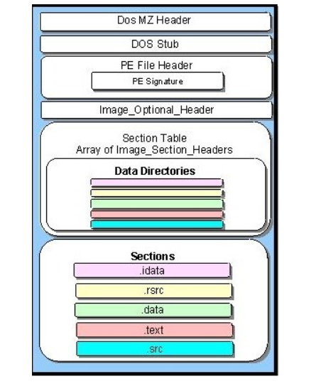
Figure 1: The structure of PE file

The DOS mz header contains the magic number which identifies the file as a P32 file. The PE file header in its raw form contains enough information to differentiate between a malicious and a benign file according to Ajit Kumar et al (2017). The header contains basic information of the rest of the file which is essential for many of our features

- Machines
- Signatures
- Number of Sections
- Size of Optional Header

The Image Optional header also contains vital information like the initial stack size, program entry point location, preferred base address, operating system version, section alignment information, etc. The array of Image section headers in the section table also provides various offsets and sizes Sections contain the main content and can be regarded as very valuable here.
- .iData - contains all imported functions and dlls. These are the API calls that the file calls when run and can indicate if the file is malicious, according to Veeramani and Nitin (2012)
- .rsrc - it is the resource section and hence can contain images
- .eData - export data
- .text – contains all executable code.

  - Clustering

Clustering is an unsupervised form of machine learning where the data taken as input is unlabelled and the output is predicted by the algorithm itself. In clustering, the data points are divided into several groups called clusters (hence the name clustering) where each cluster has data points with maximum similarity with points within the same cluster and maximum dissimilarity with data points of other clusters. This algorithm works on similarity scores. Clustering is a technique in machine learning are given below.

• Exploratory data analysis
• Labelling and classifying
• Outlier detection
• Finding duplicates
• Pre-processing

Previous research by Ulrich Bayer et al (2009), shows that clustering is extremely useful when dealing with malware detection and classification because the discrepancy in the similarity between malware and benign files is substantial. This study shows the promise of clustering algorithms in its scalability as the classification of a copious number of files (above 70000) was done within the impressive time limit of 3 hours. Even the space complexity used by clustering algorithms is considerably small and thus is of perfect use in our research. Georg Wicherski (2008) suggests through his research that clustering is the most feasible technique when classifying files because of their PE features and used K-Means and Mean Shift clustering.
    - K-Means Clustering

K-Means is an efficient clustering algorithm for medium and large-sized databases. It produces sphere-like structures. K-Means divides the data into non-overlapping clusters without any cluster internal structure. The value of K determines the number of clusters our algorithm will produce in the final output. Choosing the correct value of K is important. Using clustering to determine whether malware is malicious or benign. For this purpose, it will be ideal for us to create two clusters. Kanti and Shrivastava (2015) showed that K means clustering improves the accuracy as more samples are added to the dataset and thus scalability is achieved. Steps involved in K means are given below and shown in figure 2.

- Randomly place k centroids, one for each cluster.
- Calculate the distance of each point from the centroid. This distance we have used is the Euclidean distance which is calculated because of our features.
- Assign each data point to its closest centroid, creating a new cluster.
- Re-calculate the position of the k centroids for every new cluster formed.
- Repeat steps 2-4 until no new cluster is formed or until the centroids no longer change

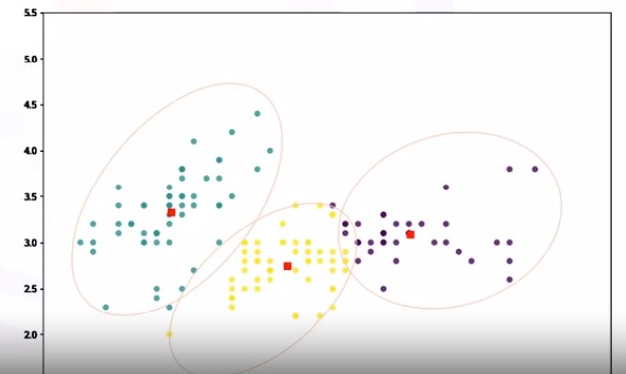
Figure 2: K-Mean clustering
    - Mean Shift Clustering
Mean shift clustering is a centroid-based algorithm where the centroids are updated to be the average (or mean, and hence the name Mean Shift) of a given set of points within a given region. These centroids are then filtered in the post-processing cycle to eliminate the near-duplicates to form the final set of centroids. In general, a dendrogram is formed and one can choose optimum clusters from it. In contrast to K-Means clustering, Mean Shift clustering does not require us to specify the number of clusters in advance. The number of clusters is identified by the algorithm itself based on the input data. Hierarchical clustering is useful when we need a smaller number of clusters. Since it is a bottom-up approach within one step, it can identify 2 clusters, and hence time complexity is certainly better in this case. However, this comes with a cost as its accuracy cannot match with K means as we will see.
  - Dimensionality Reduction

Dimensionality reduction helps in making our application run faster by ignoring the non-essential data. It reduces the data which would generally tend to be outliers. A subset of data is evaluated which most appropriately represents the entire collection of data. A high-dimensionality dataset gets converted to lower-dimension by filtering of non-essential data. As a result, it contributes to easier visualization and improved performance. Here, we have used the following for dimensionality reduction:
- Principal component analysis (PCA)
- Non-negative matrix factorization (NMF or NNMF)

    - Principal component analysis (PCA)
Principal component analysis helps in dimensionality reduction by converting the data onto lower dimensions called principal components (PCs), with the target of finding the best output of data using a limited number of PCs. Dimensionality reduction is achieved by factorization of the matrix (input data) into two sub-matrices. One of the matrices is known as Principal Component which most appropriately represents the original dataset (matrix) and the other is considered as non-essential. The Principal Component matrix is the one that gets plotted on the graph. As per studies done by Annie (2012), where intrusion detection was predicted using machine learning algorithms, it was found that both precision and recall were ameliorated with the use of principal component analysis compared to without it.

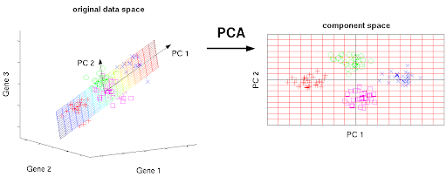
Figure 3: Principle of component analysis

    - Non-negative Matrix Factorization (NMF)

In NMF, find two non-negative matrices (W, H) whose product approximately equals the non-negative matrix V. This factorization is primarily useful for dimensionality reduction. A high-dimensionality matrix is converted into two smaller matrices. A constraint followed by NMF is that the numerical data which makes up the dataset or matrix is non-negative. The property of NMF is that all three matrices, W, H, and V have no negative elements.

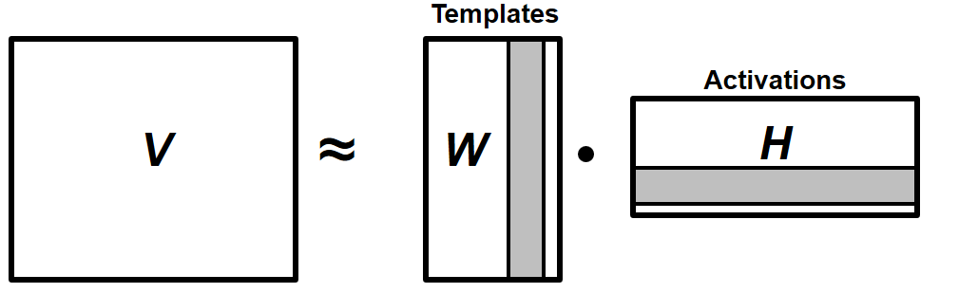
Figure 4: Non-negative Matrix Factorization (NMF)

- Proposed Features used in the model

From the PE32 files, we have parsed and collected the important data that can help our clustering algorithm predict which file belongs to which cluster. This selection will be of great importance for better results.

3.1 Entropy within file and sections

Previous research done by R. Lyda and J Hamrock (2007) helped us in deciding to use this feature. The research showed that packed and obfuscated files generally have more entropy than normal PE files. This is because they are encrypted and hence randomness increases. Now since most malwares are generally obfuscated, use this rule to check whether the files are encrypted and hence deduce whether they are malicious. Their research also showed that high amounts of entropy were found in the .text section of the PE32 file. This helps in focussing more on this section as a contributing factor compared to the others. The entropy number is from the one to eight range and includes both total file entropy and individual section entropy.

3.2 Number of sections

This is identified in the PE file header and is very useful in categorizing PE files as malicious or not. From Yonts (2012), generally, normal files tend to have approximately close to 10 sections whereas malicious files have lesser than 4.

3.3 Imported DLL

DLL’s imported can be found in .iData section of the PE32 file. They have a huge relevance as they show what dlls have been imported. Imported dll’s indicate clearly if and what malicious actions are taking place, for example, kernels are opened what system calls are invoked, etc. Thus, if any calls invoked can have a serious impact on the system, the file can term as malicious. Also based on these imports we can successfully classify within malicious files, as some imports may be network related (indicating a worm) some may be self-invoking (indicating a virus), etc.
Some important dll’s used in the malicious activity are listed below.

- Kernel32. dll - handles memory management, input/output operations, and interrupts. One of the most imported DLLs by malware according to Yinrong (2006). The research shows that many malwares call out Kernel32 DLL as the malware then can get access to memory management and thus attach itself to other files and spread. It states that many malwares to remain hidden from AV software do not call this DLL directly but through a chain reaction of other DLLs.

- User32.dll - creates and manipulates the standard elements of the Windows user interface, such as the desktop, windows, and menus. This also is a frequently used DLL by malware and thus helps us in detecting them. As shown by Ahmed et al (2012) user32dll can be used for injecting malware into the registry which can be disastrous to the device. Thus, this import is a very useful indicator that a file is likely to be malware.

- advapi32.dll - API services library that provides access to advanced functionality, designed to support several API's including security and registry calls.

- msvcrt.dll – It is a module containing important C library functions such as memcpy. Hence it helps copy into memory and many malwares use it to copy into the hard disk.

- gdi32.dll – It is a graphical device interface. It is used to graphical images on the screen and displays text. Ahmed et al (2012) showed how ransomware uses this dll to threaten the user and provide details for money transfer etc.

- shell32.dll - controls certain API functions of the Windows Shell. It is used to write shell commands and hence has even more access to the kernel than normal C commands.

- Ole32.dll - contains core Object Linking and Embedding functions for documents etc. So, any macro malware will utilize this for running when the document is opened. Hence if this import is called, safely assume that the malware is a macro or document related

- ws2_32.dll - used to handle network connections. Import of this DLL is one of the telltale signs that the file is not only malicious but is also a Trojan creating a backdoor/rootkit. Keyloggers, card theft, RATs all use this DLL extensively to access outside a network mostly to the attacker’s server.

- Shlwapi.dll - contains functions for UNC and URL paths, registry entries, and color settings.

Using a Boolean array for each of the famous DLL’s (that are generally used by malware) and a few others, where true means it is imported and false means the opposite.

3.4 Proportion of Code to initialized data

During our research, we recalled that normal PE32 files have substantial amounts of data but less executable code or initialized data. But this ratio is exactly the opposite for malware, where there are substantial amounts of initialized data and less code. Studies done by Usukhbayar (2009) showed the same where the amount of initialized data in malware was 10 times that in benign. Code can be found in the .text section and data in the data directories of the PE32 file format.

3.5 Image Version

The version of PE can be found in the image optional header. As per Raman (2012), malware has 0 or close to 0 whereas benign files have a higher value as they have a larger image version set. This is one of the best indicators to finding if it is malicious or not.

3.6 Other Section Attributes

Section size also provides immense knowledge on whether a file is malicious or not. According to Yonts (2012), malicious files generally tend to have more virtual memory compared to disk memory as they are generally obfuscated and packed. His research pointed out that generally if the ratio of a file’s virtual size to its raw size is greater than 10 then it is most likely a malicious file. Another attribute is the section address in which the pointer to raw data can reveal almost 90 % of files as malicious if it is zero. This coincides with the size of the section as raw memory is generally zero and hence there wouldn’t be any pointer to it in malicious files. Another attribute that coincides with malicious files is the flags in the section characteristics attribute as they are generally zero amongst malicious files.

- The optimum value of K

For both clustering algorithms, there would be an optimum value of K which would differ when more files are added to the dataset and when the dimensionality reduction algorithm is changed. For our implementation, we have given the user chooses to choose the number of the cluster as per his/her needs however we have also provided the optimum clusters which shall give the best results. Here we have gone ahead with two algorithms to find the optimum value of K each having its advantages.

  - Elbow method

The drawback of K-Means clustering is manually assigning the value of k. To determine the most optimal value of k, hence it can implement the elbow method. The elbow method is an iterative process where it needs different values of k and calculates the cost function or the within-cluster sum of square (WSS) until the cost drops drastically. The points are plotted on a graph for each value of k as shown in figure 5 below. The location of a bend (elbow) in the plot is generally considered as the appropriate number of clusters.

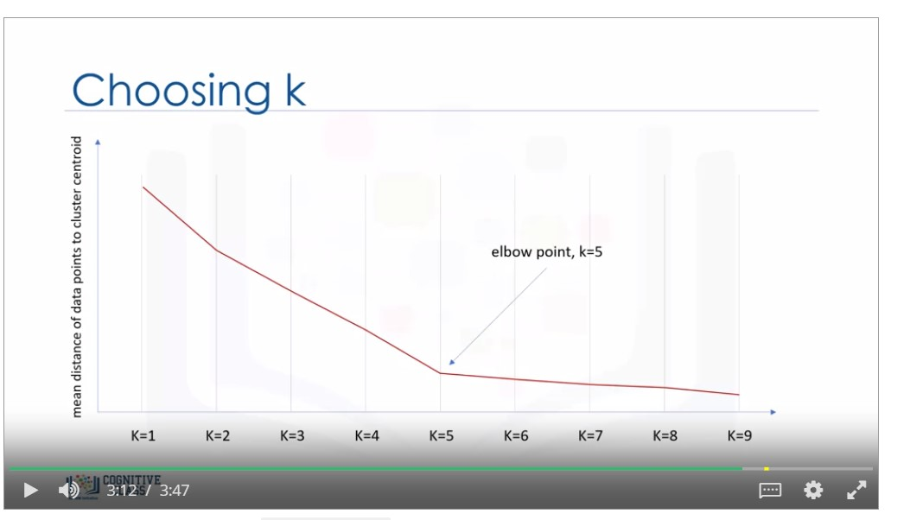

Figure 5: Elbow method with different k values

  - Silhouette Measure

Silhouette score is another technique to determine the optimal number of clusters. The SC is calculated using the average intra-cluster distance (a) and the average nearest-cluster distance (b) for each sample. The SC for a sample is mentioned in equation 1.

(𝑏 − 𝑎) / 𝑚𝑎𝑥 (𝑎, 𝑏) ... (1)

b is the distance between a sample and the nearest cluster that the sample is not a part of. SC has only defined if the number of labels is as per equation 2.

2 <= 𝑛𝑜. 𝑜𝑓 𝑙𝑎𝑏𝑒𝑙𝑠 <= 𝑛𝑜. 𝑜𝑓 𝑠𝑎𝑚𝑝𝑙𝑒𝑠 – 1 ... (2)

This function returns the average Silhouette Coefficient of all the samples. The most optimal value is 1 and the least optimal is -1. Values near 0 will indicate overlapping clusters. Negative values imply that a sample has been assigned to the wrong cluster. Following shows, the silhouette score achieved for a certain number of clusters at a certain set clustering and decomposition

Table 1: Silhouette Coefficient values w.r.to no. of clusters

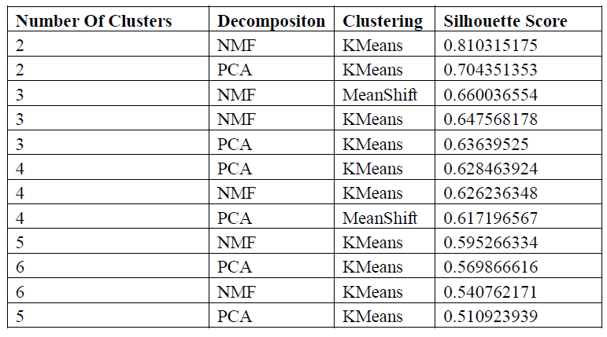
- Procedure and Implementation

The procedure and flow of our proposed model as shown in figure 6.

- First, parse through PE32 files and gather all information that is required in our features list and store them in a CSV

- Label the file with their corresponding malware type if it is malware and BEN if it isn’t. This is done for accuracy calculation, once we do the clustering

- Then apply Dimension reductionality techniques which reduce our features only to the useful ones. Apply the PCA and NMF. After applying this high dimensional data is converted to low dimensional data.

- Use clustering techniques like K-means and Mean-shift (hierarchical clustering) to group into clusters as given by the user. When 2 clusters, one shows malicious and the other shows benign. When more clusters are given, similar malwares will be grouped into their respective fields of Trojan, virus, backdoor, etc.

- Using python modules and GUI techniques to visualize the clusters and suggest several clusters to get the best results using elbow method or silhouette measure. Give cluster selection to the user for his/her preference.

- There are five graphs plotted on the GUI window namely elbow plot and silhouette map, cluster plot, color map, and K-means of n-clusters.

- Provide accuracy calculation, regarding malware detection and malware family classification.
- GUI and graphs

- Clustering- Here choose the reductionality algorithm as well as the clustering algorithm. Observe the visual representation of the clustering which has 4 graphs in figure 7.

- Algorithm Evaluation – here it is observed the accuracy of respective algorithms with their cluster sizes, silhoutte scores. Accuracy is for both detections as well as classification.

- Elbow Plot – To visualize the elbow plot for the K means algorithm. This helps to choose optimum clusters.

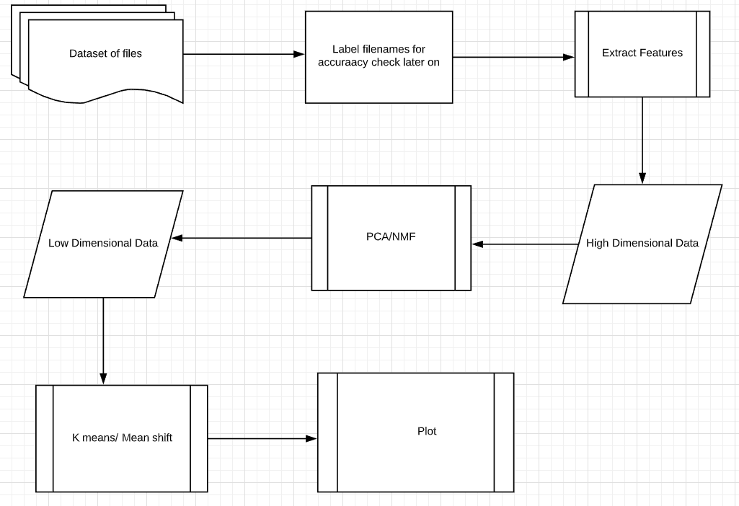

Figure 6: The data flow procedure of the proposed technique with ML

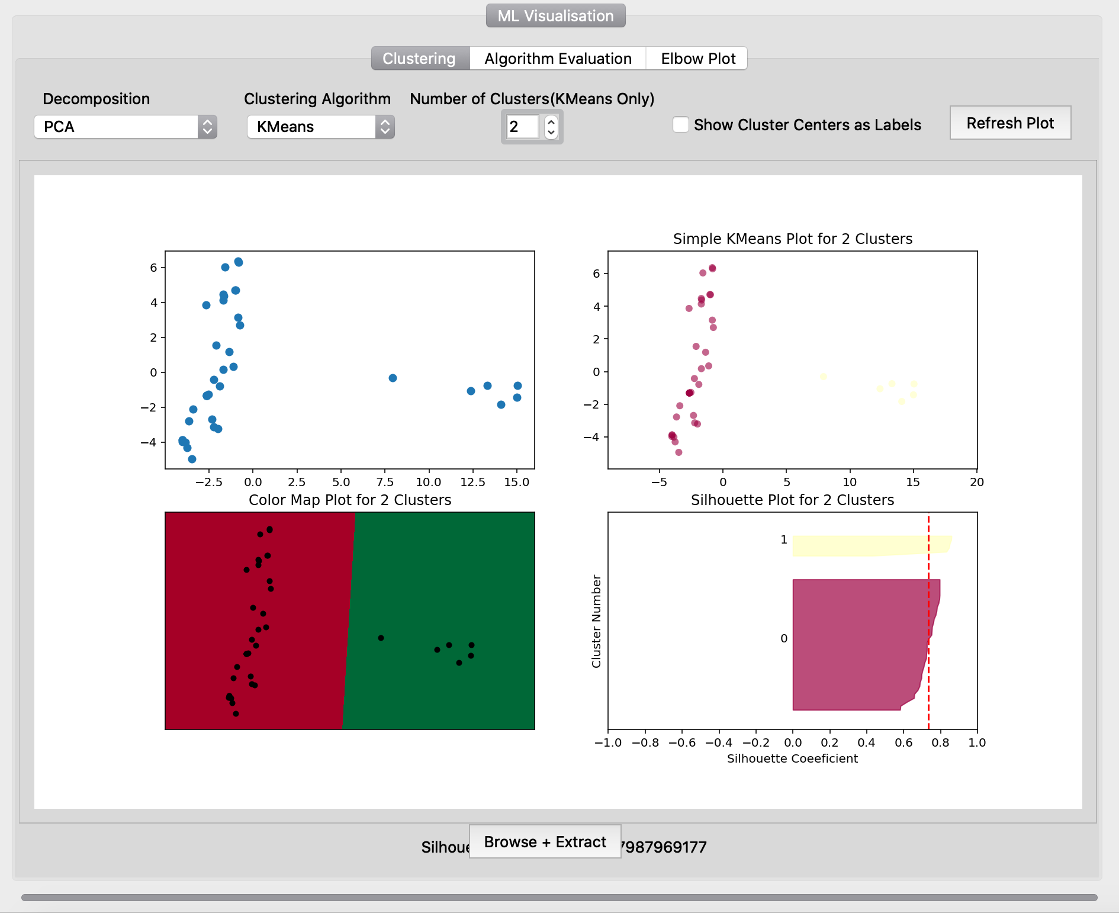

Fig 7: Visual representation of the proposed clustering technique

  - Cluster Plot

This gives a basic visualization regarding how many files are malicious or benign. Here we find the minimum and maximum value of the principle component one (PC1) and principle component two (PC2). Then we increment the maximum and decrement the minimum values to avoid the point being plotted on the extremes as shown in figure 8.

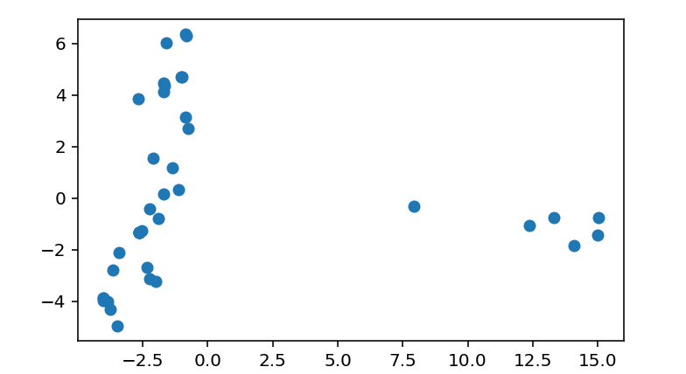

Fig 8. Cluster plot with Min. and Max. values of Principle component

  - Color visualization

Similar to the cluster plot this visualization comes in handy when we have 2 or more clusters. We assign the boundaries to the clusters and shade the different colors with a different color. The intensity of the color does not conclude whether the PE file is malicious or not. The colors are assigned at random.

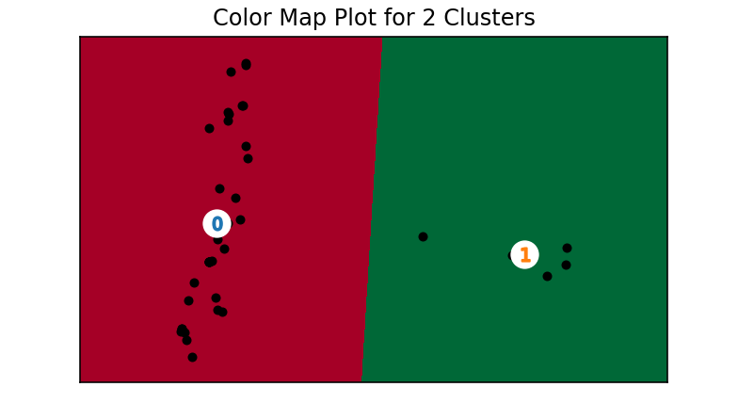

Fig 9: Colour plot w.r.to the number of clusters

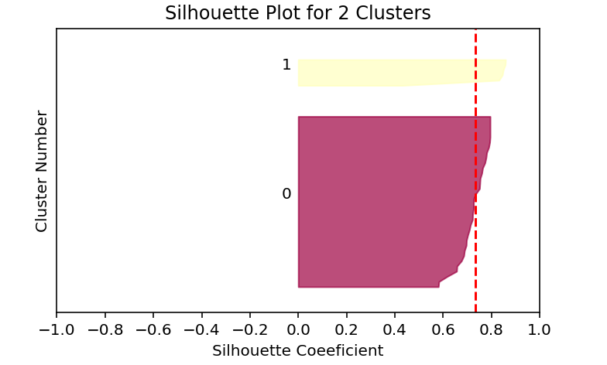

Fig 10. Estimation of Silhouette values w.r.to the data set

  - Estimation of Silhouette values

The silhouette value is calculated for all the points in the dataset. For each point in the cluster, the silhouette value is sorted and displayed along with the cluster number as the y-axis. The bottom and top of the cluster are incremented on the y axis to create a gap.

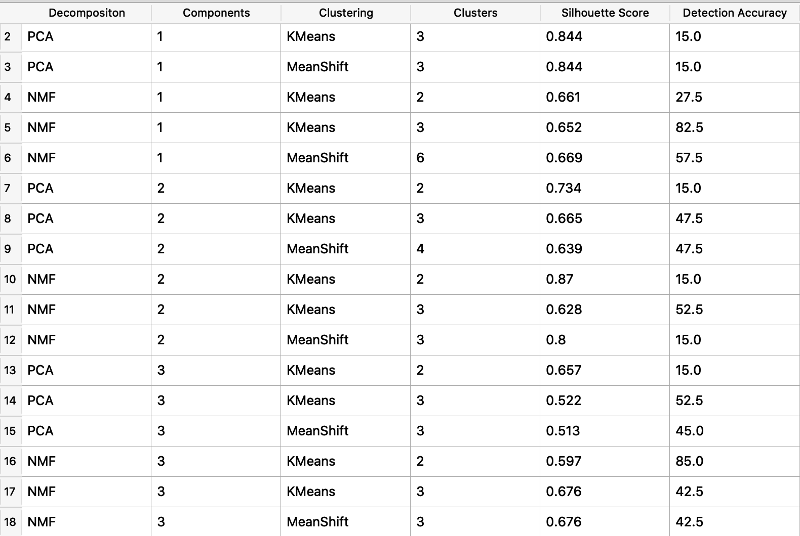
Table 2. Detection Accuracy of K-Mean and Mean shift

  - Result Analysis w.r.to K-Mean and Mean shift

The algorithm is evaluated by calculating the detection accuracy and clustering accuracy against the clustering algorithm used, the dimensional reduction algorithm, and the number of components/features. The optimal condition for clustering is determined based on the accuracy and displayed in the top right.

6.5 Elbow plot

This is available at the elbow plot tab and is useful in deciding the best cluster selection for accurate results. Below is the elbow plot is shown for PCA and NMF decomposition for K-mean. As it is shown for PCA decomposition the favorable value of k would be 2 and for NMF decomposition would be also 2. The most bend on the curve determines the favorable value of k from figure 11.

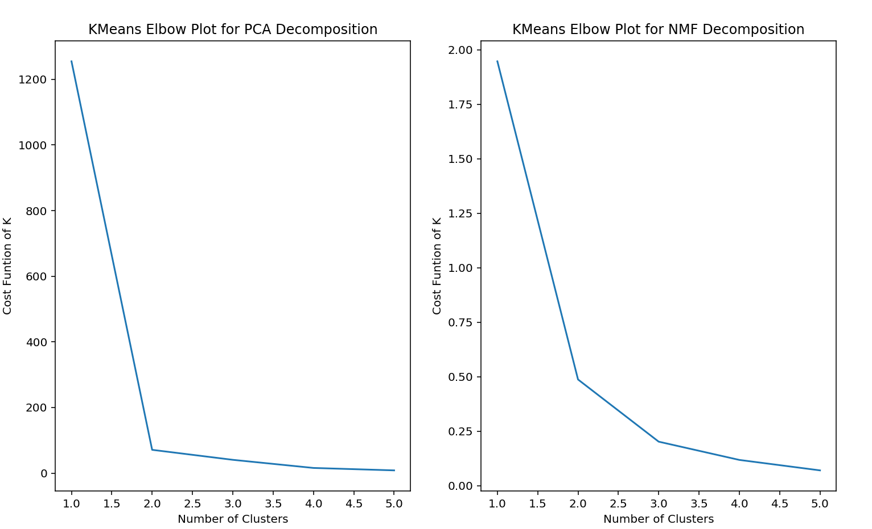

Figure 11: K-Mean Elbow plot for PCA and NMF decomposition

- Implementation and Result Analysis

7.1 Dataset

The dataset has been taken from a variety of malwares available at AnyRun, tekDefence, and VirusTotal.

Table 3: Malware sample data sets w.r.to their types

Type | Number of data sets
Trojan | 15
Virus | 21
Worm | 13
Ransom ware | 16
Benign | 14

7.2 Accuracy of the Malware Detection

Below table 4 shows the detection accuracies at different dimensionality reductions, clustering algorithms, and the number of clusters.

Table 4: Accuracy of Malware detection techniques

Decomposition | Components | Algorithm | No. of Clusters | Accuracy
NMF | 3 | K-Means | 2 | 85.00
PCA | 3 | K-Means | 2 | 83.29
NMF | 7 | K-Means | 4 | 82.1
PCA | 8 | Mean Shift | 5 | 80.4
PCA | 11 | K-Means | 3 | 80.00
PCA | 6 | K-Means | 5 | 77.32
NMF | 2 | Mean Shift | 2 | 75.98
NMF | 4 | K-Means | 4 | 73.2
NMF | 10 | K-Means | 3 | 72.3
PCA | 9 | K-Means | 5 | 72.14

Here our best accuracy of 85.00% was achieved when the numbers of clusters were 2 with the K-mean algorithm, and dimension reduction was NMF and the features were reduced to 3.

7.3 K means vs Mean Shift

In general, K-means outperforms the Mean shift substantially. With K-means averaging a detection accuracy of 52.36% and Mean shift averaging a very low 22.31%. This is because of a small number of clusters, the mean shift is not very accurate whereas k means is thorough.

7.4 NMF vs PCA

Non-matrix factorization works slightly better than principal component analysis for this dataset with NMF having an average accuracy of 54.32 % to 51.47% in PCA. This calculation was done with equal K means and mean shift on both, so there isn’t any discrepancy.

7.5 Malware Family Classification

Unfortunately, classifying malware into its respective groups wasn’t as accurate as malware detection, with the highest accuracy being only 54.32%. The best accuracy by our proposed technique malware classification is given below in table 5.

Table 5. Malware Classification Accuracy

Decomposition | Components | Algorithm | Number of Clusters | Classification Accuracy
PCA | 4 | K-Means | 4 | 54.32
PCA | 8 | K-Means | 4 | 52.19
NMF | 2 | K-Means | 3 | 49.32
NMF | 6 | K-Means | 5 | 48.76
NMF | 8 | K-Means | 4 | 45.08
PCA | 5 | Mean Shift | 3 | 43.12
PCA | 5 | Mean Shift | 2 | 42.22
NMF | 8 | K-Means | 2 | 42.17
PCA | 7 | K-Means | 5 | 41.90
PCA | 3 | Mean Shift | 3 | 40.10

- Conclusion

The proposed work is a static analysis of PE32 files that should be able to detect and differentiate between a file being malware versus benign and achieved the accuracy of 85.0 % for a relative dataset. We extract the metadata from the PE file such as library imports, entropy, and code to data ratio. Using these parameters, the algorithm is trained to cluster. The accuracy of 85.0% was achieved with NMF, three components, K-Means, and two clusters and therefore, it is efficiently used for malware detection with scalability and less computational power. Our proposed technique is also achieved usage of the machine learning techniques which are extremely scalable for better accuracy on the extremely varied samples. The adjustable options are provided for the number of clusters, dimensionality reduction algorithms for specific datasets. However, if the dataset contained a small number of malware training samples, the proposed technique may not predict accurately the family of the malware due to machine learning algorithms. Future work includes efficiently categorizing the malware based on their family and developing the algorithm in predicting more efficiently using few malware samples. Further work can be done to categorize the malware because of dynamic analysis and reverse engineering using machine learning algorithms.

References

Alasiri, A., Alzaidi, M., Lindskog, D., Zavarsky, P., Ruhl, R. and Alassmi, S.(2012), ‘Comparative Analysis of Operational Malware Dynamic Link Library (DLL) Injection Live Response vs. Memory Image’ in International Conference on Computing, Communication and Informatics Management (ICCCSIM 2012).

Alazab, M., Venkataraman, S. and Watters, P. (2010) ‘Towards Understanding Malware Behaviour by the Extraction of API Calls’ in Second Cybercrime and Trustworthy Computing Workshop.

Annie, G. (2012) ‘Anomaly Detection based on Machine Learning: Dimensionality Reduction using PCA and Classification using SVM’, International Journal of Computer Applications, vol. 47 No. 21, pp. 5-8

Baldangombo, U., Jambaljav, N. and Horng, S. (2013) ‘A Static Malware Detection System Using Data Mining Methods’ in arXiv:1308. 2831.

Bayer, U., Milani Comparetti, P., Hlauschek, C., Krugel , C., and Kirda, E. 2009. ‘Scalable, Behavior-Based Malware Clustering’ in Proceedings of the 16th Annual Network and Distributed System Security Symposium (NDSS’09).

Huang, Y. (2003) Vulnerabilities in Portable Executable (PE) File Format for Win32 Architecture.

Kumar, A., Kuppusamy, K.S. and Aghila, G. (2019) ‘A learning model to detect maliciousness of portable executable using integrated feature set’, Journal of King Saud University - Computer and Information Sciences, vol. 31 Issue 2, pp. 252-265

Lyda, R. and Hamrock, J. (2007) ‘Using Entropy Analysis to Find Encrypted and Packed Malware’, IEEE Security & Privacy, vol. 5 Issue 2, pp. 40-45

Raman, K.(2012) ‘Selecting Features to Classify Malware’, InfoSec Southwest 2012, pp. 1–5.

Ravi, C. and Manoharan, R. (2012) ‘Malware Detection using Windows API Sequence and Machine Learning’, International Journal of Computer Applications, vol. 43 No. 17, pp. 12-16.

R, Veeramani and Rai, N. (2012) ‘Windows API based Malware Detection and Framework Analysis’, in International conference on networks and cyber security, vol 25.

Rudd, Ethan M., Rozsa, A., Gunther, M. and Boult, Terrance E. (2017) ‘A Survey of Stealth Malware Attacks, Mitigation Measures, and Steps Toward Autonomous Open World Solutions’, IEEE Communications Surveys & Tutorials, vol, 19 Issue 2, pp. 1145-1172.

Sahu, K. and Shrivastava, S.K. (2015) ‘Kernel k-Means Clustering for Phishing Website and Malware Categorization’, International Journal of Computer Applications, Vol. 111 No. 9, pp. 20-25

Sanchit, G., Sharma, H. and Kaur, S. (2016) ‘Malware Characterization Using Windows API Call Sequences’, in International Conference on Security, Privacy, and Applied Cryptography Engineering.

Wang, T., Wu, C. and Hsieh, C. (2009) ‘Detecting Unknown Malicious Executables Using Portable Executable Header’, in Fifth International Joint Conference on INC, IMS and IDC.

Wicherski, G. (2008) ‘peHash: A Novel Approach to Fast Malware Clustering’, In Proceedings of Large Scale Exploits and Emergent Threats.

Yonts, J. (2012) Attributes of Malicious Files.

Anyrun.com [online] https://any.run/

Malware Samples [online] http://www.tekdefense.com/downloads/malware-samples/

VirusTotal.com [online] https://www.virustotal.com/gui/

