# Abstract

# [terminology](app:ds:terminology)

## SIMPLE

（**SIP for Instant Messaging and Presence Leveraging Extensions**），是一个基于[sip协议](http://zh.wikipedia.org/wiki/%E4%BC%9A%E8%AF%9D%E5%8F%91%E8%B5%B7%E5%8D%8F%E8%AE%AE" \o "会话发起协议)的即时消息通信协议族。此协议由[IETF](http://zh.wikipedia.org/wiki/%E4%BA%92%E8%81%94%E7%BD%91%E5%B7%A5%E7%A8%8B%E5%B7%A5%E4%BD%9C%E5%B0%8F%E7%BB%84)的IMPP工作组提出，与SIMPLE协议类似的协议还有[XMPP](http://zh.wikipedia.org/wiki/XMPP" \o "XMPP)。

## XCAP

（XML Configuration Access Protocol）是[SIMPLE](http://tools.ietf.org/wg/simple/)协议的一部分。The XCAP protocol is based on the following [IETF](http://en.wikipedia.org/wiki/IETF) standards: RFC4825 [[1]](http://en.wikipedia.org/wiki/XML_Configuration_Access_Protocol#cite_note-0), RFC4826 [[2]](http://en.wikipedia.org/wiki/XML_Configuration_Access_Protocol#cite_note-1), RFC4827 [[3]](http://en.wikipedia.org/wiki/XML_Configuration_Access_Protocol#cite_note-2), RFC5025[[4]](http://en.wikipedia.org/wiki/XML_Configuration_Access_Protocol#cite_note-3)

# Mobicents SIP Presence and Xcap

## Mobicents Platform

Jboss VoIP Java Platform architecture



### **SIP Presence**总述

**SIP Presence**组建在Mobicents JAIN SLEE之上。提供了基于SIP网络的presence功能，XDM Server是Presense Server的一个组成部分。

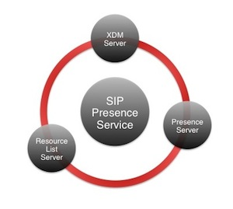

### SIP Presence depends

Mobicents SIP Presence Service depends on:

1. Mobicents JAIN SLEE Container
2. Mobicents JAIN SLEE SIP11 Resource Adaptor
3. Mobicents JAIN SLEE HTTP Servlet Resource Adaptor
4. Mobicents JAIN SLEE XCAP Client Resource Adaptor
5. Mobicents JAIN SLEE SIP Subscription Client Enabler
6. Mobicents JAIN SLEE XDM Client Enabler

### XDMS包含的XCAP AppUsages

The XDMS includes the following XCAP Application Usages:

1. [IETF Presence Rules (RFC 5025)](http://tools.ietf.org/html/rfc5025)
2. [OMA Presence Rules (OMA Presence Simple v1.1)](http://www.openmobilealliance.org/Technical/release_program/Presence_simple_v1_1.aspx)
3. [IETF Resource Lists](http://tools.ietf.org/html/rfc4826)
4. [OMA Group Usage List (OMA XDM v1.1)](http://www.openmobilealliance.org/Technical/release_program/xdm_v1_1.aspx)
5. [IETF RLS Services (RFC 4826)](http://tools.ietf.org/html/rfc4826)
6. [OMA User Profile (OMA XDM v2.0)](http://www.openmobilealliance.org/Technical/release_program/xdm_v2_0.aspx)
7. [OMA Locked User Profile (OMA XDM v2.0)](http://www.openmobilealliance.org/Technical/release_program/xdm_v2_0.aspx)
8. [IETF XCAP-CAPS (RFC 4825)](http://tools.ietf.org/html/rfc4825)
9. [OMA XCAP Directory (OMA XDM v1.1)](http://www.openmobilealliance.org/Technical/release_program/xdm_v1_1.aspx)

### Functional Elements of the XDM Server

The **XDM Server** comprises the following functional elements:

**Data Source**

The XDM Server data source is where all user XML documents are stored. Information related to the server itself is also stored in this element along with the user's provisioned data.

The data source also handles subscriptions to updates on specific documents, or complete XCAP application usages.

**Aggregation Proxy**

The aggregation proxy is responsible for handling an XDM client's XCAP requests.

**Authentication Proxy**

The authentication proxy is responsible for authentication of the user related with each XCAP request handled.

**Request Processor**

This element includes the XCAP Server logic to process an XCAP request and return a proper response, including authorization for the authenticated user.

**XDM Event Subscription Control**

This element, using the SIP protocol, is responsible for handling subscriptions to documents managed by the XDM. Its functions include the authentication and authorization of a subscription, attachment to update events on specific documents or application usages, and the sending of notifications when documents change.

## JAIN SLEE Develop

1. Depand Softwaare

mobicents eclipse plugin地址:

<http://mobicents.googlecode.com/svn/downloads/eclipse-update-site/>

mobicents-jainslee-2.4.1

1. [Hello SLEE World Service JAIN SLEE Tutorial](http://community.jboss.org/wiki/HelloSLEEWorldServiceJAINSLEETutorial)

注意设置JBOSS_HOME，指向mobicents-jainslee-2.4.1\jboss-5.1.0.GA

xcap-client



# XCAP

[**REST风格的XCAP协议**](http://www.iteye.com/topic/109749)<http://www.iteye.com/topic/109749>

[xcapclient研究](http://jefry.iteye.com/blog/1073257) <http://jefry.iteye.com/blog/1073257>

[XCAP协议中的幂等性(idempotency)研究](http://blog.csdn.net/gobitan/article/details/1642942)

# Openxcap and Opensips

Opensips网址: opensips.org, openxcap 和opensips集成，完成xcap的功能，

OpenXCAP server工作在[OpenSIPS Presence Agent](http://opensips.org) 的外围。见下图:

[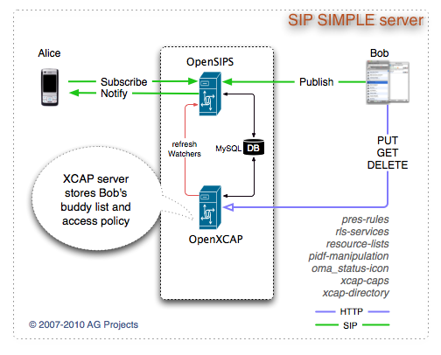](http://openxcap.org/attachment/wiki/WikiStart/SIMPLE-Server.png)

安装opensips过程

官方方默认只给出了debian的安装过程。以**ubuntu为列**

[**http://www.opensips.org/Resources/Install**](http://www.opensips.org/Resources/Install)

**数据库的安装**

<http://wenku.baidu.com/view/f64ea4d333d4b14e852468c2.html>

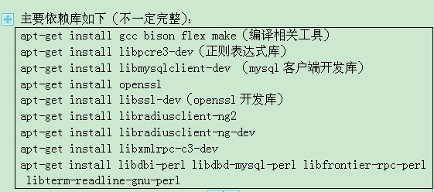

F:\360data\重要数据\我的文档\Tencent Files\491089448\Image\0XNX]JG[6$H11P0(]48J726.jpg

GRANT ALL PRIVILEGES ON *.* TO 'opensips'@'%' IDENTIFIED BY 'opensipsrw';

GRANT ALL PRIVILEGES ON *.* TO 'opensipsro'@'%' IDENTIFIED BY 'opensipsro';

# Appendix

## 开源sip/simple/xcap

|  |  |  |  |
| --- | --- | --- | --- |
| Mobicents | [Website](http://www.mobicents.org/) | Java /jboss Server |  |
| Kamailio (OpenSER) | [Website](http://www.kamailio.org/w/) | C | GPL 2.0 |
| OpenSIPS | [Website](http://opensips.org/) | C |  |
|  |  |  |  |

[OpenXCAP](http://openxcap.org/) server在OpenSIPS代理封包的外围工作。

## JAIN SLEE related links

1. [SIP Presence Service User Guide](http://ci.jboss.org/jenkins/view/Mobicents/job/MobicentsBooks/lastSuccessfulBuild/artifact/sip-presence/index.html)
2. [开源的 JAIN-SLEE SIP 软交换 -- Mobicents](https://www.ibm.com/developerworks/cn/opensource/os-jain-slee/) (中文)
3. [JAIN JSLEE JSIP resouces](http://www.sipcenter.com/sip.nsf/html/JAVA+JAIN+JSLEE+JSIP)

## 相关资料

1. [优秀的Voip门户网站](http://www.voip-info.org/)

java.net搜索

<http://www.java.net/search/node/xcap>

服务逻辑执行环境

<http://jainslee.org>

## commercial App

1. **WebSphere Presence Server** 收集、管理和分发用户的实时在线状态信息。该服务器完全与 JavaEE 体系结构集成，支持通过 SIP 协议提供用户在线状态感知功能。
2. **Oracle Communications Presence**

<http://www.oracle.com/technetwork/middleware/ocp/overview/index.html>