Actigraphy Report

**Subject ID:** Actiwatch Spectrum PRO

**DOB:** 1965/1/1 **Age:** 48 **Gender:** Male

**Recording Period:** from 2013/11/5 15:51:00 to 2013/11/12 11:33:30

**Indications for Use:**

|  |
| --- |
|  |

**Summary Statistics:**

|  |  |  |  |  |  |  |  |  |
| --- | --- | --- | --- | --- | --- | --- | --- | --- |
|  | Bed Time | Get Up Time | Time in Bed (hours) | Total Sleep Time (hours) | Onset Latency (minutes) | Sleep Efficiency (percent) | WASO (minutes) | #Awak. |
| Min | 21:37:45 | 5:14:00 | 7:24:30 | 6:16:30 | 9.00 | 79.60 | 10.50 | 15 |
| Max | 22:35:00 | 7:50:00 | 9:32:30 | 8:29:15 | 64.25 | 92.83 | 25.25 | 59 |
| Avg | 22:08:12 | 6:06:27 | 7:58:15 | 7:03:08 | 21.71 | 88.79 | 16.43 | 32.00 |

**Interpretation:**

|  |
| --- |
|  |

|  |
| --- |
| 1 **Subject ID:** Actiwatch Spectrum PRO |
| **DOB:** 1965/1/1 |

**Actogram:** 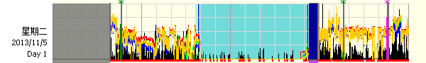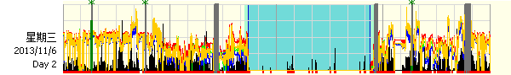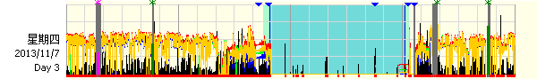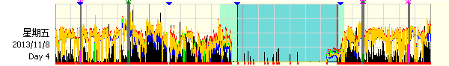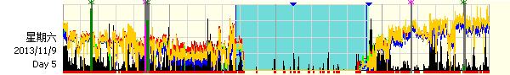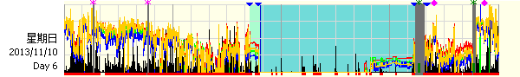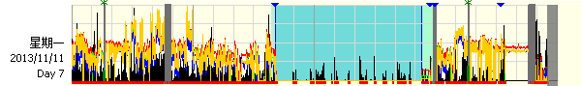



Activity Scale: 394/0, White Light Scale: 26850.0/0.1, Color Light Scale: 2.700E+04/1.000E-02

|  |
| --- |
| 1 **Subject ID:** Actiwatch Spectrum PRO |
| **DOB:** 1965/1/1 |

**Daily Statistics:**

|  |  |  |  |  |  |  |  |  |
| --- | --- | --- | --- | --- | --- | --- | --- | --- |
| Date | Bed Time | Get Up Time | Time in Bed (hours) | Total Sleep Time (hours) | Onset Latency (minutes) | Sleep Efficiency (percent) | WASO (minutes) | #Awak. |
| 星期二 2013/11/5 | 21:37:45 | 5:18:45 | 7:41:00 | 7:04:00 | 14.00 | 91.97 | 17.00 | 46 |
| 星期三 2013/11/6 | 22:15:00 | 5:39:30 | 7:24:30 | 6:40:30 | 9.00 | 90.10 | 11.25 | 20 |
| 星期四 2013/11/7 | 22:35:00 | 6:19:15 | 7:44:15 | 6:59:00 | 18.75 | 90.25 | 15.25 | 15 |
| 星期五 2013/11/8 | 22:34:30 | 6:27:30 | 7:53:00 | 6:16:30 | 64.25 | 79.60 | 10.50 | 16 |
| 星期六 2013/11/9 | 21:44:30 | 5:14:00 | 7:29:30 | 6:57:15 | 38.98 | 92.83 | 25.25 | 32 |
| 星期日 2013/11/10 | 22:17:30 | 7:50:00 | 9:32:30 | 8:29:15 | 32.75 | 90.73 | 19.00 | 36 |
| 星期一 2013/11/11 | 21:53:15 | 5:56:15 | 8:03:00 | 6:55:30 | 13.25 | 86.02 | 16.75 | 59 |

Each day represented above is from 12:00:00 to 12:00:00 on the next day.

**Summary Statistics:**

|  |  |  |  |  |  |  |  |  |
| --- | --- | --- | --- | --- | --- | --- | --- | --- |
|  | Bed Time | Get Up Time | Time in Bed (hours) | Total Sleep Time (hours) | Onset Latency (minutes) | Sleep Efficiency (percent) | WASO (minutes) | #Awak. |
| Min | 21:37:45 | 5:14:00 | 7:24:30 | 6:16:30 | 9.00 | 79.60 | 10.50 | 15 |
| Max | 22:35:00 | 7:50:00 | 9:32:30 | 8:29:15 | 64.25 | 92.83 | 25.25 | 59 |
| Avg | 22:08:12 | 6:06:27 | 7:58:15 | 7:03:08 | 21.71 | 88.79 | 16.43 | 32.00 |