* Create a database called "contact"
* Create a collection called "contactlist"
* Insert these documents  in "contactlist" :

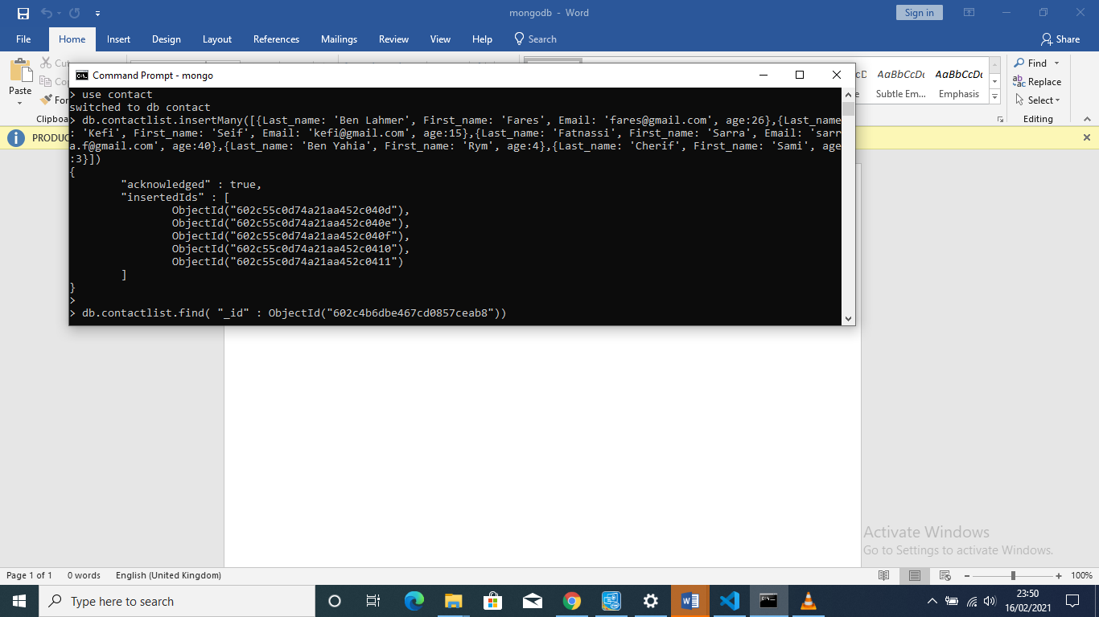

* Display all the information about only one person using his id

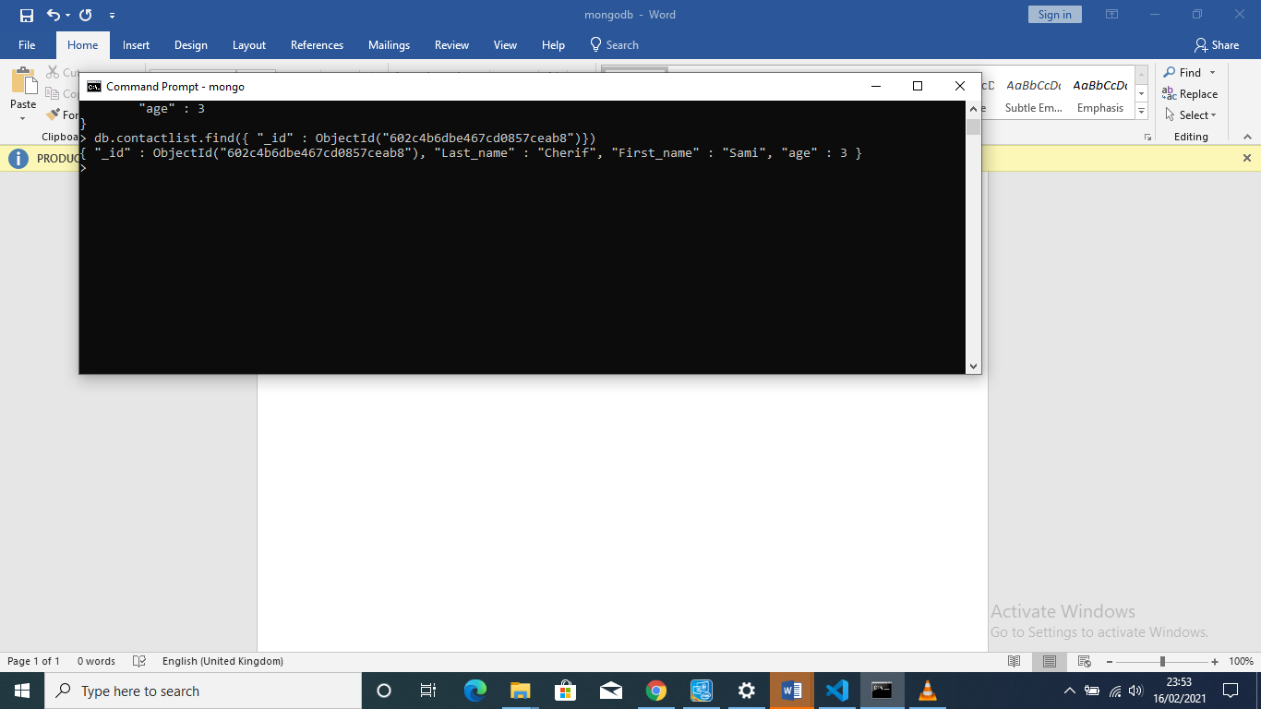

* Display all the contact list having age>18

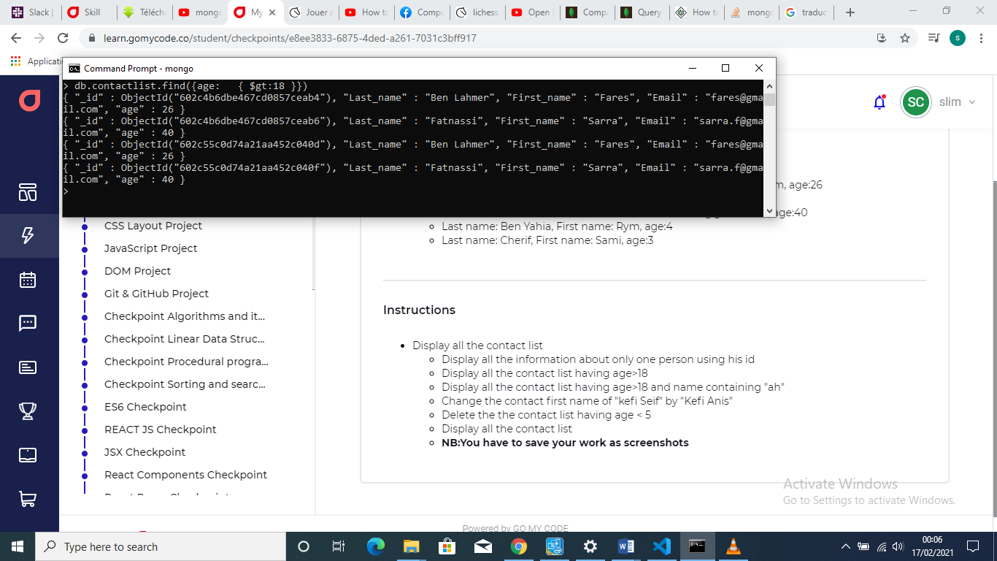

* Display all the contact list having age>18 and name containing "ah"

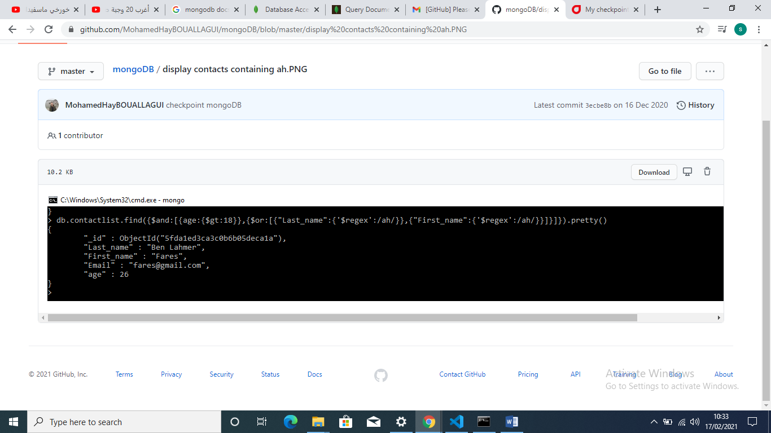

* Change the contact first name of "kefi Seif" by "Kefi Anis"

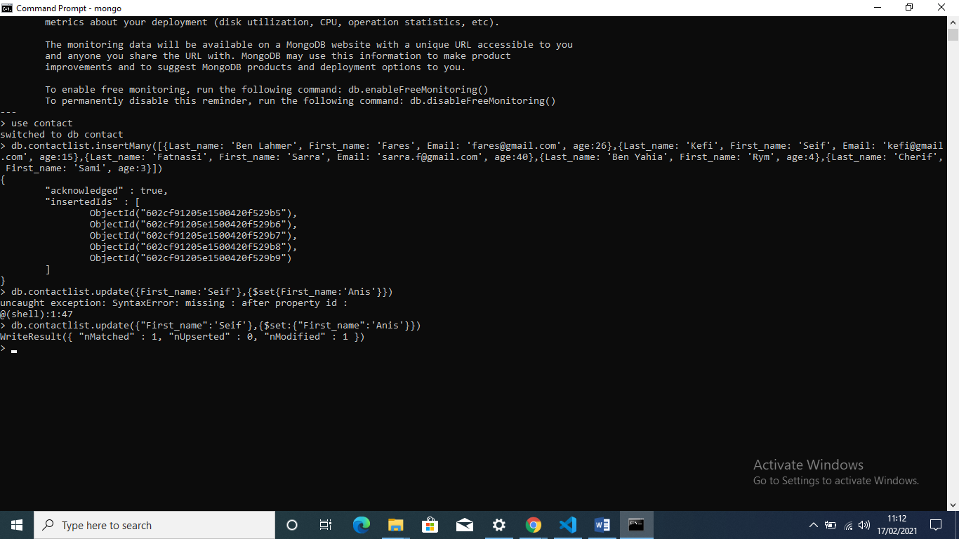

* Delete the the contact list having age < 5
* Display all the contact list

