**EARTHSYS/ESS 8: The Oceans**

***An introduction to the marine environment***

Instructors: Claudette Proctor ([proctorc@stanford.edu](mailto:proctorc@stanford.edu))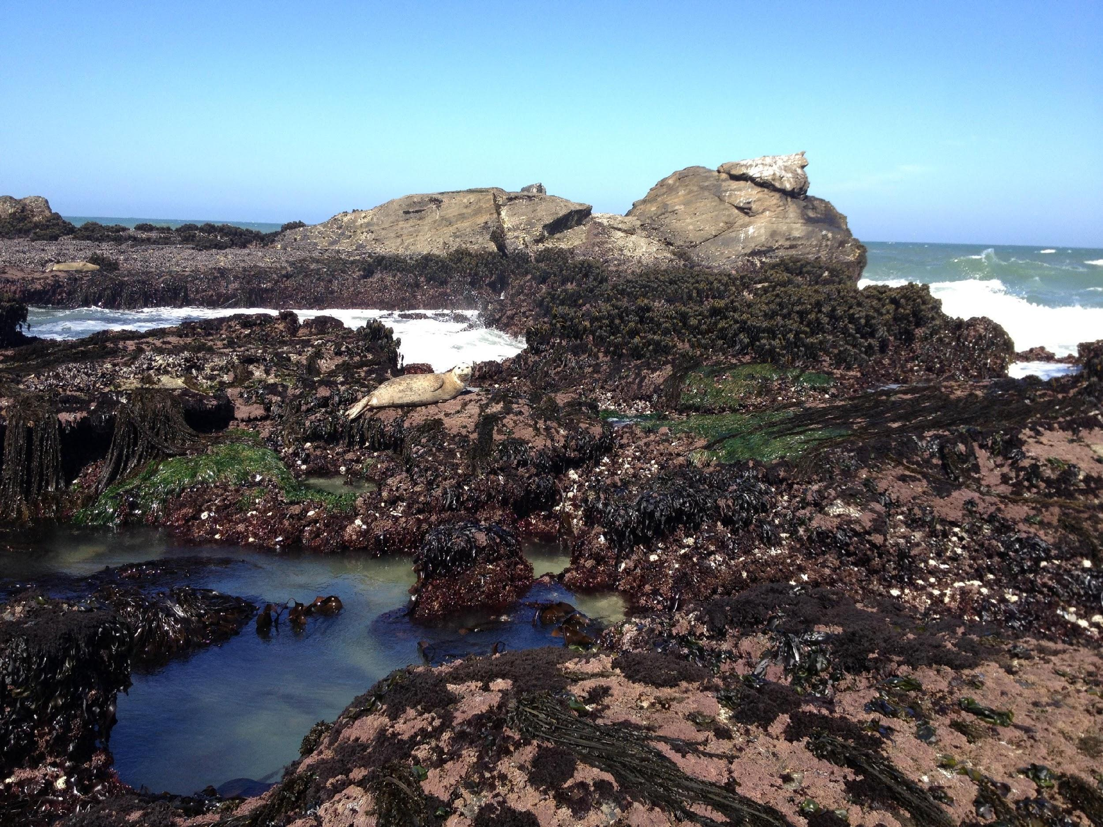

Stephanie Lim ([smlim@stanford.edu](mailto:smlim@stanford.edu))

Prof. Kevin Arrigo ([arrigo@stanford.edu](mailto:arrigo@stanford.edu))

Lecture: Tu/Th 3-4:20pm, STLC 119

Office hours: Claudette: F 10-11am, Mitchell B025

Stephanie: W 2:30-3:30pm, Mitchell B025

Textbook: *Investigating Oceanography* (2nd Ed)

by Keith Sverdrup & Raphael Kudela

Available on Amazon ([2nd Ed](https://www.amazon.com/Investigating-Oceanography-Keith-Sverdrup/dp/0078022932/ref=sr_1_2?crid=KZIYHVHTTH5D&keywords=investigating+oceanography&qid=1647552017&sprefix=investigating+oceanography%2Caps%2C194&sr=8-2)), at the [Branner Earth Sciences library](https://searchworks.stanford.edu/view/12369197), and PDF copies will be provided on Canvas.

**Assignments and Grading**

In order to receive a Satisfactory (S) grade in the class, students need to receive a 70% or higher on assignments in the course. Students who receive less than 70% will receive a No Credit (NC) grade in the class.

Final Grade Breakdown

Reading feedback 15%

Participation 15%

Activities 20%

Midterm 1 15%

Midterm 2 15%

Final paper 20%

*Reading feedback (15%)*

For every class with a reading assignment (see course schedule), students must submit 1-3 thoughtful questions about the reading as well as one practice midterm question with an answer. Questions should consider concepts or synthesis, not simple definitions that can easily be searched online. Reading feedback assignments are due by 8 am the day of our class meeting and should be submitted through Canvas.

*Participation (15%)*

We expect students to attend class meetings and to be engaged in lectures, discussions and group assignments. If circumstances prevent attendance or participation in class, communicate with the instructors in advance so that we can adjust and accommodate accordingly.

*Activities (20%)*

There are four activities to reinforce lecture and reading materials. Activities are designed to be completed during allotted class time, but in some cases groups will finish the activity outside of class. Students will work in small groups (3-4 students) to complete the activities and turn in a single document (listing all group member’s names) on Gradescope. All students must contribute equally and work through all parts of the assignment together. All students are held accountable for all of the material covered during activities. Concepts covered in the activities will be assessed in the midterms. Materials for activities will be posted on Canvas prior to class.

*Midterms (15% each; 30% total)*

The two midterms (April 30 and May 23) will be take-home exams which will include a combination of multiple choice (to assess content-based learning goals) and short answer questions (to assess both skill-based and content-based learning goals).

*Final research paper (20%)*

The goal of the final research paper is to provide an in-depth analysis of a relevant oceanography topic (chosen by the student) that incorporates recent research as well as fundamental concepts from class material. Details of the final paper proposal and assignment will be discussed further during class time. The proposed topics will be presented and discussed in class (May 7) and the “Research Paper Workshop” (May 30) is aimed to help students incorporate primary literature and current research into their analysis papers, as well as improve the student’s ability to communicate science in written form. Skill-based learning goals 1-3 will be assessed on the final paper. Students are also recommended to meet with a [Hume Center tutor](https://undergrad.stanford.edu/tutoring-support/hume-center/see-tutor) to discuss their paper before the final paper is turned in.

*Submitting Assignments & Late Policy*

Reading feedback assignments are due by 8 am the day of our class meeting via Canvas. These assignments ensure that students come into class having read the material critically and can then solidify and expand their knowledge from the reading during lecture. Late reading feedback assignments will not receive credit.

For midterms, 10% of the final grade will be docked for every day exams are turned in late.

Students may contact the instructors to discuss a potential extended deadline under extenuating circumstances.

Any students who register for class late have 2 weeks after the date they join class to make up all assignments for full credit. Please communicate with Claudette and Stephanie about making up assignments and lecture material.

**Learning goals**

*Skill-based learning goals*

The overall goal of this course is to engage students in scientific arguments, logical reasoning, and science communication. This course will enable students to achieve the following specific skill-based learning goals:

1. Follow a scientific argument throughlogical reasoning.
2. Critically evaluate scientific arguments.
3. Communicate scientific concepts in both written and spoken form.

*Content-based learning goals*

Broadly, the goal of this course is to introduce students to an integrated perspective of biological (marine organisms), physical (circulation, tides, waves), chemical (constituents of seawater), and geological (plate tectonics, seafloor) oceanography. Throughout the course we consider the impacts of human activities on the ocean, including discussions on global climate change, marine pollution, overfishing and eutrophication. This course will enable students to achieve the following specific content-based learning goals:

1. Describe Earth’s internal structure, explain plate tectonics, and the major geologic forces shaping the oceans (Ch. 2)
2. Identify the main elements of the seafloor and understand the formation and classifications of ocean sediments (Ch. 3)
3. Understand the physical properties of water, predict how temperature, pressure, and salinity impact density, and describe how energy is transmitted through seawater (Ch. 4)
4. Describe the chemical composition of seawater by understanding salinity, the major constituents of seawater, residence times, nutrients, and dissolved gasses (Ch. 5)
5. Explain how the ocean and atmosphere interact by understanding Earth’s heat budget and atmospheric circulation (Ch. 6)
6. Distinguish between thermohaline circulation and surface currents in order to describe oceanic circulation patterns and features (Ch. 7)
7. Predict the formation and dispersion of waves and quantify wave characteristics (Ch. 8)
8. Model the Earth-moon-sun system, compare and contrast tidal patterns, and describe resultant tidal currents (Ch. 9)
9. Recognize the major types of coastal zones and beaches and describe how human impacts (dams, breakwaters, jetties) may interfere with the equilibrium of beaches (Ch. 10)
10. Differentiate the major environmental zones of the oceans and understand the flow of energy through trophic levels in food webs (Ch. 11)
11. Identify key planktonic organisms and, after working directly with satellite and in situ data, understand top-down and bottom-up controls on global patterns of productivity (Ch. 12)
12. Describe evolutionary adaptations of marine nekton, including invertebrates, fish, marine mammals, reptiles and birds (Ch. 13)
13. Characterize different benthic environments, including intertidal zone, coral reefs, hydrothermal vents and deep-sea floor, to predict the zonation of marine organisms (Ch. 14)
14. Evaluate the environmental problems posed by various human activities including pollution, eutrophication, oil spills and overfishing (Ch. 15)
15. Understand the role of the oceans in global climate change and predict what the oceans might look like in a warmer world (Ch. 16)

**Students with documented disabilities**

Students who may need academic accommodations based on the impact of a disability must initiate the request with the Office of Accessible Education (OAE). Professional staff will evaluate the request with required documentation, recommend reasonable accommodations, and prepare an Accommodation Letter for faculty dated in the current quarter in which the request is being made. Students should contact the OAE as soon as possible since timely notice is needed to coordinate accommodations. The OAE is located at 563 Salvatierra Walk; Phone: 650-723-1066; Web site:

<http://studentaffairs.stanford.edu/oae>.

If you are a student with a documented disability who needs special accommodations, please talk to the instructors as soon as possible.

**Stanford Honor Code**

Students must follow Stanford University’s Honor Code and the Fundamental Standard:

<https://communitystandards.stanford.edu/policies-guidance/honor-code>

**Course schedule:**

| **Week** | **Date** | **Lecture** | **Reading\*** | **Assignments** |
| --- | --- | --- | --- | --- |
| Week 1 | April 2 | Introduction |  |  |
| April 4 | Earth structure and plate tectonics + The seafloor and its sediments | 2, 3 | Reading feedback |
| Week 2 | April 9 | Physical properties of water + The chemistry of seawater | 4, 5 | Reading feedback |
| April 11 | *Activity 1: Shape of ocean basins and bathymetry of the seafloor* |  | Activity 1 write-up |
| Week 3 | April 16 | *Activity 2: Seafloor sediments* |  | Activity 2 write-up |
| April 18 | The atmosphere and ocean | 6 | Reading feedback |
| Week 4 | April 23 | Ocean structure and circulation + content review | 7 | Reading feedback |
| April 25 | *Activity 3: Surface ocean currents and ocean-atmosphere interactions* |  | Activity 3 write-up |
| Week 5 | April 30 | **Midterm 1** |  |  |
| May 2 | The waves and tides | 8, 9 | Reading feedback |
| May 3 | Field trip |  |  |
| Week 6 | May 7 | Coasts, beaches, and estuaries + 1 min presentation of final paper topic + How to read a research paper | research papers | Final paper proposal |
| May 9 | The plankton, productivity, and food webs; the living ocean | 11, 12 | Reading feedback |
| Week 7 | May 14 | *Activity 4: Primary productivity in the ocean* |  |  |
| May 16 | The nekton: swimmers of the ocean | 13 | Final paper outline |
| Week 8 | May 21 | The benthos: living on the seafloor + content review | 14 | Reading feedback |
| May 23 | **Midterm 2** |  |  |
| Week 9 | May 28 | The oceans and climate disruptions -- discussion | 16 | Reading feedback |
| May 30 | Research paper workshop |  | Final paper draft |
| Week 10 | June 4 | Environmental issues | 15 | Reading feedback |
| June 6 | Short group presentations |  |  |
| Finals | June 11 | **Final paper due at 3pm** | | |

*Sections to skip:

“Diving In” sections for all chapters

Ch. 2: read 2.1 – 2.5

Ch. 3: read 3.1 – 3.3, can skip “Sampling Methods” and “Sediments as Historical Records”;

Ch. 5: read 5.1 – 5.4

Ch. 7: read 7.1 – 7.9

Ch. 9: read 9.1 – 9.5, 9.8

Ch. 11: read 11.2 – 11.6, only need to understand terms ‘prokaryote’ and ‘eukaryote’ from 11.1