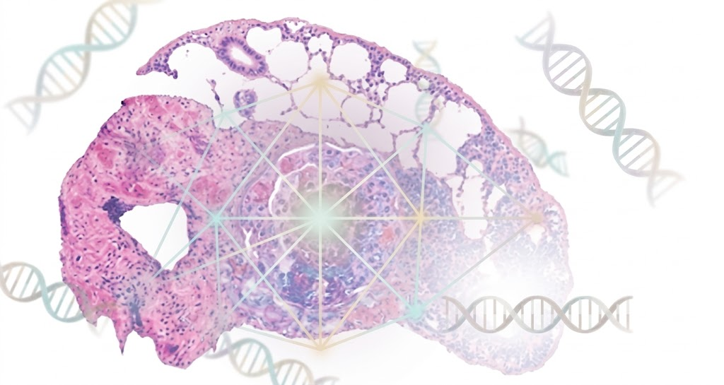
LCHAI v2.0 — User Manual
Lung Cancer Histologic Analysis with AI
Explainable mutation prediction from H&E whole-slide images

Manual Version 11 April 2026

DISCLAIMER: LCHAI v2.0 is a research tool (THESIS_INTERNAL evidence). Mutation predictions use ABMIL + Fuzzy Choquet MIL. Inconclusive genes (AUROC < 0.70) require molecular testing. NOT for clinical diagnosis.

Content
1. System Overview 5
ML Pipeline Summary 6
2. Getting Started — Login 7
User Roles 7
3. Analysis Tab — Upload, Analyze, and Explain 8
3.1 Uploading an Image 8
3.2 Analyzing a Slide 8
3.3 Gene Sub-tabs 9
3.4 Pattern Overlay and ABMIL Attention Heatmap 9
3.5 SHAP Decomposition with Fuzzy Balance Label 10
3.6 Ablation Comparison 10
3.7 AI-Generated Explanation 11
3.8 Fuzzy Choquet Analysis (Conditional) 12
3.9 Morphologic Profile 12
4. Viewer Tab — Image Exploration 13
Layer Controls 13
Navigation 13
Hover Tooltips 13
Active Learning (Pattern Correction) 14
5. Graph Tab — Knowledge Graph 14
Building the Graph 14
AI Explanation 14
6. Admin Tab — System Configuration 15
Parameters 15
Fuzzy Labels 16
Other Sub-tabs 16
7. User Profile and Settings 17
8. Supported Image Formats 17
9. Understanding the Results 17
Mutation Probability 17
Conclusive vs Inconclusive 17
Gene-Specific Associations 18
10. Fuzzy Linguistic Labels 18
The Five Scales 18
Anti-Hallucination 19
11. Troubleshooting 19
Performance Tips 19

1. System Overview
LCHAI v2.0 is an AI-powered decision-support system for lung adenocarcinoma (LUAD) histopathology. It analyzes whole-slide images (WSI) to:
- Classify histological growth patterns: lepidic, acinar, papillary, micropapillary, solid, cribriform
- Predict oncogenic mutations: TP53, EGFR, KRAS, STK11, KEAP1, RBM10
- Provide six-level explainability: attention maps, pattern overlays, SHAP decomposition, Choquet Shapley values, per-slide ablation, and fuzzy linguistic labels
- Generate knowledge graphs linking predictions to biomedical ontologies (NCIt, MONDO) and treatment associations
- Produce AI-generated explanations grounded in the knowledge graph with numbered PubMed citations

ML Pipeline Summary
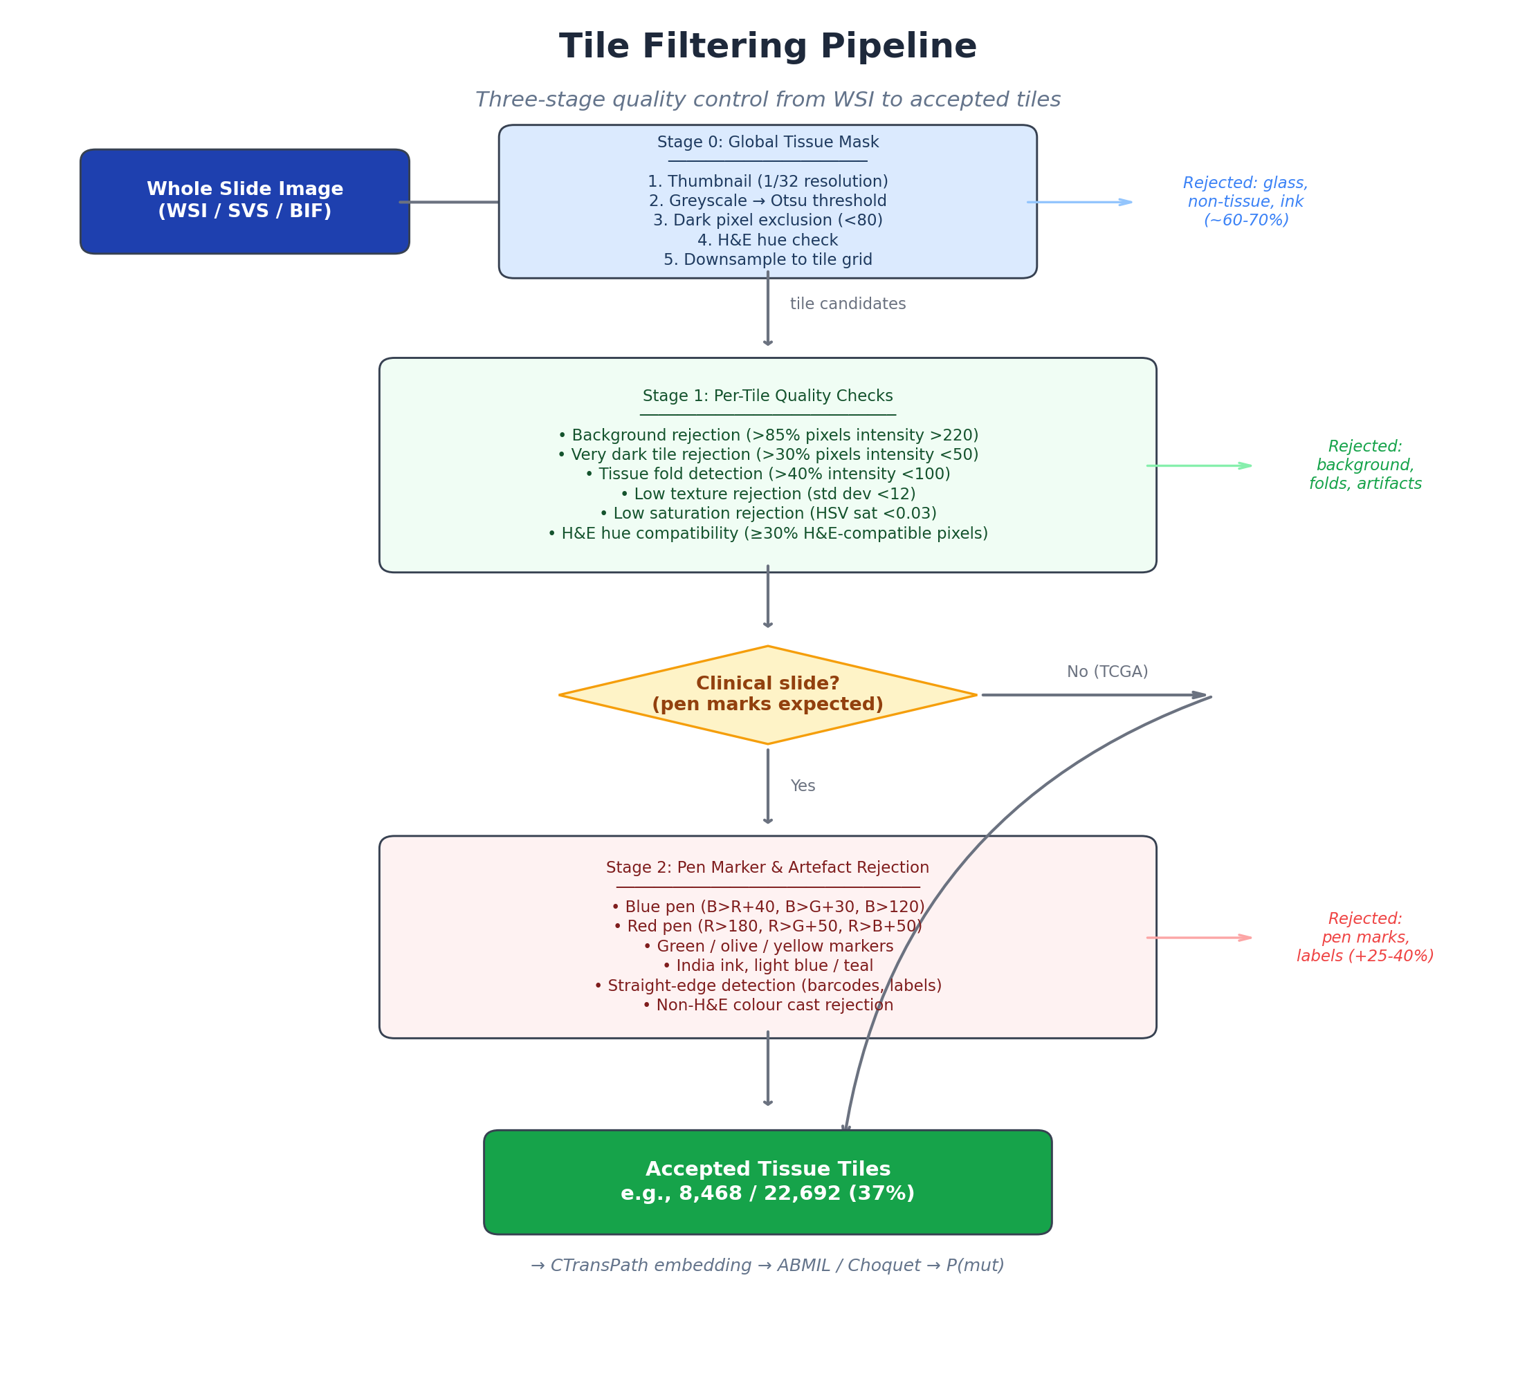
Figure 1: Three-stage tile filtering pipeline from WSI to accepted tissue tiles
- WSI Decode — Opens the slide file (SVS, TIFF, or BIF) using OpenSlide
- Tile Filtering — Three-stage quality control rejects glass, artifacts, pen marks (see Figure 1)
- CTransPath Inference (GPU) — Each tile produces a 512-dimensional embedding
- Pattern Classification — FuzzyArcLoss V2 classifies each tile into 1 of 6 histological patterns
- Mutation Prediction — Gene-specific models (ABMIL or Fuzzy Choquet MIL) predict mutation probability
- Explainability — Ablation, SHAP decomposition, Choquet Shapley values, and fuzzy linguistic labels

2. Getting Started — Login
Navigate to the LCHAI system (https://lchai.gptfy.biz or http://localhost:3000). You will be redirected to the Keycloak authentication page.
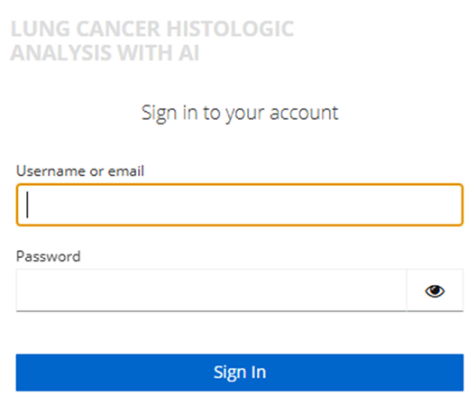
Figure 2: Keycloak login screen
Method | Description
Username / Password | Enter your assigned credentials (e.g., admin1 / admin1)
Google | Click “Google” to sign in with your Google account (OAuth2)

User Roles
Role | Access
Clinician | Analysis, Viewer, Graph tabs
Admin | All clinician access + Admin tab
Auditor | Read-only access to audit trail

3. Analysis Tab — Upload, Analyze, and Explain
The Analysis tab is the primary workspace. It integrates image upload, mutation prediction, and multi-level explainability into a single unified view.
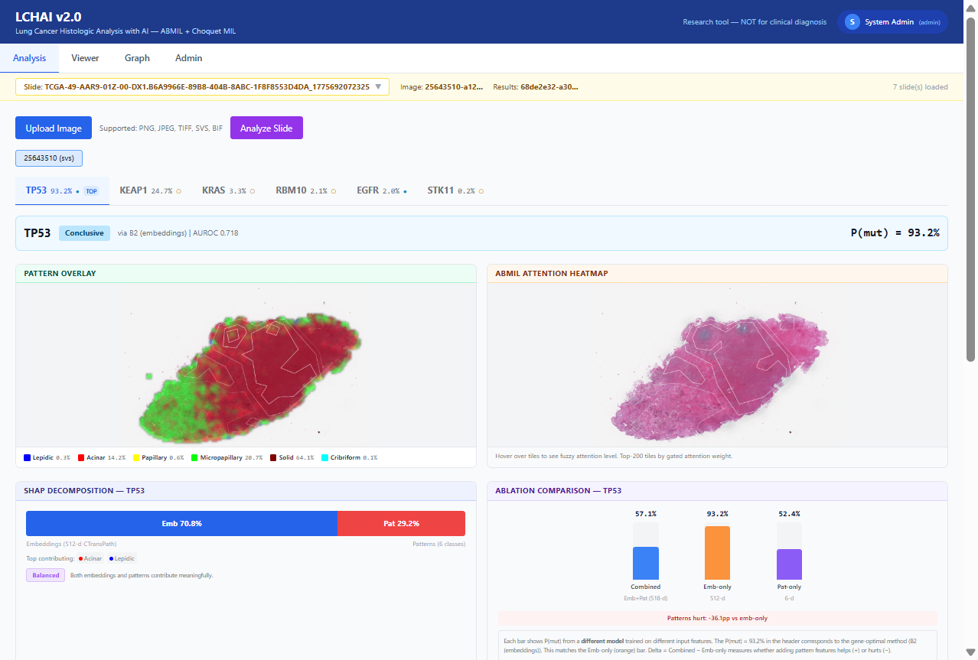Figure 3: Analysis tab showing TP53 (93.2%, Conclusive). Gene sub-tabs at top, side-by-side overlays, SHAP with fuzzy label, and ablation comparison.

3.1 Uploading an Image
- Click “Upload Image” (blue button)
- Select a histopathology image file (PNG, JPEG, TIFF, SVS, BIF)
- A progress bar shows upload percentage
- The system creates a new case and selects the uploaded slide
Slide Selector: The yellow bar at the top shows all uploaded slides. Click the dropdown to switch.

3.2 Analyzing a Slide
- Select a slide, then click “Analyze Slide” (purple button)
- A processing modal shows real-time progress:
Stage | Description | Time
Decoding image | Opens WSI, creates thumbnail | 5-10s
CTransPath inference | GPU processes tiles | 10-30s
Mutation prediction | ABMIL/Choquet for 6 genes | 5-10s
Ablation + permutation | Model comparison | 10-20s
SHAP decomposition | Feature attribution | 5-15s
Saving results | Store in database | 2-5s
Click “Cancel and discard” to abort at any time.

3.3 Gene Sub-tabs
After processing, gene sub-tabs appear sorted by descending P(mut). The highest-probability mutation is selected by default.
Each tab shows: - Gene name, P(mut) percentage, and prediction method - A filled circle (●) for Conclusive genes, empty circle (○) for Inconclusive - A “TOP” badge on the highest-probability gene

3.4 Pattern Overlay and ABMIL Attention Heatmap
Two images are displayed side by side:
Left: Pattern Overlay | Right: ABMIL Attention Heatmap
Tile-level color map of 6 growth patterns | Top-200 tiles by gated attention weight
Legend shows pattern names with composition % | Red = high attention
Hover: shows tile pattern name and % | Hover: shows fuzzy attention label (e.g., “High Attention, p97”)
Pattern Color Legend:
Color | Pattern
Blue | Lepidic
Red | Acinar
Yellow | Papillary
Green | Micropapillary
Dark red | Solid
Cyan | Cribriform

3.5 SHAP Decomposition with Fuzzy Balance Label
A stacked bar shows what percentage of the prediction comes from: - Embeddings (512-d CTransPath visual texture) — blue - Patterns (6-class histological classification) — red
A fuzzy linguistic label classifies the balance:
Label | Meaning
Embedding-Dominated | Patterns nearly irrelevant (<10%)
Embedding-Led | Patterns provide minor signal (10-25%)
Balanced | Both contribute meaningfully (25-55%)
Pattern-Led | Patterns are primary signal (55-70%)
Pattern-Dominated | Embeddings secondary (>70%)

3.6 Ablation Comparison
Three vertical bars compare P(mut) from three independently trained models: - Combined (blue): embeddings + patterns (518-d) - Emb-only (orange): embeddings alone (512-d) - Pat-only (purple): patterns alone (6-d)
A delta indicator shows whether patterns help (+) or hurt (-).
Important: These are three different models, not components of one prediction. The P(mut) in the header comes from the gene-optimal method, which may differ from any bar.

3.7 AI-Generated Explanation
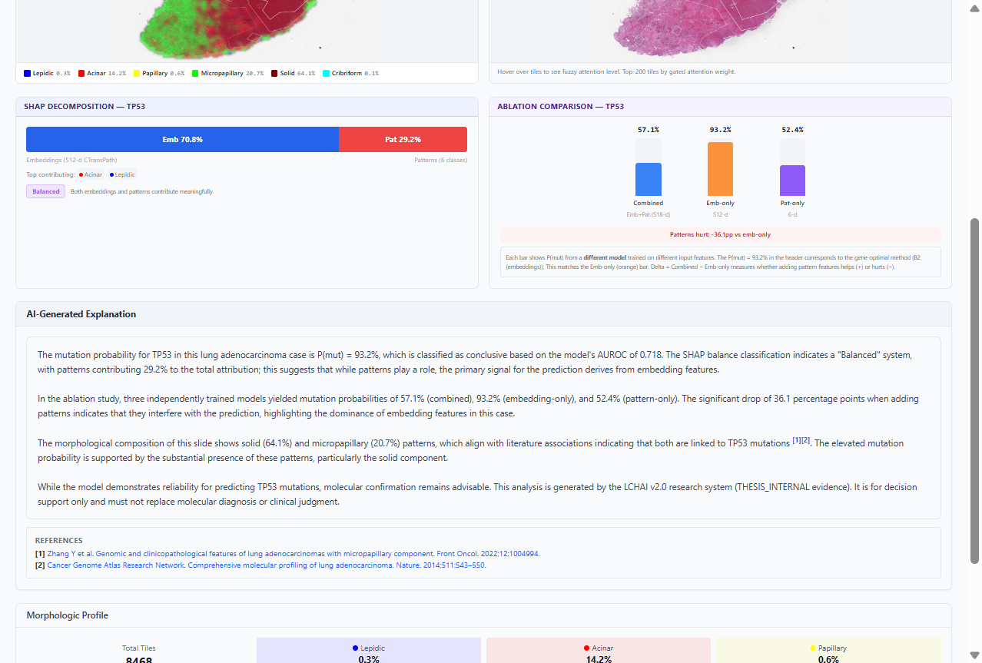Figure 4: AI-generated explanation with SHAP fuzzy label, ablation interpretation, literature citations [1][2], and PubMed references
The system generates a structured clinical narrative (8-12 sentences) that: - States P(mut) and whether it is conclusive or inconclusive - Describes the SHAP balance using the system’s fuzzy label - Interprets the ablation comparison - Compares the slide’s patterns to literature expectations with numbered PubMed citations [1], [2] - Includes the thesis disclaimer
All fuzzy labels and clinical facts are system-controlled — the LLM cannot invent intensity terms or clinical associations.
References: Below the explanation, clickable PubMed links for each cited paper.

3.8 Fuzzy Choquet Analysis (Conditional)
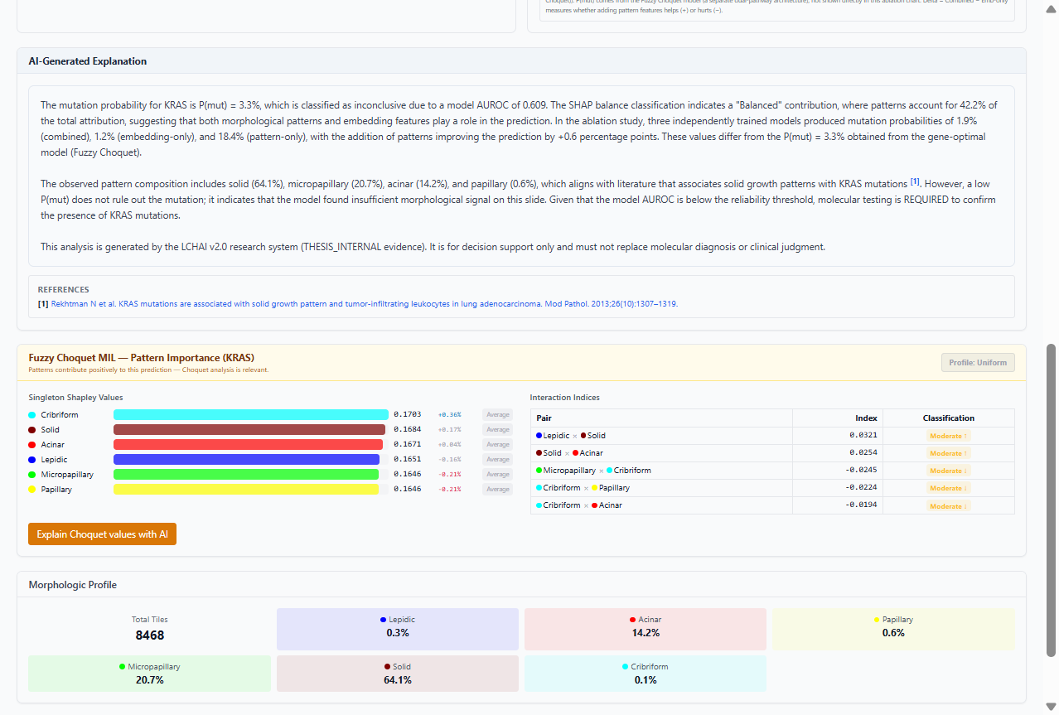Figure 5: Choquet section for KRAS with “Profile: Uniform” badge, per-pattern Shapley labels, and interaction indices with fuzzy classifications
This section appears only when patterns contribute positively (Combined > Emb-only).
Component | Description
Profile badge | Fuzzy classification of Shapley spread (e.g., “Uniform”, “Near-Uniform”)
Shapley value bars | Per-pattern importance with individual fuzzy labels (e.g., “Average”)
Interaction indices table | Pairwise synergy/redundancy with fuzzy intensity (e.g., “Moderate Synergy ↑”)
Explain with AI button | LLM interpretation using the system-computed fuzzy labels

3.9 Morphologic Profile
Grid showing total tile count and percentage breakdown of all 6 histological patterns.

4. Viewer Tab — Image Exploration
The Viewer tab provides an interactive image viewer with zoom, pan, and overlay layers.
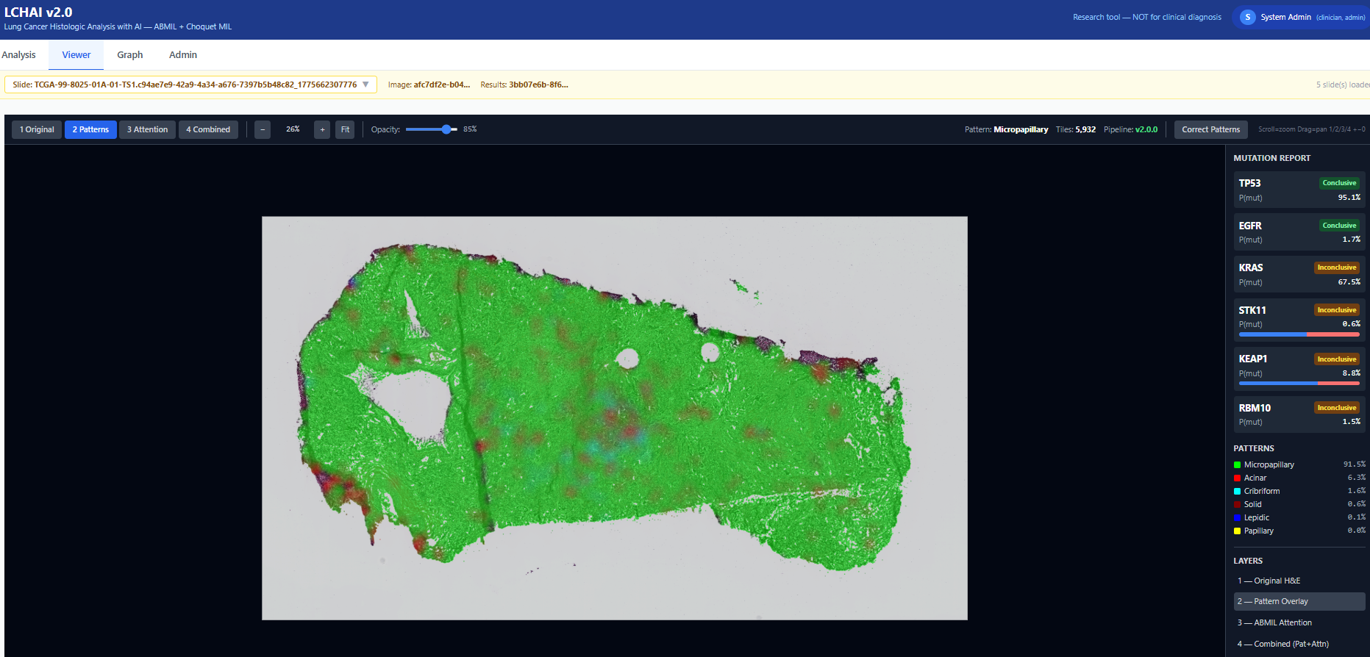
Figure 6: Viewer tab with pattern overlay layer

Layer Controls
Button | Layer | Description
1 Original | H&E image | The original histopathology image
2 Patterns | Pattern overlay | Color-coded pattern classification per tile
3 Attention | ABMIL attention | Heatmap with white contour lines
4 Combined | Both | Pattern colors + attention contours

Navigation
Action | How
Zoom in/out | Scroll wheel or +/- keys
Pan | Click and drag
Reset view | Click “Fit” or press 0
Switch layers | Press 1, 2, 3, 4

Hover Tooltips
On Pattern and Combined layers, hovering over a tile shows the pattern name with a color indicator.

Active Learning (Pattern Correction)
In Pattern/Combined layers, click “Correction Mode” to: 1. Draw a lasso around misclassified tiles 2. Select the correct pattern from the dropdown 3. Submit corrections for delta retraining

5. Graph Tab — Knowledge Graph
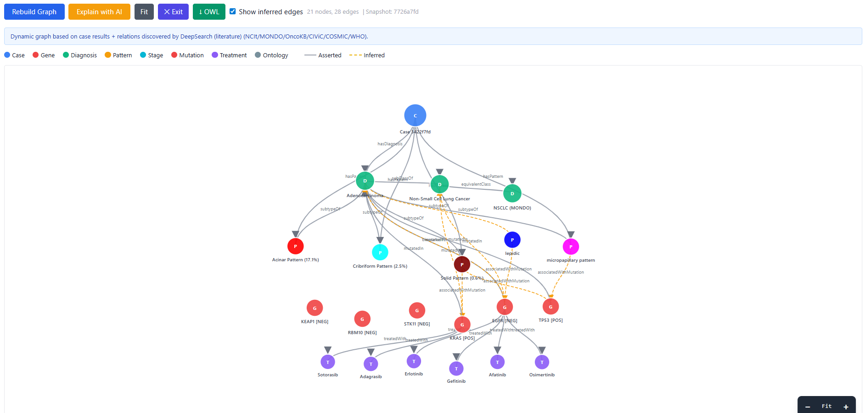Figure 7: Knowledge graph linking patterns, genes, treatments, and ontology concepts

Building the Graph
Click “Rebuild Graph” to generate a case-specific knowledge graph from: - Predicted mutations and patterns - NCIt and MONDO ontology relationships - Treatment associations (OncoKB/FDA guidelines) - DeepSearch-discovered literature relations

AI Explanation
Click “Explain with AI” to generate a natural language summary in your selected language.
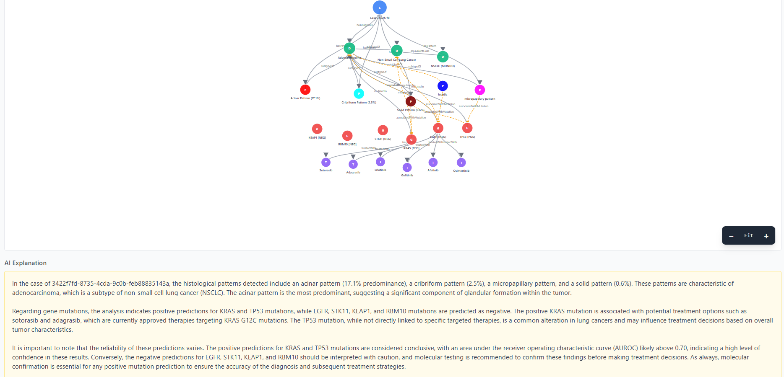Figure 8: LLM-generated graph explanation

6. Admin Tab — System Configuration
Accessible only to users with the admin role. Contains seven sub-tabs:

Parameters
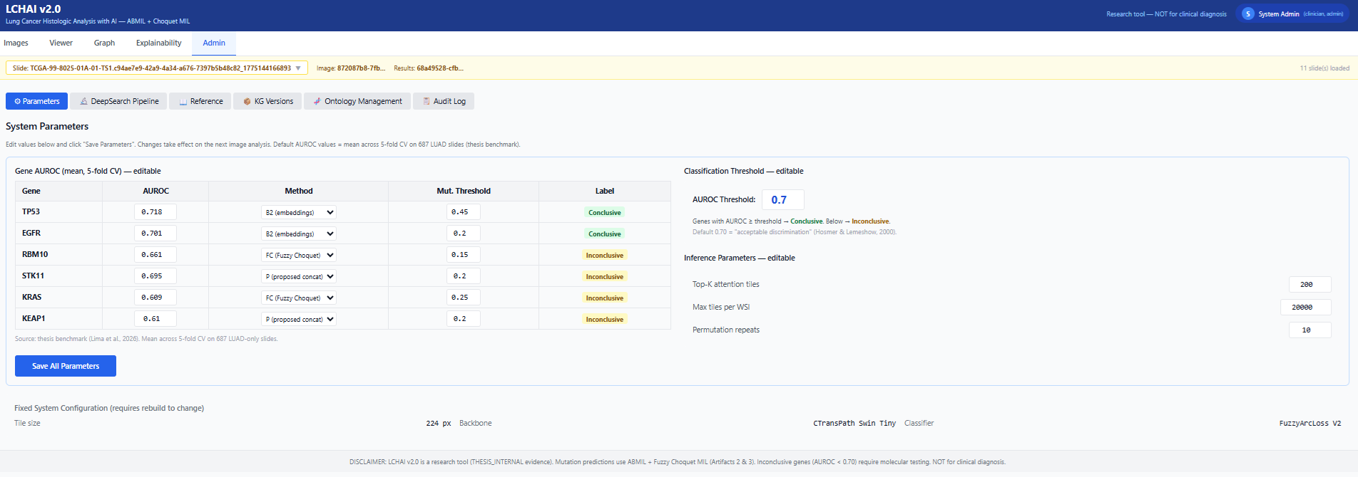Figure 9: System parameters — AUROC values, methods, thresholds
Parameter | Description | Default
Gene AUROC values | Mean 5-fold CV AUROC per gene | 0.609–0.718
Method per gene | Optimal model (B2, P, or FC) | From thesis Finding 2
AUROC Threshold | Conclusive/Inconclusive boundary | 0.700
Max tiles per WSI | Tile extraction limit | 20,000

Fuzzy Labels
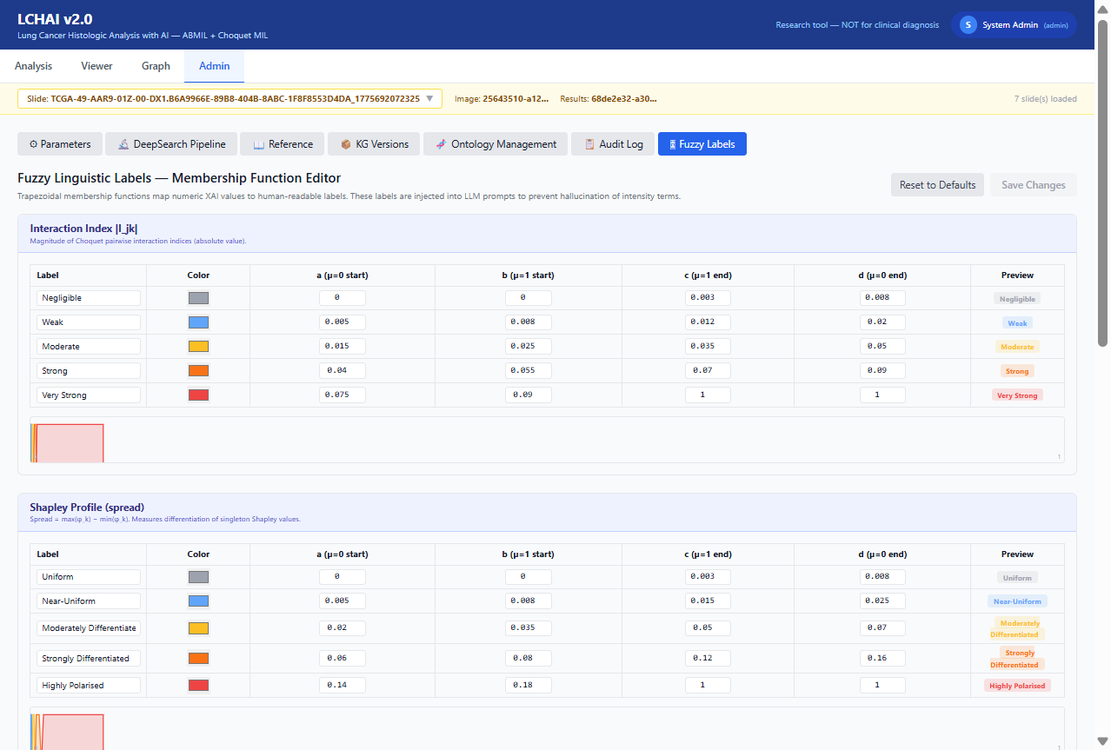Figure 10: Fuzzy linguistic label editor with trapezoidal membership functions
Edit the five fuzzy scales that classify XAI outputs: 1. Interaction Index — Negligible to Very Strong 2. Shapley Profile — Uniform to Highly Polarised 3. SHAP Balance — Embedding-Dominated to Pattern-Dominated 4. Shapley Individual — Average to Strongly Above 5. ABMIL Attention Level — Very Low to Very High
Each scale shows editable trapezoidal parameters [a, b, c, d] with real-time SVG preview. Changes take effect immediately in the Analysis tab.

Other Sub-tabs
Sub-tab | Purpose
DeepSearch Pipeline | Automated literature search for new gene-pattern-treatment relations
Reference | Clinical reference tables and method formulas
KG Versions | Knowledge graph snapshot management
Ontology Management | NCIt/MONDO ontology update proposals
Audit Log | System event history with user, case, action, timestamp

7. User Profile and Settings
Click your name in the top-right corner to access:
- Profile: Name, email, role badges
- Explanation language: English, Espanol, Deutsch, Francais, Portugues
  - Affects AI-generated explanations in the Analysis and Graph tabs
- Logout: End session

8. Supported Image Formats
Format | Extension | Notes
SVS | .svs | Recommended. Fastest via OpenSlide
TIFF | .tif, .tiff | Flat TIFFs auto-converted to pyramidal
BIF | .bif | Ventana/Roche. Auto-converted via pyvips
PNG | .png | For small sections
JPEG | .jpg, .jpeg | For small sections

9. Understanding the Results

Mutation Probability
P(mut) | Interpretation
> 70% | Strong evidence — confirm with molecular testing
50-70% | Moderate evidence — molecular testing recommended
30-50% | Weak signal — molecular testing needed
< 30% | Likely wild-type

Conclusive vs Inconclusive
- Conclusive (AUROC >= 0.70): Reliable prediction. The model has demonstrated acceptable discrimination.
- Inconclusive (AUROC < 0.70): Limited accuracy. Molecular testing is strongly recommended.

Gene-Specific Associations
Gene | Pattern association | Treatment implications
TP53 | Solid, micropapillary | No targeted therapy; immunotherapy in selected cases
EGFR | Lepidic, papillary | Osimertinib, erlotinib, gefitinib, afatinib
KRAS | Solid (mucinous not in taxonomy) | Sotorasib, adagrasib (G12C-specific)
STK11 | Variable (immune-cold) | May predict IO resistance
KEAP1 | Diffuse | NRF2 pathway; affects IO response
RBM10 | Variable | No targeted therapy; splicing biology

10. Fuzzy Linguistic Labels
LCHAI uses trapezoidal fuzzy membership functions to classify numeric XAI outputs into human-readable intensity terms. These labels are:
- Displayed as badges in the Analysis tab
- Injected into LLM prompts to prevent hallucination of intensity terms
- Editable by administrators via Admin > Fuzzy Labels

The Five Scales
Scale | Input | Labels
SHAP Balance | Pattern contribution % | Emb-Dominated → Emb-Led → Balanced → Pat-Led → Pat-Dominated
Shapley Profile | Spread (max-min) | Uniform → Near-Uniform → Mod. Diff. → Strongly Diff. → Polarised
Shapley Individual | % deviation from uniform | Average → Slightly → Moderately → Strongly Above/Below
Interaction Index | |I_jk| | Negligible → Weak → Moderate → Strong → Very Strong
Attention Level | Tile percentile | Very Low → Low → Moderate → High → Very High

Anti-Hallucination
The fuzzy labels create a dual anti-hallucination mechanism: 1. Knowledge Graph constrains what the LLM says (clinical facts with PMID provenance) 2. Fuzzy labels constrain how it says it (intensity terms computed deterministically)
This ensures the AI explanation matches exactly what is displayed in the interface.

11. Troubleshooting
Problem | Solution
Blank screen after login | Refresh (F5) or clear browser cache
Upload stuck at 0% | Check internet connection
Processing too slow | Normal ~1min GPU, ~5min CPU. Check Admin > Max tiles
No results after processing | Select the correct slide in the dropdown
BIF file fails | Large BIFs auto-convert. Check worker logs
Admin tab not visible | Requires admin role
Explanation in wrong language | Change in user menu (top-right)
Attention hover not showing labels | Slide needs re-processing with current pipeline
Choquet section not appearing | Only shows when patterns help (Combined > Emb-only)

Performance Tips
- Use SVS format for large slides
- Keep Max tiles at 20,000 for balanced accuracy/speed
- GPU acceleration reduces processing from ~5 min to ~1 min
- Close other tabs when uploading large files (>2 GB)

