- Node daemon

It seems Slimcolin derived from Peercoin v0.4.0ppc and partially patched from v0.5Xppc.

1). Basic
- Address prefix
 | Peercoin | Slimcoin
P2PK/P2PKH (PUBKEY_ADDRESS) | P | S (0x3F)  Ex: STQsfoPDjmGK4n5JoMW3n8TccVhn6MF9St
P2SH (SCRIPT_ADDRESS) | p | s (0x7D)

- Hash of Genesis Block
hashGenesisBlockOfficial("0x00000766be5a4bb74c040b85a98d2ba2b433c5f4c673912b3331ea6f18d61bea");
hashGenesisBlockTestNet("0x00000d7e8a80fec4057cb6d560822705596040bf41f0ebb2465dcdf46e4c517e");

- DNS seed & pnSeed
// FIXME: strDNSSeed required
static const char *strDNSSeed[][2] = {
{"seed0", "seed.slimcoin.bit"},
{"seed1", "145.239.189.106"},
{"seed2", "185.68.67.37"},
{"seed3", "5.9.39.9"},
{"seed4", "144.76.64.49"}
};
These are the DNS name of seed nodes. After booted, node try to get connection to these addresses.
The IP addresses must be changed as DNS name in future.

- Port
Peercoin | Slimcoin
#define PPCOIN_PORT 9901  #define RPC_PORT 9902  #define TESTNET_PORT 9903  #define TESTNET_RPC_PORT 9904 | #define SLIMCOIN_PORT 41682  #define RPC_PORT 41683  #define TESTNET_PORT 41684  #define TESTNET_RPC_PORT 41685
The listening port of node is 41682.

2). Command
- Daemon command added
maxorphanblocks | Maximum number of orphan blocks to store in the memory (default: 750)  Orphan blocks are verified and valid blocks, but not accepted by the block chain network due to a time lag in the acceptance of the block.

- RPC commands added
calcburnhash | Returns the smallest hash of all of the burn transactions
burncoins | Burn coins to get right to write blocks
getburndata | View the PoB statistics of the wallet  Net Burnt Coins is the total amount of coins you have burnt.  Effective Burnt Coins is your score: it is the number of coins you burnt minus the decayed burnt coins.  Inmature Burnt Coins are coins you burnt but still haven’t matured. The maturing period is XX blocks.  Decayed Burnt Coins is the amount of coins being deducted from your score (see above) to avoid early adopter attacks and make burning fairer.  Formatted nEffectiveBurnCoins is the sum of the “Effective Burnt Coins” score of all acounts together. It is a rough measure to calculate the amount of coins you have to burn if you want to find blocks regularly: the higher this value, the higher the amount of coins you should burn.  nEffectiveBurnCoins is another way to display the Effective Burnt coins score.  nBurnBits is a technical term referring to the burn hash target stored in the current block.  General info is probably not being used actually.
listburnminted | Returns the blocks and respective rewards for all PoB blocks found by this wallet.
dumpbootstrap | Creates a bootstrap format block dump of the blockchain
linearizehashes | Creates a dump of linearized block hashes
getinscription | Return the inscription of the specified transaction
getmoneysupply | Return the money supplied into chain by the block.  nMoneySupply = SUM(tx.Output-tx.Input)
getburnedcoins | Return the burnt amount by the block
importpassphrase | Adds a private key into your wallet.
encryptmessage | Encrypts an arbitrary message with the public key provided
decryptmessage | Decrypts an arbitrary message with the private key provided
encryptdata | Encrypts arbitrary data with the public key provided
decryptdata | Decrypts arbitrary data with the private key provided
getmemorypool | Returns data needed to construct a block such as block version, previousblockhash, transactions, time and so on

- RPC commands updated
makekeypair | Make a public/private ECC key pair

3). PoB
- Burn status added into transaction info
Keyword: IsBurnTx, fBurnTx

- Block information updated
Keyword: blockToJSON

- Asset transfer
Keyword: IsBurnAddress
It’s disabled to transfer asset to the burn address
const CBitcoinAddress burnOfficialAddress("SfSLMCoinMainNetworkBurnAddr1DeTK5");
const CBitcoinAddress burnTestnetAddress("mmSLiMCoinTestnetBurnAddress1XU5fu");

- Ccheckpoints updated
Checkpoints serve as a safety switch in the events of critical problems in network functionality (something like System Restore functionality in Windows).
Keyword: mapCheckpoints
Function added: CheckpointExists
Updated: IsSyncCheckpointTooOld, strMasterPubKey

- Block hash algorithm changed
Keyword: DcryptHash
Files added: dcrypt.h dcrypt.cpp
The block hash is SHA256 hash value of block information such as version, hash of previous block, and so on.

- Protocol switch time
unsigned int nProtocolV04SwitchTime = 2436585981;
unsigned int nProtocolV04TestSwitchTime = 2395700000;
// Protocol switch time of v0.5 kernel protocol
unsigned int nProtocolV05SwitchTime = 2461700000;
unsigned int nProtocolV05TestSwitchTime = 2447700000;
These values are using to check whether the given transaction is subject to the specified protocol.

- Functions added for PoB
CBlock::BurnCheckPubKeys | Check this block's coinbase public key signature with that of the given transaction index
CBlock::CheckBurnEffectiveCoins | Check if effective burn coins is match
CheckProofOfBurn | Verify the burn hash, matching signatures between block and burn tx, and effective coins
EffectiveBurntCoinsLeft | Return the number of effective burnt coins of a burnTx
GetAllTxClassesByIndex | Return then block, transaction and txOut with the given block height, transaction depth and out transaction depth
getBurnCoinBalances | Returns then Net Burnt Coins, Effective Burnt Coins and Immature Burnt Coins
GetBurnDepthInMainChain | Return burn depth. The burn depth is the amount of PoW blocks between (not including) the transaction and the best block
GetBurnHash | Gets the hash for PoB given only the indexes and a hashPrevBlock, usually the best block's hash at the time.  After get the burn tx with index, it calls the HashBurnData to calculate PoB hash
GetBurnOutTxIndex | Return the index of a burn transaction in vout, -1 if not found
GetBurnOutTx | Return the burnt out transaction in vout
GetNextBurnTargetRequired | Return the next nBurnBits
GetProofOfBurnReward | Retrun block reward in PoB
GetSendersPubKey | Returns the public Key of the first txIn of the speicifed transaction
FindBlockByHeight | Find block by block height
HashAllBurntTx | Returns the best hash with the transaction that produced it
HashBurnData | Calculates the PoB hash with the given input data  burnBlockHash: the hash of the block holding the burn transaction  hashPrevBlock: the hash of the previous block of the block the hash is being calculated on  burnTxHash: the hash of the burn transaction  burnBlkHeight: the nHeight of the block holding the burn transaction  burnValue: the amount of coins burnded
IsBurnTx | Check whether the transaction is burn transaction.  It call GetBurnOutTxIndex.
IsBurnTxMature | Check whether the burn transaction is confirmed.  Min confirm count is 6.
IsProofOfBurn | Check whether the block contains burn transaction
PruneOrphanBlocks
ScanBurnHashes | Scans all of the hashes of this transaction and returns the smallest one
SlimCoinAfterBurner | CPU miner for PoB. Check the coin burn and create new block

- Functions updated for PoB
CBlock::AcceptBlock | Added codes to check if nEffectiveBurnCoins and nBurnBits are correct
CBlock::AddToBlockIndex | Update the set of burn block
CBlock::CheckBlock | Check if block reward exceeded
CBlock::ConnectBlock | Update burnt field
CBlockIndex::GetBlockTrust | Calculate the trust score for the specified block
CheckWork | Check burn hash in case of PoB block
CreateNewBlock | Add the additional block information in case of PoB block
ProcessBlock | Check the duplicated burn block, verify burn block, prune orphan blocks

- QT wallet
The added pages are following as:

- BlockBrowser
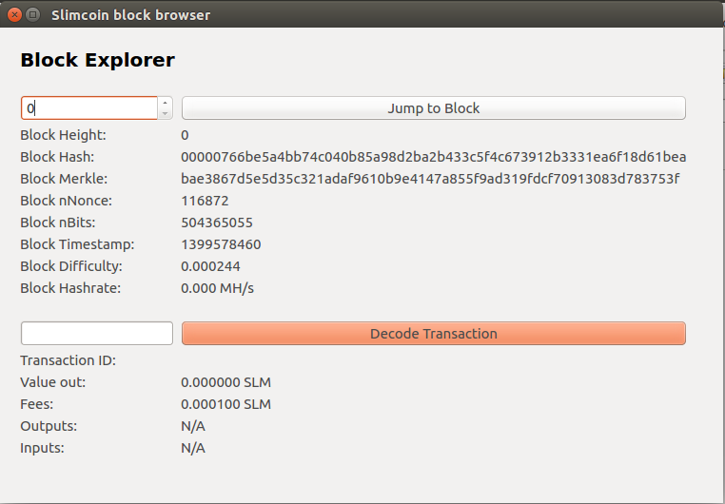

- BurnCoinsDialog
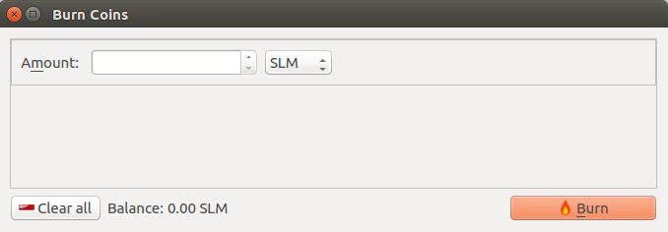

- ChatWindow
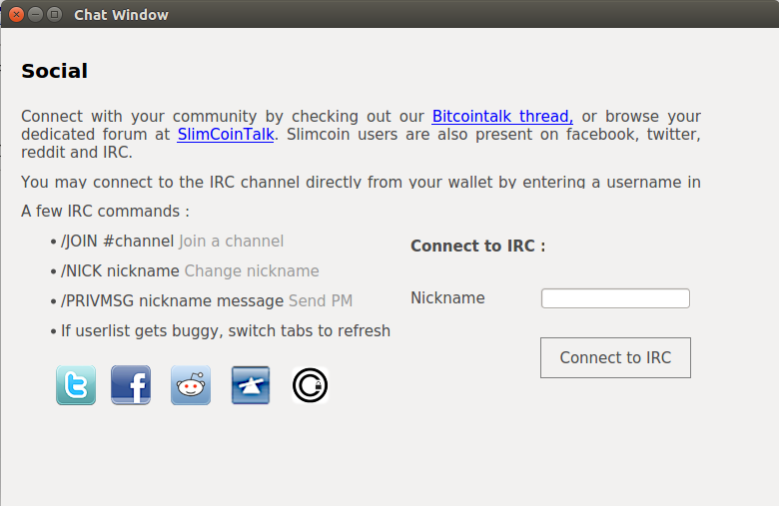

- EncryptDecryptMessageDialog
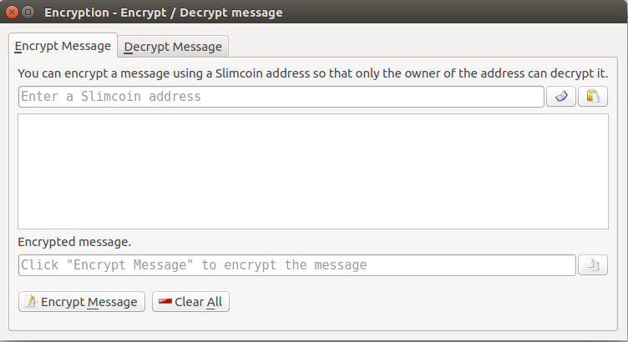

- InscriptionDialog
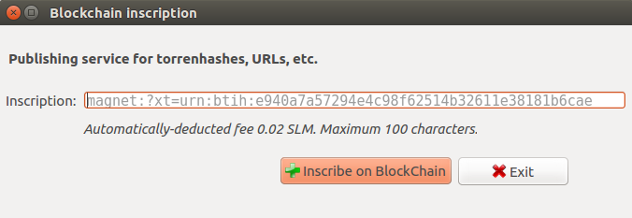

- MiningPage
