# 1. Description

## 1.1. Project

|  |  |
| --- | --- |
| Project Name | MainBoard |
| Board Name | custom |
| Generated with: | STM32CubeMX 5.4.0 |
| Date | 12/14/2019 |

## 1.2. MCU

|  |  |
| --- | --- |
| MCU Series | STM32F4 |
| MCU Line | STM32F407/417 |
| MCU name | STM32F407VETx |
| MCU Package | LQFP100 |
| MCU Pin number | 100 |

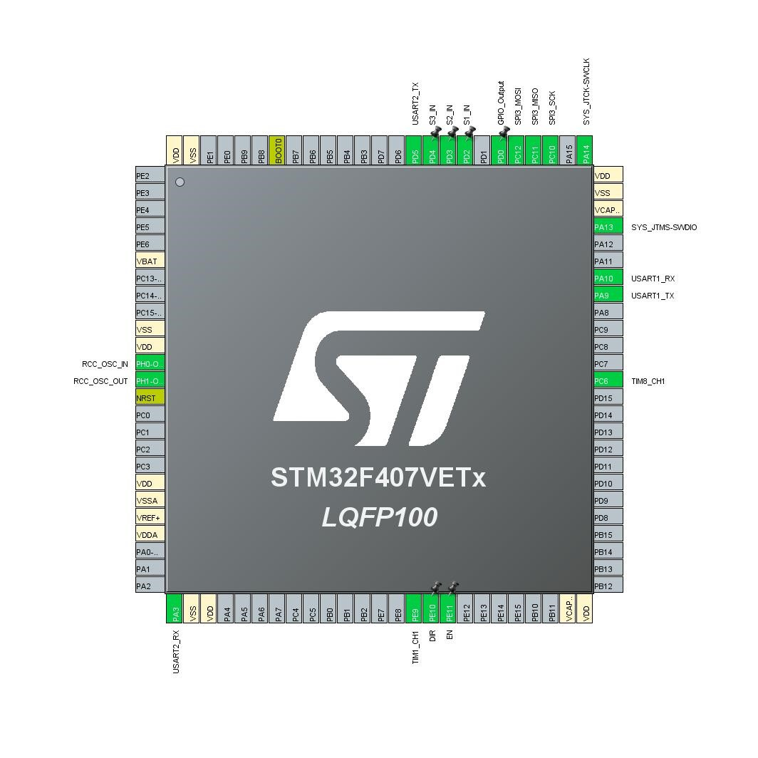***2. Pinout Configuration***

# 3. Pins Configuration

|  |  |  |  |  |
| --- | --- | --- | --- | --- |
| Pin Number  LQFP100 | Pin Name  (function after reset) | Pin Type | Alternate Function(s) | Label |
| 6 | VBAT | Power |  |  |
| 10 | VSS | Power |  |  |
| 11 | VDD | Power |  |  |
| 12 | PH0-OSC_IN | I/O | RCC_OSC_IN |  |
| 13 | PH1-OSC_OUT | I/O | RCC_OSC_OUT |  |
| 14 | NRST | Reset |  |  |
| 19 | VDD | Power |  |  |
| 20 | VSSA | Power |  |  |
| 21 | VREF+ | Power |  |  |
| 22 | VDDA | Power |  |  |
| 26 | PA3 | I/O | USART2_RX |  |
| 27 | VSS | Power |  |  |
| 28 | VDD | Power |  |  |
| 40 | PE9 | I/O | TIM1_CH1 |  |
| 41 | PE10 * | I/O | GPIO_Output | DIR |
| 42 | PE11 * | I/O | GPIO_Output | EN |
| 49 | VCAP_1 | Power |  |  |
| 50 | VDD | Power |  |  |
| 63 | PC6 | I/O | TIM8_CH1 |  |
| 68 | PA9 | I/O | USART1_TX |  |
| 69 | PA10 | I/O | USART1_RX |  |
| 72 | PA13 | I/O | SYS_JTMS-SWDIO |  |
| 73 | VCAP_2 | Power |  |  |
| 74 | VSS | Power |  |  |
| 75 | VDD | Power |  |  |
| 76 | PA14 | I/O | SYS_JTCK-SWCLK |  |
| 78 | PC10 | I/O | SPI3_SCK |  |
| 79 | PC11 | I/O | SPI3_MISO |  |
| 80 | PC12 | I/O | SPI3_MOSI |  |
| 81 | PD0 * | I/O | GPIO_Output |  |
| 83 | PD2 * | I/O | GPIO_Input | S1_IN |
| 84 | PD3 * | I/O | GPIO_Input | S2_IN |
| 85 | PD4 * | I/O | GPIO_Input | S3_IN |
| 86 | PD5 | I/O | USART2_TX |  |
| 94 | BOOT0 | Boot |  |  |
| 99 | VSS | Power |  |  |
| Pin Number  LQFP100 | Pin Name  (function after reset) | Pin Type | Alternate Function(s) | Label |
| 100 | VDD | Power |  |  |

* The pin is affected with an I/O function

# 4. Clock Tree Configuration

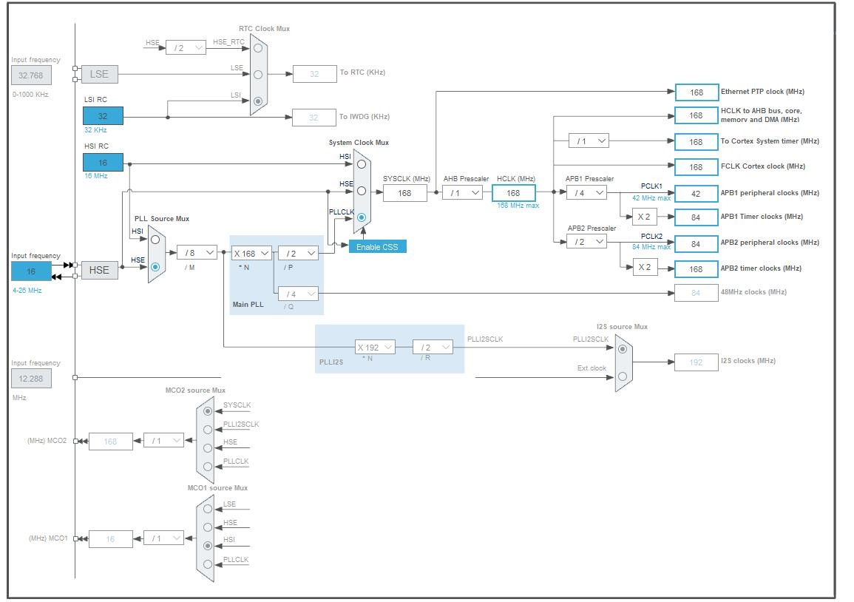

# 5. Software Project

## 5.1. Project Settings

|  |  |
| --- | --- |
| Name | Value |
| Project Name | MainBoard |
| Project Folder | C:\Users\User\YandexDisk\MainBoard_FreeRTOS |
| Toolchain / IDE | MDK-ARM V5.27 |
| Firmware Package Name and Version | STM32Cube FW_F4 V1.24.1 |

## 5.2. Code Generation Settings

|  |  |
| --- | --- |
| Name | Value |
| STM32Cube MCU packages and embedded software | Copy all used libraries into the project folder |
| Generate peripheral initialization as a pair of '.c/.h' files | No |
| Backup previously generated files when re-generating | No |
| Delete previously generated files when not re-generated | Yes |
| Set all free pins as analog (to optimize the power consumption) | No |

# 6. Power Consumption Calculator report

6.1. Microcontroller Selection

|  |  |
| --- | --- |
| Series | STM32F4 |
| Line | STM32F407/417 |
| MCU | STM32F407VETx |
| Datasheet | 022152_Rev8 |

6.2. Parameter Selection

|  |  |
| --- | --- |
| Temperature | 25 |
| Vdd | 3.3 |

# 7. IPs and Middleware Configuration

***7.1. GPIO***

## 7.2. RCC

**High Speed Clock (HSE): Crystal/Ceramic Resonator**

**7.2.1. Parameter Settings:**

**System Parameters:**

|  |  |
| --- | --- |
| VDD voltage (V) | 3.3 |
| Instruction Cache | Enabled |
| Prefetch Buffer | Enabled |
| Data Cache | Enabled |
| Flash Latency(WS)  **RCC Parameters:** | 5 WS (6 CPU cycle) |
| HSI Calibration Value | 16 |
| HSE Startup Timout Value (ms) | 100 |
| LSE Startup Timout Value (ms)  **Power Parameters:** | 5000 |
| Power Regulator Voltage Scale      ***7.3. SPI3***  **Mode: Full-Duplex Master 7.3.1. Parameter Settings:**  **Basic Parameters:** | Power Regulator Voltage Scale 1 |
| Frame Format | Motorola |
| Data Size | 8 Bits |
| First Bit  **Clock Parameters:** | MSB First |
| Prescaler (for Baud Rate) | **8 \*** |
| Baud Rate | **5.25 MBits/s \*** |
| Clock Polarity (CPOL) | Low |
| Clock Phase (CPHA)  **Advanced Parameters:** | 1 Edge |
| CRC Calculation | Disabled |
| NSS Signal Type | Software |

## 7.4. SYS

**Debug: Serial Wire**

**Timebase Source: TIM2**

## 7.5. TIM1

**Channel1: PWM Generation CH1**

**7.5.1. Parameter Settings:**

**Counter Settings:**

|  |  |
| --- | --- |
| Prescaler (PSC - 16 bits value) | **99 \*** |
| Counter Mode | Up |
| Counter Period (AutoReload Register - 16 bits value ) | **335 \*** |
| Internal Clock Division (CKD) | No Division |
| Repetition Counter (RCR - 8 bits value) | 0 |
| auto-reload preload  **Trigger Output (TRGO) Parameters:** | Disable |
| Master/Slave Mode (MSM bit) | Disable (Trigger input effect not delayed) |
| Trigger Event Selection | Reset (UG bit from TIMx_EGR) |

**Break And Dead Time management - BRK Configuration:**

BRK State Disable

BRK Polarity High

**Break And Dead Time management - Output Configuration:**

|  |  |
| --- | --- |
| Automatic Output State | Disable |
| Off State Selection for Run Mode (OSSR) | Disable |
| Off State Selection for Idle Mode (OSSI) | Disable |
| Lock Configuration  **PWM Generation Channel 1:** | Off |
| Mode | PWM mode 1 |
| Pulse (16 bits value) | 0 |
| Output compare preload | Enable |
| Fast Mode | Disable |
| CH Polarity | High |
| CH Idle State | Reset |

## 7.6. TIM8

**Channel1: PWM Generation CH1**

**7.6.1. Parameter Settings:**

**Counter Settings:**

|  |  |
| --- | --- |
| Prescaler (PSC - 16 bits value) | **9 \*** |
| Counter Mode | Up |
| Counter Period (AutoReload Register - 16 bits value ) | **1679 \*** |
| Internal Clock Division (CKD) | No Division |
| Repetition Counter (RCR - 8 bits value) | 0 |
| auto-reload preload  **Trigger Output (TRGO) Parameters:** | Disable |
| Master/Slave Mode (MSM bit) | Disable (Trigger input effect not delayed) |
| Trigger Event Selection | Reset (UG bit from TIMx_EGR) |

**Break And Dead Time management - BRK Configuration:**

BRK State Disable

BRK Polarity High

**Break And Dead Time management - Output Configuration:**

|  |  |
| --- | --- |
| Automatic Output State | Disable |
| Off State Selection for Run Mode (OSSR) | Disable |
| Off State Selection for Idle Mode (OSSI) | Disable |
| Lock Configuration  **PWM Generation Channel 1:** | Off |
| Mode | PWM mode 1 |
| Pulse (16 bits value) | 0 |
| Output compare preload | Enable |
| Fast Mode | Disable |
| CH Polarity | High |
| CH Idle State      ***7.7. USART1***  **Mode: Asynchronous 7.7.1. Parameter Settings:**  **Basic Parameters:** | Reset |
| Baud Rate | **9600 \*** |
| Word Length | 8 Bits (including Parity) |
| Parity | None |

|  |  |  |  |
| --- | --- | --- | --- |
| Stop Bits  **Advanced Parameters:** | | 1 | |
| Data Direction | | Receive and Transmit | |
| Over Sampling      ***7.8. USART2***  **Mode: Asynchronous 7.8.1. Parameter Settings:**  **Basic Parameters:** | | 16 Samples | |
| Baud Rate | | **9600 \*** | |
| Word Length | | 8 Bits (including Parity) | |
| Parity | | None | |
| Stop Bits  **Advanced Parameters:** | | 1 | |
| Data Direction | | Receive and Transmit | |
| Over Sampling      ***7.9. FREERTOS***  **Interface: CMSIS_V2 7.9.1. Config parameters:**  **API:** | | 16 Samples | |
| FreeRTOS API **Versions:** | | CMSIS v2 | |
| FreeRTOS version | | 10.0.1 | |
| CMSIS-RTOS version **Kernel settings:** | | 2.00 | |
| USE_PREEMPTION | | Enabled | |
| CPU_CLOCK_HZ | | SystemCoreClock | |
| TICK_RATE_HZ | | 1000 | |
| MAX_PRIORITIES | | 56 | |
| MINIMAL_STACK_SIZE | | 128 | |
| MAX_TASK_NAME_LEN | | 16 | |
| USE_16_BIT_TICKS | | Disabled | |
| IDLE_SHOULD_YIELD | | Enabled | |
| USE_MUTEXES | | Enabled | |
| USE_RECURSIVE_MUTEXES | Enabled |
| USE_COUNTING_SEMAPHORES | Enabled |
| QUEUE_REGISTRY_SIZE | 8 |
| USE_APPLICATION_TASK_TAG | Disabled |
| ENABLE_BACKWARD_COMPATIBILITY | Enabled |
| USE_PORT_OPTIMISED_TASK_SELECTION | Disabled |
| USE_TICKLESS_IDLE | Disabled |
| USE_TASK_NOTIFICATIONS | Enabled |
| RECORD_STACK_HIGH_ADDRESS  **Memory management settings:** | Disabled |
| Memory Allocation | Dynamic / Static |
| TOTAL_HEAP_SIZE | 15360 |
| Memory Management scheme  **Hook function related definitions:** | heap_4 |
| USE_IDLE_HOOK | Disabled |
| USE_TICK_HOOK | Disabled |
| USE_MALLOC_FAILED_HOOK | Disabled |
| USE_DAEMON_TASK_STARTUP_HOOK | Disabled |
| CHECK_FOR_STACK_OVERFLOW | Disabled |

**Run time and task stats gathering related definitions:**

|  |  |
| --- | --- |
| GENERATE_RUN_TIME_STATS | Disabled |
| USE_TRACE_FACILITY | Enabled |
| USE_STATS_FORMATTING_FUNCTIONS **Co-routine related definitions:** | Disabled |
| USE_CO_ROUTINES | Disabled |
| MAX_CO_ROUTINE_PRIORITIES  **Software timer definitions:** | 2 |
| USE_TIMERS | Enabled |
| TIMER_TASK_PRIORITY | 2 |
| TIMER_QUEUE_LENGTH | 10 |
| TIMER_TASK_STACK_DEPTH | 256 |

**Interrupt nesting behaviour configuration:**

LIBRARY_LOWEST_INTERRUPT_PRIORITY 15

LIBRARY_MAX_SYSCALL_INTERRUPT_PRIORITY 5

**7.9.2. Include parameters:**

**Include definitions:**

vTaskPrioritySet Enabled uxTaskPriorityGet Enabled

vTaskDelete Enabled

|  |  |
| --- | --- |
| vTaskCleanUpResources | Disabled |
| vTaskSuspend | Enabled |
| vTaskDelayUntil | Enabled |
| vTaskDelay | Enabled |
| xTaskGetSchedulerState | Enabled |
| xTaskResumeFromISR | Enabled |
| xQueueGetMutexHolder | Enabled |
| xSemaphoreGetMutexHolder | Disabled |
| pcTaskGetTaskName | Disabled |
| uxTaskGetStackHighWaterMark | Enabled |
| xTaskGetCurrentTaskHandle | Disabled |
| eTaskGetState | Enabled |
| xEventGroupSetBitFromISR | Disabled |
| xTimerPendFunctionCall | Enabled |
| xTaskAbortDelay | Disabled |
| xTaskGetHandle | Disabled |

**\* User modified value**

# 8. System Configuration

## 8.1. GPIO configuration

|  |  |  |  |  |  |  |
| --- | --- | --- | --- | --- | --- | --- |
| IP | Pin | Signal | GPIO mode | GPIO pull/up pull  down | Max Speed | User Label |
| RCC | PH0-  OSC_IN | RCC_OSC_IN | n/a | n/a | n/a |  |
| PH1-  OSC_OUT | RCC_OSC_OUT | n/a | n/a | n/a |  |
| SPI3 | PC10 | SPI3_SCK | Alternate Function Push Pull | No pull-up and no pull-down | **Very High**  **\*** |  |
| PC11 | SPI3_MISO | Alternate Function Push Pull | No pull-up and no pull-down | **Very High**  **\*** |  |
| PC12 | SPI3_MOSI | Alternate Function Push Pull | No pull-up and no pull-down | **Very High**  **\*** |  |
| SYS | PA13 | SYS_JTMS-  SWDIO | n/a | n/a | n/a |  |
| PA14 | SYS_JTCK-  SWCLK | n/a | n/a | n/a |  |
| TIM1 | PE9 | TIM1_CH1 | Alternate Function Push Pull | No pull-up and no pull-down | **High \*** |  |
| TIM8 | PC6 | TIM8_CH1 | Alternate Function Push Pull | No pull-up and no pull-down | **Very High**  **\*** |  |
| USART1 | PA9 | USART1_TX | Alternate Function Push Pull | Pull-up | **Very High**  **\*** |  |
| PA10 | USART1_RX | Alternate Function Push Pull | Pull-up | **Very High**  **\*** |  |
| USART2 | PA3 | USART2_RX | Alternate Function Push Pull | Pull-up | **Very High**  **\*** |  |
| PD5 | USART2_TX | Alternate Function Push Pull | Pull-up | **Very High**  **\*** |  |
| GPIO | PE10 | GPIO_Output | Output Push Pull | No pull-up and no pull-down | Low | DIR |
| PE11 | GPIO_Output | Output Push Pull | No pull-up and no pull-down | **Medium \*** | EN |
| PD0 | GPIO_Output | Output Push Pull | No pull-up and no pull-down | Low |  |
| PD2 | GPIO_Input | Input mode | No pull-up and no pull-down | n/a | S1_IN |
| PD3 | GPIO_Input | Input mode | No pull-up and no pull-down | n/a | S2_IN |
| PD4 | GPIO_Input | Input mode | No pull-up and no pull-down | n/a | S3_IN |

## 8.2. DMA configuration

nothing configured in DMA service

## 8.3. NVIC configuration

|  |  |  |  |
| --- | --- | --- | --- |
| Interrupt Table | Enable | Preenmption Priority | SubPriority |
| Non maskable interrupt | true | 0 | 0 |
| Hard fault interrupt | true | 0 | 0 |
| Memory management fault | true | 0 | 0 |
| Pre-fetch fault, memory access fault | true | 0 | 0 |
| Undefined instruction or illegal state | true | 0 | 0 |
| System service call via SWI instruction | true | 0 | 0 |
| Debug monitor | true | 0 | 0 |
| Pendable request for system service | true | 15 | 0 |
| System tick timer | true | 15 | 0 |
| TIM2 global interrupt | true | 0 | 0 |
| USART2 global interrupt | true | 6 | 0 |
| PVD interrupt through EXTI line 16 |  | unused |  |
| Flash global interrupt |  | unused |  |
| RCC global interrupt |  | unused |  |
| TIM1 break interrupt and TIM9 global interrupt |  | unused |  |
| TIM1 update interrupt and TIM10 global interrupt |  | unused |  |
| TIM1 trigger and commutation interrupts and  TIM11 global interrupt |  | unused |  |
| TIM1 capture compare interrupt |  | unused |  |
| USART1 global interrupt |  | unused |  |
| TIM8 break interrupt and TIM12 global interrupt |  | unused |  |
| TIM8 update interrupt and TIM13 global interrupt |  | unused |  |
| TIM8 trigger and commutation interrupts and  TIM14 global interrupt |  | unused |  |
| TIM8 capture compare interrupt |  | unused |  |
| SPI3 global interrupt |  | unused |  |
| FPU global interrupt |  | unused |  |

**\* User modified value**

# 9. Software Pack Report