**Retention of Medicare Patients: Approaches for Federally-Qualified Health Centers**

Stephane Labossiere, M.S., 1 Christopher Lindeman, MBA.2

**Abstract**

**Objectives:** The objective of this study is to address the barriers that U.S. Medicare patients face to have access to healthcare services in Federally-Qualified Health Centers (FQHCs), including quality geriatric care, for patients in their local community. **Methods:** We useddata collected through anonymous internal and external surveys of pre-Medicare and Medicare-eligible adults ages 50 and older. Internal surveys were distributed to every patient upon check-in at the CHN Lower East Side and Washington Heights sites in New York City. **Result:** A unique population has been identified which demands further investigation.  Survey results indicate a variety of needs to be met to improve the adequacy of care of these patients.

**Discussion: Conclusion:** Follow-up with a properly randomized study to determine a more accurate scope and scale for the needs of the population. Considerations for this study are provided.

**Keywords:** Medicare, Aging, FQHCs, Geriatric patients, determinants of health

1 Johns Hopkins University, MD, USA

2 West Texas A&M University, TX, USA

**BACKGROUND**

Access to healthcare services for Medicare patients remains a public health issue and little is known for beneficiaries who use FQHCs (Chang, 2016). In 1989, Congress established the Federally Qualified Health Centers (FQHCs) program with the objective of supporting community health centers with primary care services delivery in low-income areas (Centers for Medicare and Medicaid, 2018). FQHCs are based on the FQHC Prospective Payment System (PPS) for medically necessary primary health services and qualified preventive health services furnished by an FQHC professional (CMCS, 2018). By 2011, the number of FQHCs exceeded 5000 in the United States (Chang, 2016); the number of Medicare beneficiaries seen at FQHCs experienced a dramatic increase between 2001 to 2011 (from 745,000 to nearly 1.6 million) (Russel, 2019) . Older adults from low socioeconomic status (SES) often have higher difficulty tapping into much needed, life-sustaining health care. (Bennet et al. 2009; Ponce, 2006). According to the State of Aging and Health in America (SOA, 2013), the aging population of Americans aged sixty-five years or older will double during the next 25 years to about 72 million. Moreover, by 2030, older adults will account for roughly twenty percent of the U.S. population (SOA, 2013). Thus, it is important to link Medicare patients to services provided by FQHCs not only to insure that they are receiving proper treatment or referral to specialty care, but also FQHCs depend on Medicare patients for their operation and sustainability (CMS, 2013, Chang, 2016). Due to the mandated comprehensive care Medicare beneficiaries receive during their visits, FQHCs are capable of detecting and preventing health problems early because they offer a unique opportunity for patients to receive comprehensive, coordinated care in their communities (Leos, 2012). Functioning as a “one-stop shop” for health care needs, FQHCs may potentially be an ideal place for older adults to receive quality geriatric care. Although there has been a number of studies focusing on populations under age 65 (Falik et al., 2001, McClaskey EL., 2010, Bhatia P, 2013), there is little research on the topic. There is no study of older adults who rely on FQHC services from a population-based perspective (Chang, 2016). Medicare patients suffering from multiple chronic diseases, unable to access FQHCs in their communities, or seek specialty care are some examples of public health issues older adults may face over the years. Research has shown that many Americans who survive to age 65 can expect to need and use long-term services and supports (LTSS) with an average cost of $138,000 in future LTSS costs (HHS, 2016). Therefore, the purpose of this article is to address the barriers that Medicare patients face to have access to healthcare services in their community. Since it is crucial to understand characteristics and service use of Medicare beneficiaries who use FQHCs, this article will make recommendations for federally qualified health centers to consider when proposing, implementing, or designing geriatric care programs.

**METHODOLOGY**

In the United States, community health centers provide primary care for 1 in 7 Medicaid enrollees (Gao et al., 2017) However, FQHCs alone may not meet the  KLNFEBOIHBOIFE

It is indisputable that the sample group is representative of not the general population, but a specific sub-group, namely a particularly vulnerable population of community health center patients in New York City.  In comparing socioeconomic factors with the national average, we can see a stark lack of education in the sample, we can see that the population that this sample represents faces several challenges.

**STATISTICS**

The data consists of categorical responses to a survey questionnaire with asample size *N=124*. The data was transformed from an Excel file provided by Survey Monkey into a Pandas DataFrame for analysis. The study is on a cross-sectional survey where respondents were chosen from a convenience sampling of patients at three local community health centers in New York City.  The design of the questionnaire has yielded nominal data of interest, and some ordinal data that shows little importance.

It is of utmost importance that the statistical analysis be prefaced by the following:

Due to the nature of the convenience sampling from just 3 health centers, we cannot infer proper randomness in our sample, and as such we have not accurately identified a population to which we are able to generalize our findings. Nonetheless, further investigation of the patients of community health centers is warranted, and while our findings may be limited, they show some interesting and important aspects to consider for future research.

The design of the questionnaire included categorical and ordinal response questions which were binned prior to conducting the survey, nullifying its usefulness in quantitative analysis. As the primary purpose of this survey was to aid in investigation, there is great potential for a follow-up survey on a similar sample with new questions designed to measure the degree of effect of these concerns.

An alpha value of 0.05 was considered significant in determining similarity when compared with the general population of the United States. Statistical analysis was performed using modules in the Python v. 3.7. Jupyter notebook files containing the exploratory data analysis, along with the survey data can be found at the GitHub repository for the work (Lindeman, 2020).

**Target Study Population**

Our internal and external surveys targeted adults aged 50-64, identifying the specific health care needs, concerns, and utilization trends of Medicare-eligible and pre-Medicare patients. Our findings resulted in practical solutions Community Healthcare Network (CHN) may consider when proposing, implementing, or designing geriatric care programs for older adults. These recommendations may also apply for other similar clinics and health centers in the United States. The recommendations serve as an opportunity to address gaps in care and identify actionable and innovative ways in which geriatric health services can be delivered.

Of the questions posed to our sample, many bring interesting insights into particular hurdles that affect our respondents. Significant deviations from the overall US population were observed, identifying particular challenges to this population.

**Racial Bias**

Our sample is overwhelmingly skewed towards the Hispanic patients. The racial makeup of our sample differs strongly from the general population (*U.S. Census Bureau QuickFacts: United States*, n.d.).

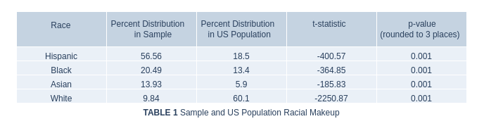

**Education**

The most striking characteristic of our sample is the undeniably low educational achievement across all categories. In comparing the education of the sample with that of the US population, a new DataFrame was created from the answers to the question ‘What is your highest level of education?’. This returned an array for each category, which we compared with the US national statistics on education from March 1995 (Day & Curry, 1996). The choice of using such an old dataset is a naive way to help control for the increase in education across the general population, and the assumption that the sample attained its peak education before the age of 25 years. It is worth noting that according to the 1995 data, metropolitan residents are significantly more likely (82.9% vs. 76.9%) to have at least completed high school, along with having attained a bachelor’s degree (25% vs. 14.8%) when compared with non-metropolitan residents, further indicating the comparatively uneducated nature of our sample.

The result of comparing education levels yielded a significant difference from the national average. The sample population has a dramatically higher incidence of having not completed high school, and significantly lower incidence of education across all other levels. This is further confirmed by a one-sample t test, resulting in *p<α*, indicating that the sample is significantly different from the greater population.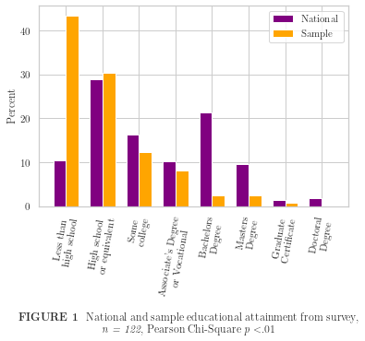

**Disease Incidence**

The incidence of disease within the sample shows no significant similarity to the US population at large, though a particularly higher incidence of both diabetes and high blood pressure should be noted. The

lower incidence of chronic kidney disease, COPD, IBD, IBS, and vertigo is unexplained, and without statistics on the incidence of disease for this particular age group, we expect limited power in extrapolation of the data.

In attempting to find similarity with national averages, 1-sample t-tests were performed on incidence of seven conditions against US general population data from various sources (*Diabetes Statistics*, n.d.; *Estimated Hypertension Prevalence, Treatment, and Control Among U.S. Adults | Million Hearts®*, n.d.; *FastStats - Heart Disease*, n.d.(CDC, 2019; *Estimated Hypertension Prevalence, Treatment, and Control Among U.S. Adults | Million Hearts®*, n.d.)(*COPD Prevalence among Adults by Smoking Status U.S. 2017 | Statista*, n.d.). While three of the results were representative of the general population, four were significantly different.

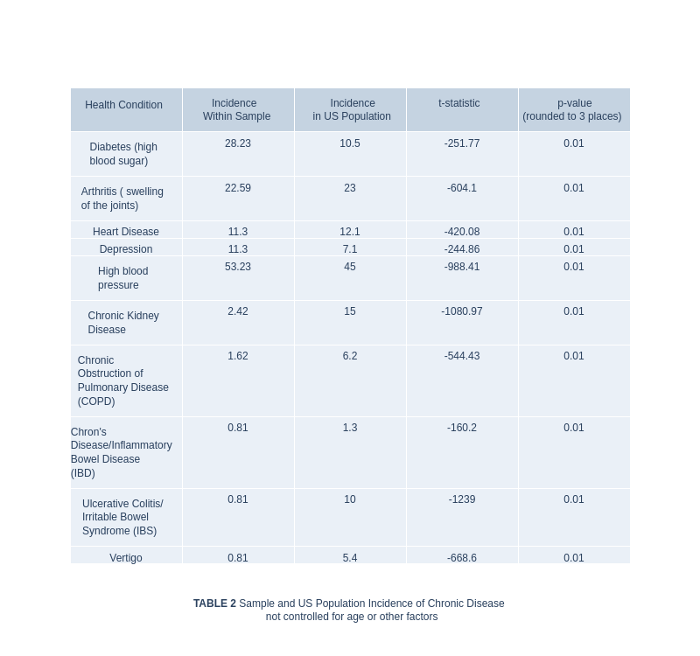

**Factors in Choice**

Considering the desires of patients is essential in providing care. The survey asks for respondents to list those concerns important to them in choosing a provider. There are 11 answers to choose from, and respondents are encouraged to check all that apply. Over 85% of respondents indicated that the location and language of the provider was important in choosing a provider. This may indicate that patients have limited access to choose providers, as accessibility and comprehension are necessary for effective care. It is equally possible that this need is being met but is nonetheless a concern for patients and should be followed up with clearer questions regarding their access to providers who speak the patient’s primary language.

Without considering the general logistical concerns of location and speaking the same language (109 and 107 responses), we see several interesting concerns, particularly those of cost of care (and insurance), as well as convenience issues that may indicate necessity for some patients, such as evening and weekend hours, and the ability to receive primary and specialty treatment at the same facility.  The primary consideration here is that the difference between convenience and necessity is the resources available to the person concerned, and factors such as transportation or other assistance may be limited or restricted to weekend or evening hours.

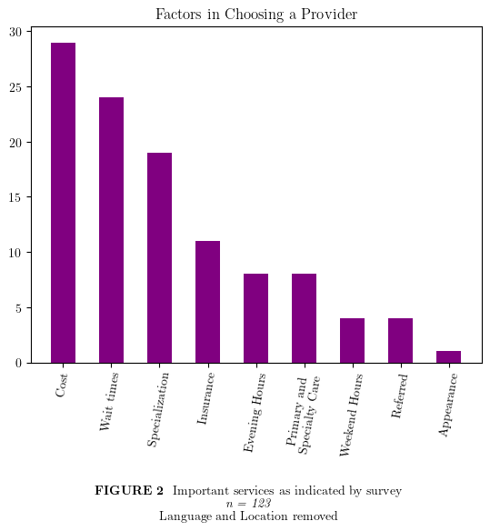

***Analysis***

We lack any external validity due to the nature of the sampling methodology and no comparative population upon which to identify acceptable means.

**LIMITATIONS**

***Categorical Responses***

By presenting the survey answers as categorical, this was primarily a fact-finding mission. The responses we’ve recorded give us insight into concerns within the population that warrant further investigation. Without quantitative data, establishing a concrete baseline for the efficacy of any intervention is highly limited.  Additionally, binning survey answers in the collection process nullifies the power of the quantitative variables.

**Uniqueness**

The study provides insight to unmet needs in a community health center patient cohort.  This information is essential to understand service demand and increase awareness of these shortfalls.  Nonetheless, limitations need to be recognized; the estimates of incidence rates come from a relatively small sample, due to limitations in design and access to participants.

That said, this preliminary data highlights some unmet needs in the community and deserves further investigation on a larger scale, preferably with access to diagnosis reports from official sources.

Comparing the sample to the national average obscures the impact of the results as the age, race, and ethnicity of the sample are not representative of the national population. Further, sampling only from community health centers in NYC means that our population for generalization must be limited to community health center patients in NYC. This is an area of importance for CHN in particular but should not be extrapolated.  The data exists to draw more useful conclusions, which are not accompanied with this study.

**Recommendation**:

A more well-designed questionnaire could aid in greater insights from the data, particularly regarding discrete variables. For instance, attempting to regress binned data, such as age group 55-64, leaves enough room for error that either a much larger sample would be needed, or it would be practically useless. The same goes for the number of visits respondents have made in the past year. Ideally, answers that are numeric should be obtained as a numeric answer. Clarification of some answers should be provided by offering alternative answers, such as ‘other’, as in the case of the chronic conditions question.

Answers of preference are of value in identifying problems experienced by the sample, however we cannot assume that these conditions and concerns can be applied to a wider community writ large without being able to *identify the larger population more precisely*.

**DISCUSSION**

Some questions to consider (these are just suggestions) and provide recommendations based on the overall paper:

1. How can CHN address patients in need of LTSS (long-term services and supports)
2. How can community health centers address these financial barriers, averaging $138,000? (*Long-Term Services and Supports for Older Americans: Risks and Financing Research Brief | ASPE*, n.d.)
3. How can the AHRQ Quality Indicators—Guide to Prevention Quality Indicators: Hospital Admission for Ambulatory Care Sensitive Conditions be used to assist community health centers based on the data of this study (*AHRQ Quality Indicators Guide to Prevention Quality Indicators: Hospital Admission for Ambulatory Care Sensitive Conditions*, 2001)
4. State 2-3 points regarding further research as it relates to this study (Chris).

***Will come from complete analysis of the information***

A more thorough identification of the population as a whole will be essential in determining the robustness of any inquiry into the needs of a sample of said population: that of geriatric CHN patients. This can be achieved by acquiring a truly random sample selection from the population. By administering the survey to a proper sample we can be assured that it is representative of the population and will be able to more accurately assess the value of implementing treatments to the provide services.

In the follow-up study, survey questions should be modified to produce the most robust data, particularly by allowing for free-response answers to questions with a reasonable expectation of response. For instance, in querying the age of patients (Q18), we understand that a free response will yield an integer which creates a condition amenable to further quantitative analysis, yet allows for categorization (e.g. senior, adult, child) if desired. The following questions from the original survey should be re-framed to allow for free responses:

2, 3, 18

Questions that ask for the most important factor should not allow for multiple responses from the same respondent, as in Q6. This question (6) is of particular interest as it identifies potential shortfalls in the current system and should certainly be investigated further. We propose that 4 new questions are posed in place of Q6:

1. “Which of these are most important to you when choosing a doctor?” (choose 1)

2. “Are any of the following also important to you when choosing a doctor?” (choose many)

3. “Which, if any, of the services you’ve identified are not being met?” (choose many from selection)

4. “Which unmet need is most distressing for you as a patient?” (choose 1 from selection)

In this way we will be able to identify the most important considerations for each participant, identify unmet needs, and identify other, possibly important but less urgent, needs that CHN patients have.

35% of respondents state that they are most likely to get help with a health problem at the emergency room. Greater clarification would be highly valuable in determining whether this is a result of greater incidence of injury in the sample or if some other factor is causing patients to seek treatment at emergency departments (ED). While visits to the ED of persons over age 65 is 56,803 per 100,000 in the general US population (*Trends in Hospital Emergency Department Visits by Age and Payer, 2006-2015 #238*, n.d.), this does not specify that ED visits are a source of primary care, or that these are unique visitors. The EDs, especially in overwhelmed circumstances like the current COVID-19 pandemic, benefit from any treatment that would reduce unnecessary visits, such as for checkups and general care, so further investigation of this issue may be valuable in freeing up ED resources.

**RECOMMENDATIONS**

Supporting community health centers (CHCs) and their services for patients—especially older adults—are essential for rural and inner-city communities. CHCs are often prepared to provide culturally-appropriate health care at little to no cost to patients accessing these services (Leos, 2012).

The following points are some lessons learned from the implementation of CHN Geriatric program:

1. **Medication Intake:** Internal data show the program may help in reducing patients’ medication intake. With the assistance of the nursing staff members, patients were able to follow proper doses and avoid taking the wrong prescriptions.
2. **Marketing Healthcare Services:** CHN and many community health centers in New York City offer a myriad of health care services and programs in addition to primary care. However, even though patients utilizing the resources had access to other multidisciplinary doctors (e.g., foot doctor, dentist, eye doctors), many did not use other services. Due to low health literacy, some patients did not understand the importance of certain services that are beneficial for their overall health and well-being. Thus, a continuum effort to mail brochures and employ other marketing strategies are important for being current and future patients.
3. **Glucose Machine Usage:** Some patients were not aware of how to use glucose machines and/or may not be aware of that option. Some diabetes patients did not know how to use glucose machines. To solve this issue at CHN, brochures and provide patients ample opportunities to use these innovative methods for monitoritation under the supervision of a health care provider.
4. **Documentation:**  Proper documents and build rapport The nurse was able to follow-up and get referrals from their health providers. Moreover, files of patients were scanned and added to the patient's file.
5. **Language Barrier:** Hiring staff and/or ensuring this is accessible to interpretive services should be part of any new programs.
6. **Privacy:** Assuring there is a space that ensures patients’ privacy is critical. This is important especially for open spaces (e.g., computer labs, cafeteria, etc).

**CONCLUSION**

**(Stephane & Chris)**

**ACKNOWLEDGMENT**

  We are grateful to several staff at Community Healthcare Network (CHN) including

  We also wish to acknowledge the contributions of the survey respondents, who made this study possible through their participation in the external.

**DECLARATION OF CONFLICTING INTERESTS:** The authors declared no potential conflicts of interest with respect to the research, authorship, and/or publication of this article.

**FUNDING:** This study was funded by the Samuels grant, **Grant #**. The findings and conclusions presented here are those of the authors and do not necessarily represent the views of the Samuel’s

**REFERENCES (20-25)**

*AHRQ Quality Indicators Guide to Prevention Quality Indicators: Hospital Admission for Ambulatory Care Sensitive Conditions*. (2001). www.ahrq.gov

CDC. (2019). *Chronic Kidney Disease in the United States, 2019*.

*COPD prevalence among adults by smoking status U.S. 2017 | Statista*. (n.d.). Retrieved August 5, 2020, from https://www.statista.com/statistics/1019926/copd-prevalence-among-adults-us-by-smoking-status/

Day, J., & Curry, A. (1996). *Current Population Characteristics Population Reports Educational Attainment in the United States: March 1995*.

*Diabetes Statistics*. (n.d.). Retrieved August 5, 2020, from https://www.diabetesresearch.org/diabetes-statistics

*Estimated Hypertension Prevalence, Treatment, and Control Among U.S. Adults | Million Hearts®*. (n.d.). Retrieved August 5, 2020, from https://millionhearts.hhs.gov/data-reports/hypertension-prevalence.html

*FastStats - Heart Disease*. (n.d.). Retrieved August 5, 2020, from https://www.cdc.gov/nchs/fastats/heart-disease.htm

Gao, Y. N., Nocon, R. S., Sharma, R., & Huang, E. S. (2017). What factors are associated with medicaid patients’ use of health centers? *Journal of Primary Care and Community Health*, *8*(3), 141–146. https://doi.org/10.1177/2150131916687919

Lindeman, C. (2020). *cwl21/CHN_2020*. https://github.com/cwl21/CHN_2020

*Long-Term Services and Supports for Older Americans: Risks and Financing Research Brief | ASPE*. (n.d.). Retrieved August 5, 2020, from https://aspe.hhs.gov/basic-report/long-term-services-and-supports-older-americans-risks-and-financing-research-brief

*Trends in Hospital Emergency Department Visits by Age and Payer, 2006-2015 #238*. (n.d.). Retrieved August 5, 2020, from https://www.hcup-us.ahrq.gov/reports/statbriefs/sb238-Emergency-Department-Age-Payer-2006-2015.jsp

*U.S. Census Bureau QuickFacts: United States*. (n.d.). Retrieved August 5, 2020, from https://www.census.gov/quickfacts/fact/table/US/PST045219

**APPENDIX**