Need from Stephane:

Sampling method {**probabilistic:** random [simple random, stratified random (proportional or disproportional), cluster random, systemic], **non-probabilistic** [convenience (***most likely***), quota, purposive (expert’s choice), snowball]}

DEFINING:

Cross-Sectional study

n = 124

(several uncontrolled variables may demand higher n)

To Perform:

Power analysis (estimate likelihood of type 2 error or estimating n requirements)

PA reduces type 2 error (rejection of true H_a)

prob of type 2 error = beta

1-beta = P(rejecting H_0 and statistically significant result)

Testing the difference between 2 means (t-test) - gamma g for small effects g = .20; medium effects g = .50; large effects g = .80

NEEDS:

population variance for each condition to perform Power Analysis.

**Exploratory Data Analysis**

This cross-sectional survey was performed by convenience sampling of patients at LGKJHGULGU . The non-random nature of the sample leaves much to be desired, though some important insights were gleaned from analyzing the data from respondents answers. Among those are concerns in availability and accessibility of treatment, along with a high incidence of several health factors, which may be exacerbated by inference based on other answers.

Of the 124 participants, 70.16% have been diagnosed with a chronic illness, with high blood pressure (HBP) being the most common (53.23% of all participants). While walking and light exercise are recommended to help alleviate the symptoms of many of these diseases **(*insert reference here*)**, a majority of the respondents **(*insert percent when data is clean)***, when asked how they get to appointments responded with public transportation of walking. Rather than being a result of intentional exercise, this appears to be more of a necessity than a choice and deserves further investigation. The coincidence of walking or public transportation with a chronic condition is 70.96% (**DATA IS BAD HERE)**. This highlights a particularly vulnerable segment of the population. To further compound the concerns, the sample shows an exceptionally significant lack of education when compared with national averages. Understanding that educational attainment in the US has grown significantly, over the past decades, we compare the education levels of our sample against the distribution of the US in 1995 as a more accurate comparison. (<https://www.google.com/url?sa=t&rct=j&q=&esrc=s&source=web&cd=&ved=2ahUKEwi9gL311_rpAhXjsDEKHdXxAe8QFjACegQIDBAD&url=https%3A%2F%2Fwww.census.gov%2Fprod%2F2%2Fpop%2Fp20%2Fp20-489.pdf&usg=AOvVaw1YQdO4ToH5JC1gOGBdpnP9>)

Even with these measures, the sample shows that the sample population is dramatically under-educated.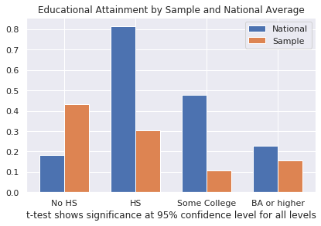

Survey Results

The health center survey was completed by 124 individuals. (completed is a loaded word in this study). Respondents were from 3 community health centers. The age of respondents was 45-54 = 0.81%; between 55 and 64 = 11.38%; 65+ = 87.80%. The race of the respondents was Hispanic = 55.65%; Black = 20.16%; Asian = 13.71%; White = 9.68%; Another race = 1.61%. Education levels were particularly interesting, as the breakdown is as follows:

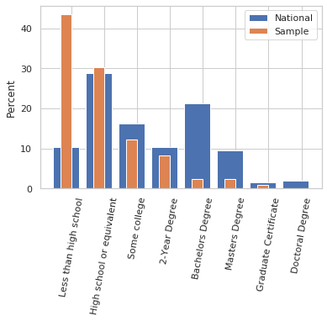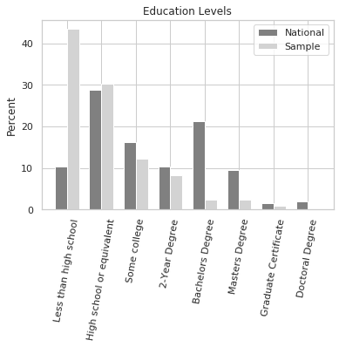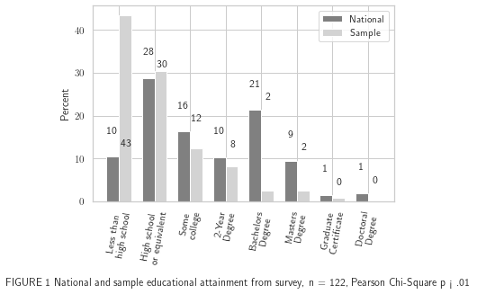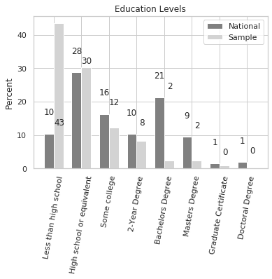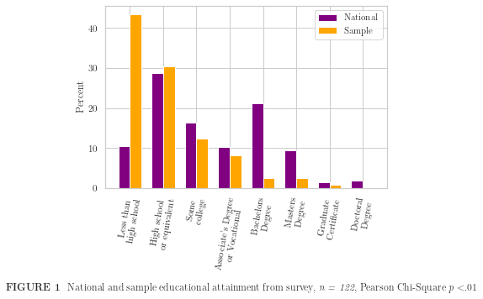

CONSIDERATIONS IN CHOICE

When asked about respondents’ most important considerations in choosing a doctor, responses were quite varied. *Respondents were allowed to choose multiple responses to this question*. Location was identified as the most prominent consideration at 88.62%. Following that were that the doctor speaks the same language as the respondent at 86.99%. Categorizing the answers into broader buckets

|  |  |  |  |  |
| --- | --- | --- | --- | --- |
| Access | Need | Cost | Convenience | Other |

we can see that Access is by far the most important consideration. Further reduction of answers is considered to highlight those attributes which would be considered for any service.

Eliminating cost-related answers, convenience-related answers, specialization, location, language, appearance and recommendation, we have two related and important considerations to address; whether the doctor has weekend or evening hours (totaling 9.75%).

OVERALL HEALTH ***None = None of the Above or None at All?***

Participants were asked whether they were diagnosed with any of several chronic health conditions. 165 responses were recorded that identify a chronic condition, while 37 respondents answered ‘None’. Ambiguity in the answer (‘none at all’ vs. ‘none of the above’) and general self-reporting demands a further investigation.

* Operating under the assumption that ‘None’ means there are no chronic conditions

As all participants answered the question, the results show that across 87 respondents, we have 165 chronic conditions, averaging approximately 2 per person (**Cross-check with main data for outliers)** while 29.84% of the sample can be considered generally healthy. At first glance, this is surprisingly positive data, as the NIH estimates that 85% of older adults suffer from at least one chronic health condition https://www.nia.nih.gov/health/supporting-older-patients-chronic-conditions . As this outcome is counter-intuitive, it may be worth investigating the rate of undiagnosed symptoms among the respondents reporting no chronic conditions.

It has been shown that ‘Among elderly Medicare beneficiaries, significant racial/ethnic differences exist in the diagnosis and treatment of depression. Vigorous clinical and public health initiatives are needed to address this persisting disparity in care.’Racial and Ethnic Disparities in Depression Care in Community-Dwelling Elderly in the United States [Ayse Akincigil](https://ajph.aphapublications.org/author/Akincigil%2C+Ayse) , [Mark Olfson](https://ajph.aphapublications.org/author/Olfson%2C+Mark) , [Michele Siegel](https://ajph.aphapublications.org/author/Siegel%2C+Michele) , [Karen A. Zurlo](https://ajph.aphapublications.org/author/Zurlo%2C+Karen+A) , [James T. Walkup](https://ajph.aphapublications.org/author/Walkup%2C+James+T) , and [Stephen Crystal](https://ajph.aphapublications.org/author/Crystal%2C+Stephen) . This suggests that several respondents are likely to proceed without diagnosis to depression, possibly accounting for the lower incidence of chronic conditions reported to the survey.

**Limitations**

The study provides insight to unmet needs in a community health center patient cohort. This information is essential to understand service demand and increase awareness of these shortfalls. Nonetheless, limitations need to be recognized; the estimates of incidence rates come from a relatively small sample, due to limitations in design and access to participants. Another limitation of the study is that of self-reporting error, as well as ambiguity in the questionnaire.

That said, this preliminary data highlights some unmet needs in the community and deserves further investigation on a larger scale, preferably with access to diagnosis reports from official sources.