***Preface***

Our internal and external surveys targeted adults aged 50-64, identifying the specific health care needs, concerns, and utilization trends of Medicare-eligible and pre-Medicare patients. Our findings resulted in practical solutions Community Healthcare Network (CHN) may consider when proposing, implementing, or designing geriatric care programs for older adults. These recommendations may also apply for other similar clinics and health centers in the United States. The recommendations serve as an opportunity to address gaps in care and identify actionable and innovative ways in which geriatric health services can be delivered.

It is of utmost importance that the statistical analysis be prefaced by the following:

Due to the nature of the convenience sampling from just 3 health centers, we cannot infer proper randomness in our sample, and as such we have not accurately identified a population to which we are able to generalize our findings. Nonetheless, further investigation of the patients of community health centers is warranted, and while our findings may be limited, they show some interesting and important aspects to consider for future research.

***Description of Sample***

Of the questions posed to our N=124 sample, many bring interesting insights into particular hurdles that affect our respondents. Significant deviations from the overall US population were observed, identifying particular challenges to this sub-population.

**Racial Bias**

Our sample is overwhelmingly skewed towards the Hispanic patients. The racial makeup of our sample differs strongly from the general population.

<https://www.census.gov/quickfacts/fact/table/US/PST045219>← US population data from census for racial makeup

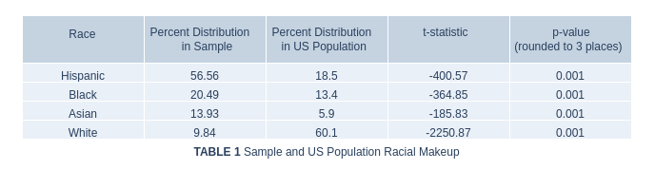

**Education** *N=122*

The most striking characteristic of our sample is the undeniably low educational achievement across all categories. In comparing the education of the sample with that of the US population, a new DataFrame was created from the answers to the question ‘What is your highest level of education?’ using the get_dummies function. This returned an array for each category, which we compared with the US national statistics on education from March 1995[Curry, Day. ‘Educational Attainment in the United States: March 1995’. *Current Population Reports.* Census Bureau p 20-489. published August 1996]. The choice of using su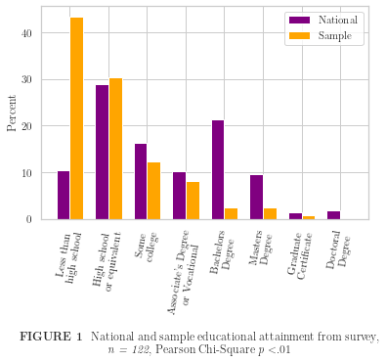ch an old dataset is a naive way to help control for the increase in education across the general population, and the assumption that the sample attained its peak education before the age of 25 years. Any educational attainment after age 25 would present as unexpectedly high educational attainment among the sample group. It is worth noting that according to the 1995 data, metropolitan residents are significantly more likely (82.9% vs. 76.9%) to have at least completed high school, along with having attained a bachelor’s degree (25% vs. 14.8%) when compared with non-metropolitan residents, further indicating the comparatively uneducated nature of our sample.

The result of comparing education levels yielded a significant difference from the national average. The sample population has a dramatically higher incidence of having not completed high school, and significantly lower incidence of education across all other levels. This is further confirmed by a one-sample t test, resulting in *p<α*, indicating that the sample is significantly different from the greater population.

**Disease Incidence**

The incidence of disease within the sample shows no significant similarity to the US population at large, though a particularly higher incidence of both diabetes and high blood pressure should be noted. Th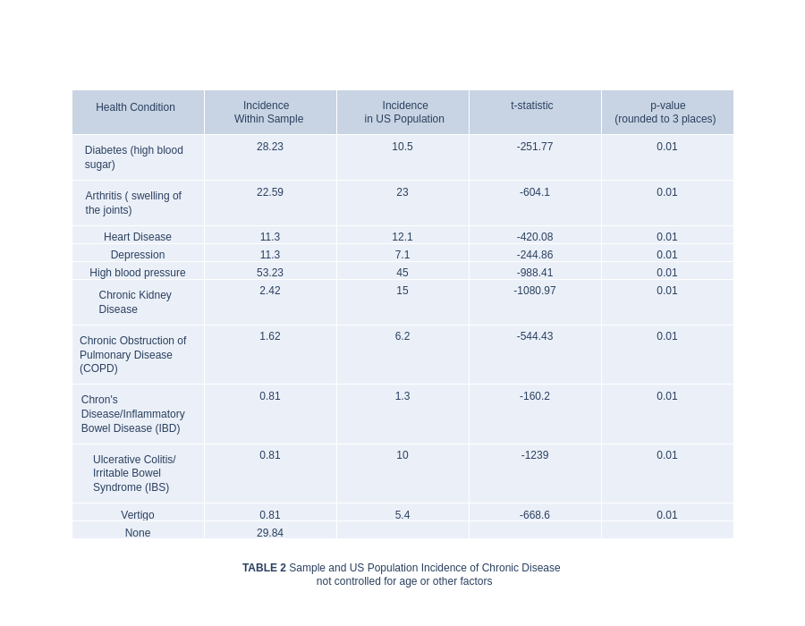e lower incidence of chronic kidney disease, COPD, IBD, IBS, and vertigo is unexplained.

**Factors in Choice** *N=123*

Considering the desires of patients is essential in providing care. The survey asks for respondents to list those concerns important to them in choosing a provider. There are 11 answers to choose from, and respondents are encouraged to check all that apply. Over 85% of respondents indicated that the location and language of the provider was important in choosing a provider. This may indicate that patients have limited access to choice in providers, as accessibility and comprehension are necessary for effective care. It is equally possible that this need is being met, but is nonetheless a concern for patients and should be followed up with clearer questions regarding their access to providers who speak the patient’s primary language.

*Access/Transportation covariance*

*Cost/Insurance covariance (correlate education?)*