Statistics

The data consists of categorical responses to a survey questionnaire with a sample size N=124 overall. The data was transformed from (FILL IN HOW THE DATA IS PROVIDED BY SURVEYMONKEY) into a Pandas DataFrame for analysis. The study is on a cross-sectional survey where respondents were chosen from a convenience sampling of patients three local community health centers in New York City. The data is categorical and primary nominal, answering questions about personal experiences and dispositions.

The design of the questionnaire included ordinal questions which were binned prior to conducting the survey, nullifying its usefulness in ordinal analysis. As the primary purpose of this survey was to aid in investigation, there is great use for designing a follow-up survey on a similar population with new questions designed to measure the degree of BLKJFALKUJGHSAF concerns.

An alpha value of 0.05 was considered significant in determining similarity of incidences when compared with the general population of the United States. We performed statistical analysis using the following modules in the Python programming language (version 3.7):

*Pandas v.1.0.3 *Numpy v.1.18.1 *Matplotlib v.3.1.3 *Seaborn v.0.10.1 *Scipy v.1.4.1 *Plotly v.4.8.1

Education (N=122)
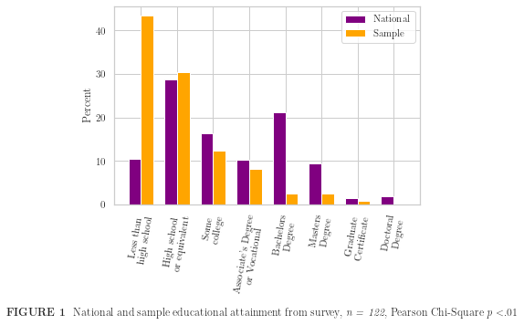
In comparing the education of the sample with that of the US population, a new DataFrame was created from the answers to the question ‘What is your highest level of education?’ using the get_dummies function. This returned an array for each category, which we compared with the US national statistics on education from March 1995[Curry, Day. ‘Educational Attainment in the United States: March 1995’. Current Population Reports. Census Bureau p 20-489. published August 1996]. The choice of using such an old dataset was a naive attempt to help control for the increase in education across the general population, and the assumption that the sample attained its peak education before the age of 25 years. Any educational attainment after age 25 would present as unexpectedly high educational attainment among the sample group. It is worth noting that according to the 1995 data, metropolitan residents are significantly more likely (82.9% vs. 76.9%) to have at least completed high school, along with having attained a bachelor’s degree (25% vs. 14.8%) when compared with non-metropolitan residents.

The result of comparing education levels yielded significant difference from the national average. The sample population has a dramatically higher incidence of having not completed high school, and significantly lower incidence of education across all other levels. This is further confirmed by a one-sample t test, resulting in p<α, indicating that the sample is significantly different from the greater population.

Importance in Choice (N=123)
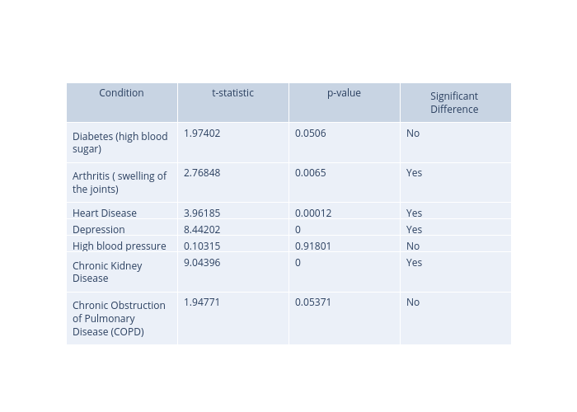
Considering the desires of patients is essential in providing care. The survey asks for respondents to list those concerns important to them in choosing a provider. There are 11 answers to choose from, and respondents are encouraged to check all that apply. Over 85% of respondents indicated that the location and language of the provider was important in choosing a provider. This may indicate that patients have limited access to choice in providers, as accessibility and comprehension are necessary for effective care.

Analysis
In attempting to find similarity with national averages, 1-sample t-tests were performed on incidence of seven conditions against data from various sources^{[listed in the python files]}. While three of the results were representative of the general population, four were significantly different.

Limitations

Categorical Responses
By presenting the survey answers as categorical, this was primarily a fact-finding mission. The responses we’ve recorded give us insight into concerns within the population that warrant further investigation.

Self-reporting error
As with any survey, gathering the information directly from individuals may leave out some relevant answers, such as

Uniqueness
This is a very unique population, the findings of whom will not translate directly to the greater population. The racial makeup and education attainment of this sample are not representative of a population that we have recognized. Further, the incidence of diseases varies widely when compared with national statistics.

References (not properly cited above):

https://www.diabetesresearch.org/diabetes-statistics
https://www.cdc.gov/chronicdisease/resources/publications/factsheets/arthritis.htm
https://www.cdc.gov/nchs/fastats/heart-disease.htm
https://www.dbsalliance.org/education/depression/statistics/
https://www.google.com/url?sa=t&rct=j&q=&esrc=s&source=web&cd=&cad=rja&uact=8&ved=2ahUKEwjIwo_p9u7pAhVYmHIEHaDMDV0QFjAOegQIARAB&url=https%3A%2F%2Fmillionhearts.hhs.gov%2Fdata-reports%2Fhypertension-prevalence.html&usg=AOvVaw1BGjT0NggEl2CG5y-YK_3B
https://www.cdc.gov/kidneydisease/publications-resources/2019-national-facts.html
https://www.statista.com/statistics/1019926/copd-prevalence-among-adults-us-by-smoking-status/

