Screw It Pro
Integrated Assembly & Logistics Platform
Development Proposal
Phase 1 MVP Scope, Investment & Maintenance
March 2026
Prepared for: Travis Wade & Monique Crayton
Prepared by: Sydney Sanders, Preeminent Professional Services

1. Executive Summary
This proposal outlines the scope, investment, and maintenance plan for the Screw It Pro Phase 1 MVP platform. The platform consists of one web application with four role-based interfaces, a shared database, and a unified order lifecycle that supports the complete Screw It Pro business model: customer books, admin manages, technician assembles, driver picks up and delivers.
This proposal reflects adjustments made through collaborative discussions to focus the MVP on what is needed to run real orders with pilot customers in one metro area, while establishing a clear path to Phase 2 enhancements.

Total Investment (Phase 1) | $6,500
Monthly Retainer (Post-Launch) | $50/month (Maintenance Retainer) + hosting paid directly by Screw It Pro. Active Care triggered at volume per §6.
Payment Structure | Milestone-based (30% / 25% / 25% / 20%)
Interfaces | 4 role-based views (Customer, Admin, Technician, Driver) within 1 web application
Payment Processor | Stripe (confirmed)
Tech Stack | Next.js, Supabase (database, auth, storage), Stripe, transactional email
Code Ownership | All code, data, and proprietary materials transfer to Screw It Pro upon receipt of the Milestone 4 payment and written acceptance of the Launch & Handover deliverables, as defined in §4.

2. Investment Breakdown by Component
The following table shows what each component of the $6,500 investment covers. All components are part of a single web application with a shared database and order lifecycle.

Component | Cost | % | What It Covers
Landing Page + Static FAQ | $350 | 5.4% | Marketing front door: hero section, How It Works flow, service area, call-to-action, SEO setup, analytics tracking, static FAQ page
Customer Experience (Portal + Loyalty/Rewards) | $1,800 | 27.7% | Everything the customer touches: account creation, login, booking flow, Stripe payment checkout, order tracking across 8+ statuses, email notifications, order history, loyalty points (accrual on orders, sign-up bonus, points ledger in profile)
Operations Hub (Admin Dashboard + Pickup Workflow) | $2,100 | 32.3% | Command center for your team: order management, full lifecycle control (8+ statuses including pickup), technician/driver assignment, manual inbound tracking, damage photo uploads, delivery scheduling, Stripe payment/invoice tracking, photo management, and filterable order views per §3.3
Field Team Tools (Technician + Driver Views) | $1,050 | 16.2% | Mobile-friendly views within the same web application. Technicians: see assigned jobs, upload assembly photos, mark complete. Drivers: see assigned pickups/deliveries, tap for Google Maps, upload proof of pickup/delivery photos, mark Delivered or Refused. Both sync back to the Admin Dashboard.
Platform Foundation (Database, Auth, Payments, Email, Storage) | $1,100 | 16.9% | What connects everything: database design (20+ tables), role-based auth for 4 user types, data protection so each role only sees their own information, Supabase storage for all photo uploads, Stripe checkout/webhooks/invoicing, transactional email with templates and triggers, deployment configuration
Documentation & Handover | $100 | 1.5% | Architecture overview, data model documentation, how-to guides so another developer could maintain the platform if needed
TOTAL | $6,500 | 100%

Important: This is one web application, not four separate builds. All four interfaces share the same URL, the same database, and the same codebase. The cost reflects the development effort for each user experience within that single application.

3. Detailed Feature List by Component

3.1 Landing Page + Static FAQ
- Hero section with clear value proposition
- How It Works overview (Shop, Ship to Hub, We Assemble, We Deliver)
- Service area / city focus for initial launch region
- Call-to-action (Book Now / Get Started)
- Static FAQ page addressing common customer questions
- SEO setup: meta titles and descriptions optimized for search, Open Graph tags for social media sharing, semantic HTML structure, image optimization with alt tags, sitemap.xml and robots.txt configured for search engine crawling
- Google Analytics connected for traffic tracking

3.2 Customer Experience (Portal + Loyalty/Rewards)
- Email-based account registration and secure login
- Submit new assembly requests (furniture details, retailer links, tracking number, notes)
- Choose from available delivery windows
- Pay deposits or full charges through Stripe checkout
- View payment status (Paid / Pending)
- View current and past orders
- Track order status across the full lifecycle: Awaiting Arrival, Boxes Received, In Assembly, Assembly Completed, Ready for Delivery, Out for Delivery, Delivered
- View assembly photos once items are completed at the hub
- Receive email notifications on every status change
- Loyalty/Rewards: points accrual on completed orders, sign-up bonus for marketing campaigns, points ledger visible in customer profile

3.3 Operations Hub (Admin Dashboard)
- View all orders with status filters
- See customer details, notes, and payment status per order
- Step orders through the full lifecycle (8+ status states including pickup)
- Log tracking numbers / retailer confirmations (manual inbound tracking)
- Manually match incoming boxes to customer orders, mark Boxes Received
- Upload inbound photos (damaged boxes, torn packaging) to order records
- Flag orders for review if damage is visible at intake
- Assign assembly jobs to specific technicians
- Assign drivers for both pickup and delivery legs
- Set delivery/pickup date and time per order
- Set the price for each job
- Trigger payment links / invoices through Stripe
- View payment status (Paid / Pending / Unpaid)
- View and review photos uploaded by technicians and drivers
- View customer loyalty points and order history

Reporting in Phase 1
Reporting in Phase 1 is limited to filterable order views and payment status columns. Dedicated reporting (charts, exports, performance analytics) is Phase 2.
Available filters and columns in Phase 1:
- Filter orders by status (Awaiting Arrival, Boxes Received, In Assembly, Assembly Completed, Ready for Delivery, Out for Delivery, Delivered, Refused)
- Filter orders by date range (created, completed, delivered)
- Filter orders by assigned technician or driver
- Filter orders by payment status (Paid, Pending, Unpaid)
- Column: order ID, customer, status, assigned tech, assigned driver, payment status, total, created date, delivery date
- Column: photo attachment indicators (assembly photo present, delivery photo present, damage photo present)

3.4 Field Team Tools (Technician + Driver Views)
Both views are accessed through the same web application on a phone browser. No app download required. No App Store involvement.
Technician View:
- Role-based login (technician sees only the technician interface)
- View list of jobs assigned by admin
- See item details, customer notes, and admin notes per job
- Upload completed assembly photos from phone camera via browser
- Mark job as complete (status syncs to Admin Dashboard)
Driver View:
- Role-based login (driver sees only the driver interface)
- View assigned pickups and deliveries
- See customer address, notes, and time window per assignment
- Tap address to open Google Maps for navigation
- Upload proof of pickup/delivery photos from phone camera via browser
- Mark as Delivered or Refused (status syncs to Admin Dashboard and Customer Portal)

3.5 Platform Foundation
- Database schema design (20+ tables covering users, roles, orders, statuses, jobs, deliveries, photos, payments, tracking, loyalty points)
- Role-based authentication for 4 user types (customer, admin, technician, driver)
- Data protection policies ensuring each role only sees and accesses their own information
- Supabase Storage for all photo uploads across interfaces
- Stripe integration: checkout sessions, payment links, invoices, webhook handling, payment status tracking
- Transactional email service with templates and triggers on status changes
- Deployment and hosting configuration
- SEO infrastructure: auto-generated sitemap, structured data markup (LocalBusiness schema for Google search results), page speed optimization across all public-facing pages
- Database designed for Phase 2 expansion (no rebuild required when adding features)

3.6 Documentation & Handover
- Architecture overview: what was built, how the system is structured
- Data model documentation: tables, relationships, and what each stores
- User guide / how-to documentation for platform operation
- Credential handover: all accounts, keys, and access transferred
- All source code stored in a private GitHub repository. GitHub is a secure, industry-standard platform used to store, track, and manage software code. Every change made to the platform is recorded and accessible.
- Training walkthrough with the Screw It Pro team

4. Payment Schedule
Payments are milestone-based and tied to demonstrated progress. You see working software before you pay at each stage.

 | Amount | Milestone | What You See Before Paying
30% | $1,950 | Project Kickoff | Landing page live, database and infrastructure built, Stripe connected, auth system configured for all 4 roles
25% | $1,625 | Core Development Complete | Customer Portal and Admin Dashboard working end to end with internal demo. Booking, payment, order tracking, assignments, status lifecycle, loyalty points all functional.
25% | $1,625 | MVP Ready for Pilot | All 4 role-based views functional. Full lifecycle testable end to end: customer books, admin assigns, tech assembles, driver picks up/delivers. Stripe payments processing. Email notifications firing.
20% | $1,300 | Launch & Handover | Deployed to production. All P0/P1 bugs resolved per §4 acceptance criteria below. Documentation delivered. Training walkthrough complete. All credentials and access transferred.

Milestone 4 Acceptance Criteria
Milestone 4 release requires resolution of all P0/P1 bugs (defined as: prevents core lifecycle from functioning, blocks payment processing, or exposes data across roles). P2/P3 bugs and UX refinements are tracked and addressed in the Maintenance Retainer post-handover.
UX Refinement Scope at Milestone 4
UX refinements in Milestone 4 are limited to: copy edits, color/spacing adjustments, button placement, and form field tweaks on screens already built. Any request introducing new screens, flows, data fields, or logic is a change order under §11.

5. Projected Timeline
The following timeline reflects the revised scope and current project availability. Target months are provided rather than fixed dates to allow flexibility as the project progresses. Development begins upon signing and receipt of Milestone 1 payment.

Milestone | Target | What Gets Done
1. Project Kickoff | End of May / June 2026 | Landing page goes live (first 1-2 weeks). Database schema designed and built (20+ tables). Supabase configured. Stripe account connected with webhook handling. Transactional email service configured. Branding and design system established.
2. Core Development | July 2026 | Customer Portal fully functional. Admin Dashboard fully functional. Internal demo of both systems working end to end.
3. MVP Ready for Pilot | August 2026 | Technician and Driver views functional within the web application. Full order lifecycle testable end to end. Stripe payments processing with real checkout. Email notifications firing on all status changes.
4. Launch & Handover | September 2026 | Deployed to production. P0/P1 bugs resolved per §4. Documentation delivered. Training walkthrough with Travis and Monique. All credentials, accounts, and source code access transferred.

The landing page is the first deliverable and will be live within 1-2 weeks of project kickoff. This gives Screw It Pro a public presence while the core platform is being built.
Monthly retainer ($50/month) begins after Milestone 4 is complete and handover is accepted. Hosting costs are owned and paid directly by Screw It Pro to the respective providers.
Client Responsibility Delay Provisions
If Screw It Pro fails to deliver any client responsibility under §9 within 5 business days of written request, the active milestone deadline extends by one business day for each day of delay. Cumulative delays exceeding 20 business days trigger a project pause and reactivation fee equal to 10% of remaining milestones.

6. Monthly Maintenance & Support
After launch, the monthly retainer keeps the platform maintained and functional. This is separate from the $6,500 build investment. The retainer begins after Milestone 4 (Launch & Handover) is complete, not during the build.

$50/month Maintenance Retainer
Post-launch platform maintenance. Paid to developer for time and expertise.
- Security patches and dependency updates
- Bug fixes for Phase 1 features
- Minor UX refinements (for features built in Phase 1)
- FAQ updates
- SEO monitoring and meta tag updates as the business learns what customers search for
- Monthly check-in

Hosting Infrastructure (paid directly by Screw It Pro)
Screw It Pro owns and pays all hosting accounts directly to the respective providers. These are separate from the maintenance retainer.

Service | Est. Cost | Purpose
Supabase | ~$25/month | Database, authentication, and file storage for all photo uploads
Vercel | ~$20/month | Application hosting and deployment
n8n | ~$25/month | Workflow automation and email notifications

Projected Hosting Costs at Scale
As platform volume grows, hosting costs increase. The following estimates reflect what Screw It Pro can expect to pay directly to providers at each stage.

Volume | Supabase | Vercel | n8n | Est. Total
Launch (0-100 orders/mo) | ~$25 | ~$20 | ~$25 | ~$70/mo
Growth (100-500 orders/mo) | ~$50 | ~$40 | ~$50 | ~$140/mo
Scale (500+ orders/mo) | ~$75 | ~$60 | ~$100 | ~$235/mo

Estimates are based on current provider pricing and may vary based on actual usage, photo volume, and traffic patterns.

Active Care
Active Care covers the additional monitoring, scaling, and edge-case work that surfaces at higher order volume.
- Everything in the Maintenance Retainer
- Active database health monitoring (performance tuning, query optimization, storage management)
- Increased security monitoring for a growing user base and higher payment volume
- Priority response on edge cases that surface at scale
- Feature enhancements based on real customer usage patterns
- Infrastructure scaling guidance and implementation
Active Care Trigger
When the platform processes 100+ orders/month for two consecutive months, either party may trigger Active Care negotiation. If parties have not signed an Active Care agreement within 30 days of the trigger, the Maintenance Retainer terminates and ongoing support is billed hourly at $125/hr until a new agreement is signed.

What Is Not Included (Separate Change Orders)
- New feature development (AI chatbot, full technician/driver portals, advanced analytics, route optimization)
- Third-party integrations (CRM, payroll, additional payment gateways)
- Major UI redesigns or overhauls
- Native mobile app development (iOS/Android)
- Phase 2 feature buildouts

The distinction: if it was built in Phase 1 and it needs a fix, a refinement, or a content update, that is covered by the retainer. If it is a new feature that was not part of Phase 1, that is a separate conversation with separate pricing.

7. Phase 2 & Beyond
The following features are not included in the Phase 1 MVP. They are documented here so both sides have a clear roadmap for future development. Each item will be scoped and priced separately when the business is ready.

Feature | Description
Full Technician Portal | Daily job lists, start/complete workflow with timestamps, quality checklist system, unboxing photo step, damage/exception reporting
Full Driver Portal | Daily route management, signature capture, real-time GPS tracking, route optimization, structured exception handling
AI-Powered Mascot Chatbot | Branded chat interface, natural language Q&A, curated knowledge base, conversation logging for quality review
Automated Inbound Tracking | Scan-and-match system: scan shipping labels, system automatically matches boxes to customer orders and updates status
Time Slot Capacity Management | Define time slots, track capacity per slot for bulky assembled items, prevent overbooking
Advanced Analytics & Reporting | Technician/driver performance tracking, lifecycle time analytics, demand forecasting, exportable CSV/Excel reports, charts and visual dashboards, customer acquisition and retention analytics
Advanced Loyalty & Marketing | Tiered membership plans, referral programs, seasonal campaigns, advanced redemption rules
CRM & Payroll Integrations | Direct integration with HubSpot, Salesforce, ADP, Gusto, QuickBooks, or similar tools
Native Mobile Apps | iOS and Android apps for customers, drivers, or technicians (App Store / Google Play deployment)
Multi-Hub / Multi-City | Cross-location routing, capacity planning, multi-hub operations management

The Phase 1 database is designed with Phase 2 in mind. Adding these features will build on top of the existing foundation, not require a rebuild.

8. Order Lifecycle (End to End)
Every order moves through the following stages. Each status change is visible in the Admin Dashboard. Key changes trigger customer email notifications.

# | Status | Who Acts | What Happens
1 | Order Placed | Customer | Customer submits booking with furniture details, retailer info, and tracking number. Pays deposit or full amount through Stripe. System creates order, sends confirmation email.
2 | Awaiting Pickup / Arrival | Admin | Admin assigns a driver for pickup (if applicable) or awaits direct shipment to hub. Logs tracking numbers on order.
3 | Pickup Complete | Driver | Driver picks up unassembled furniture from customer or receives shipment at hub. Uploads photo, marks boxes received.
4 | Boxes Received | Admin | Admin confirms boxes are at the hub, inspects for damage, uploads damage photos if needed, flags for review if necessary.
5 | In Assembly | Admin / Technician | Admin assigns job to a technician. Technician sees the job on their phone, works on assembly.
6 | Assembly Completed | Technician | Technician uploads completed assembly photo, marks job as done. Admin reviews photo for QA.
7 | Ready for Delivery | Admin | Admin assigns a driver and sets delivery date/time. Customer is notified.
8 | Out for Delivery | Driver | Driver sees delivery on their phone, navigates via Google Maps, places furniture in customer's home.
9 | Delivered / Refused | Driver | Driver uploads proof of delivery photo, marks Delivered or Refused. Status updates across Admin Dashboard, Customer Portal. Customer receives email. Loyalty points accrue.

9. Client Responsibilities
To ensure smooth, on-time delivery, the following items are needed from Screw It Pro:
- Domain name and DNS access
- Email address for client communications (to embed into the notification system)
- Stripe account setup (Screw It Pro creates and owns the Stripe account)
- Branding assets: logo, colors, fonts (or creative discretion given to developer)
- Initial FAQ content (common customer questions and answers)
- Legal or policy content if applicable (Terms of Service, Privacy Policy)
- Timely feedback on designs, flows, and milestones to keep development on schedule
Consequences of Non-Delivery
Failure to provide any item in §9 within 5 business days of request triggers the delay provisions in §5. Items not delivered by Milestone 3 (Stripe account, domain access, branding, FAQ content) entitle PPS to deliver Milestone 4 with reasonable placeholders, satisfying the milestone.

10. Ownership & Intellectual Property
All code, data, and proprietary materials transfer to Screw It Pro upon receipt of the Milestone 4 payment and written acceptance of the Launch & Handover deliverables, as defined in §4. Preeminent Professional Services retains no ownership of the codebase or customer data following transfer.
Deliverables include full source code access via a private GitHub repository, database credentials, hosting account access, Stripe configuration, and documentation sufficient for another developer to understand, maintain, and extend the platform. The GitHub repository includes the complete history of every change made during development, giving full context to any future developer.

11. Agreement
This proposal is valid for 30 days from the date of issuance. Development begins upon signing and receipt of Milestone 1 payment.
Change Orders
Any request for functionality, screens, integrations, or data fields not explicitly listed in §3 is a change order, billed separately, and not started until written approval and a 50% deposit are received.

Screw It Pro  Signature / Date  Printed Name / Title | Preeminent Professional Services  Signature / Date  Printed Name / Title

Appendix A: Application Architecture
The diagram below shows the complete application structure. One web application, one login page, four role-based experiences. Every interface connects to the same shared database and infrastructure.

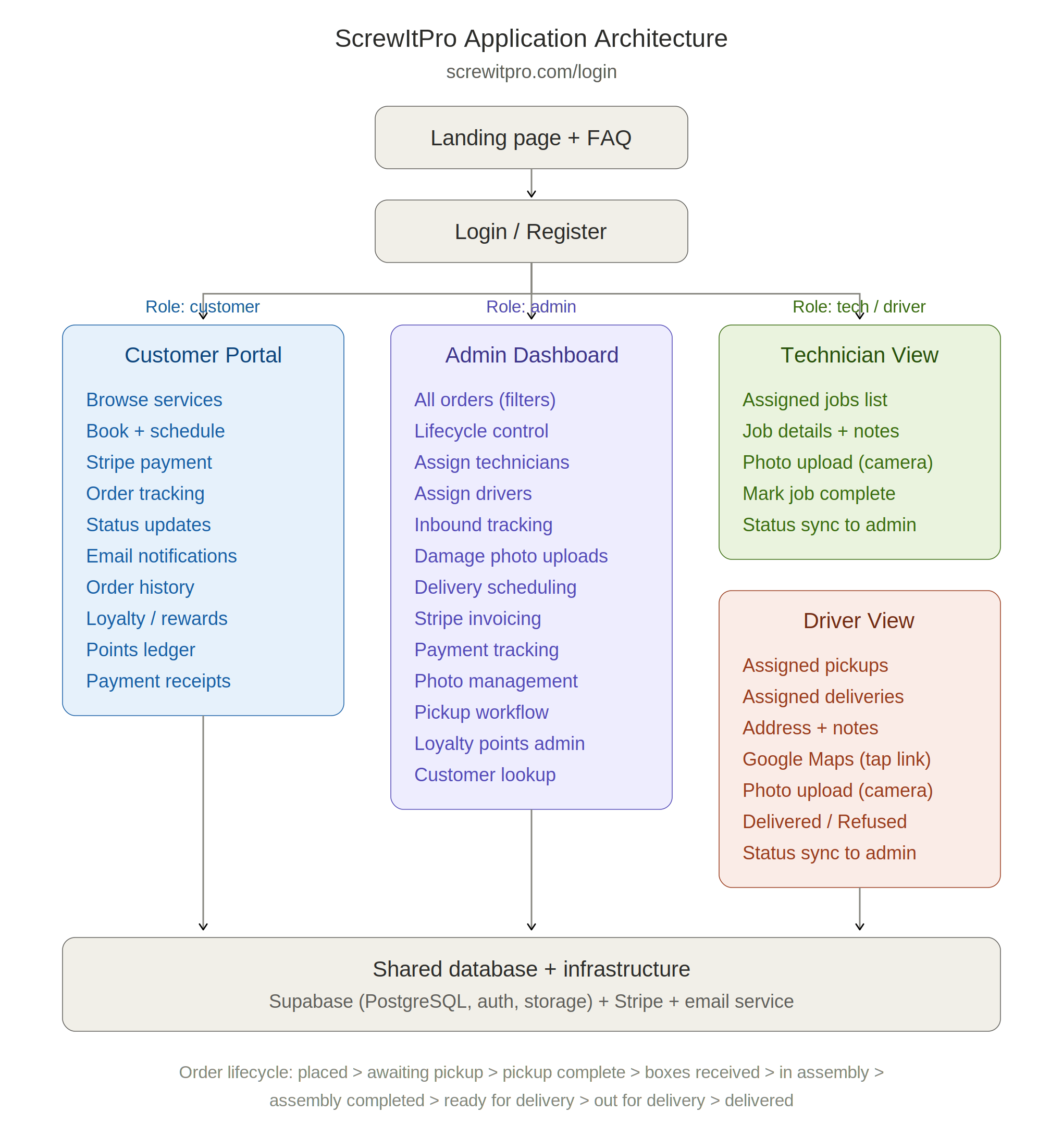

Appendix B: Order Lifecycle
The diagram below shows how a single order moves through the system from booking to delivery. Each stage shows who acts, the status name, and what happens. Every status change syncs across the Admin Dashboard and Customer Portal.

