Green Asian Wok

Web Design Proposal

STATUS  Proposed |  | OWNER  Not assigned |  | LAST UPDATED  10 October 2026

Authors | Codex
Reviewers | Business owner and provider
Related docs | Website audit and three visual concepts
Scope | Customer-facing website and provider handoff

1. Abstract
Green Asian Wok needs a clearer path from choosing food to placing an order. This proposal combines the website audit and review findings with a menu-led frontend, while retaining the existing ordering provider for checkout and fulfilment.
Evidence was collected on 10 October 2026. Three visual concepts are delivered separately. This is a proposed system design, not a shipped website or an assertion about provider capabilities. Operational contacts, schedules and integration access require confirmation.

2. Goals and Non-Goals
Goals | Non-goals
Show useful dishes and prices before ordering | Build a second payment or order ledger
Make contact and hours consistent | Infer service quality from six ratings
Support mobile, keyboard and readable states | Assert dietary or health claims without approval
Verify the provider handoff before release | Assume undocumented provider APIs

3. Background and Problem Statement
The current homepage prioritises a large food banner and app promotion. Desktop ordering then adds a fulfilment page and another banner before dishes. Maps and the site show different phone numbers; collection hours are difficult to interpret across midnight.
Google showed 4.5 stars from six ratings. Four visible written reviews praised flavour, value or portions; the visible two-star rating had no comment. Five individual records were exposed. These limited observations support honest dish discovery, not claims about delivery reliability.

4. Proposed Architecture

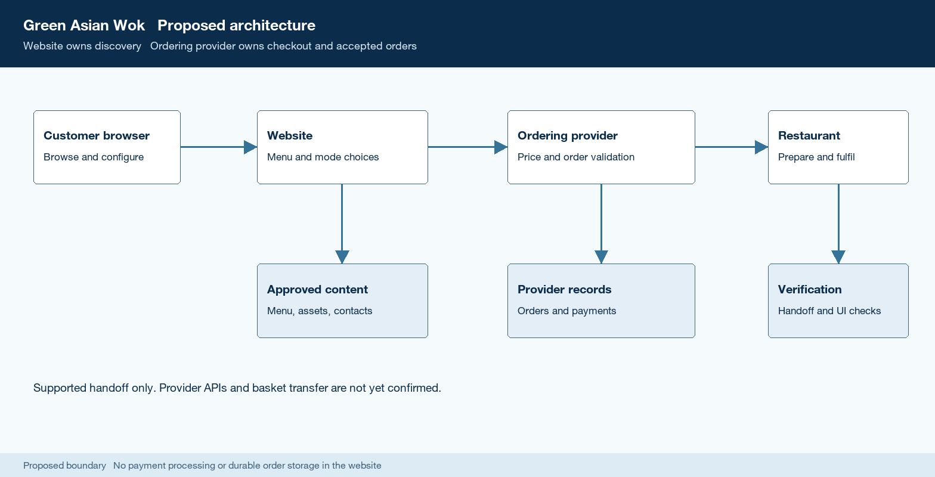
Figure 1. Proposed website and ordering provider boundary.

Core components

Component | Responsibility | Primary storage | Failure behavior
Website UI | Accessible menu, search, mode choice and item options | Static build and content delivery network | Useful error and official ordering route
Menu content | Dish names, prices, allergens and option groups | Versioned business-approved content file | Reject invalid publication and retain approved content
Business record | Contact number, address and day-specific availability | Approved location and schedule record | Hide unconfirmed values and explain unavailable modes
Ordering provider | Current prices, checkout, payment and accepted order status | Existing provider service and order records | No unconfirmed success state or duplicate submission
Verification | Responsive, keyboard, total and supported handoff checks | Aggregate checks and monitoring records | Flag broken order routes and prevent unsafe release

5. Request Lifecycle
- A customer opens the homepage or menu. Browsing should work without an account or address; delivery and collection are explicit choices.
- The frontend validates required item options and quantities. The provider validates current availability, service area and final prices at checkout.
- Load a business-approved menu version, contact record and day-specific schedule. Treat unconfirmed operational data as unpublished.
- Show dishes, prices and allergen information. Selecting a dish opens options and an updated total before adding it to the basket.
- Store only a transient basket if supported. The provider remains responsible for durable order and payment records.
- Handoff through a supported provider route. If an integration is unavailable, use its official ordering page and make that transition clear.
- Only provider-confirmed success represents an accepted order. Measure menu engagement and successful handoff without recording personal payloads.

6. API and Data Contracts

Primary data contract

Field | Type | Required | Description
item_id | string | Yes | Stable provider or approved internal identifier
name | string | Yes | Business-approved dish name
category | string | Yes | One category from the menu taxonomy
price_minor | integer | Yes | Non-negative cents; options are separate
currency | enum | Yes | EUR for this location
allergens | array | Yes | Approved labels; empty only if verified
options | array | Yes | Required/optional groups and surcharges

Contract guarantees

- Validate the menu contract before publication; reject missing prices, ambiguous currency and unapproved allergen labels.
- Assign stable item IDs and a version to each approved menu; never use display text as the identifier.
- Retain the menu version and verification timestamp. At checkout, the provider must revalidate price and availability.
- The content contract is the website display source. It is not a payment ledger or proof of restaurant order acceptance.
The proposed display contract is supplied in
menu-contract.schema.json. Provider API access and basket transfer remain unconfirmed.

7. Consistency, Idempotency, and Replay

Repeated menu reads may be cached. Basket additions must not be duplicated by retries. Payment and order idempotency belong to the provider; this proposal does not assume undocumented provider guarantees. A failed handoff must never display order success.
Scenario | Expected behavior | Reasoning
Repeated add action | One intentional addition per activation | Prevent double taps and pending retries
Invalid menu publication | Keep last approved version | Avoid misleading prices or allergens
Provider unavailable | Explain issue; no order confirmation | Do not imply acceptance without provider success
Menu changes in basket | Revalidate before payment | Final price belongs to current provider state

8. Security and Privacy Considerations

- Public browsing needs no login. Restrict menu publication to authorised staff; use provider-supported authentication for ordering administration.
- Collect no address or phone number on the marketing site unless a supported flow requires it. Exclude payment, address and contact values from analytics.
- Keep provider credentials server-side if an approved API is used. No secret belongs in browser code or static content.
- Preview menu changes before publishing. Operational support views should expose only the data needed to resolve an issue.
- The business and provider must confirm retention and privacy responsibilities. Keep analytics aggregate and document deletion and support routes before launch.

9. Operational Readiness
Signal | SLO or alert | Owner | Launch gate
Order entry | All route checks pass | Site owner | Required
Menu visibility | Useful item within opening viewport | Designer | Required
Handoff failure | Zero broken supported order links | Developer | Required
Content drift | Contacts and menu checked at release | Business | Required
Accessibility | Core journey works with keyboard | Developer | Required
Rollout constraint: Verify in preview, test provider handoff, retain rollback and publish only after the business confirms operational content. Targets are proposed acceptance gates, not measured production SLOs.

10. Alternatives Considered

Alternative | Why it was considered | Why it was not selected
Keep existing template | Minimal engineering effort | Leaves discovery and content problems
Custom checkout | Full control of the journey | Adds payment and fulfilment responsibilities
Marketplace-only site | Existing ordering infrastructure | Less control over brand and direct discovery
Native app first | Potential repeat ordering convenience | Creates installation friction for first visits

11. Open Questions
- Which phone number is correct: Maps 01 265 9610 or the website 01 491 0221 / 085 199 6556?
- What are the correct day-specific delivery and collection intervals, including the after-midnight boundary?
- Does the existing provider support stable menu links, mode persistence, basket handoff or a documented API?
- Who approves menu prices, allergens, real food photography, brand assets and listing updates?

12. Decision and Next Steps
Recommended architecture: build the selected visual concept around a verified menu record and retain provider ordering. Confirm operational data, replace illustrative assets, implement interactions, then test the complete browse-to-handoff path. Release only after visual, accessibility and provider checks pass.
Milestone | Deliverable | Exit criteria
M1 | Verified content and selected concept | Business confirms disputed details and assets
M2 | Responsive menu interactions | Keyboard, options and totals pass
M3 | Verified provider handoff | Real supported flow checked in test mode
M4 | Production release | Visual QA, rollback and content checks pass

Evidence reflects publicly visible pages on 10 October 2026. Architecture and acceptance gates are proposals.

