Traffic Light Controller

Sam Miller
Danny Yang

EECE 344

10/19/17

Introduction
For this project, we had to implement a traffic controller for the intersection of Warner Street and 1st Street. Each street has a traffic light (Red,Yellow,Green) and a Walk light. Each street has a car sensor (SW1,SW2) and a button for pedestrians (B1,B2). A green light should hold for 7 seconds, a yellow light should hold for 2 seconds, and a Walk signal should hold for 4 seconds. Lights should never both be green, and a Walk signal should never occur across a street whose light is green.

Body
We first figured out how many states we would need. We needed 7 altogether. Sensor/button inputs should be acknowledged in the order they are received. If multiple requests can be serviced simultaneously without causing conflict/safety hazard, they should be (ex. both streets can have Walk signals if both traffic lights are red.) We came up with all possible transitions via a state transition graph, and transferred them to a state transition table.

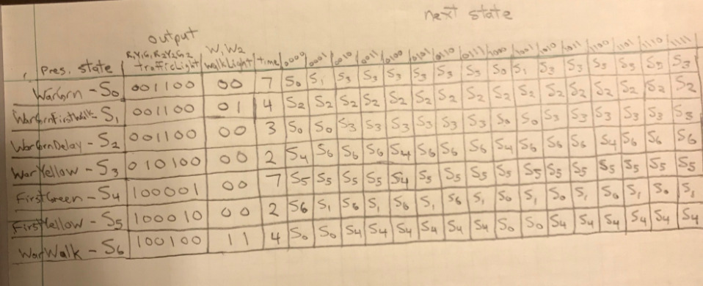
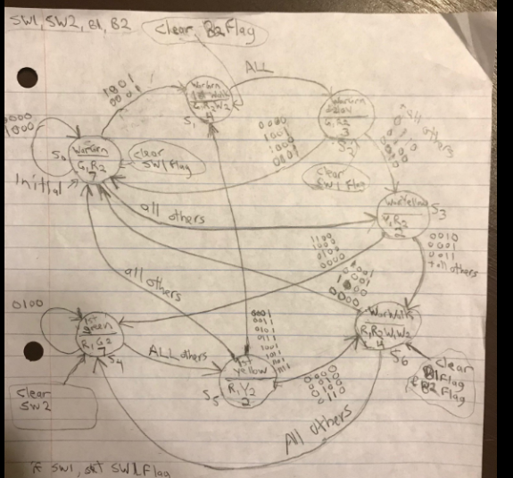

We simulated traffic lights and Walk signals with LEDs, and used push buttons as sensor and button inputs. We wrote C code to control our ARM Launchpad microcontroller. We organized the states as an array of linked structures – each state structure included a 6-bit trafficLight, 2-bit walkLight, hold time (in seconds), 4-bit "clearServicedInputs", and array of possible next states (pointers).

Conclusion
This project was very challenging for me. Figuring out the state transitions wasn't bad, but getting the microcontroller and circuit to function accordingly was a pretty big challenge. The example in our textbook helped me debug, and also, I ended up writing a simple C file that did nothing except read the inputs, and turn on all LEDs if any inputs were high. This helped me a lot in debugging step-by-step. This assignment really helped me solidify a lot of concepts, and it felt good to finally get the circuit working properly.

