Introduction

In this document, I'll be specifying the quality requirements for my subsystem ‘USU Student App’. The specified quality requirement is ‘FR-ST-1 - Student registration and login. My subsystem registers students to the app and enables them to log in to their specific union using their student credentials, while protecting their data from unauthorized access. The ‘functional requirements’ that we choose are a specification of what our system should do, such as performing a login or passing a user to their correct page based on the information they have given. Whereas the quality requirements depict how the system is meant to actually do those actions in certain areas, such as its security and reliability.

Security and privacy protection

Security and privacy protection for registration is to make sure credentials, phone number, and address can only be viewed by the user. Since this is personal information, it must be kept safe behind several security protocols. The USU student app would ensure encryption in the password, and ask to create a stronger password if needed, or use 2FA when logging in through a new device.

During registration, unauthorized access must be prevented, so carrying out detection on the number of incorrect login attempts is an important step. If a student were to incorrectly enter their information, they would be prompted to wait 15. This enables administrators to identify if the requests for entry should be authorized. For example, a student is trying to register for the USU student app. They use university and personal information on the registration page and carry out the 2FA. If this information is correct, then the user is prompted with a success page; if not, they are locked out of the login and asked to wait for 15 minutes, giving administrators time to analyze the access attempts. The metric measurement for this scenario is the number of successful login attempts through 2FA compared to all the login attempts measured every 10,000 successful logins. However, if there are unauthorized login attempts below the count, then those attempts must be flagged by the system to explore why they’re denied. One other metric measurement is the time it takes for the login to be allowed. If the login attempt has run over 3 seconds, it will be warned; however, if it exceeds more than 8 then it will be flagged for further inspection and denied access since it might indicate bypassing encryption.

Performance

The USU student app, under the performance requirement, during peak times, such as Freshers week, there may be up to 10,000 registration attempts of registration and at least 85% of registration attempts should complete without delay or issues. The time it takes the registration to finalize is no more than 8 seconds; otherwise, users would be prompted with an error message to wait for a period of time. If 85% of users are under the limit, the performance is working as planned; however, if the limit is exceeded, administrators must report this performance issue and notify the users with an error message and delays, and potential crashes. This must be tested beforehand using applications like ‘locust’, which can send up to 0,000 requests simulating real-time users. This will detect the error rate and whether it will drop before the safety level of 85%

Front-end performance validation will be measured by the time it takes to display registration feedback informing users about registration eros. This would be measured under a time of 6 seconds from the time the request is passed and the information is displayed on the user's device. This helps users identify what to do next with the registration. Again, this should be tested using applications like JMETER to overload the system, as this will display the number of registration attempts it takes to crash the system. With this information, developers can fix the issue to serve users at peak times.

Back-end performance is based on how long it takes for registration data to be stored in the system's database and whether that information is correct. During freshers week, registration forms may peak at 10,000 within a single day, so delays may occur. The data must be 100% during any busy time frame, preventing future credential issues. At peak times, data might be delayed from the time the registration form is completed to the time it takes for the server to respond, so prompting the user with a wait time not to close their page can help prevent storing any incorrect data. Performing back-end checks by simulating data can test the average wait time for it to be stored.

Reliability

The USU student app must always keep its registration form available throughout the entire year, allowing new students to apply during both peak and off-peak usage periods. The service should not be out of service for more than 40 hours per year in a consecutive working period. The aim would be to have the service working at all times, both the front end to deliver the registration page and the back-end to store the users' data. Its availability can be calculated using the formula “Availability = (total time - downtime) / Total time. This will define the downtime and the uptime for the system for each time frame. In this case, the service must be reliable during a freshers' week to prevent downtime since it will cause delays in registrations, so some users might not be able to join their activities through the app.

The metric would be the time of uptime measured across each month of the year, using a percentage rate with a precision rate of 1 minute for a value of 40 minutes per month. This will allow for 40 minutes of downtime per month. By measuring this, you can determine whether the registration page functions correctly during peak times.

The functional requirement reliability integrates with the correctness of data. Once a student has completed the registration form, the application must store the correct data in its database before passing the student to the next section. Their name, student ID, or study program should all be correct. If not, the user would be prompted with a message indicating a wrong username or student ID. This requirement can be tested by having a few users complete the registration form, then verifying whether the information is correct, or by simulating thousands of users entering the information virtually on several systems.

Scalability

Scalability is whether the USU student app can perform when the user count increases and during large data transfer from each registration to the server, especially during university events such as freshers' weeks or societies informing new students to complete the registration forms. The USU student app should specify the student unions that new users can register for throughout the university and allocate users' data correctly to their union.

- - Data scalability

Large amounts of data must be processed during peak times, when users are registering and logging into their unions. There may be up to 5,000 or 10,000 new users registering and logging in, depending on the event; however, process time should be kept to a minimum of 6 seconds and the application must not crash the user's device;it must not go over a certain threshold like CPU usage, or cause delays to the universities wfi since many users may be logging in through there.

- Efficient Data

Changes/updates or just new registrations from new users must be handled correctly to synchronize with their previous data or their student union. Scaling this to handle many users requires stress testing using JMeter to deliver thousands of requests to either a cloud storing data or inside its actual code or database to propose fixes or check for response times from the server to the user's device and their display.

- Validation

Validation through the school's IT system for correct student information and assigning them to the correct student union, allocating the correct ID, and granting them access to their memberships should be completed without crashes or inconsistent data handling. Even if storage increases, there shouldn't be a limit on the users who can register for the application, as this may cause issues for the unions in understanding who all their current members may be. Validation checks, testing using LOCUS to simulate user packets to measure error rates and response times, shouldn't surpass an average limit.

Task 3

Use Case Model
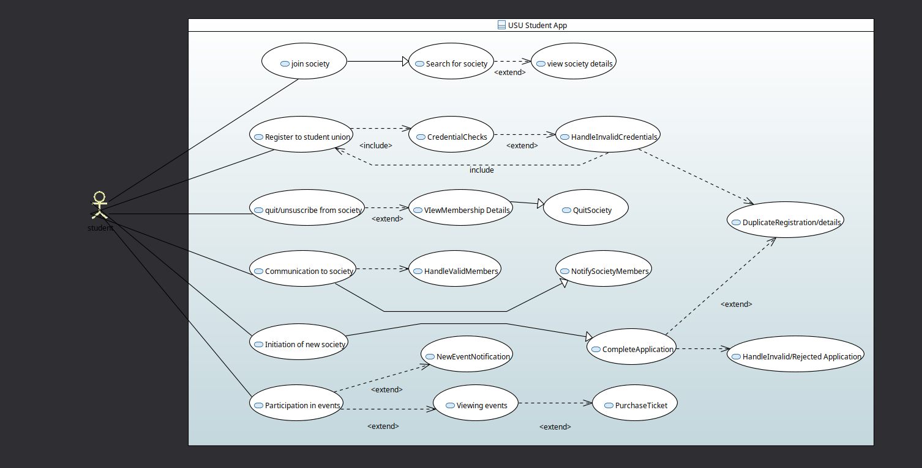

Activity Model

