Lab2

Contents

Ex1 – Clock configuration 1

Ex2 – Digital I/O 8

Ex3 – Interrupts 10

Ex4 – UART 13

Ex5 – Timer I 16

Ex6 – Timer II 19

# Ex1 – Clock configuration

1. Setup SMCLK to run on DCO

Figure - family guide p. 72

1. Configure the DCO to run at 8 MHz

1. Setup SMCLK with a divider of 32

1. Configure P3.4 as output, set it to output SMCLK

Figure - datasheet pg. 2

Figure - datasheet pg. 81

# Ex2 – Digital I/O

1. Configure PJ.0, PJ.1, PJ.2, PJ.3, P3.4, P3.5, P3.6, P3.7 as digital outputs

1. Set the LEDs 1 to 8 to output 10010011

|  |  |  |  |  |  |  |  |  |
| --- | --- | --- | --- | --- | --- | --- | --- | --- |
| **Value** | 1 | 0 | 0 | 1 | 0 | 0 | 1 | 1 |
| **LED** | LED8 | LED7 | LED6 | LED5 | LED4 | LED3 | LED2 | LED1 |
| **Reg** | P3.7 | P3.6 | P3.5 | P3.4 | PJ.3 | PJ.2 | PJ.1 | PJ.0 |

Figure - board datasheet pg. 17

1. Write a program to blink the LEDs that are 0 in step 2. Use a delay loop in the main infinite loop to visibly blink the LED

**int** **main**(**void**)

{

**int** i;

WDTCTL = WDTPW | WDTHOLD; // stop watchdog timer

// Configure PJ.0, PJ.1, PJ.2, PJ.3, P3.4, P3.5, P3.6, and P3.7 as digital outputs

PJDIR |= BIT3 + BIT2 + BIT1 + BIT0;

P3DIR |= BIT7 + BIT6 + BIT5 + BIT4;

// Set the LEDs 1 to 8 to output 10010011

PJOUT |= BIT1 + BIT0;

PJOUT &= ~(BIT3 + BIT2);

P3OUT |= BIT7 + BIT4;

P3OUT &= ~(BIT6 + BIT5);

**while** (1) {

PJOUT ^= (BIT3 + BIT2);

P3OUT ^= (BIT6 + BIT5);

**for** (i = 0; i < 20000; i++) {

_NOP();

}

}

**return** 0;

}

# Ex3 – Interrupts

1. Configure P4.0 as digital input (SW1)

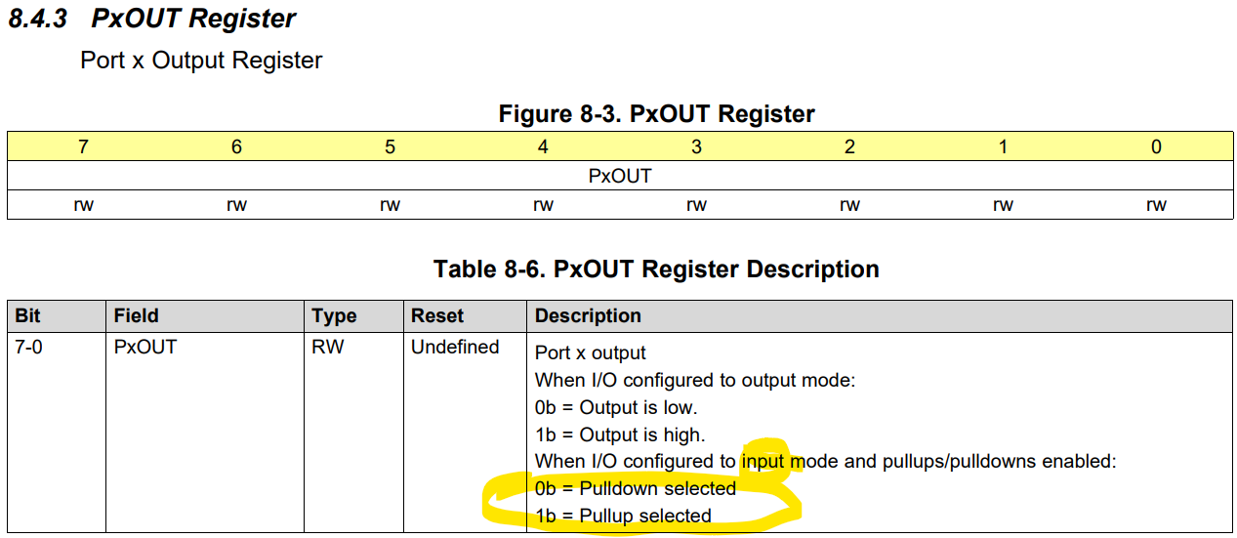

Set P4OUT.0 to select pullup

1. Enable internal pull up resistors for the switch S1 connected to P4.0 on the EXP board

PULLUP: open = 1, close = 0

1. Set P4.0 to get interrupted from a rising edge

Interrupted at the release of S1 switch (button)

// enable global interrupt

_EINT();

1. Configure P3.7 as output (LED8)

// configure P3.7 as output (connected to LED8)

P3DIR |= BIT7;

1. Write an ISR to toggle LED8 when S1 provides a rising edge

Figure - user guide pg. 45

# Ex4 – UART

1. Configure the UART to operate at 9600, 8, N, 1

Baud rate = 9600 bits/s

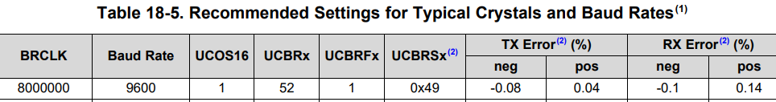

Data size = 8 bits

Parity = None

# stop bits = 1

1. Set up P2.0 and P2.1 for UART communications

// Configure ports for UART

P2SEL0 &= ~(BIT0 + BIT1);

P2SEL1 |= BIT0 + BIT1;

1. Write a program to periodically transmit the letter ‘a’ to the serial port

while (1)

{

// Periodically transmit an "a" character

while (!(UCA0IFG & UCTXIFG));

UCA0TXBUF = 'a';

for (i=0;i<20000;i++)

_NOP();

}

1. Check the transmission using the CCS terminal in debug (or PuTTY)

CCS terminal -> COM3

**Serial terminal, COM3, 9600, 8, None, 1, UTF-8**

1. Enable UART receive interrupt. Enable global interrupt

UCA0CTLW0 |= UCSWRST; // Put the UART in software reset

UCA0CTLW0 |= UCSSEL0; // Run the UART using ACLK

UCA0MCTLW = UCOS16 + UCBRF0 + 0x4900; // Baud rate=9600 from 8 MHz clk

UCA0BRW = 52;

UCA0CTLW0 &= ~UCSWRST; // release UART for operation

UCA0IE |= UCRXIE; // Enable UART Rx interrupt

// Global interrupt enable

_EINT();

1. Set up an interrupt service routine so that when a single byte is received, the same byte is transmitted by back (or echoed) to the serial port. Check using CCS terminal/PuTTY.

#pragma vector = USCI_A0_VECTOR

__interrupt void USCI_A0_ISR(void)

{

unsigned char RxByte = 0;

RxByte = UCA0RXBUF; // Get the new byte from the Rx buffer

while (!(UCA0IFG & UCTXIFG)); // Wait until the previous Tx is finished

UCA0TXBUF = RxByte; // Echo back the received byte

while (!(UCA0IFG & UCTXIFG)); // Wait until the previous Tx is finished

UCA0TXBUF = RxByte + 1; // Echo back the received byte + 1

if (RxByte == 'j') PJOUT |= BIT0; // Turn on LED1 when a 'j' is received

else if (RxByte == 'k') PJOUT &= ~BIT0; // Turn off LED1 when a 'k' is received

}

1. In addition to echoing, also transmit the next byte in the ASCII table. Check again using PuTTY
2. Add code to turn on LED1 when a ‘j’ is received and turn off LED1 when ‘k’ is received

# Ex5 – Timer I

1. Set up Timer B in the “up count” mode.
2. Configure TB1.1 to produce a 500 Hz square wave. You may need to use frequency dividers when setting up the clock and the timer. Output on P3.4. Verify using an oscilloscope. LED5 should also be lit.

Default clock, TB1CCR0 = 2000 -> 250 MHz (Mode 0)

Want 500 MHz -> TB1CCTL1 |= OUTMOD_7; TB1CCTL2 |= OUTMOD_7;

TB1CCR1 = 1000; // 50% duty cycle

TB1CCR2 = 500; // 25% duty cycle

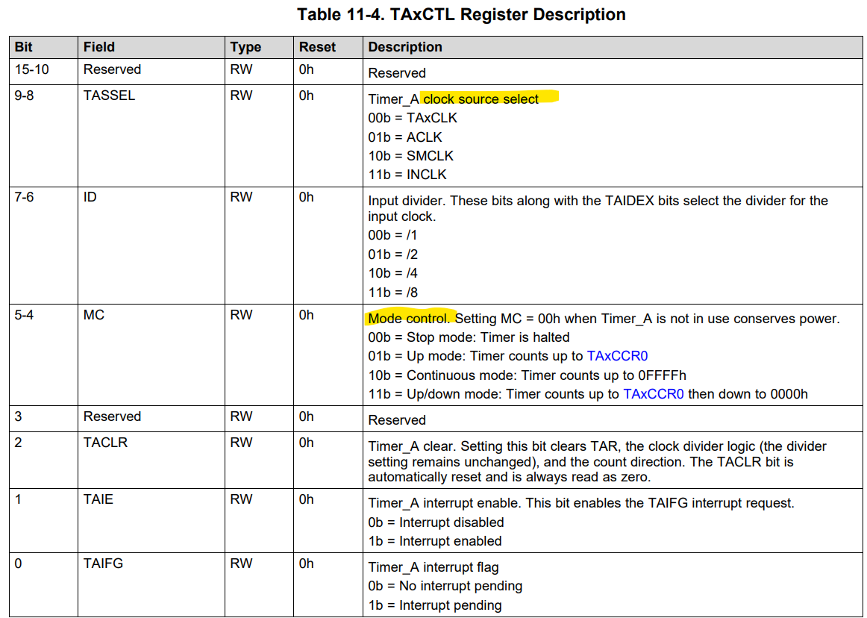

Figure - device datasheet pg 73

1. Configure TB1.2 to produce a 500 Hz square wave at 25% duty cycle. Output on P3.5. Verify using an oscilloscope. LED6 should be lit. Verify that LED6 is dimmer than LED5.

# Ex6 – Timer II

1. Set up timer A to measure the length of time of a pulse from a rising edge to a falling edge.
2. Connect the timer output from the previous exercise to the input of this timer.
3. Using the debugger to check the measured 16-bit value