Chapter 6, Exercise 3 (p. 260)

a) Training RSS will steadily decrease, since increasing s from 0 will restrict the Bj coefficients, which will increase coefficients to least squares estimates, which make the model more flexible.

b) Test RSS will decrease initially and then eventually start increasing in a U shape. When we increase s from 0, Bj coefficients become more restricted which makes the model more flexible, which make the an initial decrease and then increasing again.

c) Variance will Steadily increase, with similar reasoning as above the more flexible model will give a steadily increasing variance (amount of new function f would change if we estimated it using a different set of data)

d) Bias will steadily decrease, since the model becomes steadily more flexible the steadily decreases because the bias calculates the error for the particular model. (Ex: high-bias corresponds to model like linear regression)

e) Irreducible error remains constant, because it is independent of the model which means independent of s

Chapter 6, Exercise 4 (p. 260)

a) Training RSS will steadily increase, because increasing lambda from 0 will restrict the Bj coefficients causing the model to become less flexible which increases the training RSS.

b) Test RSS will decrease initially and eventually start increasing in a U shape, because the less flexible model

c) Variance will steadily decrease, since a less flexible model corresponds to a less change in function, then variance would steadily decrease.

d) Bias will steadily increase, because a less flexible model corresponds higher bias. See example from previous question part d)

e) Same as previous part e) where the irreducible error in independent of model

Chapter 6, Exercise 9 (p. 263). Don't do parts (e), (f), and (g)

a)

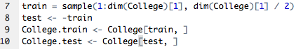

b)

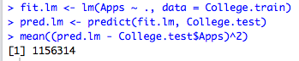

c)

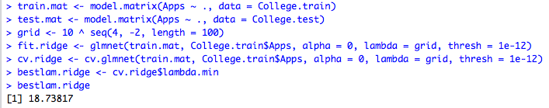

Macintosh HD:Users:samlin:Desktop:Screen Shot 2017-07-30 at 7.05.14 PM.png

*The test MSE is higher for ridge regression than for least squares.*

d)

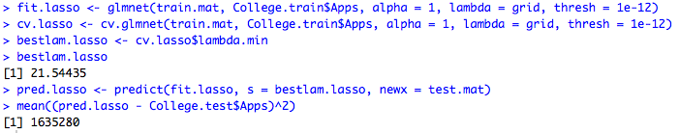

Test MSE is higher for ridge regression than for least squares.

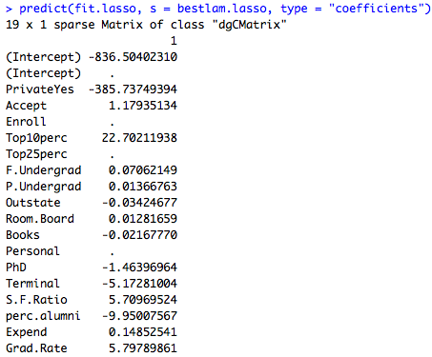

The above are the non-zero coefficient estimates

Chapter 8, Exercise 4 (p. 332)

a)

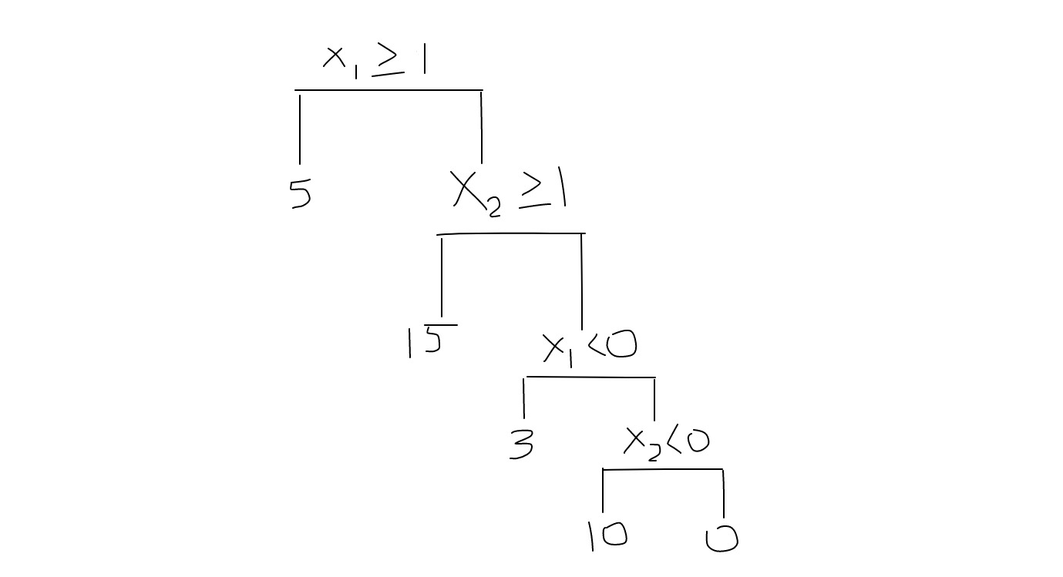

b)

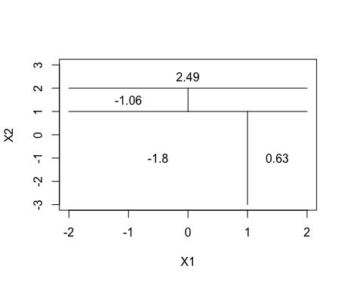

Chapter 8, Exercise 8 (p. 333)

a)

Macintosh HD:Users:samlin:Desktop:Screen Shot 2017-07-31 at 3.07.46 PM.png

b)

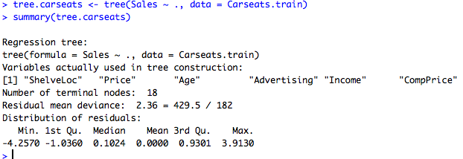

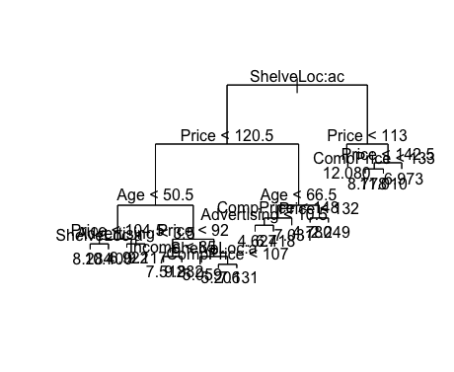Macintosh HD:Users:samlin:Desktop:Screen Shot 2017-07-31 at 3.12.36 PM.png

Test error rate is approximately 4.15.

c)

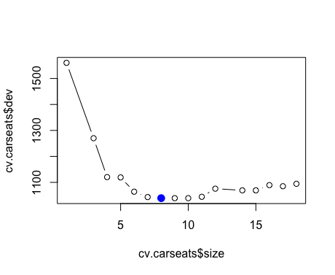

Tree of size 8 used for cross-validation. Prune the tree to get 8-node tree.

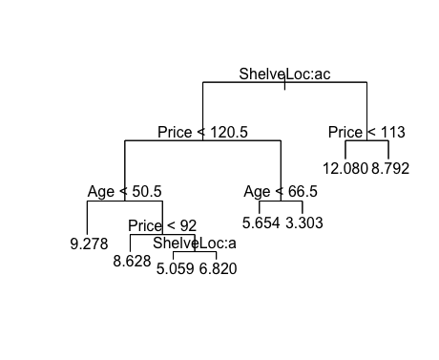

Macintosh HD:Users:samlin:Desktop:Screen Shot 2017-07-31 at 3.16.01 PM.png

Pruning the tree increases the MSE from 4.15 to 5.1

d) 

Bagging decreases Test MSE to 2.6

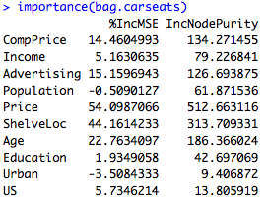

e)



Test MSE of 3.3

