Sample capture report
Three fictional posts deliberately pasted out of date order. Use this document to try PostOrder. No real account or investigation data is included.

Instagram captures
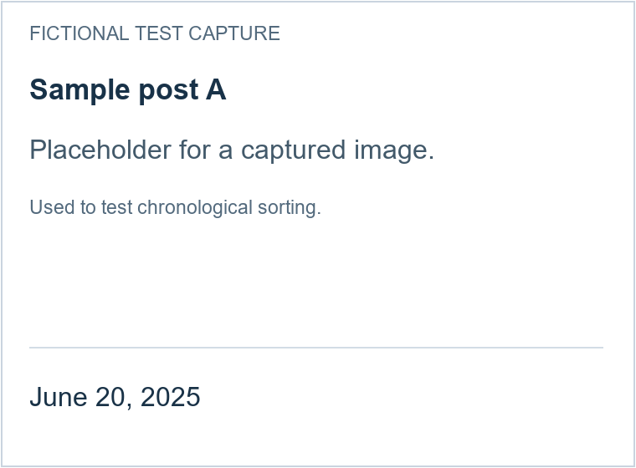
Note for sample post A. This note should move with its screenshot.
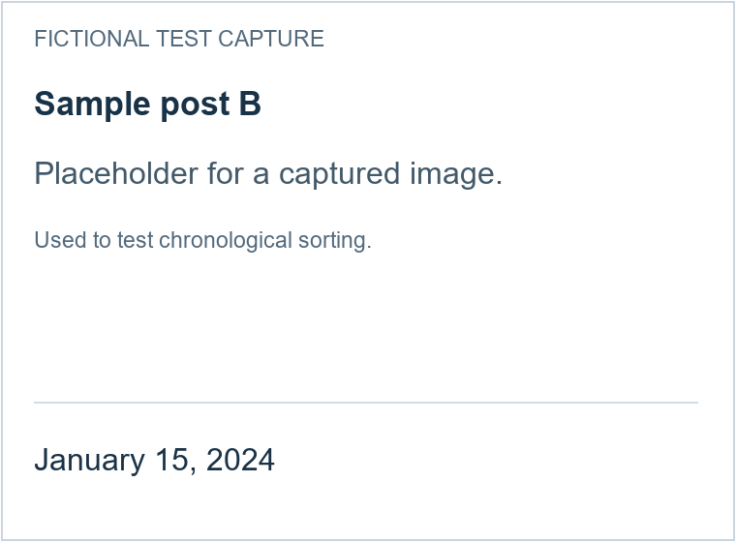
Note for sample post B. This note should move with its screenshot.
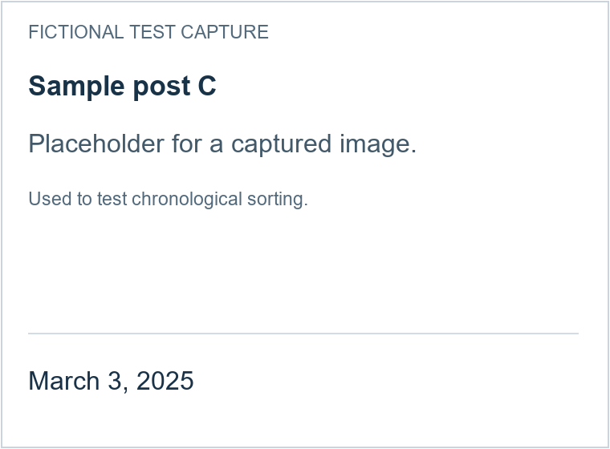
Note for sample post C. This note should move with its screenshot.

Report notes
This section should remain after the captures. The chronological order is B, C, A.

