Multivariate Interpolation

**Abstract**

Demonstrate multivariate interpolation using the Vandermonde matrix method. We will be designing an algorithm that creates a polynomial interpolation given some sample data. This algorithm will be analyzed to determine where it is most useful. Specifically, we will be looking at different types of functions and sample sizes.

**Introduction**

Interpolation is a method used to approximate a function by using a sample data set. Multivariate interpolation involves interpolating a function of more than one variable. In many scientific applications there will be functions of multiple parameters required for computation. Some examples of these functions are the weather (variables: temperature, wind speed, humidity), people (variables: height, weight, hair color), and gas mileage (variables: speed, tire pressure, wind speed). Therefore, having a way to interpolate samples of these studies allows researchers to predict future outcomes like forecasting the weather or calculating the cost of gas for a road trip.

There are many methods used to do multidimensional interpolation which each have their own strengths and weaknesses. The purpose of this paper is to examine a specific algorithm used for multivariate interpolation and report on its performance and where it can be improved. Three-dimensional graphs will be used to visually display the resulting interpolated polynomials. This along with error analysis will be our means of judging the success of our interpolated polynomial.

**Related Works**

(to be written)

**Algorithm**

The Vandermonde matrix method involves creating an *n x n* matrix where each row is a linear combination of bivariate monomials which span a set of *basis functions*. The basis functions are dependent upon the number of data points given, ((x1,y1), z1), ((x­2,y2), z2), …, ((xn,yn), zn), where the polynomial created is a linear combination of the form:

z(x,y) = c0 + c1*x1 * y0 + c2*x0 * y1 + … + cn* xm * ym

And the degree of the polynomial is such that if there are *n* data points, the degree *m* follows the equation:

$m= floor(\sqrt{\left(n-1\right)}$).

The coefficients are determined by using the solving the equation V*c = z using Gaussian elimination, where V is the Vandermonde matrix, *c* are the coefficients, and *z* is the solution vector given in the data set. The Vandermonde matrix spans the basis function creating a unique bivariate polynomial of the form above for each point ((x1,y1), z1), ((x­2,y2), z2), …, ((xn,yn), zn).

The algorithm must be able to create this matrix given a set of data points, determine the degree of the polynomial, create the basis function, and fill in the matrix row by row using the same index of x and y values for each row. Then the algorithm solves the system using the equation above for the coefficients and creates a general polynomial which can be used to interpolate any set of data points.

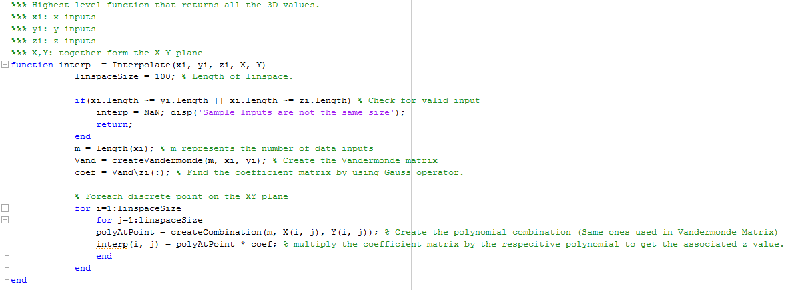

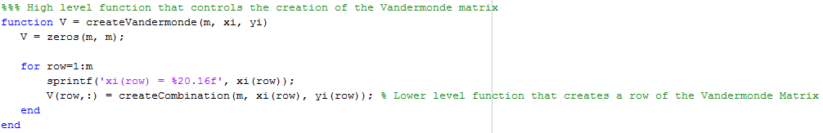

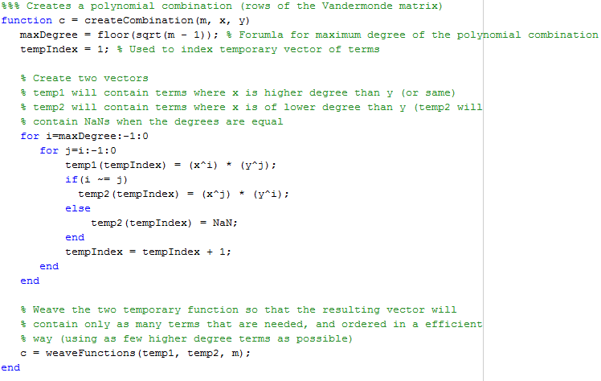

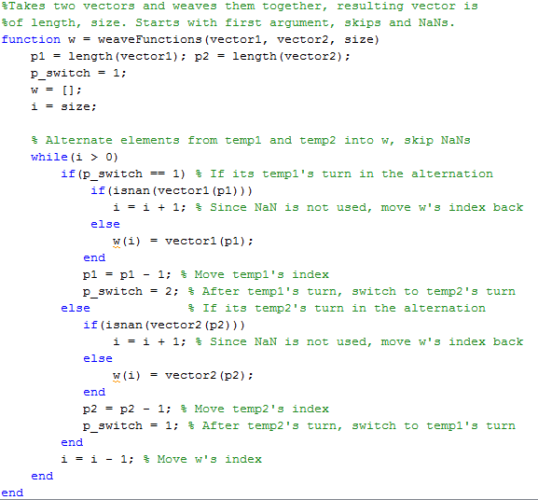

**Results**

We have successfully written the algorithm which creates a bivariate polynomial given a sample data set and plots the three-dimensional surface. So far we have only tested a couple functions and have shown the output graph of one of them below.

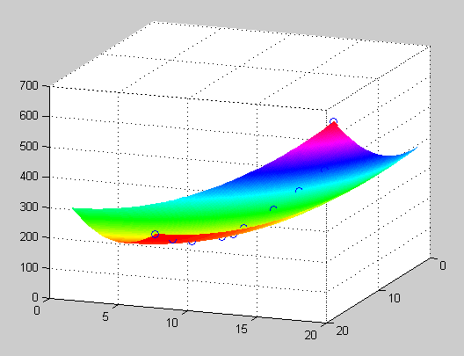

Figure: Graph of the function interpolated from points of the form f = x2 + y2.

**Conclusion**

(to be written)

**Error documentation (not part of the report)**

11/17/14

We chose a different function to interpolate using our algorithm today to test how it would perform on different types of functions. The function we chose was

z = sin(1 + sqrt(x^2 + y^2))

We tested different methods of obtaining points using randomly chosen points, a linear point distribution, and strategically picking points. The results from the random points and the linear point distribution was not interpolating the function well which is shown below. Then we realized that we needed to pick the points based on the areas of interest in the graph, like where the changes in curvature are and such. This is where we strategically picked the points based on the different curves in the graph and the result was much better as shown below.

Also, we tried to replicate the exact graph of the function by using a linspace as our data set for x, y, and z. This was a problem because picking a linear combination of points (a linspace create a set of evenly spaced points) creates a non-singular matrix like the problem we were having before. (what if we used a different method of solving the matrix instead of c = z/V? (Gauss).

Also, we were unsure if creating the linspace would have been an accurate interpolation because there would have been a high number of data points which would create a high degree polynomial. However, we were unable to test this because the matrix created with a linspace was singular.

