**CHM 673, Lab 2. Bond-breaking in H2**

In this lab, we will investigate the bond-breaking reaction in H2 molecule. We will compare the performance of restricted and unrestricted Hartree-Fock models (RHF and UHF) and density functional theory (DFT) for bond-breaking. We will benchmark these results with respect to the Full Configuration Interaction (FCI) values obtained using the coupled cluster with single and double excitations (CCSD) calculations, which give the exact answer for the two-electron system. We will calculate the correlation energy, which is a difference between FCI and HF electronic energies, and learn how to distinguish between dynamic and non-dynamic contributions to the correlation energy.

**Lab procedure**

Use 6-31G** basis for all the calculations in this lab.

In order to construct the H2 potential energy surface, you need to run a series of calculations at different H-H separations (in Angstroms), e.g.,

0.3, 0.4, 0.5 … 4.9, 5.0 Angstroms

1. Calculate the H2 potential energy surface at the RHF level. Write down (or print) the *electronic energies* at all calculated points.

Hint: Use the PES Scan function under Calculate option. This lets you perform a relaxed potential energy surface scan along a particular coordinate. In this case, the scan will be along the stretching mode of the H-H bond. In IQmol, when you click on PES Scan option, it will display a section called $scan. You will have to manually input the stretching mode for this calculation. It will look like this:

$scan

stre 1 2 0.3 5.0 0.1

$end

*Explanation: Scan the stretch mode between atom 1 (1st H) and atom 2 (2nd H) starting from 0.3 angstroms until 5.0 angstroms at a step size of 0.1 angstroms.*

Alternately, you can manually input the 48 geometries between 0.3 and 5.0 Angstroms!!!

2. Calculate the same potential energy surface at the UHF level. In order to obtain the unrestricted solution for a singlet, you may need to specify additional options in SCF control section:

# UHF

unrestricted = 1 (check “Unrestricted”)

# non-default guess for HF

scf_guess = gwh (Guess GWH)

# rotating alpha and beta orbitals to find unrestricted solution

scf_guess_mix = 1 (Guess Mix 10%)

# Use Geometric direct minimization algorithm

scf_algorithm = GDM

For this UHF simulation, you may use the same PES_SCAN method as described earlier for RHF. Write down the electronic energies and the S2 expectation values.

3. Calculate the same potential energy surface at the DFT level. Use PBE functional, found under “Method” menu. Use restricted wave function.

4. Calculate the H2 PES at the FCI level. For a two-electron system, the FCI results may be obtained by using the CCSD method (details on this technique will come in a due time).

To create an input for the CCSD calculations, find “CCSD” option in “Method” menu.

Write down the CCSD energies. Hint: they are not necessarily printed by IQmol, however, you can look for them in the output files (the last few lines).

Also record total CCSD amplitudes: CCSD T1^2 = … T2^2 = … and the value of the largest T2 amplitude just below, e.g.,

Amplitude Orbitals with energies

-0.2199 1 (Ag) A 1 (Ag) B -> 1 (B1u) A 1 (B1u) B

-0.4666 -0.4666 0.0971 0.0971

The values of amplitudes show a relative weight of singly and doubly excited determinants in the wave function. If T1 and/or T2 are large (generally speaking, if a particular T2 >0.1), the wave function is considered to be multi-configurational (i.e., containing several important Slater determinants). In other words, this is a region where non-dynamic (static) correlation is significant. Several small T1 and T2 amplitudes tell about (almost always present) dynamic correlation.

Calculate energy of a single H atom (change the multiplicity value correspondingly) with RHF and DFT methods in the same basis set. Explain what will be the energies in UHF and FCI methods. Use the energy of H atom to calculate the binding energy in H2, i.e., Ebind = E(H2) – 2 x E(H).

**Practical tips**

1. In this lab, it may be quicker to run Q-Chem from linux shell rather than through IQmol.

2. You can prepare an input containing several jobs (aka “train”), using

@@@ as a separator between the jobs (this is done using green plus in IQmol). For example, you may perform all jobs corresponding to the same H-H separation together (i.e., RHF, UHF, DFT, CCSD).

3. CCSD calculation will provide both RHF and CCSD energies, such that you may skip RHF calculations altogether.

4. However, you will need to perform separate calculations for orbital plots in IQmol as you won’t be able to see all orbitals from a “train” output.  
(If you did a PES Scan, the orbitals printed out may correspond to the optimization steps in the scan procedure. They are not necessarily what you are looking for!).

**Lab report**

1. Plot on the same graph the RHF, UHF, DFT, and FCI **binding energies** in H2 versus the H-H distance. Use kcal/mol energy units (1 Hartree= 627.51 kcal/mol).  
   Note: Clicking on ‘Scan Geometries’ option in IQmol prints the total energy curve, not the binding energy!
2. Comment on the behavior of RHF and UHF curves wrt FCI at short (around 0.7 Angstroms) and long distances. (You can read paragraph 3.8.7 from Szabo and Ostlund book for a discussion of RHF and UHF solutions).

3. Make a table or plot of S2 values from the UHF calculations. Explain why S2 deteriorates when the H-H bond is stretched.

4. Make a sketch of the first two H2 molecular orbitals (HOMO and LUMO) from your RHF and UHF calculations at the equilibrium (0.7 Angstroms), 1.3, and 5.0 Angstroms. Comment on qualitative changes in the shape of the orbitals.

5. Difference between FCI and HF energies is the correlation energy. What is the nature of the correlation energy (dynamic vs non-dynamic) in H2 at equilibrium? At long distances? At what distance does the non-dynamic correlation become important?

6. Comment on the behavior of DFT at equilibrium and long distances. What is the reason of DFT failure for bond-breaking?

7. **Bonus question**: Try computing the energy of H atom with B3LYP functional (method = B3LYP).

1. Compare the energy of H atom computed with RHF, B3LYP and the exact energy of H atom (from your undergraduate PChem class).
2. Do you see any discrepancy with the B3LYP energy? If so, what is/are the reason(s) for such discrepancies?

**Part - B**:

Your friend, who is an experimental chemist, seeks your help knowing that you have expertise in running quantum chemistry simulations. Their research group has measured the singlet-triplet gap of ozone recently. They want to see if computational simulations can support their measurement. How will you measure the singlet-triplet gap in ozone?

No procedure will be provided for this lab. Use the ideas from the previous part of this lab and the following hints.

1. Assume that the singlet and triplet ozone molecules have same geometry.
2. You will have to optimize the geometry of ozone to start with. Alternately, you can grab the optimized geometry of O3 from CCCBDB!
3. Use RHF/6-31G* for simulating the singlet ozone molecule. Use UHF/6-31G* for simulating the triplet ozone molecule. Use the energy difference to compute the singlet-triplet gap.
4. Write the electronic energies corresponding to singlet and triplet ozone molecules, the singlet-triplet gap in eV, and the <S^2> value for triplet ozone.

Now, compute the singlet-triplet gap (between the 1g and 3g- states) of oxygen molecule and report it in eV. Compare the singlet-triplet gap you computed in this lab with the ones available in CCCBDB (link: <http://cccbdb.nist.gov/stgap1.asp>). It should be an exact match! Is it?

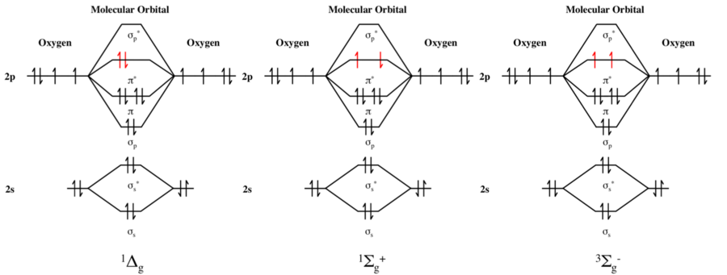

Of all the four cases (singlet and triplet, oxygen and ozone) you have computed so far, which one suffers the most spin contamination?

**Bonus**: Compute the singlet-triplet gap between the 1g+ and 3g- states of oxygen atom.

Hint: Start with 1g geometry; Use the Maximum Overlap Method (MOM) to force the highest beta electron to occupy the second * orbital. Example: [Click here](http://www.q-chem.com/qchem-website/manual/qchem50_manual/sect-mom.html).

******************************************************************