**Midterm CHM 673, Spring 2020**

*due March 10*

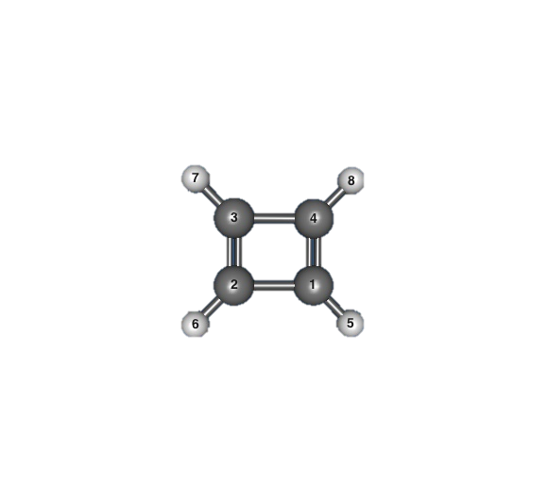

1. **(This question assumes that you do not perform electronic structure calculations)**

Cyclobutadiene (C4H4) is a planar molecule with a rectangular shape, i.e., there are two shorter and two longer C-C bonds.

* 1. Cyclobutadiene has four π molecular orbitals. Draw these (π) orbitals in the proper energetic order; name their symmetries
  2. Distribute four electrons on these orbitals (assuming the ground electronic state). Show the highest occupied (HOMO) and the lowest unoccupied (LUMO) orbitals.
  3. Energies of molecular orbitals (and corresponding orbital symmetries) from Hartree-Fock calculations with 6-31G* basis set are summarized below. Estimate the lowest ionization energy of cyclobutadiene. What approximation did you use?

--------------------------------------------------------------

Orbital Energies (a.u.)

--------------------------------------------------------------

Alpha MOs, Restricted

-- Occupied --

-11.234 -11.234 -11.233 -11.232 -1.160 -0.914 -0.818 -0.696

1 A1 2 A1 1 B1 2 B1 3 A1 4 A1 3 B1 4 B1

-0.694 -0.554 -0.534 -0.473 -0.445 -0.274

5 A1 6 A1 7 A1 1 B2 5 B1 2 B2

-- Virtual --

0.110 0.275 0.282 0.285 0.290 0.323 0.348 0.439

1 A2 8 A1 9 A1 2 A2 6 B1 7 B1 10 A1 8 B1

* 1. Judging from the corresponding MOs, describe and briefly rationalize anticipated significant changes in molecular geometry *in the ground state of the* *cation relative to the ground state of the neutral molecule*, i.e.

C1-C4 and C2-C3 bonds will shorten / lengthen

C1-C2 and C3-C4 bonds will shorten / lengthen

* 1. One of the low-lying excited electronic states of cyclobutadiene is a triplet, in which one electron is promoted from the HOMO to the LUMO. Estimate the excitation energy of this state.
  2. This triplet state favors a square geometry. Can you rationalize why this happens?
  3. There is also a singlet excited state with a spatial distribution of electrons as in the triplet state, i.e., one electron in the HOMO and another in the LUMO orbital (so called open-shell singlet). Do you expect this excited singlet state to be higher or lower in energy than the triplet state? Rationalize.

1. The figure below shows a scan of potential energy surfaces of phenol (C6H5OH) along a coordinate representing detaching of a hydrogen from the hydroxyl group, i.e., C6H5OH-> C6H5O----H. A laser pulse (red vertical arrow) simultaneously brings a phenol molecule in a hot (vibrationally excited) electronic excited state (1A’ ππ*); after that the phenol is allowed to relax.
2. Show a trajectory of the molecule if the Born-Oppenheimer approximation were always valid. Which product would be formed in this case? (Possible answers: phenol in the ground state (S0), phenol in one of the excited states (1A’ or 1A”), deprotonated phenol (phenolate) in the ground state, phenolate in a particular excited state)
3. Circle places where the BO approximation may break.
4. Show possible trajectories in realistic scenario (with BO approximation breaking). What is the most possible product (or products) in this case?

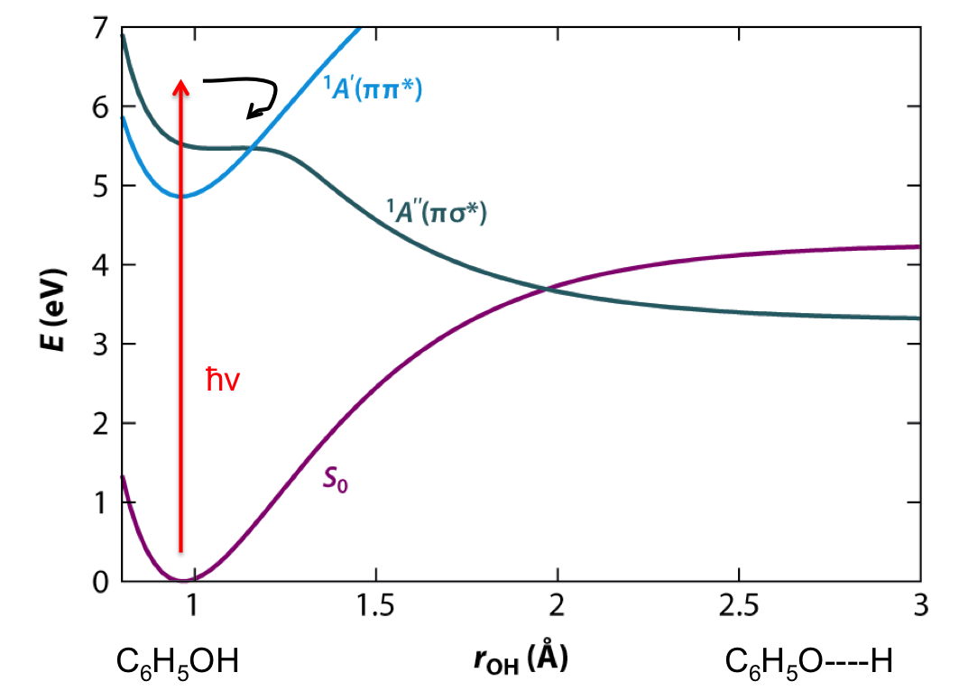

1. Consider a crystal of aspirin (a unit cell is shown; C: dark grey, H: light grey, O: red).

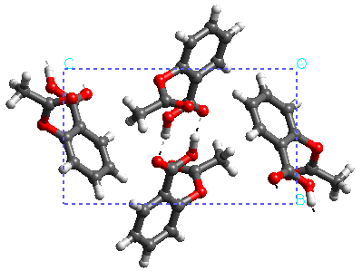

1. Which basis set would you use for calculations of structure and binding energy of this crystal? Explain.
2. Suppose the calculation of one aspirin molecule with the Hartree-Fock method takes 1 minute. Estimate the time you need to calculate the cluster of 2 aspirins (1 unit cell), 4 aspirins (2 unit cells), 128 aspirins (64 or 4x4x4 unit cells). Express the answer in appropriate time units.
3. Consider (again) cyclobutadiene C4H4.
4. 6-31G* and 6-311++G** basis sets for C and H atoms are given on the last page of the exam. Annotate the bases, i.e., find (not all bases have all types of functions):

* core functions
* valence functions
* polarization functions
* diffuse functions

1. Determine the total number of basis functions for calculations of C4H4 in these basis sets. Assume cartesian angular momentum (6d, 9f) functions.
2. What is the size of the Fock matrix in SCF calculations with these bases?
3. Assuming the SCF/6-31G* calculation took 10 seconds, estimate how long the SCF/6-311++G** job would take.
4. For each of 6-31G* and 6-311++G**, suggest correlation-consistent basis set of similar quality.
5. Consider HeH molecule (2 nuclei, 3 electrons). Define any notations you use in answering the following questions.
6. Write down the electronic Hamiltonian for HeH. Mark one-electron and two electron terms.
7. Write down the Slater determinant for the ground state of HeH corresponding to the following electronic configuration: (1sHe)2(1sH)1.
8. Write down the expression for the Hartree-Fock energy corresponding to this determinant (include h, J, and K terms for each electron).
9. Consider ionized molecule with electronic configuration (1sHe)2(1sH)0. Write down HF expression for this electronic configuration. Comparing this expression with the HF energy from c), prove Koopmans’ theorem.
10. Read the following two papers: 1. Jursic, Int. J. Quantum Chem., Vol. 61, 93-100 (1997) and 2. Bauschlicher, Int. J. Quantum Chem., Vol. 66, 285-286 (1998) – in this order, please. This is one of (unfortunately) many examples when researchers misuse and misinterpret computer simulations.

Answer the following questions:

1. The main mistakes in Jurasic’s paper are due to a wrong assignment of the ground states of B, Al and Ga ions. Rationalize why ions have triplet rather than singlet state. (Show orbital diagrams to help with reasoning).
2. There is also a problem with calculations of Be, Mg, and Ca. Why the ground state of these atoms is the singlet but not the triplet?

6-31G*

****

H 0

S 3 1.00

18.7311370 0.03349460

2.8253937 0.23472695

0.6401217 0.81375733

S 1 1.00

0.1612778 1.0000000

****

C 0

S 6 1.00

3047.5249000 0.0018347

457.3695100 0.0140373

103.9486900 0.0688426

29.2101550 0.2321844

9.2866630 0.4679413

3.1639270 0.3623120

SP 3 1.00

7.8682724 -0.1193324 0.0689991

1.8812885 -0.1608542 0.3164240

0.5442493 1.1434564 0.7443083

SP 1 1.00

0.1687144 1.0000000 1.0000000

D 1 1.00

0.8000000 1.0000000

****

6-311++G**

****

H 0

S 3 1.00

33.8650000 0.0254938

5.0947900 0.1903730

1.1587900 0.8521610

S 1 1.00

0.3258400 1.0000000

S 1 1.00

0.1027410 1.0000000

S 1 1.00

0.0360000 1.0000000

P 1 1.00

0.7500000 1.0000000

****

C 0

S 6 1.00

4563.2400000 0.00196665

682.0240000 0.0152306

154.9730000 0.0761269

44.4553000 0.2608010

13.0290000 0.6164620

1.8277300 0.2210060

SP 3 1.00

20.9642000 0.1146600 0.0402487

4.8033100 0.9199990 0.2375940

1.4593300 -0.00303068 0.8158540

SP 1 1.00

0.4834560 1.0000000 1.0000000

SP 1 1.00

0.1455850 1.0000000 1.0000000

SP 1 1.00

0.0438000 1.0000000 1.0000000

D 1 1.00

0.6260000 1.0000000

****