**Interface of iQmol to Scholar cluster**

Download "iqmol_scholar.cfg" script to your local machine. Check that the file does not get a different extension (like .txt)

Open iQmol and select Calculations->Edit Servers in the upper menu.

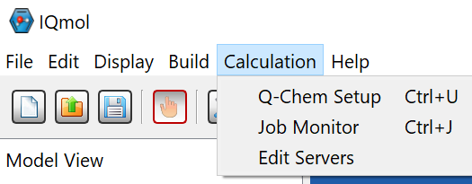

This will open “Server List” window:

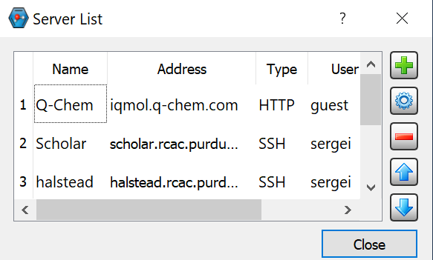

By default, it will have Q-Chem server as the only option. Every user is granted 5 minutes of computer time on Q-Chem server, which is only sufficient for small molecules. Purdue Scholar server allocates every user 4 hours of machine time per each job.

To add Scholar to iQnol servers:

press large green "+" button. New server dialog will appear:

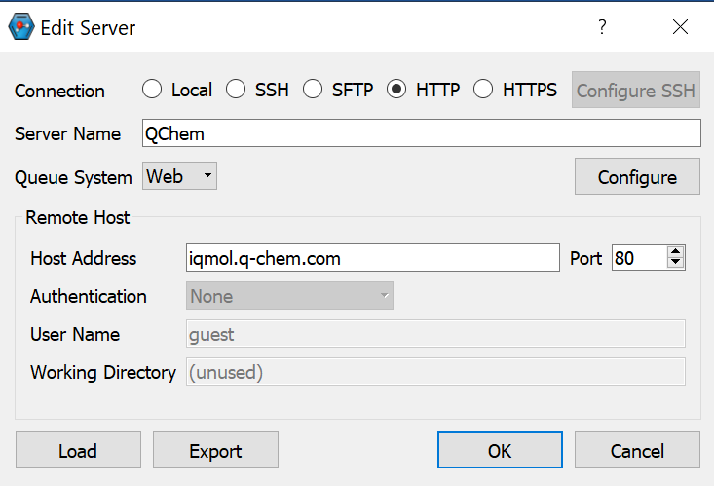

Click "Load" button in the low left corner and select iqmol_scholar.cfg file. In the server setting dialogue, change "yourcareerid" to your real career ID in User name and Working Directory.

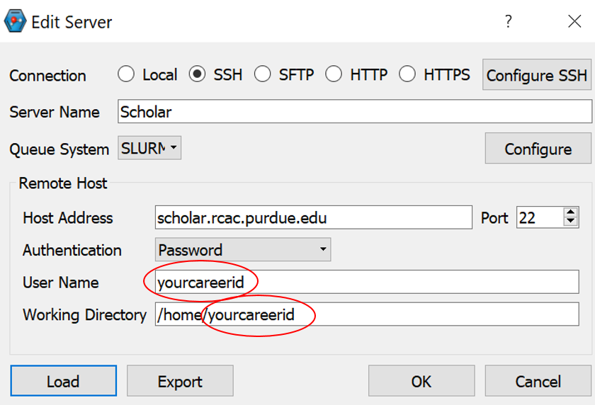

Click OK.

**Running Q-Chem simulations**

Try to run a test job on Scholar. As usual, create a test molecule and go to Calculation>Q-Chem Setup.

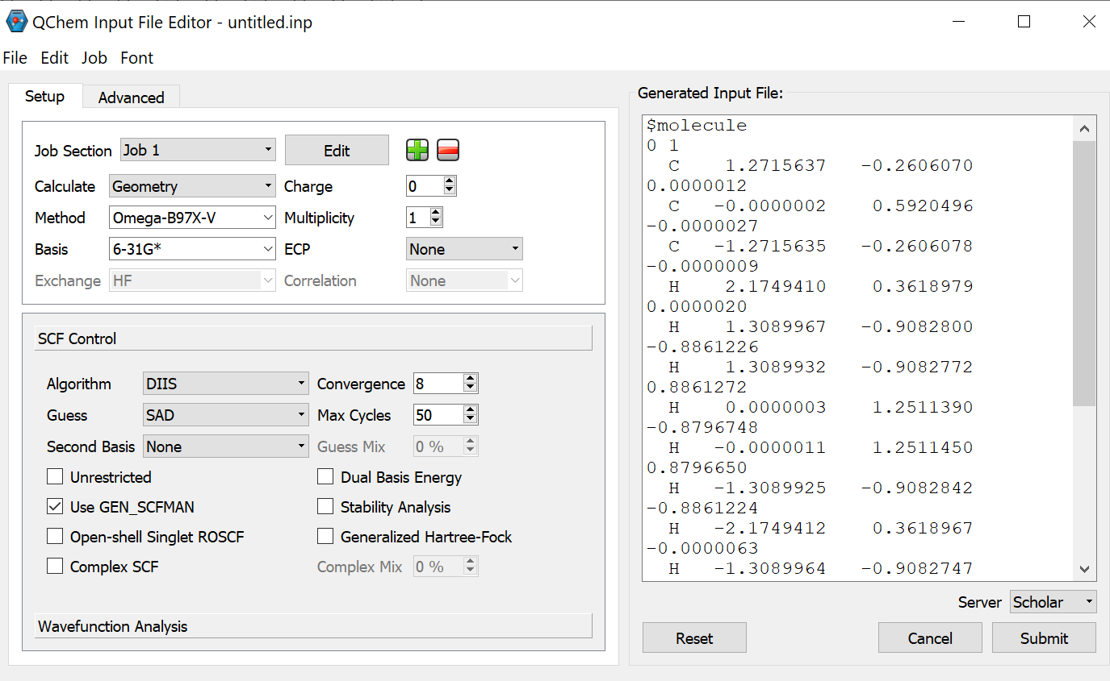

Select the needed options on the left screen and check that they appear as new keywords in the right (text) screen.

Select Server (Scholar) in the bottom-right corner and Submit the job. You will be asked for password (your Boilerkey password).

In the screen called "Resource Limits" you can modify Wall time (up to 4 hours) and number of CPUs (maximum of 20). Many jobs will run just fine (and with faster wait time in queue) on a single processor.

Once job is finished iQmol will notify you and ask for a directory name to which the results should be downloaded. It will automatically load the data into its editor enabling you to visualize the results.