**Running simulations with iQmol**

iQmol is a job manager for the Q-Chem electronic structure package.

Q-Chem: <https://www.q-chem.com/>

Q-Chem manual contains relevant keywords and theoretical description of each implemented model: <https://manual.q-chem.com/pdf/qchem_manual_5.0.pdf>

iQmol: <http://iqmol.org/>

iQmol should be installed to your favorite laptop/desktop.

IQmol user guide: <http://iqmol.org/downloads/IQmolUserGuide.pdf>

IQmol tutorial <https://www.q-chem.com/Teaching%20Materials/IQmol-Intro-I_new.pdf> provides a nice introduction to iQmol. Please follow it to familiarize yourself with the software and basic Q-Chem simulations.

iQmol allows you to build molecules, view structures, orbitals etc. However, all Q-Chem calculations will be performed on external supercomputers. iQmol can send a task to a supercomputer of your choice and download the results of calculations back to your PC.

To learn iQmol, you can submit quick jobs to “QChem” server. Later on, you will be able to interface iQmol to Purdue Scholar supercomputer or other machines of your choice (instructions to follow).

In order to be able to run tasks on external servers they must be configured first. You have been granted access to Purdue Scholar supercomputer cluster.

**Interface of iQmol to Scholar cluster**

Download "iqmol_scholar.cfg" script to your local machine. Check that the file does not get a different extension (like .txt)

Open iQmol and select Calculations->Edit Servers in the upper menu.

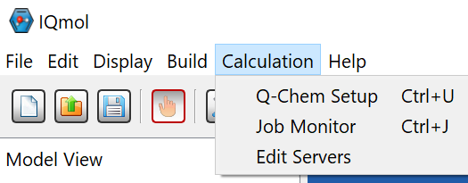

This will open “Server List” window:

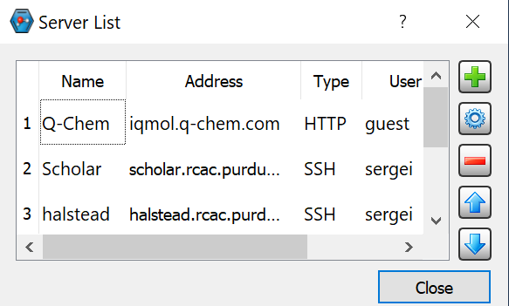

By default, it will have Q-Chem server as the only option. Every user is granted 5 minutes of computer time on Q-Chem server, which is only sufficient for small molecules. Purdue Scholar server allocates every user 4 hours of machine time per each job.

To add Scholar to iQnol servers:

press large green "+" button. New server dialog will appear:

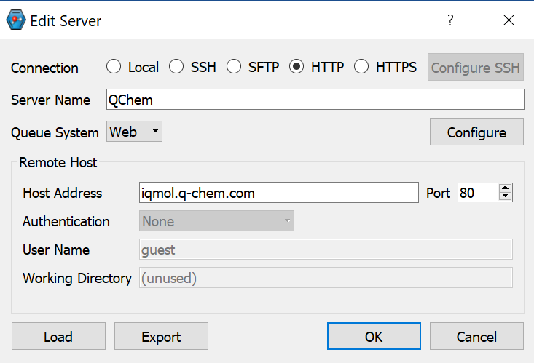

Click "Load" button in the low left corner and select iqmol_scholar.cfg file. In the server setting dialogue, change "yourcareerid" to your real career ID in User name and Working Directory.

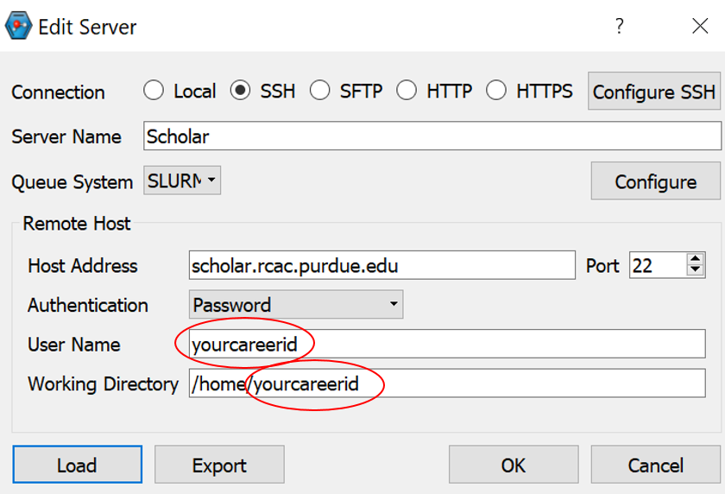

Click OK.

**Building your molecule**

When you first start iQmol it opens in “Build” mode. Clicking right mouse button anywhere within the workspace will place a carbon atom at cursor location. You can add another atom bound to the first by clicking on the first atom and dragging bond to other atom location and then releasing the mouse button.

You can select different atoms from the top menu. You can also add missing hydrogens automatically by clicking on respective button in top build menu. Since bond lengths are most surely off when you build a molecule in such way use Minimize Energy button to run a quick classical molecular dynamic simulation to optimize the structure for minimum energy.

The editor allows you to test iQmol and Q-Chem on simple molecules (by submitting the calculation to “QChem” server).

**Loading molecule from xyz file.**

Alternatively you can load a molecule from XYZ file.

**Running Q-Chem simulations**

Once molecule is created or loaded into iQmol go to Calculation>Q-Chem Setup.

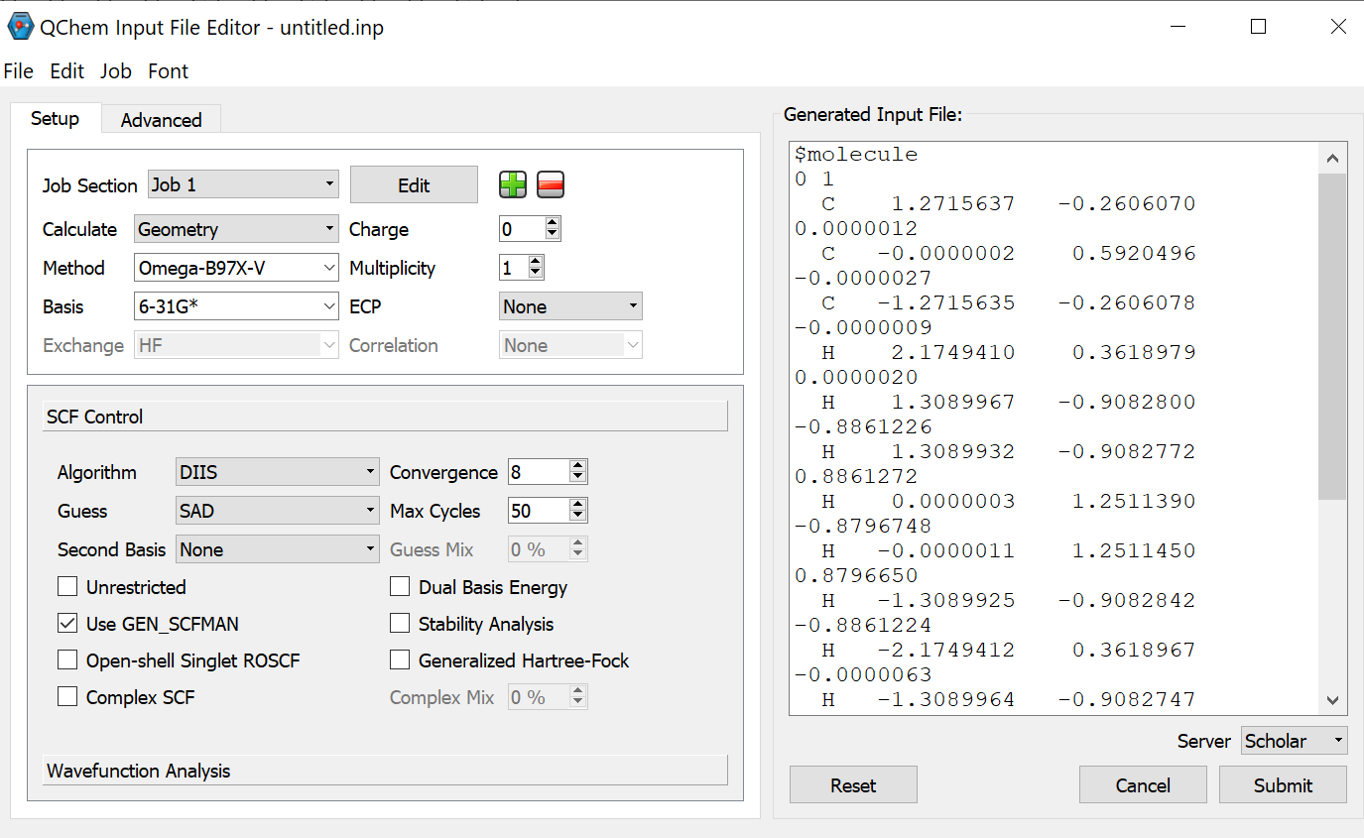

Select the needed options on the left screen and check that they appear as new keywords in the right (text) screen. You also can modify options in the text screen directly.

Select Server (Scholar) in the bottom-right corner and Submit the job. You will be asked for password (your Boilerkey password).

In the screen called "Resource Limits" you can modify Wall time (up to 4 hours) and number of CPUs (maximum of 20). Many jobs will run just fine (and with faster wait time in queue) on a single processor.

Once job is finished iQmol will notify you and ask for a directory name to which the results should be downloaded. It will automatically load the data into its editor enabling you to visualize the results.