**[8888 -- Introduction to Digital Graphics & Design](http://learnonline.gmit.ie/course/view.php?id=538" \o "42209 -- Introduction to Digital Graphics & Design)**

Photoshop assessment 10%

SOFTWARE GROUP D

Follow instructions below to create this Final Image.

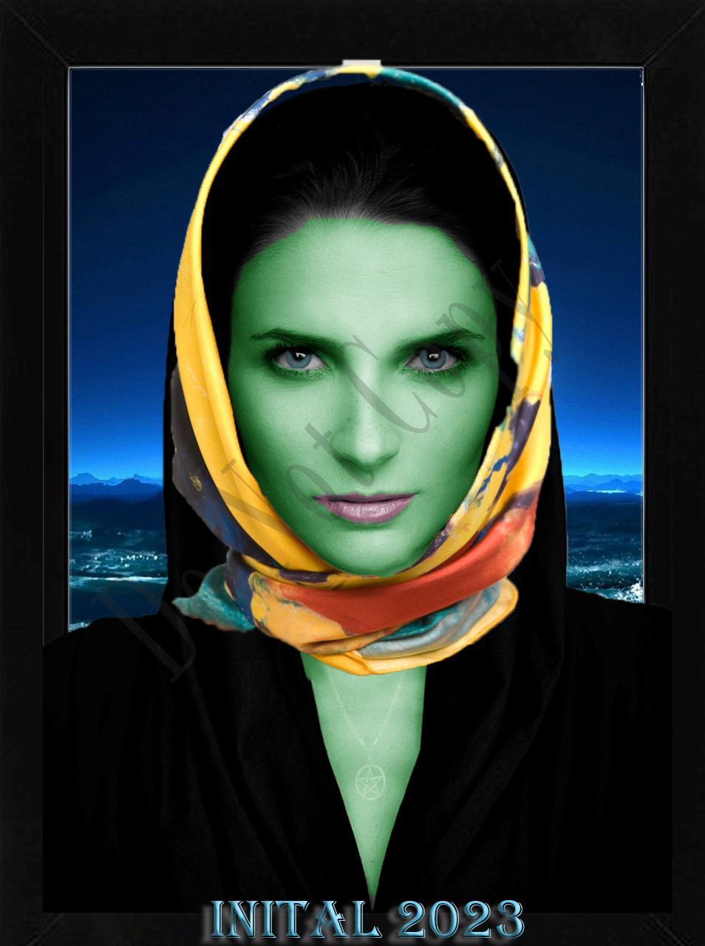

**Instructions**:

* Given the image files provided, create the final image above
* You may use module Moodle resources , Adobe help and Adobe tutorials.
* You are **not allowed** to use generative AI. This includes photoshop generative AI.
* You are **not allowed** to use the remove background option.
* Save your work as you go along.
* Follow the steps below

|  |  |  |
| --- | --- | --- |
|  | **Tasks and Marking scheme** |  |
|  |  |  |
|  | Place files on to desktop |  |
| 1. | **Important:**  open a word document and for each of the tasks 2-8 below, describe the tools, techniques and the steps you took to complete the task. You must include this word document in your submission. In each category, description, accuracy, method and detail, will account for 50%. |  |
| 2. | Repair Tear damage to face | 20 |
| 3 | Clean up skin, including removing the writing, retouch skin, and change colour of skin to green. | 10 |
| 4 | redden lips and change colour of eyes to blue, and blend in | 10 |
| 5 | Position Pendant and scarf on model | 20 |
| 6 | Add Text:  <your initals> 2024  Font: Algerian 75pt  Effect: Bevel and Emboss,  Colour: white | 10 |
| 7 | Place image in Frame | 10 |
| 8 | Take out background and replace with Sea. | 10 |
| 9. | * Save project as photoshop project PSD file and name it <your initials>.psd * Export your photoshop project as PNG file and name file as <your initials>.png * Save the word document (describing the tools, techniques and the steps you took to complete the task) as <your initials>.docx | 10 |
|  |  |  |
|  | Total | 100 |

Submission.

* Zip up PSD, PNG and your WORD document into folder called <lastnameFirstname>.zip
* Upload <lastnameFirstname>.zip to moodle to complete the assignment

First moved the missing piece into place and filled in the missing white spots.

Then I used the spot heal brush to remove any blemishes and the red line.

After I made the skin green by selecting her skin and then using the brush tool with low opacity to colour it in green but still see whats underneath.

On the next layer I did the same thing but to the lips and eyes.

And on the third layer I added the scarf.

After adding the scarf, I made a new layer and added the text at the bottom with my initials.