Tomasz Pruś
Independent Researcher, Łódź, Poland
mail: prus.tomasz.1972@gmail.com

Bidirectional cross-attention does not perform cross-modal interaction: architectural degeneracy and variance decomposition in histopathology–clinical data fusion

Abstract
Background. Fusion of histopathology images with clinical data is increasingly implemented using cross-attention modules, which are intended to let one modality selectively query the other. Whether such modules actually perform the operation they are said to perform is rarely verified.
Methods. In a cohort of 229 patients from TCGA-BRCA (primary-tumour H&E whole-slide images and non-molecular clinical variables), six architectures for hormone receptor status prediction were compared: two unimodal baselines, two concatenation variants differing in parameter budget, and two cross-attention variants. Slides were filtered by TCGA barcode, excluding normal-tissue and metastatic material. We used repeated stratified 5×5 cross-validation with three weight-initialisation seeds per fold (450 trained models), patient-level evaluation, and a permutation-based measure of modality reliance.
Results. Late fusion by rank averaging of unimodal model predictions achieved the highest discrimination (AUC 0.772) and was the only model to exceed all others after Holm correction, including both early-fusion architectures and the best unimodal variant. We show analytically, and confirm numerically, that the attention direction in which the image acts as query and the clinical vector as key and value is degenerate: with a single-element key, the softmax evaluates identically to 1, so the module output is bitwise identical for arbitrarily different images. Image reliance rose monotonically from the unidirectional cross-attention variant (rely_img = +0.006) to plain concatenation (+0.018); the only comparison of this measure surviving Holm correction was concatenation versus the unidirectional variant (p_Holm = 0.025). A capacity-matched control arm showed no difference (narrow vs wide concatenation: ΔAUC = 0.001; p = 0.50). At the level of discrimination, none of 15 pairwise comparisons survived correction for multiple testing. Variance decomposition of AUC attributed 86.2% of variability to data splitting, 11.5% to weight initialisation and 2.3% to architecture; initialisation variance exceeded architectural variance 5.1-fold.
Conclusions. Image signal in the cross-attention architecture studied reaches the classifier predominantly through residual pathways equivalent to concatenation; the contribution of the attention mechanism itself is small, and plain concatenation uses the image more effectively at lower parameter cost. Where modalities are weakly correlated and complementary (prediction correlation 0.173), late fusion outperforms early fusion. At cohort sizes typical of digital pathology, differences between fusion variants are indistinguishable from split and initialisation noise, which undermines the reliability of ablations reported from a single run.

1. Introduction

Molecular subtype of breast cancer is determined by immunohistochemical assessment of oestrogen (ER), progesterone (PR) and HER2 receptors. A haematoxylin and eosin (H&E) stained section, by contrast, is always produced as the first diagnostic step. The extent to which morphology visible in routine H&E permits prediction of receptor status therefore matters both practically — triage of cases for priority immunohistochemistry — and conceptually, as a mapping of molecular onto histological phenotype.
Work combining imaging with clinical data increasingly employs cross-attention. [1] The motivation is intuitive: concatenation of feature vectors joins modalities whose representations were derived independently, whereas cross-attention is intended to let clinical context influence which regions of the image are treated as salient — by analogy with a pathologist who distributes attention across a slide differently for a 34-year-old with a grade 3 tumour than for a 71-year-old with a grade 1 tumour.
This intuition is appealing but seldom verified. Published work typically reports that the cross-attention variant achieves a higher metric than concatenation, and stops there. It is not examined whether (a) the attention module, in the given dimensional configuration, is even capable of performing the stated operation, (b) the model in fact uses both modalities, or (c) the observed difference exceeds the variability arising from data splitting and weight initialisation.
The present work addresses all three questions using bidirectional cross-attention applied to prediction of hormone receptor status from H&E slides. [5] [6]

1.1. Contributions
- Proof of degeneracy. We show analytically, and confirm numerically, that the attention direction in which the image serves as query and the clinical vector as key and value performs no cross-modal interaction.
- Interventional measurement. By selectively removing architectural components we show that image signal reaches the classifier exclusively through a residual pathway equivalent to concatenation.
- Variance decomposition. We quantitatively separate metric variability into three sources — data splitting, weight initialisation and architecture — and derive an evaluation protocol.
- Documented replication instability. We show that the same experiment, re-run without any code change, shifted the p-value by more than two orders of magnitude.

2. Materials and methods

2.1. Cohort
We used data from The Cancer Genome Atlas, BRCA project (breast invasive carcinoma). Clinical data were taken from nationwidechildrens.org_clinical_patient_brca.txt (1,097 patients). The file contains three header rows — short names, full common data element (CDE) names, and CDE identifiers — the latter two of which must be skipped on loading.
Slides in Aperio .svs format were available for 298 patients (335 files). The TCGA barcode encodes, in the positions following the patient identifier, the sample type (01 — primary tumour, 06 — metastasis, 11 — normal tissue) and the slide type (DX — diagnostic FFPE; TS/BS/MS — frozen section). Verification of these fields revealed that 52 slides (12.5% of patches) depicted normal tissue and one a metastasis; for 25 patients only normal-tissue material was available, which would mean assigning the tumour's receptor label to images containing no tumour. Normal-tissue and metastatic slides were excluded; frozen sections were retained and noted as a limitation (Section 5). An integrity check — comparing the patient identifier parsed from each .svs filename with the mapping-table assignment — found no mismatch (0 of 27,573 patches).
After material filtering and exclusion of cases with indeterminate receptor status (Section 2.2), the analytic cohort comprised 229 patients (186 HR+, 43 HR−) from 33 tissue source sites; all patches derived from primary tumour (11,650 from FFPE slides, 15,923 from frozen sections).

2.2. Label definition and HER2 adjudication
Subtype was assigned by the St. Gallen consensus rule. ER and PR status were read from er_status_by_ihc and pr_status_by_ihc.
HER2 status was adjudicated according to ASCO/CAP [7] guidance: fluorescence in situ hybridisation (her2_fish_status) takes precedence over immunohistochemistry (her2_status_by_ihc), and cases equivocal by IHC without FISH confirmation are excluded rather than assigned arbitrarily. Incorporating FISH increased the number of patients with adjudicated HER2 status from 728 to 957 (+229; +31%).
The subtype distribution in the analytic cohort matched published values for TCGA-BRCA (Luminal A ~63%, Luminal B ~17%, HER2-enriched ~4%, triple-negative ~15%), which served as a check on the labelling rule.
Given the size of the HER2-enriched class (11 patients among those with slides), four-class classification was judged statistically infeasible. The target was therefore binary hormone receptor status (HR+ = Luminal A or B; HR− = HER2-enriched or triple-negative), with a distribution of 186 HR+ / 43 HR− after material filtering.

2.3. Clinical feature space
The following were removed from the feature space:
- label-defining variables (ER, PR, HER2 in all encodings) — retaining them reduces the task to recovering a logical rule;
- post-diagnostic variables (vital_status, days_to_death, last_contact_days_to) — these are events occurring after the time point to which the prediction refers.
Twenty-six predictors were retained: age, menopausal status, T and N stage (parsed from AJCC classification), number of lymph nodes examined, neoadjuvant treatment, race, histological type, margin status, laterality, and missingness indicators for continuous variables.
Tumour grade is not recorded in TCGA-BRCA; a search of all 112 columns of the clinical file found no such field. This is a material limitation, as grade is the strongest known morphological correlate of ER status.
The feature space was verified by an automated leakage test: a decision tree trained on features alone achieved 0.686 cross-validated accuracy against a majority-class baseline of 0.804 — below the trivial classifier, excluding label leakage.

2.4. Slide processing
Slides were tiled into 224×224 pixel patches at pyramid level 0. Tissue was detected in two stages: first on a thumbnail (greyscale intensity threshold, morphological closing and opening with a 5×5 kernel), then verified on the full-resolution patch (minimum tissue fraction 30%). Patches were sampled at random, 40 per patient from the material-filtered pool, yielding 10,500 patches (a few patients had fewer patches available after filtering).
Representations were extracted with a frozen ImageNet-pretrained EfficientNetB0, without classification layers and without global average pooling. Retaining the 7×7 feature map yields a sequence of 49 spatial tokens of dimension 1,280 — a necessary condition for cross-attention, since one cannot selectively attend over a single vector. Representations were cached to disk in float16 (~1.3 GB). [2]
Freezing the encoder was deliberate: with 229 patients, fine-tuning 19 million parameters would invite overfitting, and caching made 450 training runs feasible on hardware without an accelerator.

2.5. Compared architectures
All variants share the same classification head (Dense-64 → Dropout 0.3 → Dense-1 sigmoid) and the same training protocol.
Arm | Description | Parameters
tab | clinical data only | 11,777
img | image only (mean-pooled tokens) | 172,289
concat | concatenation of both modalities | 183,937
concat_wide | concatenation, parameter budget matched to cross | 408,833
cross | bidirectional cross-attention | 448,897
cross_a2b | clinical-queries-image direction only | 319,873

The cross-attention module implements two directions:
- A→B: the projected clinical vector is the query (a length-1 sequence); the 49 image tokens are keys and values;
- B→A: image tokens are the query; the clinical vector is key and value.
Each block contains standard transformer components: LayerNorm with a residual connection after attention, a feed-forward expansion network, and a second LayerNorm with a residual connection. Outputs of both directions are mean-pooled over the sequence dimension and concatenated.
In the cross_a2b variant the clinical branch was attached explicitly alongside the attention output, so that the variant does not lose access to clinical data; otherwise the comparison with cross would be unfair.
Modality dropout. In multimodal arms, entire modalities were zeroed at random for selected samples (rate 0.3, mask shared across all dimensions of a sample). Without this mechanism a model may rely on a single branch exclusively. [3]

2.6. Modality reliance diagnostic
We introduced a measure that directly quantifies use of each modality. After training, AUC was computed with the image input permuted across patients (clinical data unchanged), and conversely:
rely_img = AUC − AUC(image permuted)
rely_tab = AUC − AUC(clinical permuted)
A value near zero indicates that the modality does not influence prediction. The measure is direct: it does not require interpreting attention weights, whose diagnostic value is contested.

2.7. Validation protocol
- Repeated stratified 5×5 cross-validation (25 folds), split at patient level.
- Three initialisation seeds per fold — 450 trained models in total.
- Inner validation set (18% of the training fold, at patient level) for early stopping, monitoring AUC.
- Median imputation and standardisation fitted on the training fold only.
- Patient-level aggregation: probabilities averaged over the 40 patches before computing metrics. Patch-level evaluation would inflate results and misestimate variance because patches from one patient are correlated.
- Fully deterministic computation (enable_op_determinism, single-threaded execution), verified by comparing two independent runs — results were bitwise identical.
As a robustness analysis we additionally performed a tissue source site split using StratifiedGroupKFold. Plain GroupKFold was rejected because, given the highly uneven site distribution, it produced a fold consisting of a single hospital with a 45:6 class ratio.

2.8. Statistical analysis
Pairwise comparisons used the Wilcoxon signed-rank test on fold-paired results (after averaging across seeds), with Holm correction for multiple testing. Confidence intervals for means were computed by the normal approximation using the standard error across folds.
Variance was decomposed into three sources: the standard deviation between folds (averaged over arms), between seeds (at fixed fold and arm), and between arms (averaged over folds).

3. Results

3.1. The B→A direction is mathematically degenerate
In the "image queries clinical data" direction, the key and value are a single clinical vector. The attention operation then takes the form
softmax(QKᵀ/√d) · V, where K, V ∈ ℝ^(1×d)
The softmax over one element evaluates identically to 1, so the output equals V exactly — independently of the query. The block performs no selection and no cross-modal interaction.
Numerical verification: for two independently drawn image tensors with identical clinical input, the maximum difference in outputs was 0.000·10⁰, and the output was constant across all 49 spatial positions. (Figures 1-2)

- Figure 1. Architecture schematic showing both attention directions and residual pathways; the pathway actually carrying image signal highlighted.
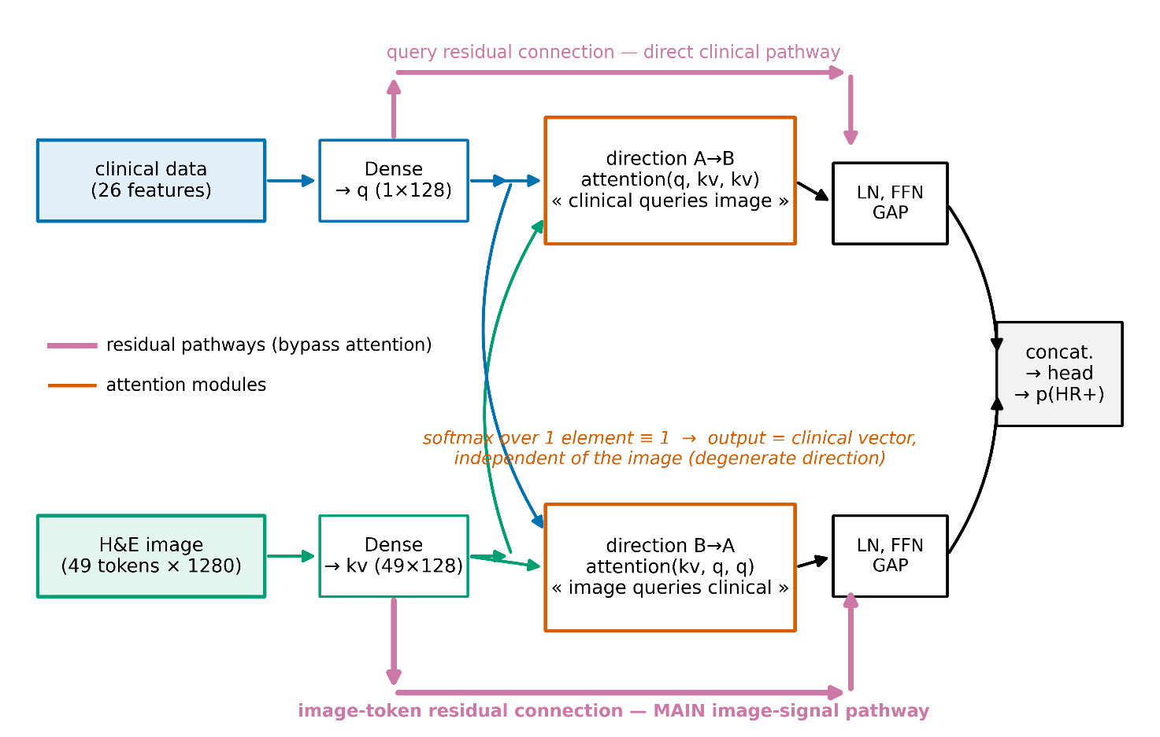
The B→A direction is not, however, inert: its residual connection passes mean-pooled image tokens to the output. It therefore constitutes an additive fusion equivalent to concatenation, implemented at a cost of 129 thousand parameters (29% of the model).

- Figure 2. Illustration of B→A degeneracy: two different image inputs, identical module outputs.
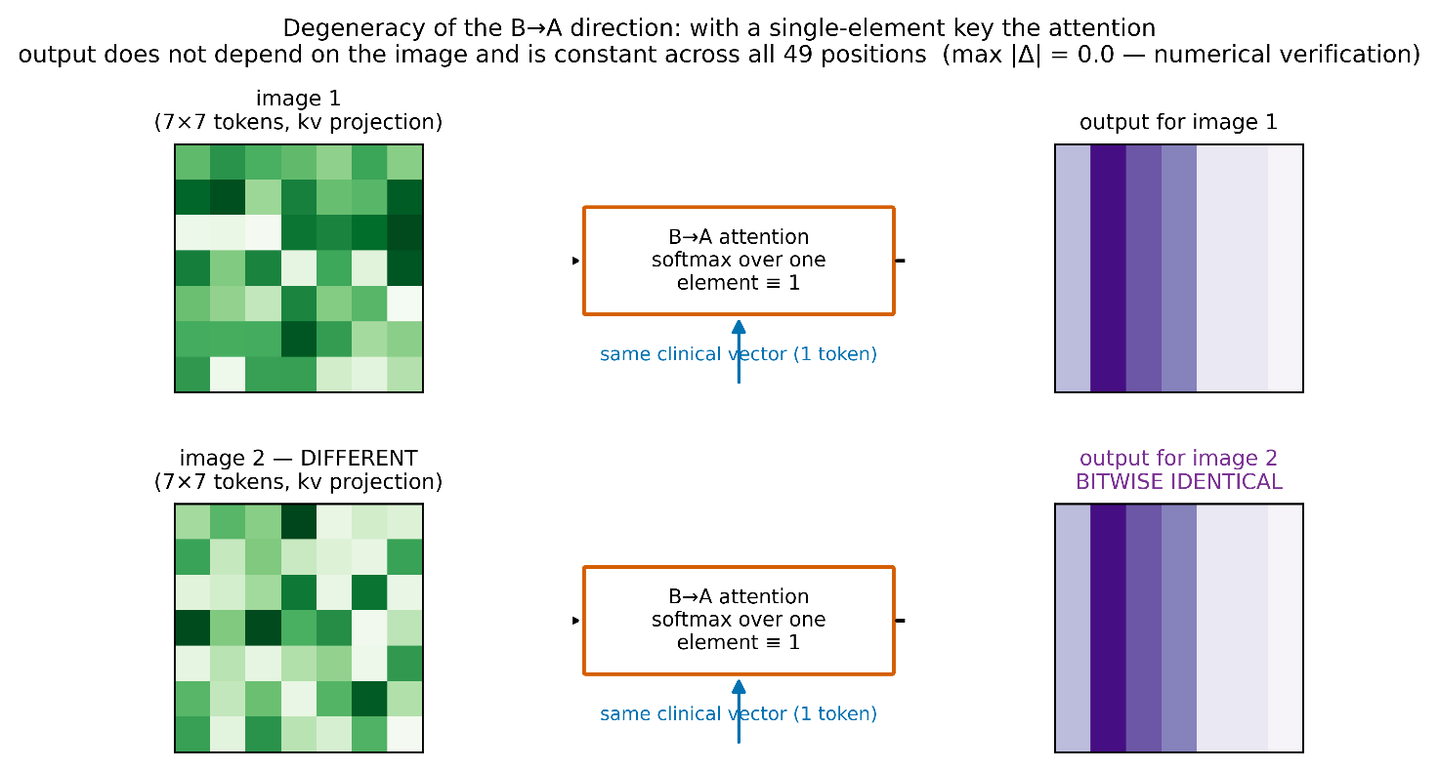

3.2. Discrimination: no differences between architectures
Table 1. Patient-level AUC, mean over 25 folds after averaging three initialisation seeds.
Arm | AUC | 95% CI | SD
concat | 0.742 | [0.702; 0.781] | 0.100
concat_wide | 0.741 | [0.703; 0.779] | 0.097
cross_a2b | 0.740 | [0.708; 0.772] | 0.082
cross | 0.736 | [0.698; 0.773] | 0.096
tab | 0.725 | [0.690; 0.760] | 0.089
img | 0.709 | [0.681; 0.737] | 0.072

None of the 15 pairwise comparisons survived Holm correction; the smallest corrected p-value was 0.17 (tab vs concat). All multimodal variants nominally exceed the unimodal ones, but the differences lie within noise.
The capacity control was unambiguous: concat and concat_wide, differing 2.2-fold in parameter count, yielded practically identical mean AUC (difference 0.001; p = 0.50). Model capacity therefore does not explain any of the observed differences.

3.3. Modality reliance: image signal comes from the residual pathway
Table 2. rely_img (drop in AUC after permuting the image input). (Figure 3)
Arm | rely_img | 95% CI | p (>0)
concat | +0.0178 | [+0.0100; +0.0257] | 0.0002
concat_wide | +0.0167 | [+0.0084; +0.0251] | 0.0001
cross | +0.0126 | [+0.0067; +0.0185] | 0.0002
cross_a2b | +0.0064 | [+0.0002; +0.0126] | 0.0096

- Figure 3. Box plot of AUC for the six arms, points = 25 folds.
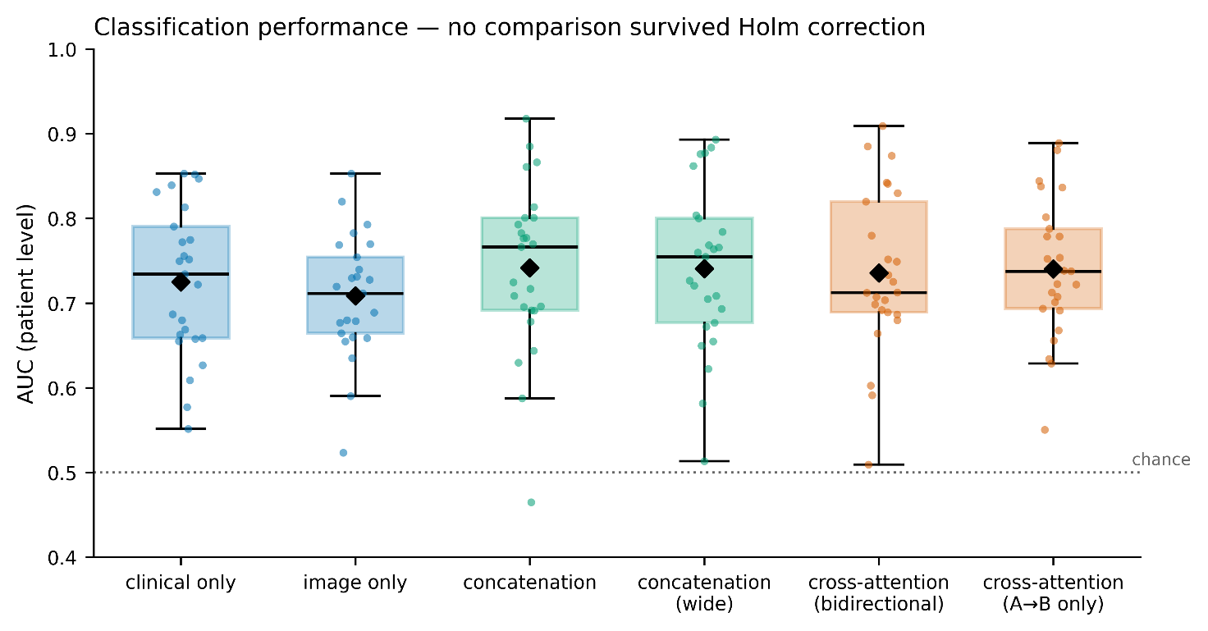
Table 3. Pairwise comparisons for rely_img (Wilcoxon, Holm correction).
Comparison | Δ | p | p_Holm
concat vs cross_a2b | +0.0115 | 0.0042 | 0.0251
concat_wide vs cross_a2b | +0.0104 | 0.0237 | 0.1183
cross vs cross_a2b | +0.0062 | 0.0710 | 0.2839
concat vs cross | +0.0053 | 0.0926 | 0.2779
concat_wide vs cross | +0.0042 | 0.3666 | 0.7332
concat vs concat_wide | +0.0011 | 0.8415 | 0.8415

Image reliance rises monotonically from the unidirectional variant (+0.006) through full cross-attention (+0.013) to concatenation (+0.018) (Figure 4). The only comparison surviving Holm correction is concat versus cross_a2b. The A→B direction — the only one implementing genuine attention — thus carries a small but measurably non-zero amount of image information (p = 0.0096); it is, however, nearly three times smaller than in plain concatenation. Since the B→A direction performs no attention (Section 3.1) while its residual connection passes mean-pooled image tokens, the conclusion is: image signal in the full architecture arrives predominantly through residual pathways equivalent to concatenation, and the contribution of the attention mechanism itself is small. Notably, in an earlier iteration of this analysis, performed before normal-tissue slides were filtered out, the rely_img of cross_a2b was indistinguishable from zero; cleaning the material revealed a weak but significant signal, illustrating the sensitivity of this measure to label noise.
Consistently, the concat arm, with 2.4-fold fewer parameters, uses the image more effectively than cross (0.0178 vs 0.0126), although this difference does not reach significance after correction.
The rely_tab measure proved too noisy to support inference (e.g. cross: +0.152 with SD 0.140) and is not reported as a result.

- Figure 4. rely_img for multimodal arms with confidence intervals; the drop to zero for cross_a2b highlighted.
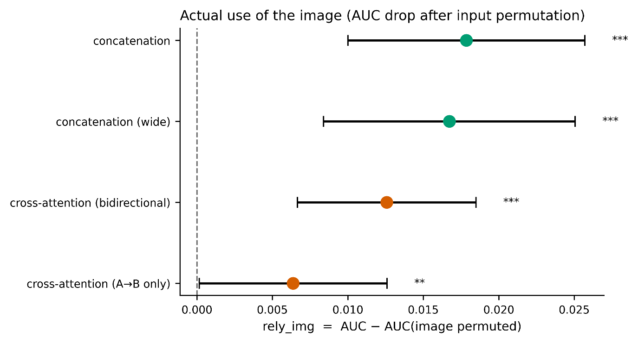

3.4. Variance decomposition
Table 4. Sources of AUC variability (Figure 5).
Source | SD | Share of variance
Data split (fold) | 0.0797 | 86.2%
Weight initialisation (seed) | 0.0292 | 11.5%
Architecture (arm) | 0.0130 | 2.3%

Variance arising from weight initialisation exceeds variance across all architectures studied by a factor of 5.1. This result was obtained on data after normal-tissue filtering; before filtering the ratio was 2.9, indicating that cleaning the material brought the architectures closer together more than it stabilised training.

- Figure 5. Variance decomposition — bar chart of the three sources.
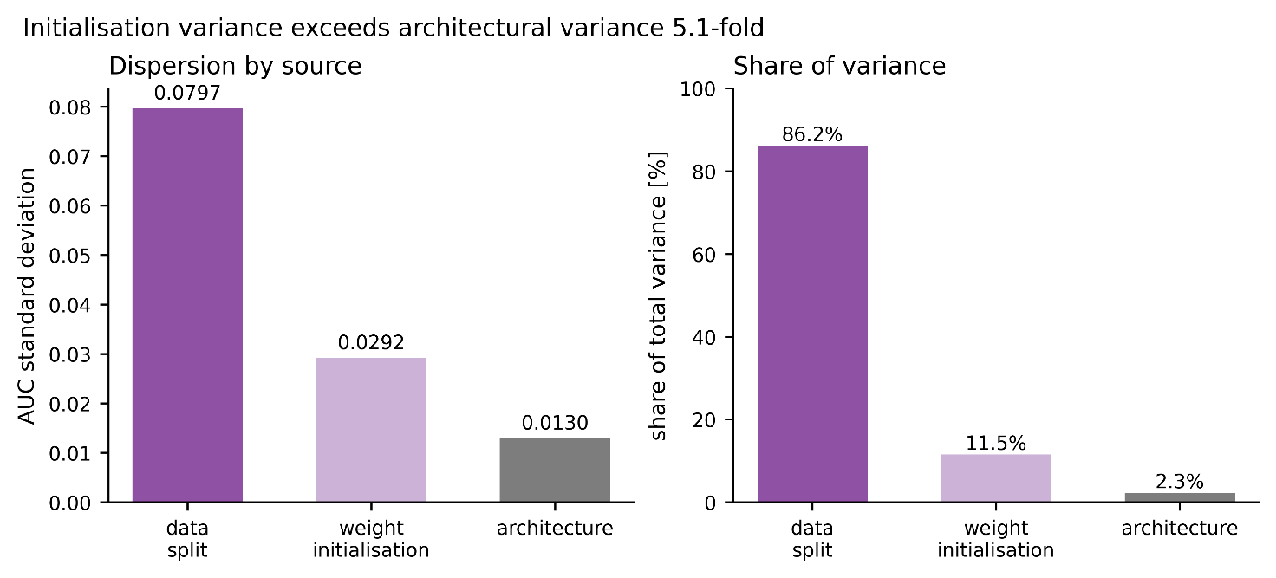

3.5. Robustness to site-based splitting
This analysis was performed on data before material filtering (255-patient cohort, including normal-tissue slides); we treat it as auxiliary, and its absolute values are not comparable with Tables 1–4.
Table 5. Comparison of splitting schemes (25 folds each, single seed; pre-filtering data).
Arm | Random split | Site split | Δ | SD (site)
img | 0.694 | 0.697 | +0.003 | 0.112
tab | 0.643 | 0.622 | −0.021 | 0.172
concat | 0.677 | 0.650 | −0.027 | 0.179
concat_wide | 0.677 | 0.648 | −0.029 | 0.185
cross | 0.660 | 0.625 | −0.035 | 0.173

The image-only variant is alone in not losing discrimination under site-based splitting, and shows the smallest dispersion. All variants containing a clinical branch lose 0.02–0.035. This suggests that the clinical data, not the image, are the source of between-site variability — the opposite of the usual concern about staining artefacts.
Under site-based splitting, the between-fold standard deviation rises from 0.096 to 0.147 and no comparison survived Holm correction (smallest p_Holm = 0.164). [4]

3.6. Replication instability
The concat versus cross comparison on rely_img was performed four times in different configurations (Figure 6):
Configuration | Δ | p
single seed, random split (run 1) | +0.0291 | 0.0005
single seed, random split (run 2) | +0.0125 | 0.106
single seed, site split | +0.0126 | 0.202
three seeds, random split | +0.0091 | 0.0275

- Figure 6. Replication instability — the same comparison across configurations.
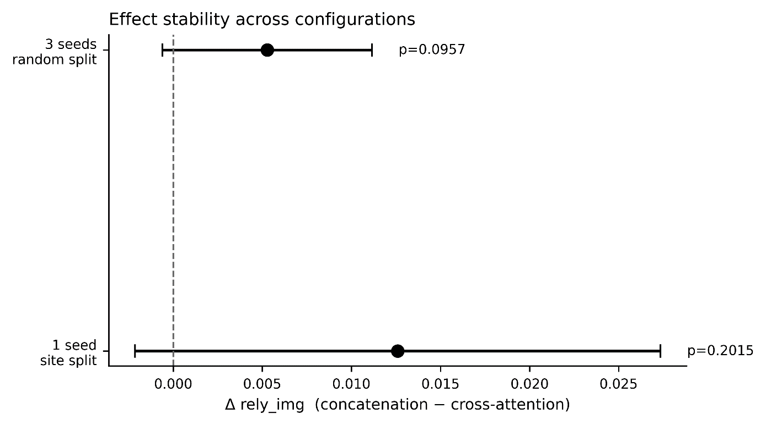
The direction of the effect is consistent across all four, but significance appears inconsistently. The first two rows come from identical code, identical splits and identical nominal seeds, run twice before full computational determinism was enabled; the p-value shifted by more than two orders of magnitude.
The opposite pattern occurred for the cross versus cross_a2b comparison: with a single seed the effect was marginal (p = 0.087), whereas averaging over three seeds strengthened it and it survived correction. Seed averaging attenuates spurious findings and reinforces genuine ones.
A third source of instability proved to be material quality: filtering out normal-tissue slides (Section 2.1) raised the AUC of every arm by 0.06–0.08 and reversed the nominal ranking (multimodal variants overtook the image-only variant), without changing any statistically significant conclusion. Results sensitive to material composition on a scale comparable to the effect under study are an additional argument for caution in interpreting ablations.
To illustrate the scale of the problem: had the analysis rested on a single 5-fold run — as most publications do — five successive split seeds would have indicated four different "winners". Individual folds yielded AUC values from 0.427 to 0.878.

3.7. Late fusion and modality agreement
Patient-level predictions of the unimodal models showed low mutual correlation (mean Pearson coefficient 0.173), indicating that the modalities carry largely complementary information. This motivates evaluating late fusion, which — unlike early fusion — does not impose a shared representation.
Table 6. Late fusion compared with early fusion (AUC, 25 folds) (Figure 7).
Model | AUC | 95% CI
late_rank (rank averaging) | 0.772 | [0.742; 0.803]
late_mean (arithmetic averaging) | 0.763 | [0.732; 0.795]
concat | 0.742 | [0.702; 0.781]
cross | 0.736 | [0.698; 0.773]
tab | 0.725 | [0.690; 0.760]
img | 0.709 | [0.681; 0.737]

- Figure 7. Late fusion compared with early fusion and unimodal variants.
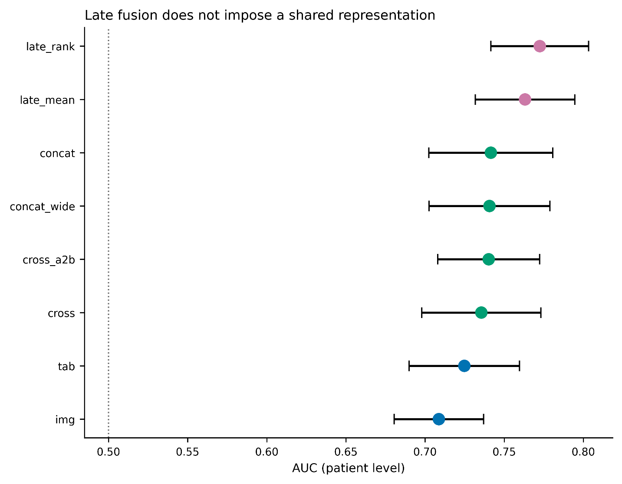
- Figure 8. Modality agreement: accuracy in concordant and discordant subgroups.
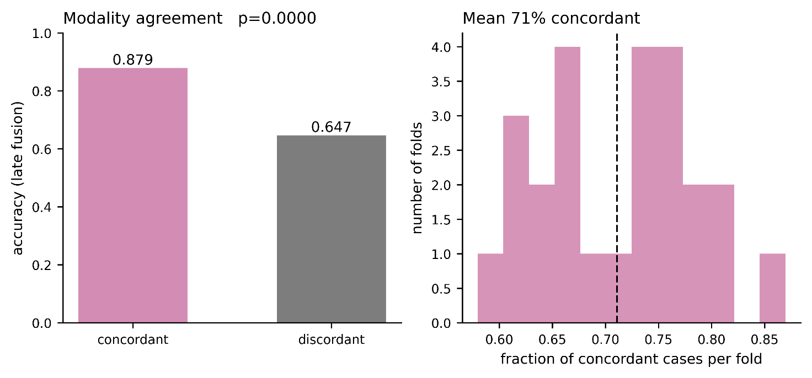
- Figure 9. Selective prediction curve — modality disagreement versus model confidence.
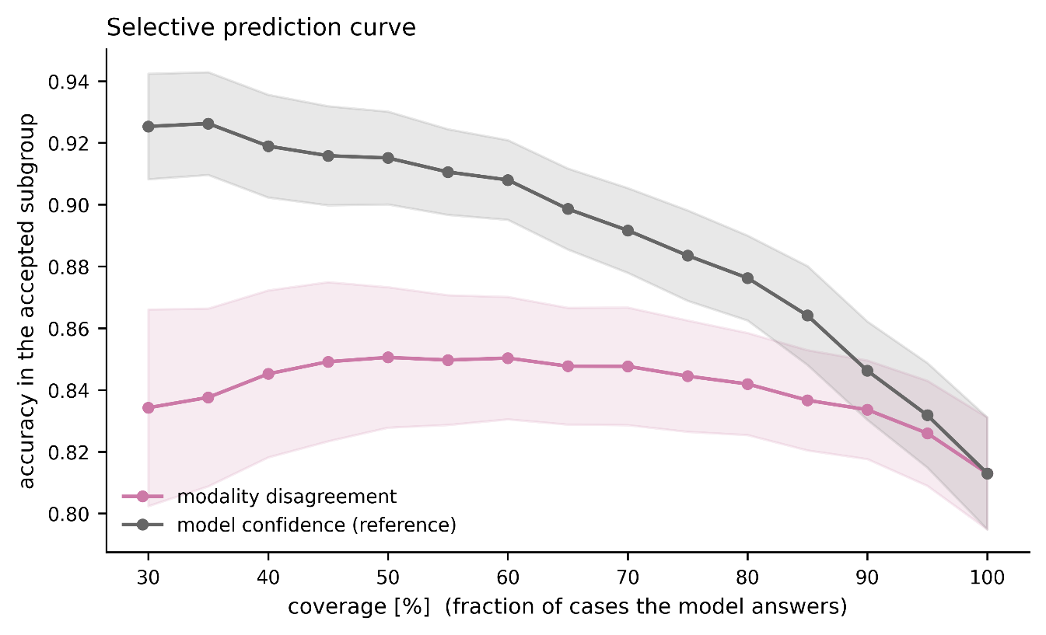
Table 7. Pairwise comparisons for late fusion (Wilcoxon, Holm correction).
Comparison | ΔAUC | p | p_Holm
late_rank vs img | +0.064 | 2·10⁻⁵ | 0.00008
late_rank vs tab | +0.048 | 0.0002 | 0.0007
late_rank vs cross | +0.037 | 0.0027 | 0.0081
late_rank vs concat | +0.031 | 0.0214 | 0.0428
late_mean vs img | +0.054 | 0.0001 | 0.0005
late_mean vs cross | +0.028 | 0.0160 | 0.0640

Rank averaging nominally outperformed arithmetic averaging (ΔAUC = +0.009; p = 0.085), consistent with differing calibration of the two component models, although on the cleaned data this difference does not reach significance.
late_rank is the only model in this study that outperforms all others after correction for multiple testing, including the best unimodal variant. Both late-fusion variants also outperform both early-fusion architectures, indicating that imposing a shared representation on complementary, weakly correlated signals loses information.
Modality agreement. At a threshold of 0.5, the unimodal models indicated the same status in 71.1% of patients. Accuracy of late fusion was 0.879 in the concordant subgroup and 0.647 in the discordant subgroup (difference +0.232; p < 10⁻⁵) (Figure 8). Modality agreement is therefore strongly associated with predictive correctness.
Selective prediction. We examined whether modality disagreement constitutes a useful uncertainty measure. As a reference we used the confidence of the fused prediction itself, 1 − |2p − 1|. At 50% coverage, accuracy was 0.851 when ordering by disagreement and 0.915 when ordering by prediction confidence (Figure 9) (difference −0.064; p = 2·10⁻⁵). Modality disagreement therefore adds no information beyond that contained in the confidence of the fused model and does not provide a better basis for flagging cases requiring verification.
These findings are not contradictory. Modality agreement is informative, but the fused model's confidence contains that information and more: the fused model uses full probability distributions rather than only the sign of the difference between them. [12]

4. Discussion

4.1. Why cross-attention fails in this configuration
The mechanism demonstrated has two components.
Dimensional degeneracy. Cross-attention requires that the side supplying keys and values be a sequence. The clinical vector is a single token, so the direction in which it serves as key reduces to a constant mapping. This is not an implementation error but a consequence of modality asymmetry: images decompose naturally into spatial tokens, tabular vectors do not.
Residual shortcut. In the A→B direction the query is the clinical vector, and the residual connection LayerNorm(q + Attention(q,K,V)) passes it directly to the output. The model may therefore zero the attention weights without losing clinical signal, rendering the image optional.
Notably, an experiment removing the residual shortcut alone (without removing the B→A direction) did not increase image reliance and lowered AUC. Interpretation: the shortcut is not the cause, but it permits nearly costless disregard of a mechanism whose own informational contribution is small (rely_img of the unidirectional variant +0.006 versus +0.018 for concatenation).

4.2. Implications for fusion architecture design
The diagnosis in Section 4.1 indicates a necessary condition for correct use of cross-attention: both sides of the operation must be sequences. The image modality satisfies this naturally; the tabular modality does not. Four remedies are ordered below by how they address this asymmetry.
(a) Feature modulation instead of attention. The FiLM mechanism [10] realises the original intention — clinical context influencing image processing — without requiring the clinical side to be a sequence. The clinical vector generates scale and shift parameters modulating the channels of the image feature map:
h' = γ(x_clin) ⊙ h_image + β(x_clin)
There is no residual connection on a query here, so no pathway arises that bypasses the image: as γ → 0 the model loses the image, but it also loses the ability to differentiate predictions at all. This is therefore an architecture in which image use is structurally enforced rather than optional.
(b) Tokenisation of the tabular modality. Representing each clinical feature by a separate learned embedding (the FT-Transformer approach [11]) converts a single vector into a sequence whose length equals the number of features — 26 tokens in the present work. The B→A direction then ceases to be degenerate: the softmax spans 26 elements, so each image region may selectively attend to specific clinical variables. This is the remedy closest to the architecture's original intention and simultaneously a direct test of the diagnosis offered here: if dimensional degeneracy is the cause of the mechanism's vacuity, tokenisation should remove it. The cost is an increase in parameters and a risk of overfitting on a small cohort.
(c) Gated fusion. A learned gate g = σ(W[h_image; h_clin]) weights the modalities per patient: h = g ⊙ h_image + (1−g) ⊙ h_clin. This is parametrically inexpensive, and the distribution of gate values is directly interpretable — it permits reporting the proportion of patients for whom the model actually relies on morphology.
(d) Late fusion — an empirically verified remedy. This direction was tested on the same cohort (Section 3.7) and proved the most effective of all approaches examined. Rank averaging of predictions from the two unimodal models achieved an AUC of 0.772, exceeding after Holm correction both early-fusion architectures (ΔAUC +0.031 versus concatenation, +0.037 versus cross-attention) and both unimodal variants (+0.064 versus image, +0.048 versus clinical). It is the only model in the study that outperforms all others after correction.
The explanation lies in complementarity: predictions of the clinical and image models correlated at only 0.173. Early fusion forces such signals into a shared representation, averaging them at a cost; late fusion lets each model retain its own characteristics and combines them only at the decision level.
(e) Modality agreement as a control signal — a partly negative result. Agreement between unimodal models proved strongly associated with correctness: accuracy in the concordant subgroup was 0.879 versus 0.647 in the discordant subgroup (p < 10⁻⁵).
This does not, however, translate into a useful triage tool. Ordering cases by modality disagreement gave 0.851 accuracy at 50% coverage, whereas ordering by the plain confidence of the fused model gave 0.915 (p = 2·10⁻⁵ against disagreement). An agreement-based measure therefore adds no information beyond that already contained in the fused model's probability distribution.
Practical conclusion: late fusion is valuable as a prediction method, but the difference between modalities is not a better uncertainty measure than standard model confidence. Selective prediction based on the latter remains the appropriate solution for a triage scenario.

4.3. Implications for evaluation protocol
The variance decomposition [9] (Section 3.4) yields a concrete recommendation: architectural ablations on cohorts of a few hundred patients require averaging over both splits and initialisation seeds. Averaging over splits alone leaves 11.5% of variance uncontrolled — three times the magnitude of the entire architectural effect under study.
Recommended minimum reporting protocol:
- repeated cross-validation (≥ 5 repeats), not a single split;
- ≥ 3 initialisation seeds per fold;
- explicit decomposition of variance into split, initialisation and architecture;
- a control arm with matched parameter budget;
- deterministic computation with documented verification of reproducibility;
- diagnostics of actual modality use, not the end metric alone.

4.4. Robustness of the image signal
The observation that the image-only variant does not lose discrimination under site-based splitting is encouraging, but does not establish the absence of a staining artefact. It establishes only that the model does not rely on features specific to sites absent from the training set; with 33 sites and a 4:1 split, the training set covers most protocol variability. A decisive test would be stain normalisation by the Macenko method, or validation on an external cohort. [4] [8]

5. Limitations
- Cohort size. With 229 patients, AUC differences smaller than ~0.035 cannot be detected at 80% power. All observed architectural differences fall below this threshold. The work therefore documents an absence of detectable differences, not an absence of differences.
- Imaging bottleneck. Clinical data were available for 1,097 patients, slides for 298, of which 264 remained after material filtering. Enlarging the slide set is the simplest route to increased power.
- No tumour grade. TCGA-BRCA does not record grade, which weakens the clinical branch and probably understates its contribution.
- Frozen encoder. Fine-tuning the image encoder could alter the balance between modalities. The decision to freeze followed from hardware constraints and cohort size.
- Frozen sections. After normal-tissue filtering, 58% of patches (15,923 of 27,573) still derive from frozen sections (TS/BS/MS), which carry ice-crystal artefacts and altered staining characteristics; 113 of 229 patients have no diagnostic FFPE slide at all. The standard in computational pathology is to work exclusively on diagnostic slides; restricting the cohort to them would, however, reduce it to ~105 patients, judged statistically unacceptable.
5a. No stain or magnification normalisation. TCGA slides mix 20× and 40× scans (in the sample examined, AppMag = 40, mpp = 0.252), and patches were taken at level 0, giving different physical scales across slides.
- IHC-based rather than expression-based labels. Concordance of the IHC surrogate with PAM50 classification is 75–80%, so some errors may reflect label limitations.
- Uneven fold sizes under site-based splitting (12 to 114 patients) — an unavoidable consequence of one site constituting 20% of the cohort. The site-split analysis (Section 3.5) was moreover performed on pre-filtering data.
- Findings apply to a specific configuration. The degeneracy of the B→A direction follows from representing the clinical modality as a single token; architectures that tokenise tabular data may behave differently.

6. Conclusions
Bidirectional cross-attention applied to fusion of histopathology images with a clinical feature vector does not perform the stated cross-modal interaction in full. The direction in which the image serves as query is mathematically degenerate and amounts to a parametrically expensive concatenation; the opposite direction implements genuine attention yet carries only a small share of the image information — image signal arrives predominantly through residual pathways equivalent to concatenation. Plain concatenation uses the image more effectively at 2.4-fold lower parameter cost.
Late fusion, which does not impose a shared representation, outperformed all early-fusion architectures studied as well as the best unimodal variant. Modality agreement proved strongly associated with predictive correctness but does not constitute a better uncertainty measure than the confidence of the fused model itself.
Independently of the architectural finding, variance decomposition showed that at cohort sizes typical of digital pathology, variability due to data splitting and weight initialisation exceeds differences between architectures many times over. Ablations reported from a single split and a single seed provide no basis for inferring the superiority of any architecture.

Declarations
Funding. This work received no external funding; computational costs were borne by the author.
Competing interests. The author declares no competing interests.
Ethics. Only publicly available, de-identified data from The Cancer Genome Atlas, distributed through the Genomic Data Commons, were used. Under TCGA policy, analysis of open-access data does not require separate ethics committee approval.
Use of artificial intelligence tools. The author used a large language model based conversational assistant (Claude, Anthropic) for code review, implementation of analysis scripts, execution of statistical analyses and manuscript editing. All numerical results were generated by code run by the author on the author's hardware and were verified by the author. The author takes full responsibility for the content of this work. The tool does not meet ICMJE authorship criteria and is not listed as an author.

Data and code availability

The code comprises the complete pipeline: slide processing, TCGA barcode-based material filtering, dataset construction, image representation precomputation, deterministic training and evaluation, late-fusion analysis, and figure and table generation. Code is available at [DOI/URL].

References
- Vaswani A. et al. Attention Is All You Need. NeurIPS 2017.
- Tan M., Le Q. EfficientNet: Rethinking Model Scaling for Convolutional Neural Networks. ICML 2019.
- Neverova N. et al. ModDrop: adaptive multi-modal gesture recognition. IEEE TPAMI 2016.
- Howard F.M. et al. The impact of site-specific digital histology signatures on deep learning model accuracy and bias. Nature Communications 2021.
- Coudray N. et al. Classification and mutation prediction from non–small cell lung cancer histopathology images using deep learning. Nature Medicine 2018.
- Naik N. et al. Deep learning-enabled breast cancer hormonal receptor status determination from base-level H&E stains. Nature Communications 2020.
- Wolff A.C. et al. Human Epidermal Growth Factor Receptor 2 Testing in Breast Cancer: ASCO/CAP Clinical Practice Guideline Focused Update. JCO 2018.
- Macenko M. et al. A method for normalizing histology slides for quantitative analysis. ISBI 2009.
- Bouthillier X. et al. Accounting for Variance in Machine Learning Benchmarks. MLSys 2021.
- Perez E. et al. FiLM: Visual Reasoning with a General Conditioning Layer. AAAI 2018.
- Gorishniy Y. et al. Revisiting Deep Learning Models for Tabular Data. NeurIPS 2021.
- El-Yaniv R., Wiener Y. On the Foundations of Noise-free Selective Classification. JMLR 2010.

