**Course: Master Software Testing + Jira + Agile**

**Section 1: Introduction**

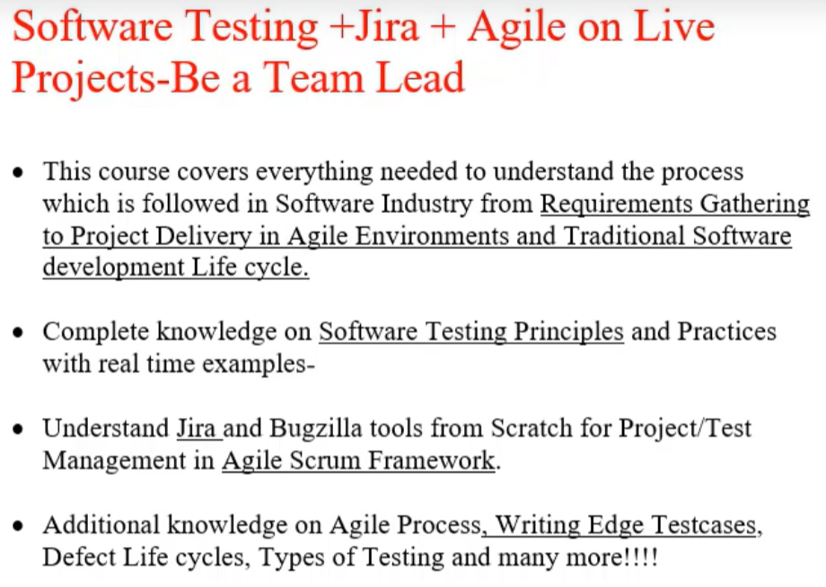

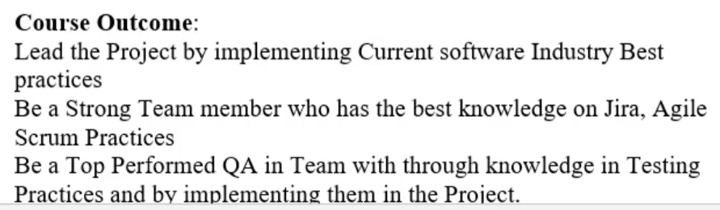

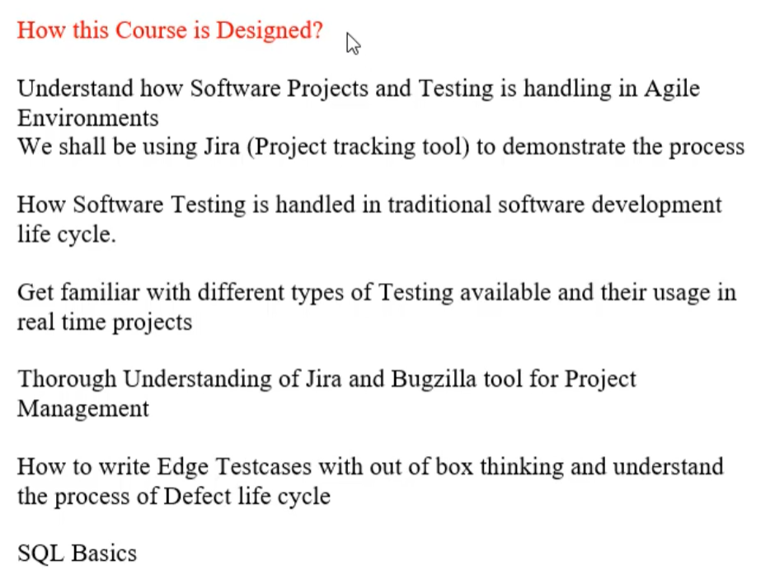

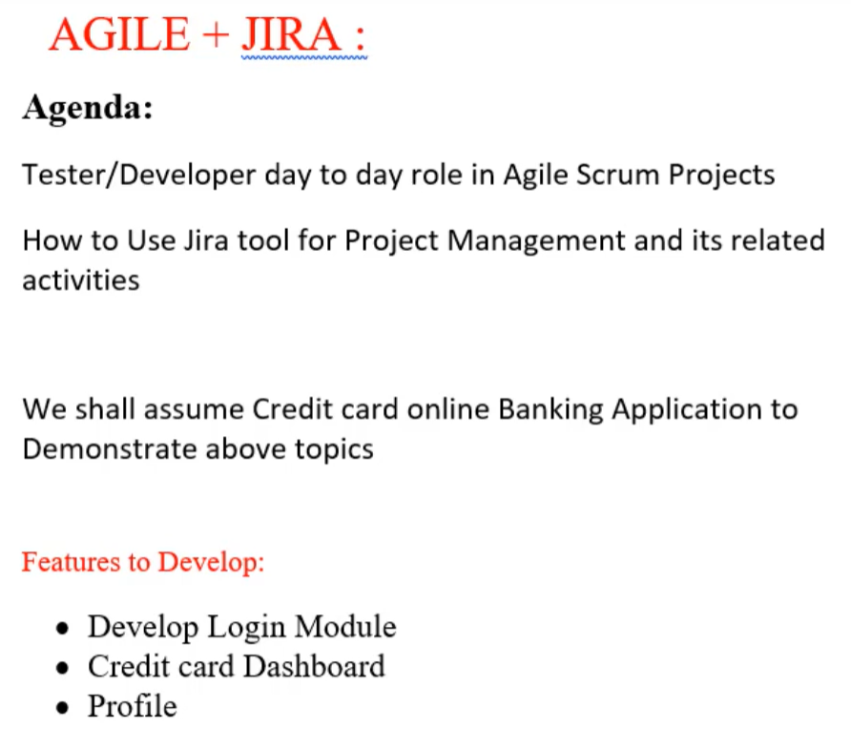

**Section 2: part 1- QA Role in Agile Scrum using Jira - Real time Project**

5. Download and Install Jira

6. Create Agile Scrum Project in Jira and Understand Epics

* What Constitutes Agile Team?

Product owner, Scrum Master, Development team (Dev,QA,BA)

* Create a new Scrum Project in Jira - CreditCardBanking

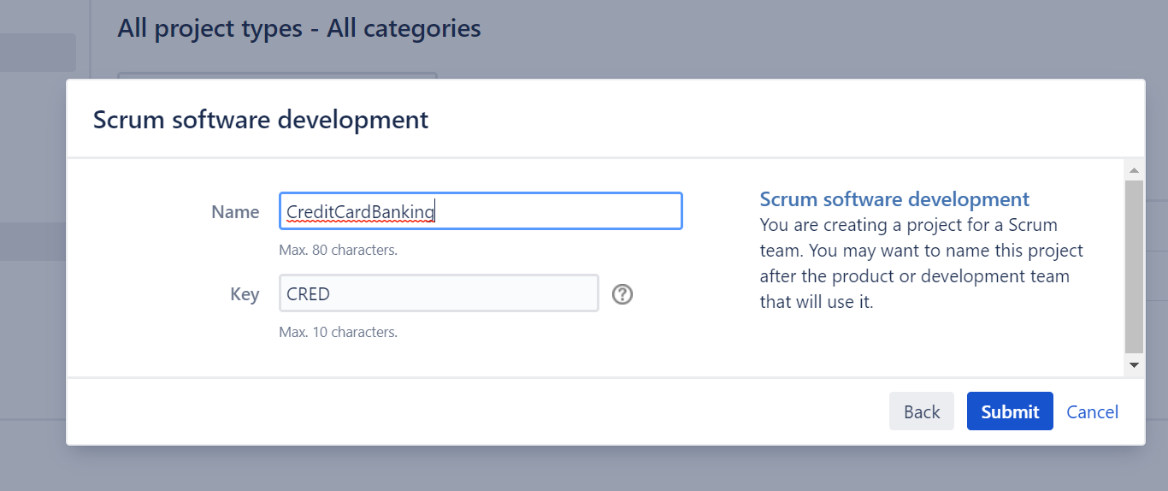

* CreditCardBanking Project home

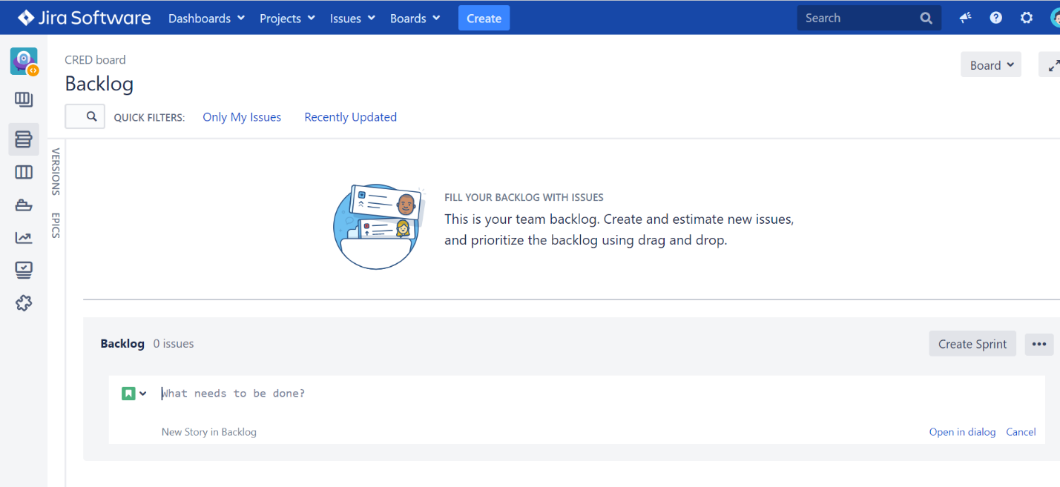



7. What are User stories in Agile? And how different they are from Epics

* CrediCardBanking Project Features to Develop :
  + Develop Login Module
  + Credit card Dashboard
  + Profile
* Or we can say there 3 epics to develop.
* what is epic?
  + An epic user story is a large that cannot be delivered as defined within a single iteration or is large enough that it can be split into smaller user stories
* What is User story?
  + A user story is the smallest unit of work in an agile framework.
  + Epics are large work items broken down into a set of stories,
  + The purpose of a user story is articulate how a piece of work will deliver a particular value back to the customer.
  + User stories are a few sentences in simple language that outline the desired outcome
* Requirements are added later, once agreed upon by the team.
* User stories are often expressed in a simple sentence, structured as follows:
  + “As a [persona], I [want to], [so that]”

8. Create epics and User stories in Jira

* Create Epic
  + In the project home, you can see the “Epics ” on the left side. Click on “Epics”, then click on “+”, the following window will pop up:

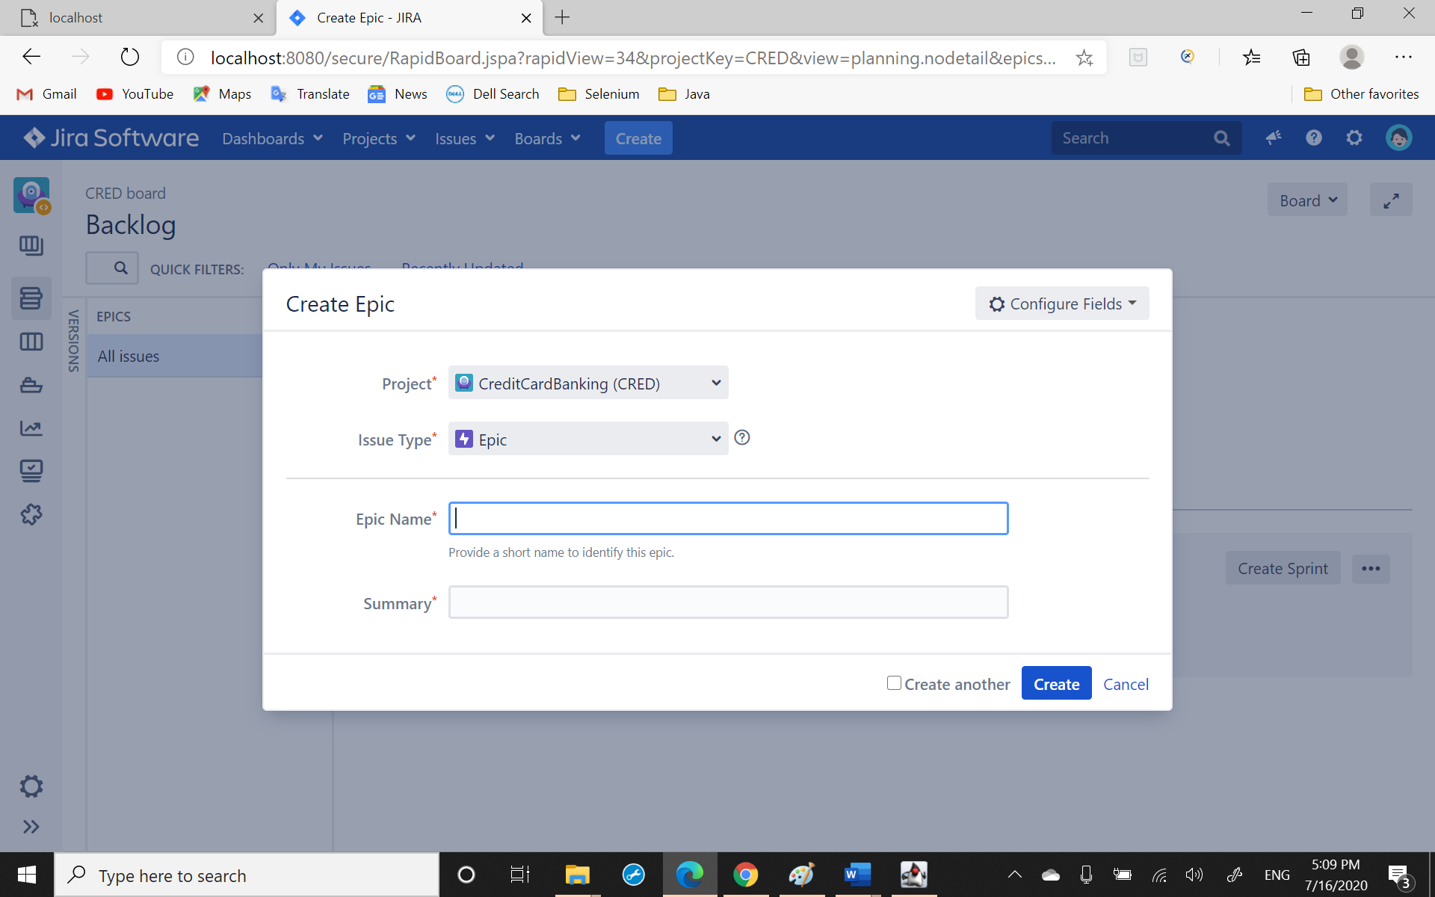

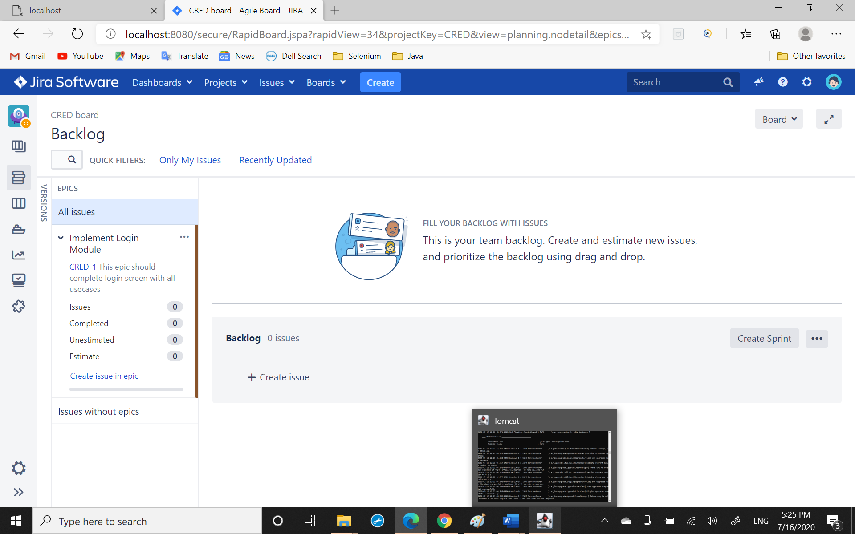

* Create user story
  + Example screen like this

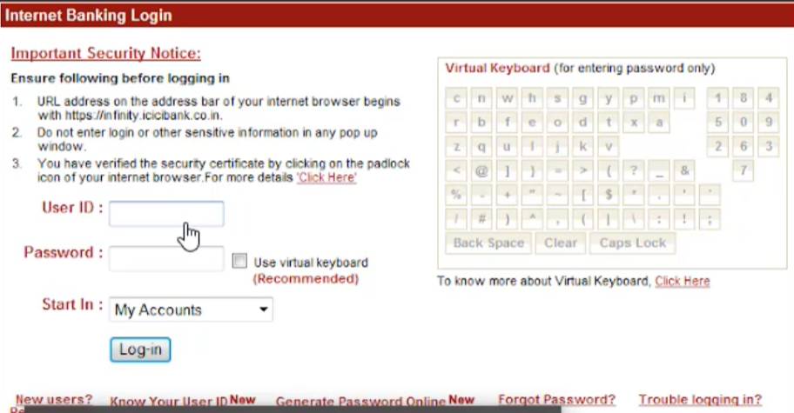

* The user story will include “User ID” input text box, ”Password” input text box, and “Start In” dropdown box.

In Jira, click on “Create” in menu bar and see the pop up window:

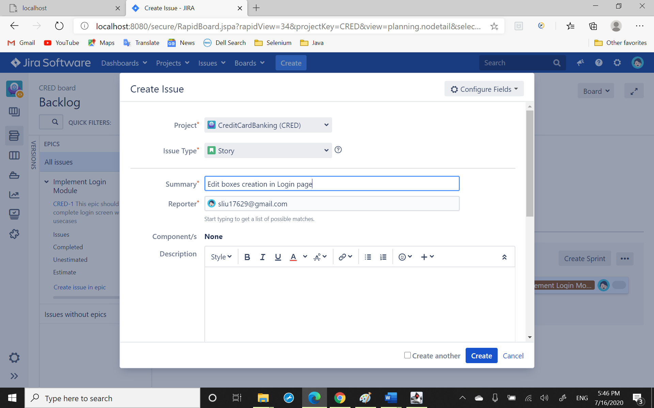

* Link the right epic and click create, then you have a user story, refresh

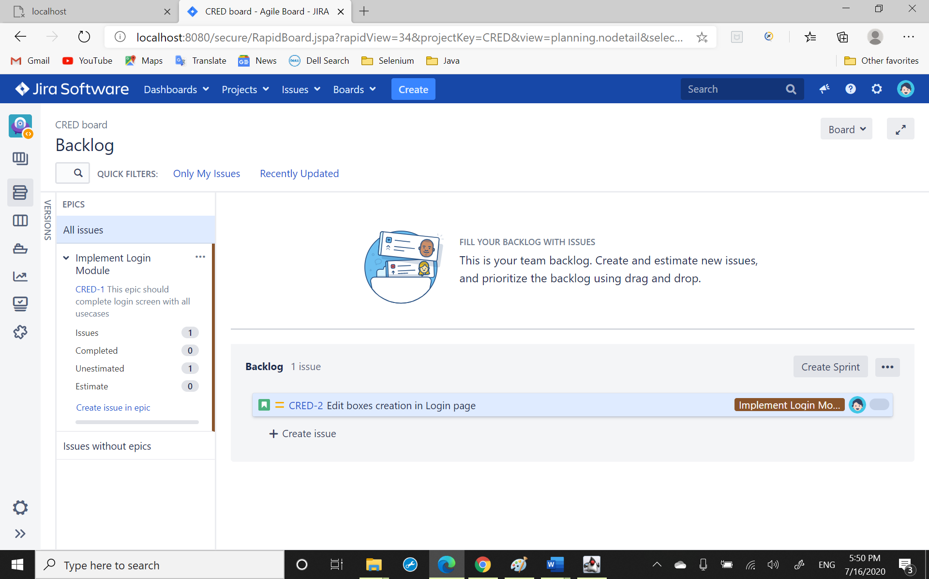

9. What are components, Release versions and how they are created in Jira

10. Defining Userstory Description to reflect Business value

* Edit boxes creation in Login page user story description:
  + “As a [persona], I [want to], [so that]”
  + As a client I should be able to enter my email and password in the login page, so that I can login.

Product owner’s duty to create one line of description for user story

Scrum team will enter the acceptance criteria (technical details)