**WFH: EMPLOYEE TASK MONITORING SYSTEM**

A Capstone Project

Presented to the Faculty of the

College of Information and Communications Technology

Bataan Peninsula State University

Main Campus

In Partial Fulfillment

of the Course Requirements in

Bachelor of Science in Information Technology

Major in Network and Web Application

by:

Dela Cruz, John Christian O.

Dela Peña, Mark Eldwin “Igiboy”

Dela Rosa, Russel John A.

Gamboa, Gabriel Rey B.

Gigante, Jascha Irish

May 2021

**TABLE OF CONTENTS**

**PRELIMINARIES Page**

Title Page i

Table of Contents ii

List of Tables iv

List of Figures v

**Chapter 1 – INTRODUCTION**

Background of the Study 1

Objective of the Study 3

Scope and Limitation of the Study 5

**Chapter 2 – CONCEPTUAL FRAMEWORK**

Review of Related Literature 9

Conceptual Framework of the Study 35

Operational Definition of Terms 37

**Chapter 3 – METHODOLOGY**

Project Design 38

Project Development 49

Operation and Testing Procedure 55

Evaluation and Procedure 59

**Bibliography**

Appendices

**LIST OF TABLES**

**Table No. Title Page**

1 User Table 48

2 Task Table 48

3 Project Table 49

4 Test Script Form 59

5 Likert’s Scale 60

**LIST OF FIGURES**

**Figure No. Title Page**

1 Conceptual of the Study 35

2 Context Diagram 39

3 Level 0 Diagram 41

4 Child Diagram for Maintenance Module 43

5 Child Diagram for Task Module 44

6 Child Diagram for Time Tracking 45

7 Entity Relationship Model 46

8 Modified Waterfall Model 50

9 Gantt Chart 54

**Chapter 1**

**INTRODUCTION**

**Background of the Study**

Technology plays a major role in changing and shaping society nowadays and has paved the way for peoples’ daily living. Advanced technology makes life easier, faster, and even better, this has created many resources that are very useful, informative, and accessible for all, it also influences the way people communicate, learn, and think. The invention of the internet provided pieces of information and learning that are very accessible all the time. As time goes by, technology will continue to develop in the future that will provide more reliable inventions.

Monitoring systems are in charge of regulating the technology used in an organization in order to examine the progress, performance, and possible errors. Monitoring systems has been very essential in every organization whether it be in an industrial, medical, or educational setting. On the other hand, task monitoring identifies, manages, and progresses the works that are needed to be accomplished at a specific time. This process involves planning, tracking, testing, setting deadlines, reporting, and ensures the projects or tasks will be fulfilled on time.

Every company and business requires the need for a workforce to perform specific functions. They are the ones who contribute to the successful performance of a company. Generally, an employees’ role in the company is the one who meets deadlines of projects or tasks, makes sales, and working on the marketing strategy. Ever since the pandemic, there are a lot of employees had the privilege to work from home.

At present, a task is manually assigned to an employee by the company's manager, who asks them to come into the office and also to submit their task. However, because of the pandemic, they are required to bring travel documents such as a travel pass and a health certificate. This takes up a lot of their time and money, and they are unable to complete their task on time. Sometimes, a task is sent via email, messenger, and discord by their manager. However, when they need to find certain tasks to do, they cannot easily access them because the messages are overlapping and the most recent messages from other people will appear right on top while the task will be behind that. Furthermore, the communication channel between the manager and the employee is through the messenger and Gmail applications, which may be a disadvantage because messages from other people are mixed in with the important ones, causing them to become out of focus due to the messenger app's notification tone.

Given the observed problems in the current situation, the proponents decided to develop WFH: Employee Task Monitoring System using an application that will monitor employees’ progress and efficiency at work. This proposed study aims to help the manager in managing their workforce and maintain a consistent and predictable schedule in distributing tasks, and as well as for the employees in submitting certain reports without having to leave the comfort of their homes.

**Statement of the Problem**

The main problem of the study is to develop and implement a task monitoring system that will prevent missing tasks due to an unorganized schedule, online submission of outputs, and unregulated tasks and profiles of the employee along with the manager.

**Specific Problems**

* How to allow the administrator to create an account and maintain all details of users, employees and managers?
* How to allow the manager to create and assign a task?
* How to allow the employees to submit outputs?
* How to allow the employees to view the task assignment?
* How to allow the manager to track employee’s working hours?
* How to allow the manager to send feedback on the submitted outputs of employees?
* How to allow the employees to ask for technical assistance?
* How to allow the employees and manager to have an online video meeting?

**Objectives of the Study**

The main objective of the study is to develop a WFH: Employee Task Monitoring System that is capable of maintaining tasks due to a well-organized schedule, online submission of outputs and monitoring employees' tasks and profiles.

Specifically, the study aims to

* Design an employee task monitoring system that is capable of:
  1. Allowing the administrator to create an account and maintain details of users, employees and manager through maintenance module;
  2. Allowing the manager to create and assign a task through the task module;
  3. Allowing the employee to submit outputs through online output submission;
  4. Allowing the employee to view the task assignment through the calendar view UI;
  5. Allowing the manager to track employee’s working hours through time tracking;
  6. Allowing the manager to send feedback on the submitted outputs of the employee through the feedback module;
  7. Allowing the employee to ask for technical assistance through technical support; and
  8. Allowing the employee and manager to have an online video meeting through a video conferencing module.
* Create a system using PHP, MySQL Server, CSS, JavaScript, Bootstrap, Adobe Photoshop, Windows OS, Web Browser, and Visual Studio Code as the software requirements, and computer system and router for hardware requirements.
* Test and improve the proposed system in terms of functional suitability, usability, reliability, security and;
* Evaluate the performance of the proposed system based on functional suitability, performance efficiency, compatibility, usability, reliability, security, maintainability, and portability.

**Scope and Delimitations of the Study**

A WFH: Employee Task Monitoring System provides a more efficient way of submitting an output and reliable way of managing output as well as employees and manager information. Also, the proposed system aims to monitor the employees’ progress and to prevent missing tasks due to an unorganized schedule.

The proposed system will allow the administrator to maintain details of users such as employees and managers of the company. Also, the employee's and manager’s details will maintain through the system along with their name, address, and other personal information. Furthermore, only the administrator can add, delete and edit information of the employee and manager through the maintenance module.

The proposed system will allow the manager to create and assign a task through the task module, as well as set the task's start and due dates. In addition, the proposed system will allow the employee to submit outputs through online output submission without going personally to the office. Also, employees can save time and money since they do not need to acquire requirements for traveling.

Through the system, the employee can view the task through the calendar view UI. It will inform employees of the tasks that must be completed on a specific day so that they do not forget about it.

The proposed system will allow the manager to track employee’s working hours through time tracking since some employers cannot imagine working without daily meetings and scheduling. This is a work procedure for the manager to improve the importance of recent works and set new tasks.

In addition, the proposed system will allow the manager to send feedback on the submitted outputs of the employee through the feedback module. Employee trust, motivation to learn, and learner performance are all enhanced by feedback.

The system will allow the employee to ask for technical assistance through technical support. Also, it will help the employees to manage their system if there is an unexpected error occurred while working. Employees will not have difficulties finding a technician since it is provided by the proposed system.

Furthermore, through video conferencing module it will allow the employee and manager to have an online video meeting. The Manager can communicate with employees’ efficiently and effectively using conference online meetings. Also, the manager can exchange ideas and share thoughts effectively as a group, regardless of distance, by holding an online meeting and bringing everyone together.

The proposed system is not capable of measuring an employee's percentage of output. In addition, the manager would not be able to determine whether an employee is working or not since it has no capability to view the monitor of every employee.

The proponents will use the required software for developing the proposed system. The proposed system requires software applications such as PHP as a major programming language for developing web applications, MySQL for database, CSS and Bootstrap for designing the front-end of the web application, JavaScript for implementing client-side scripts, Visual Studio Code as a programming platform for system development. Adobe Photoshop for creating a logo, background, and interface design of the system, Web browser for the execution of web application, and Windows OS for software program compatibility. For the hardware requirements, the proponents will use a computer system for developing the web application and documenting it. Also, the router will be used to access the internet.

The proposed system will be evaluated using ISO 25010:2011 for main quality characteristics such as functional suitability, performance efficiency, compatibility, usability, reliability, security, maintainability, and portability. It will be tested by the total respondents of thirty (30) people which is composed of twenty (20) employees (work from home), seven (7) managers, and three (3) Companies.

**Significance of the Study**

The proponents proposed system aims to help to monitor the works of the employees as well as creating and assigning a task. Also, the proponents will provide a website dedicated to employee tracking progress and submitting output more efficiently.

The proposed system will help the employees to save money and time since they do not need to travel so often. Also, the employee will prevent missing tasks and they do not need to personally go to the office to submit their reports.

Moreover, the company will be able to track employee attendance hours and project results. It will benefit them because if they can monitor an employee's attendance, they will ensure that the employee is working and that the wage they are paying is justified. In addition, the proposed system will manage the information of the users, employees and managers because it can be difficult, if not impossible to accurately track output and productivity levels without proper records.

The proposed system will benefit the community by improving the transparency and efficiency of businesses. It will improve the company's efficiency as well as the performance of the workers because it will better manage the company's target mission and objective. Also, it will benefit the community by assessing community needs and monitoring strategies or evaluating service results.

The proposed system will not be able to implement without the cooperation of the proponents. This study will be used by other students and future researchers as a guide, foundation, or additional knowledge when developing a website that implements the same functionality as the proposed system.

**Chapter 2**

**CONCEPTUAL FRAMEWORK**

This chapter presents a review of the related literature and conceptual model of the proposed study. It also includes the software requirements as well as hardware requirements needed to develop the study, and this chapter also includes an operational definition of terms to inform the reader of any unfamiliar terms they may encounter.

**Review of Related Literature and Studies**

**Company Employee**

According to Heathfield (2016), generally, an individual who is recruited by an employer to perform a specific job in exchange for payment is an employee. An employee is a term for the people who work and manage a company or organization. Employees were hired through the application and interview process which is conducted by the employer, this process will determine which applicants are the most qualified for the job.

As explained by Murray (2020), not all continually workers are employees. A person who is regularly working or serving the company in a long run typically becomes an employee. Employers normally have the authority over the employees on what and how they will administer a particular task.

However, Dewitt (2018) says that it is important to know the distinction between what makes an individual an employee and what is not. The three pieces of the test that a business should consider to differentiate their workers are social control, monetary control, and the type of relationship. These are the three pieces of the test that a business should consider to distinguish their laborers. If a worker is not an employee it is classified as independent contractors. These are the people who have their own business and at the same time accomplishing work for another business. The common law rules are not applicable for this type of worker. It is very important to determine an employee for tax purposes. The employer must withhold taxes from their profit such as social security tax, Medicare tax, and other local income taxes.

A company or business involves the use of equipment in order to operate such as manpower. Employees are the people who serve and manage an organization that was hired through an application and interview process by an employer. This is an individual who gets paid to work for a person or company under the terms of an employment contract. In this study, company employees will serve as the key player in administering the proposed system.

**Work from home**

According to Peek (2020), in the past, working remotely held a bad reputation. Many employers believe that working from home was a loss of productivity. One of their major concern was how can employees be productive and efficient without the supervision of their managers. Working from home was very unusual and it was only available as a special arrangement for the families with special cases not until the pandemic happened.

As claimed by Cook (2020), even before the worldwide pandemic made telecommuting briefly to numerous individuals, this routine has been around previously. Many people had been quitting to the inconvenience of commuting to work. Evolving technology made it unnecessary to be in an office setting to be a productive member of the team. Working from home made it easier to be connected with others through online platforms like Skype, Facetime, Zoom, Gmeet, even just texting and emails. A home office should be able to handle a wide range of tasks just as well as a traditional office.

In addition, Harvey (2020) stated in her book, “Organizations that do not offer home working may be missing out on a large pool of talent, many of whom now value home working more than the value a bonus.” Working from home benefits everyone, employees who work in a home setting without the struggle of a daily commute can be efficient while still keeping a fulfilling home life.

Working from home has been around for a very long time. Advance technology made it easier for many people to work and fulfill tasks without leaving the comfort of their homes. Due to the global pandemic, with the community quarantine in place, strict guidelines have been implemented, therefore, working from home has been the new norm. This acquired knowledge can help the proponents in developing the proposed system in which home working unfolds a variety of possibilities for the companies and other businesses to operate and utilize their resources.

**Task Monitoring**

According to Maus, et. Al (2016), the process of controlling a task during its life cycle is known as task monitoring. This can help an employee or an individual to fulfill a task or a team joining forces with their acquired knowledge or information for the attainment of the common goal. Task monitoring involves planning, testing, tracking, and reporting.

As written by Gorman (2019), every project starts with a single task. Tasks and projects are necessary to recognize how it works together to guide their team and company in attaining accomplishment. Task management is a process of dividing labor into a sequence of tasks that need to get done.

Moreover, Vennapoosa (2018) noted the importance of task management and why it needs to be included in everyday work. An employee must have at least 25 individual tasks every day, when an employee is facing these days by day without proper handling can cause difficulty in balancing work. Task management can help the employees to become more productive and in setting priorities on what important tasks need to be done and can minimize the allotted time in other tasks that are not so urgent or not that important.

Task monitoring is a process in which an individual identifies, manages, and progresses the works that are needed to be accomplished in a specific time. This involves planning, tracking, testing, setting deadlines, and reporting. This process ensures the projects or tasks to be fulfilled on time. This information will be used by the proponents as a guide on how effective task monitoring in employees’ progress and efficiency at work through this study.

**Monitoring System**

As described by Wiesen (2018), a system monitor is a piece of hardware that tracks a computer system's various aspects before showing details about its progress. This ensures the follow-up of various aspects of a computer system, such as the execution of programs, the use of resources and specific information about the hardware installed on a device.

As explained in Pandorafms (2017), the importance of having a good monitoring system. Presently, technology has been very essential for a company to continue operating. Monitoring systems are in charge of monitoring a company's technology in order to keep track of its operations and results, as well as to identify and be aware of potential errors. A good monitoring system will help a company to boost efficiency and keep track of computers, equipment, resources, and business processes.

According to Lauriac (2016), a monitoring system authorizes it to process, collect, distribute information and keep track of the task that is being handed on to the workforce. This uses a wide range of methods and tools that incorporates systems for collecting and processing data, analyzing information, communication process, and decision-making procedures.

A monitoring system allows it to collect and process data, analyze information, and helps in the communication and decision-making process. This is essential for companies and businesses because it helps in determining progress and keeps awareness of possible errors. The information obtained about the monitoring system can help the proponents in constructing and operating the suggested system.

**Web Development**

Letendart (2018) website development is a work that goes on behind the scenes to make a website look presentable and provide a simple-to-use user interface. Web developers, also known as ‘devs’, they use different language to rely on the kinds of tasks they perform and the platforms they operate on. The two parts of web development are the front-end (the user-facing side) and back-end (the back-end).

According to Berezhnoi (2018), the term web development is as broad as the ocean. There are a variety of programming languages, frameworks, and resources that are essential to technical web development. Web development, including desktop and mobile app development, is done in the same way.

In addition, Sonmez (2016) web development is a broad concept that refers to the creation and maintenance of web pages hosted on the internet. It uses the term ‘vague’ because there are so many programming languages, frameworks, and tools used in Web creation. A single web page constructed with HTML and CSS that may contain a few hundred lines of code is referred to as web development.

As a whole, web development is designing, building, and maintaining websites. When creating a website it uses different languages to rely on the kinds of tasks they perform on the website. It is related to the present study since it shows that developing a single web page required a design and maintain the website so the user will access and find the information they need more easily when using the website. The proponents will use the concept of web development for developing their web-based system.

**Database Management System**

As stated by Raza (2018), a database management system is a technology solution that optimizes and regulates the storage in databases. A database management system (DBMS) provides a method of managing databases via a user interface, along with workloads that access databases via applications. Any set of electronic documents that can be processed to generate valuable information is referred to as a database.

According to Fadhil, et. Al (2018), a database management system was used to developed software and it is useful and simple user interface, as well as a data storage, retrieval, and manipulation control system. It will make data management much easier than manually handling records. This job is beneficial in that it saves time and reduces paperwork.

Moreover, Alabdulaly (2016) reported that the information that is being collected in databases may provide the organization the ability to do various things that would be considered as well as impossible, database management systems can make data accessible to end-users and allow them to process and view it so that it can be used in their business applications. The database management system (DBMS) plays a critical role in ensuring that data is constantly systematized and manageable by acting as a crossroads between the database and end-users or application programs.

Database Management System served as a container for collecting data. It has the ability to manipulate, retrieve, and handle data in databases. The mentioned studies are related to the present study since the proposed system needs a Database Management System for handling and storing the data and personal information of the user. It is also needed by the proponents to manage data for adding removing, retrieving, and modifying information.

**Video Conferencing**

According to Correia et. Al (2020), in the context of the COVID-19 pandemic, the impetus for a shift to emergency online distance teaching has required many teachers, students, parents, and administrators to rely on videoconferencing systems for synchronous communication. This emergency response to physical distancing proves to be challenging because it is unprecedented and unplanned.

In addition, Gladović et. Al (2020) it is not economically viable to provide a full range of educational opportunities and vocational training through traditional institutions in remote or sparsely populated areas. Video conferencing has become an essential component not only of the business world, but also in education, health care, and many other ﬁelds. Nowadays, video conferencing is now used in schools and is widely recognized as a teaching method. As a form of distance education, video conferencing allows for more reliable and cost-effective delivery of learning and training.

According to Chai and Lazar (2020), a live, visual communication over the internet that simulates a face-to-face interaction between two or more remote parties is referred to as video conferencing. Video conferencing is important since it connects people who would not otherwise be able to communicate face to face. Video conferencing, at its most fundamental level, is the transmission of static pictures and text between two areas.

Video conferencing is a virtual communication between two or more people regardless of their location, which allows for real-time transmission of audio and video content. The acquired knowledge will be used in the proposed system by the proponents for communication. Video conferencing for virtual communication between employees, and managers without using third-party applications.

**Task Assignment**

According to Yanch & Wiechetek (2018), task assignment is a vital issue for businesses, employees, and administrators. Businesses must be able to satisfy the demands of a larger number of consumers, provide high-quality services, and be competitive than their competitors. The task assignment process should be well prepared, coordinated, controlled, and enhanced to increase the company's efficiency, create a productive work environment, and develop healthy relationships with employees and customers. One of the most critical steps in optimizing the capacities of enterprise capital is task assignment.

In the same way, as explained by Delfgaauw, et. Al (2017) employees in many companies work in groups to complete a range of tasks. The overall success of a team is determined by how well employees execute their tasks as well as how tasks are distributed among the employees. Allocating more important tasks to more experienced workers will increase a team's performance.

According to Technopedia (n.d), task assignment is a mechanism in which a person or a group of people keeps track of a task during its life cycle and makes decisions based on the results. Task management is achieved by the use of software tools that assist in the efficient coordination and management of tasks through features such as task creation, task assigning to the selected employee, monitoring, and reporting.

As a whole, task assignment is a process of creating a specific task and assigning it to the selected person that is needed to be fulfilled with its corresponding deadlines. The chosen topic is related to the proponents' proposed system, task assignment with calendar-based to achieve a hassle-free of assigning tasks to individuals or groups.

**Feedback Gathering**

Bowman (2020), feedback is an evaluation that provides suggestions for enhancing an assignment or task. Such advice should ideally be provided along the way, before the assignment submission. However, feedback is more than just a list of suggestions; it is a representation of teacher preparation and student engagement. Demonstrate the connection between feedback and performance, check for student comprehension, and provide opportunities for student involvement.

Furthermore, as stated by Flanagan (2017) feedback is an important component of learning and success of the culture. Providing meaningful and timely feedback to employees on their progress and career goals will be an important part of their development and success. It gives clarity to the employee about the good performance and Makes an employee feel acknowledged.

However, Marthouret & Sigvardsson (2016) feedback is frequently viewed as a crucial medium of communication, but it is not required due to the time commitment, i.e., feedback is considered as being too long to be prioritized.   
Fast feedback is conceptualized in this study as an approach to performance management that affects and contributes to an individual's personal motivation to work and employee performance. Quick feedback refers to a discussion between a manager and an employee for a few minutes.

Feedback gathering establishes an open working partnership between the team leader and the members, helping each to understand their progress toward a pre-set goal. Individuals who receive feedback will better understand what they did well and what they should improve on. The proponents will apply the concept of feedback gathering for managing workflow, employee growth, and satisfaction.

**Private Comment**

According to Kluger & DeNisi (2016), there are many possible ways for students to reduce the gap between current and desired understandings in response to feedback or private message, and they are not always effective in enhancing learning. Those likely to be effective include the following. Students can increase their effort, particularly when the effort leads to tackling more challenging tasks or appreciating higher quality experiences rather than just doing more. It is more likely to increase effort when the intended goal is clear, when high commitment is secured for it, and when belief in eventual success is high.

According to Saldana (2020), private comments authorize a person to have a one-on-one conversation with a user to help them with their issues and concerns. These allow a private conversation, and it is visible only between the user and its admin. This is necessary to privately address possible errors about the given task and to resolve problems that will take place.

Based on Classroom Help (2021), a private comment to a teacher, students can send a private comment to their teacher that only they can see from an assignment or question. Students can see their teacher’s response when they open the assignment or question. If student delete a private comment, their teacher can still see it

This acquired knowledge can help with the proposed study as a private comment can be an important part of the system as this can be used to discuss task issues confidentially. This can also be used to give feedback to have a better workforce community in an organization.

**ISO 25010:2011**

According to European Commission (2016), ISO/IEC 25010:2011 is a quality in use model that consists of five characteristics that contribute to the result of an interaction when a product is used in a particular way. This system model consists of the entire human-machine system, covering all the computer systems used and the software products used. Additionally, a product quality model with eight features that apply to the static properties of the software and the dynamic qualities of the computer system is also included.

As stated by ISO25000 (n.d.), a product quality evaluation system's foundation is the quality model. When evaluating the properties of a software product, the quality model decides which quality characteristics will be considered. A system's quality is measured by how well it meets the stated and implied needs of its various stakeholders, thus adding value. The eight quality characteristics specified in ISO/IEC 25010 are functional suitability, performance efficiency, compatibility, usability, reliability, security, maintainability, and portability.

In addition, as stated by Codacy (2021) for enterprise software teams aiming for a framework to specify software, ISO 25010:2011 is a great addition. Developers may describe software criteria that make sense for their project by breaking down the eight quality characteristics. It is mainly concerned with the specification of consistency characteristics to be used in software product assessment.

The proponents believe that ISO 25010:2011 is relevant to the study and it will use for testing and enhancing the proposed system using the parameters based on accuracy, maintainability, user-friendly convenience and user satisfaction, as well as evaluating the overall system's acceptability to end-users in terms of efficacy, reliability, consistency and timeliness.

**Google Classroom**

Google Classroom is a school of free web services that aim to simplify task creation, file distribution and task scoring. It can be used in the school to help students with homework, teamwork, and communication. Many applications that they already use, such as Gmail, Google Docs, and Google Calendar, can be used with Google Classroom.

Google Classroom and WFH: Task Monitoring System application can help users distribute files and tasks, as well as help them manage their time and communicate effectively. However, WFH: Task Monitoring System can monitor users' activities and submit employee reports, while Google Classroom is more focused on student assignments. WFH: Task Monitoring System is web-only, while Google Class is mobile and web-based, and WFH: Task Monitoring System users are people who work from home, while Google classroom users are teachers and students.

**Google Meet**

Google Meet is designed to allow thousands of people to enter a virtual meeting at the same time and talk or share videos from any location with internet access. It is meant for use by businesses and it also partnered in Google Classroom that helps the students and professors to have virtual classes. Meeting hosts will share their screen with attendees using this program. Hosts will distribute digital presentations as well as any documents, spreadsheets, or other files that they want attendees to see. HD video feeds can be accessed depending on the type of device they are using. The mobile interface shows who is in the meeting, as well as a chat room, conference details, and camera and audio on/off keys. Participants can be invited to a meeting directly from their Google calendar.

Google Meet and the proposed system are capable of virtual meeting and talking or sharing a video with one another from anywhere with internet access, and both apps can help users manage their time because the app can set the time for when the provided works are due. However, the proposed system can submit reports and docs while Google Meet only focuses on video meetings and cannot monitor or send documents.

**Time Doctor**

Time Doctor is capable of checking company-wide attendance, engagement, and workflow in real-time, as well as monitor employee application and online usage summaries and website history data. Time Doctor can take screenshots of what's being operated on in real-time if they want to. Time doctor also integrates monitored time with payroll and the chosen payment scheme and can be used to monitor time both online and offline on laptops, tablets, and mobile devices.

Time Doctor and WFH: Task Monitoring System is capable of managing employees' time. It will assist them in keeping track of their work time as well as showing them the tasks they've been given. Time Doctor, on the other hand, focuses on time monitoring, while WFH: Task Monitoring System can submit reports and documents and also a web-only application, while Time Doctor is both a web-based and a smartphone application. However WFH: Task Monitoring System has video meetings, while Time Doctor focuses on employee progress monitoring.

**Software Requirements**

The proponents will use different software in order to develop the proposed system. The following software requirements are PHP, MySQL, CSS, JavaScript, Visual Studio Code, Bootstrap, Adobe Photoshop, Web Browser, and Windows OS.

**Visual Studio Code**

As cited in educative (n.d.), Visual Studio Code (also known as VS Code) is a free open source text editor. For Windows, Linux, and macOS, VS Code is open. VS Code includes some powerful features that have made it one of the most common development environment tools in recent years, despite its lightweight. In comparison to other text editors, the VS Code user interface allows for a lot of interaction.

According to Kahlert & Giza (2016), it is a popular development platform that blends a compiler's simplicity and ease of use of a compiler with the best of what developers require during their primary code-build-debug cycle. Visual Studio Code is a cross-platform development platform that supports Operating System X, Linux and Windows.

In addition, Code visual studio (2016) Visual Studio Code comes with a lightning-fast source code editor that's suitable for daily use. In VS Code, which supports hundreds of languages, syntax highlighting and more are all available. They can navigate their code by coming in simple to keyboard shortcuts, simple customization, and community-contributed keyboard shortcut mappings.

Visual Studio Code editor has powerful features with lightning-fast source code. It also provides numerous ways for extensions to expand their abilities. The proponents will use visual studio code as the platform for developing and code editing for the proposed system.

**PHP**

Based on Guru99 (2020), PHP is a server-side scripting language that can be used to create static, dynamic, or web-based applications. The acronym PHP stands for Hypertext Preprocessor, which was formerly known as Personal Home Pages. PHP scripts can only be run on a server that has the PHP language installed.

According to Tatroe & McIntyre (2020), PHP is an effective and simple language for creating HTML content. It was created with the intention of creating interactive web content, and it is still the best tool for the job. PHP has built-in support for creating PDF files, as well as GIF, JPEG, and PNG images, and the language itself is extremely flexible.

In addition, based on Technopedia (2019) PHP stands for PHP: Hypertext Preprocessor, which is a scripting language for building dynamic and interactive HTML Web pages. When a website user opens a tab, the server processes PHP commands and sends the results to the visitor's browser. Beginners will find PHP to be very simple to use, but it also has a lot of advanced features for experienced programmers.

Based on the above-mentioned studies PHP language is commonly used by the programmer to develop static, dynamic, or web-based applications. The proponents will use PHP language to create the proposed system. Also, the programmer chose this language since it has all the features needed to develop and complete the system.

**CSS**

As stated by Morris (2020), CSS stands for Cascading Style Sheets with an emphasis placed on “Style”. CSS takes over and defines the look of their document page templates, colors, and fonts are all defined by CSS. It is written in simple, plain text through a text editor or word processor on their computer.

According to Adebola (2018), CSS is a basic design language that aims to make the process of creating a web page presentable as simple as possible. It is made up of style rules that are added to the corresponding elements in their document by the browser. A style ruler consists of three selector parts, property and value.

In addition, as stated in Technopedia (n.d) CSS allows developers to separate content from visual elements, giving them more power and versatility over their pages. A CSS file is normally attached to an HTML file by means of a link in the HTML file. It allows developers to move styling elements to a separate HTML area for clean markup.

CSS is a design language that makes it easier to make web pages look more attractive. It is in control of a web page's appearance and feels. The proponents will use CSS for designing the proposed system such as image, color, background, and text.

**JavaScript**

As stated in Developer Mozilla (2021), (JS) is a first-class compiled programming language that is lightweight, interpreted, or just-in-time compiled. It is a single-threaded, prototype-based, dynamic language that supports object-oriented, imperative, and declarative (e.g. functional programming) programming types.

Based on Hackreactor (2018), JavaScript is a text-based programming language that allows developers to create interactive web pages on both client and server sides. It adds interactive features to web pages to keep users interested. Amazon's search box, with a news rundown video embedded on The New York Times, and refreshing their Twitter feed are all examples of JavaScript that they may encounter on a daily basis.

Additionally, as discussed by Brown (2016) JavaScript is now a viable option for framework scripting, desktop application creation, backend web development, and even embedded applications, in addition to the browser. JavaScript is often used to improve a user's interaction with a website.

JavaScript is a programming language used for making websites interactive. It is used to control the behavior of different elements. The proponents will use JavaScript for manipulating the behavior of different elements that will apply in developing a web page. It will help to respond to a user's behavior in a variety of ways.

**MySQL**

Dwika (2020), stated that MySQL is a client-server relational database management system (RDBMS) that is free and open source. A relational database management system (RDBMS) is a software or service that enables them to create and maintain databases using a relational model. It is one of the most popular RDBMS software’s brand names, which implements a client-server model.

As stated by Wallen (2018), stated that MySQL is a bit easier to administer and capable of creating, editing, and deleting the database. It uses a username and password to access a database server. MySQL can be used for a variety of purposes, although it is most commonly used on web servers.

In addition, Technopedia (2018) MySQL was a free database engine that was first developed and published in 1995. MySQL was named after the daughter of one of the product's creators, Michael Widenius. The MySQL source code, on the other hand, is freely available since it was built as freeware. MySQL is a database management system written in C and C++ that runs on all major operating systems.

MySQL is a structured collection of data. It can add, retrieve, and process data stored in a computer database. The proponents will use MySQL to handle data in databases. It is highly suited since the programmer will access the database on the internet.

**Bootstrap**

Based on Career Foundry (2021), bootstrap is a large assortment of useful, reusable code written in HTML, CSS, and JavaScript. Bootstrap is a front-end development platform that allows developers to create fully responsive websites with ease.

Additionally, Techtarget (2017) explained that bootstrap is an open source front-end development framework for the development of websites and web apps. Responsive design allows a web page or app to detect the visitor's screen size and orientation and automatically adjust the display.

As cited in Simbla (2017), the responsiveness of Bootstrap means that it adjusts to the size of the screen on which the user is viewing the website, such as desktops, computers, or mobile phones. All current browsers, including Chrome, Safari, Internet Explorer, Firefox, and Opera, are supported.

Overall, Bootstrap is a free tool for any front-end developer looking to build responsive, mobile-first web projects. The proponents will use bootstrap for the responsiveness of the website since it is not implemented in android devices.

**Web Browser**

Based on Techterms (2020), a web browser is an application used to access and view websites such as Microsoft Internet Explorer, Google Chrome, Mozilla Firefox, and Safari. A web browser's primary purpose is to render HTML, which is the code used to design or markup web pages. When a browser loads a web page, it processes the HTML, which may contain text, links, and references to images and other items like CSS and JavaScript functions.

In addition, based on Computer hope (2020) a web browser is a software program to present and explore content on the World Wide Web. These pieces of content, including pictures, videos, and web pages. A web browser is connected using hyperlinks and classified with Uniform Resource Identifiers.

According to Rathod (2017), web browsers are used by users to perform different tasks such as browsing, sending email, online banking, social media applications, uploading documents and images, and so forth. Malicious (suspect) internet users attempt to steal sensitive and confidential information from internet users in order to gain personal financial benefit.

A Web browser is a software application to access information on the World Wide Web. When a user requests a web page from a specific website, the web browser loads the required content from a web server and displays it. The proponents will use a web browser as a software requirement for the proposed system to be able to access and view the content of the system.

**Windows OS**

According to Adektoju, et. Al (2020), various operating systems (OS) have emerged, each with its collection of features and functions. Users' decisions on which operating system to install on their computers are driven by their understanding of each OS's functionalities. Operating System (OS) is software that manages and controls the main computer hardware, the hardware peripherals, and software resources, so also the users

Based on Computerhope (2020), Microsoft Windows (also known as Windows or Win) is a graphical operating system that was created and distributed by Microsoft. Windows OS allows to store files, play a game, run different applications, watch videos and access the internet. A window is a portion of the screen that contains only one active program. The user can shift, resize, hide, or optimize the window as desired. This UI feature is named after the Microsoft Windows operating system.

As explained by Olusanya (2016), all computers and computer-like devices, including laptops, tablets, desktops, smartphones, smart watches, and routers, have operating systems. It serves as an interface between the hardware and other software on the computer system. It allocates memory locations to data and other computer programs. It also performs hardware and software diagnoses to detect faults and errors.

Windows operating system is an operating system developed by Microsoft. It is a primary software that manages all the hardware and software on a computer. The proponents will use the Windows operating system to construct and navigate the system. It will also be used for gathering knowledge, and software requirements for developing the proposed system.

**Adobe Photoshop**

As cited in Agitrainig (2020), users can use Adobe Photoshop to make, enhance, and edit photographs, drawings, and illustrations. It can be used to change backgrounds, simulate a real-life drawing, or create a different view of the universe. Adobe Photoshop is an essential tool for photographers, designers, web developers, and creative professionals for manipulating an image. It is a widely used editing program by users.

According to Virgillito (2021), Adobe Photoshop is imaging and graphic design software that is used by thousands of people worldwide. This software application is helpful for all kinds of business and personal uses. Also, it is not only for photos but it can use for designing websites, editing videos, and creating 3D artwork.

Additionally, as discussed by Englehardt (2016) Adobe Photoshop, Illustrator, and InDesign are the central components of the Adobe Creative Suite. Photoshop is adapted to edit and produce pixel-based images and illustrations, as well as banner advertising, photo editing for printing, video graphic design and user interface design. On the other hand, it is not the best software for making logos since it will not be able to edit or enlarge the files the way it can with a file from Illustrator.

Adobe Photoshop is computer software used for image editing and enhancement. Photoshop can be used to design websites, and create 3D artwork in addition to pictures. Adobe Photoshop will be used by the proponents for editing images and creating a logo that will be used in a website such as a background image, banner, footer, etc.

**Hardware Requirements**

The hardware requirements that will be used by the proponents in order to complete the proposed system are the Computer system and Router.

**Computer System**

As stated in Computer hope (2020), a desktop computer is intended to be used in a single location like an office or home and not moved around much. It can be installed on or under a desk. Desktop computers are large and use peripherals such as an input keyboard and mouse, as well as display devices such as a separate monitor. An All-in-One computer is made up of a desktop computer and a monitor. Unlike a laptop, which is portable, a desktop computer is stationary.

In addition, Bucki (2019) explains that a laptop computer is a portable computer that can be carried around by a user. They are meant to be more compact than standard desktop computers while still having much of the same features. Laptops come with a built-in keyboard and touchpad, as well as the ability to fold flat for transport.

However, Shankel (2020) stated that desktop computers and laptop computers have the capability to handle most of their computer needs like working on documents, sending files, emails, and connecting to the Internet. Multitasking is possible on both desktop and laptop computers. Multi-tasking simply means having numerous Web pages, blogs, or documents open at the same time. On laptops and desktop computers, it can do also video conference using applications like Skype.

Using the acquired references it shows that desktop and laptop are the same capabilities such as working on documents, connecting to the internet, sending files, images, videos, and emails. The major difference between the two computer systems is laptop computer is portable that can be carried around with the user while a desktop computer is stationary and installed on or under a desk. Proponents will use desktop and laptop computer systems for creating the proposed web-based system. It helps also in creating the design and documents needed in the proposed system.

**Router**

According to Fisher (2020), a router is the most common type of home network system. This is network hardware that connects computer systems and other wired devices to the Internet through their local home network. Most routers link to other network devices through network cables and operate without the requirement of drivers.

As explained by Ellis (2020), routers are the most common network device in the world. A router is in charge of coordinating communication among computer networks. A router takes data packets from devices and directs them to the appropriate destination. IP addresses are often used by routers to determine where to search for information.

Based on Computer hope (2019), a router is a piece of hardware that receives, analyzes, and forwards incoming packets to another network. It can also perform other network-related tasks such as sending packets to a different network interface and dropping them. A router also has much more features than other network devices such as a hub or switch, which can only perform basic network functions.

Most of the researchers and programmers used a router as a device for connecting to the internet. The router will be used by the proponents as a source of internet for gathering information that will be used in documentation and for developing the proposed system.

**Conceptual Model of the Study**

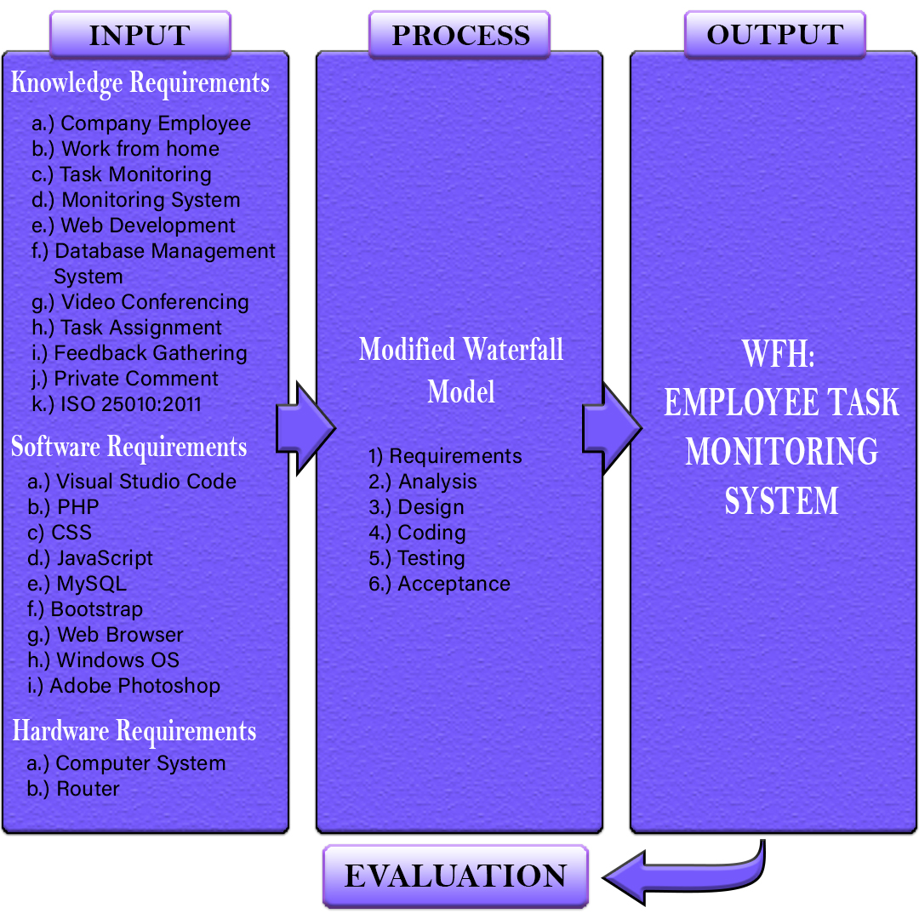 According to Argent, et. Al (2016), a conceptual model is a representation of a system that uses concepts and ideas to form said representation. Conceptual modeling is used to express relationships, explore and test ideas, check inference and causality. Also to identify knowledge and data gaps, synchronize mental models and build consensus.

***Figure 1.***Conceptual Model of the Proposed Study

The conceptual model of the proposed study is shown in Figure 1, this contains the four phases which are the input, process, output, and evaluation. The input phase contains knowledge requirements, software requirements, and hardware requirements. In knowledge requirements, it includes the Company Employee, Work from home, Task Monitoring, Monitoring System, Web Development, Database Management System, Video Conferencing, Task Assignment, Feedback Gathering, and ISO 25010:2011, these requirements will help comprehend and enrich the knowledge acquired in developing the proposed study. Also, the software requirements that will be used are Visual Studio Code, PHP, CSS, JavaScript, MySQL, Bootstrap, Web Browser, Windows OS, and Adobe Photoshop. Furthermore, the hardware requirements are the computer system and router that will be used for developing the proposed system.

The Process phase contains the methodology that will be used in developing the system, which is the Modified Waterfall Model, this includes Requirements, Analysis, Design, Coding, Testing, and Acceptance.

For the output, the proponents will develop WFH: Employee Task Monitoring System. The finishing phase will be the evaluation. The proponents will test and evaluate the proposed system using ISO 25010:2011 that has the following criteria: Functional suitability, Performance efficiency, Compatibility, Usability, Reliability, Security, Maintainability, and Portability.

**Operational Definition of Terms**

The following are the terms that operationally defined for a better understanding of the study:

**WFH: Employee Task Monitoring System** - a web-based system that allows the manager to create and assign tasks online, as well as for employees to submit outputs online. It also helps employees to use the calendar view UI to see the tasks that need to be submitted. In addition, the system allows employees and managers to conduct virtual meetings through video conferencing.

**Calendar view UI** – it allows employees to view their tasks using calendar view User Interface.

**Employee** – an employee who works from their home or comfort of their home, instead of at an office.

**Feedback Gathering** –feedback or comment by the manager on the submitted output of the employee.

**Output** – the task or documents that are already done and ready to submit either.

**Task Assignment** – assigning a task with start and due date online.

**Task Monitoring** – to monitor the task submitted by the employee either in progress or done that needs to be accomplished in a specific time.

**WFH** – stands for Work from Home

**Chapter 3**

**METHODOLOGY**

In this chapter, the process and the flow of the system will be discussed in project design such as Context diagram, Level 0 diagram, and Child diagram. It also contains a discussion of the proponents' Gantt chart and methodology used in the proposed system. In addition, this chapter also contains the Operation and Testing Procedure as well as Evaluation Procedure that will be used by the proponents to test the performance of the proposed system.

**Project Design**

The WFH: Employee Task Monitoring System is tracking employee’s progress on tasks they are working on given by their manager. The manager can create and assign tasks, it can be viewed by the employee by calendar view UI. In addition, the manager can give feedback on an employee's submitted task and track the employee’s working hours. The system allows the administrator to maintain all information and accounts of the company. Also, the administrator has the capability to add, edit, and delete information about the employee. The employee can view their daily task using the calendar view UI and it can help employees not to forget the tasks that must be completed on a specific day. Furthermore, it allows employees to ask for technical assistance if they encounter problems while working. Moreover, the system allows the employees and manager to have an online video meeting. Also, a manager can exchange ideas and share thoughts effectively as a group, regardless of distance, by holding an online meeting and bringing everyone together.

**Data Flow Diagram (DFD)**

According to Aleryani (2016), Data Flow Diagram (DFD) is a structured approach, the DFD is the primary artifact that must be developed for every system. A data flow diagram is a graphical representation of how information flows through a system. It shows data flow from outside and into the system as well as how data was passed from one phase to the next.

**Context Diagram**

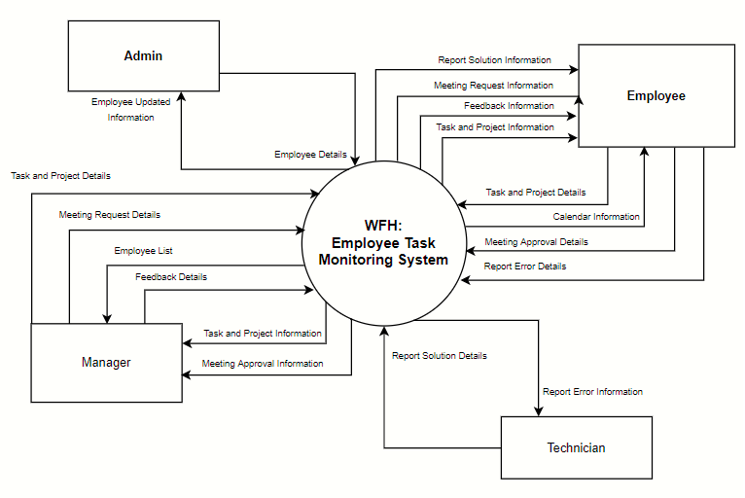 As cited from edrawmax.com (n.d.), the context diagram is the highest level of a Data Flow Diagram. It is a common method used by Business Analysts to comprehend the details and limitations of a developing project. It represents the flow of data between the system and its external components. The context diagram shows all the external components that may interact with the system.

**Figure 2.** Context Diagram

Figure 2 shows the Context Diagram of the Employee Task Monitoring System. There are four entities involved in this diagram such as Admin, Manager, Employee and Technician. This diagram shows how will be the flow of the Admin, Manager, Employee and Technician.

First, it conveys that only the Admin has the authority to make the account of the Employee. The Admin will send the Employee Details for the account of the Employee, once it was sent, this will be given by the system to the Manager to view the Employee List. Once the Employee List was reviewed, this can already assign Tasks and Project Details. The Manager will distribute Task Details and Information to the Employees through the Calendar View. If ever the Employee will encounter errors while accomplishing the task, he/she may send a Report Error for the Technician to give Report Error Solution Details in return. In addition, the Employee must also send Task and Project Details to the Manager. Once the Manager received the information, he/she may give feedback details on the given Task Details by the Employee. Lastly, the Manager may send a meeting request that is to be approved by the Employee.

**Level 0 Diagram**

As stated in Geeks for geeks (2020), the level 0 diagram is also known as a context diagram. It is intended to be a representation view, with the system represented as a single process with connections to external entities. It shows the whole system as a single bubble with receiving and sending arrows representing data input and output.

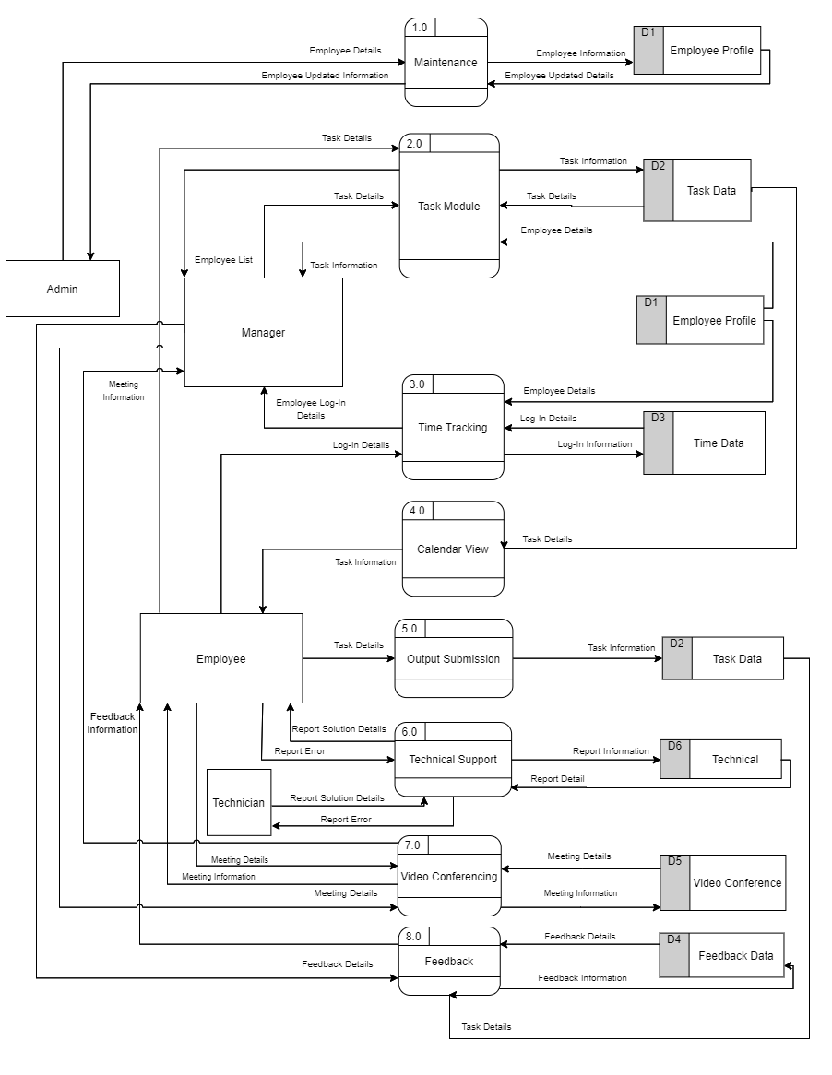 Figure 3 shows the level 0 diagram of the Developed system for the WFH: Employee Task Monitoring System. The input and output from the entities must be discussed. Eight processes are involved in this diagram such as; Maintenance module, Task module, Time tracking, Calendar view, Output submission, Technical Support, Video Conferencing, and Feedback.

**Figure 3.** Level 0 Diagram

First off is the Maintenance module. In this process, the Admin will create an account for the employees that he/she is the only one who has access to revise the pieces of information that will be stored on the Employee Profile Table. In Task Module, it processes the tasks that will be administered by the Manager to the employees. This will be kept in the Task Data Table, which will be used to transfer to Calendar View. The third process is Time tracking. In this procedure, the employee will dispense the log-in details onto the Employee Profile table to assess if the logged-in account is reliable, once it is accurate, an employee login details will be sent to the Time Tracking process that will be delivered to the Time Data table to be reviewed by the Manager. The fourth process is the Calendar View, the data in Task Data Storage will be gathered to transfer in the Calendar View process. This is for the employees to view the distributed tasks in a calendar view. The fifth process is the Output Submission. This is where the assigned tasks are being submitted by the employees. The tasks that will be conveyed in Task Data Storage will be used to transfer pieces of information to the Task Module process, to be viewed by the Manager. In Technical Support, this processes the errors that will be sent by the Employee to the Technical Support which will be moved to the Technical Data Storage to be given to the Technician. Once it is received, the Technician will provide a report of solution details to the Employee. In Video Conferencing, it processes the Meeting Request sent by the Manager that will go through the Video Conferencing process to the Video Conference table to dispense a Meeting Approval to the employee. Lastly, Feedback is a process in which the Manager will send a feedback report to the Task Data Storage back to the Feedback process table for the employee to know the assessment of the Manager on the finished task.

**Child** **Diagram**

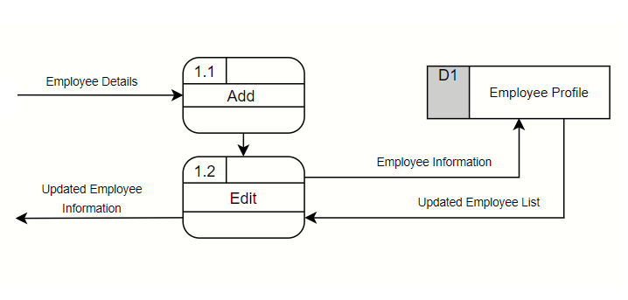 Based on w3computing (2021), vertical balancing is the main importance for developing child diagrams, which states that a child diagram cannot produce or receive input that the parent process does not either produce or receive. The child diagram must show all data flows into and out of the parent process. Entities are typically not represented on the child diagrams below Diagram 0.

**Figure 4.** Child Diagram for the Maintenance Module Process

Figure 4 shows the child diagram for Employee Maintenance Module Process. In this part, the input and output from the entities must be discussed. First, adding the Employee details to create the Employee information going to Employee Profile table, then it can be editable and to maintaining of Employee Profile.

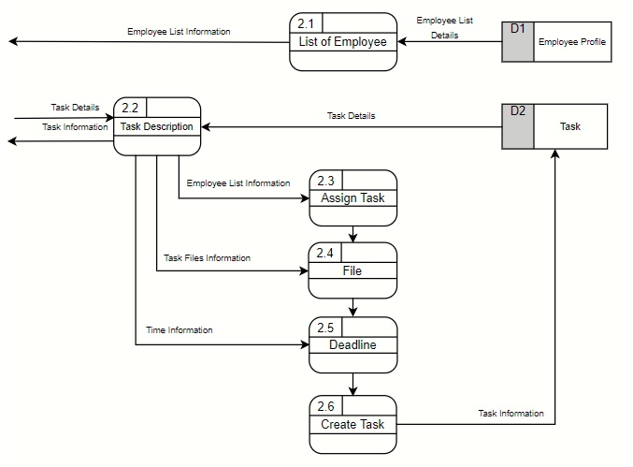

**Figure 5.** Child Diagram for the Task Module Process

Figure 5 shows the child diagram for the Task Module Process. This conveys that in 2.1 the Employee List Information was gathered in the D1 Employee profile by the Manager, once it is reviewed, it can now disseminate Task Details on 2.2 which is the Task Description. On the Task Description, this will provide Employee List Information in 2.3, Task Files Information in 2.4, and Time Information in 2.5. Once it is processed, the information will go through process 2.6, which is the Create Task process. The Create Task process will give Task Information to the Task Data Storage or the D2. Lastly, the Task Data will provide the Task Details onto the Task Description that will produce the Task Information.

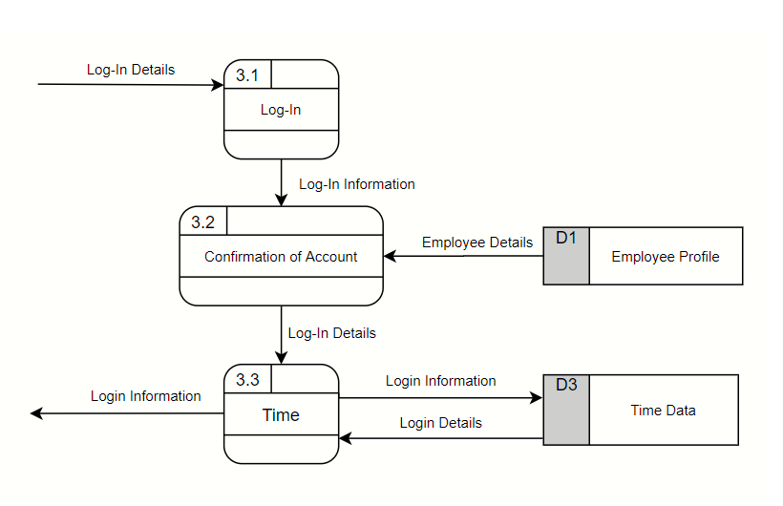

**Figure 6.** Child Diagram for the Time Tracking Process

Figure 6 shows the child diagram for the Time Tracking Module Process. Firstly, this conveys that there are existing log-in details onto the 3.1 or the Log-in process table, which indicates that an Employee has logged in. After administering the Login Information by the 3.1 onto the 3.2, this is the Confirmation of Account. This shows that Employee Details were provided from the D1 or the Employee Profile, which means that the account that was logged in by the Employee needs to assess if it is already existing on the Data storage. Once the Employee has successfully logged in, 3.2 will disseminate a piece of log-in information onto the 3.3 or the Time process table. This shows that 3.3 has provided a piece of log-in information to the D3 or the Time Data Storage. The D3 will provide the Log-in details back to 3.3, which will give the output. This just indicates that 3.3 or the Time process table will be able to access the time which the Employee has logged in, and out, once it succeeds on 3.2 or the Confirmation of Account.

**Database Design**

This part discusses all the tables needed in the system that is defined in ERM and Data Dictionary. The major tables of the system are User, Task and Project.

**Entity Relationship Model**

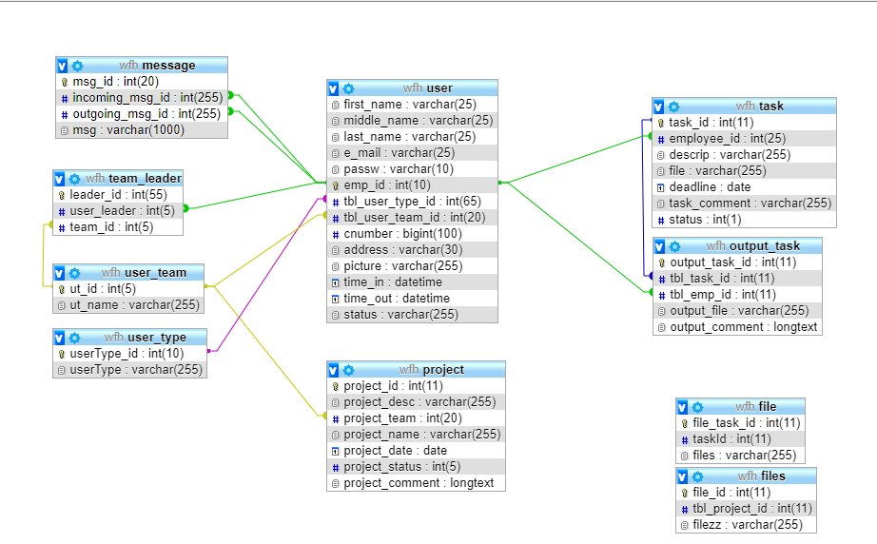 According to Singh (2018), an entity-relationship model (ER model) uses a diagram called an Entity Relationship Diagram to explain the structure of a database (ER Diagram). An entity set is a collection of similar entities and these entities can have attributes. A table or an attribute of a table is an entity in a database management system, so an ER diagram describes the entire logical structure of a database by displaying relationships between tables and their attributes.

**Figure 7.** Entity-Relationship Model

As illustrated in Figure 7, this entity-relationship model shows the relationships between different data in the WFH: Task Monitoring System, which is accessed via a web-based system has eight (10) tables. The table for users contains information about the admin, who is responsible for adding and editing Manager, and employee account information. The admin has access to the pending documents and can approve or reject the approval of the users. A user can create a large number of records, and the administrator can create a large number of account users. The message table contains, the message id of users, incoming message id, outgoing message id, and message. In team leader table it includes leader id, user leader, and team id. The user team table is the same as the team leader table it includes user id and user team name. While the user type table includes user type id and user types such as admin, manager, and employees.

Project information such as project id, project description, project team, project name, project date, project status, and project comment will be stored in the project table. There are also fields such as task id, employee id, description, file, deadline, task comment, and status in the task table. Output task id, table task id, table employee id, output file, and output comment are all included in the output task. Finally, the task table contains information such as file task id, task id, files, file id and table of project id.

**Data Dictionary**

As described by Chai (2020), a data dictionary is a set of interpretations of data objects or items in a data model for programmers and those who need to refer to them. A data dictionary is often used as a centralized metadata repository. Identifying each interactive object and its relationship to other objects is the first step in evaluating a system of interactive objects.

**Table 1.** User Table

|  |  |  |  |  |  |  |  |
| --- | --- | --- | --- | --- | --- | --- | --- |
| **Data Dictionary** | | | | | | **Reference Number:** | |
| **Version Number: 6.0** | |
| **System Name:** WFH: Employee Task Monitoring System | | | | | | | |
| **Subject: User Table** | | | | | | | |
| **PK** | **FK** | **Field Name** | **Data Type** | **Length** | **Nullable** | **Default Value** | **Description** |
| No | No | first_name | varchar | 25 | No | None | Employee First Name |
| No | No | middle_name | varchar | 255 | No | None | Employee Middle Name |
| No | No | e_mail | varchar | 25 | No | None | Employee Email |
| No | No | passw | varchar | 10 | No | None | Employee Password |
| Yes | No | emp_id | int | 10 | No | None | Unique Code for Employee |
| No | No | tbl_user_type_id | int | 65 | No | None | Unique Code for Table User Type |
| No | No | tbl_user_team_id | int | 20 | No | None | Unique Code for Table User Team |
| No | No | cnumber | bigint | 100 | No | None | Employee Contact Number |
| No | No | address | varchar | 30 | No | None | Employee Address |
| No | No | picture | varchar | 255 | No | None | Employee Picture |
| No | No | time_in | datetime |  | No | None | Employee Login Time |
| No | No | time_out | datetime |  | No | None | Employee Logout Time |
| No | No | status | varchar | 255 | No | None | Status of Employee |

Table 1 shows the user table. The User table contains the personal information of every user in the Maintenance module of the system as well as time in and time out. The primary key for this table is Employee ID.

**Table 2.** Task Table

|  |  |  |  |  |  |  |  |
| --- | --- | --- | --- | --- | --- | --- | --- |
| **Data Dictionary** | | | | | | **Reference Number:** | |
| **Version Number: 7.0** | |
| **System Name:** WFH: Employee Task Monitoring System | | | | | | | |
| **Subject: Task Table** | | | | | | | |
| **PK** | **FK** | **Field Name** | **Data Type** | **Length** | **Nullable** | **Default Value** | **Description** |
| Yes | No | task_id | int | 11 | No | None | Unique Code for Task |
| No | No | Employee_id | int | 25 | No | None | Unique Code for Employee |
| No | No | descrip | varchar | 255 | No | None | Task Description |
| No | No | file | varchar | 255 | No | None | Task File |
| No | No | deadline | date |  | No | None | Deadline of Submission |
| No | No | task_comment | varchar | 255 | No | None | Task Comment |
| No | No | Status | Int | 1 | No | None | Task Status |

Table 2 shows the Task table. The Task table contains the task information such as Task ID, Employee ID, Description of Task, File of Task, Deadline of Task, Task Comment and Status of the task. The primary key for this table is Task ID.

**Table 3.** Project Table

|  |  |  |  |  |  |  |  |
| --- | --- | --- | --- | --- | --- | --- | --- |
| **Data Dictionary** | | | | | | **Reference Number:** | |
| **Version Number: 5.0** | |
| **System Name:** WFH: Employee Task Monitoring System | | | | | | | |
| **Subject: Project Table** | | | | | | | |
| **PK** | **FK** | **Field Name** | **Data Type** | **Length** | **Nullable** | **Default Value** | **Description** |
| Yes | No | project_id | int | 11 | No | None | Unique Code for Project |
| No | No | project_desc | varchar | 255 | No | None | Project Description |
| No | No | project_team | int | 20 | No | None | Unique Code for Project Team |
| No | No | project_name | varchar | 255 | No | None | Project Name |
| No | No | project_date | date |  | No | None | Project Date |
| No | No | project_status | int | 5 | No | None | Project Status |
| No | No | project_comment | longtext |  | No | None | Project Comment |

Table 3 shows the Project Table. The Project table contains the Project ID, Project Description, Project Team, Project Name, Date, Status and Project Comment. The primary key for this table is Project ID.

**Project Development**

According to Rayo et. Al (2016), the modified waterfall model implements the same phases as the pure waterfall model. In response to perceived weaknesses in the pure waterfall model, an updated waterfall model was implemented. It is capable of overlapping when needed. The proponents will use a modified waterfall model to develop the proposed system since it is more flexible than the pure waterfall model. This method allows proponents to check at the design and testing phase if there are any flaws. The software development process must step back to the design phase if there is a problem or forgot to implement. It will help the proponent ensure that every phase is finished before proceeding to the next phase and carry out the plan successfully.

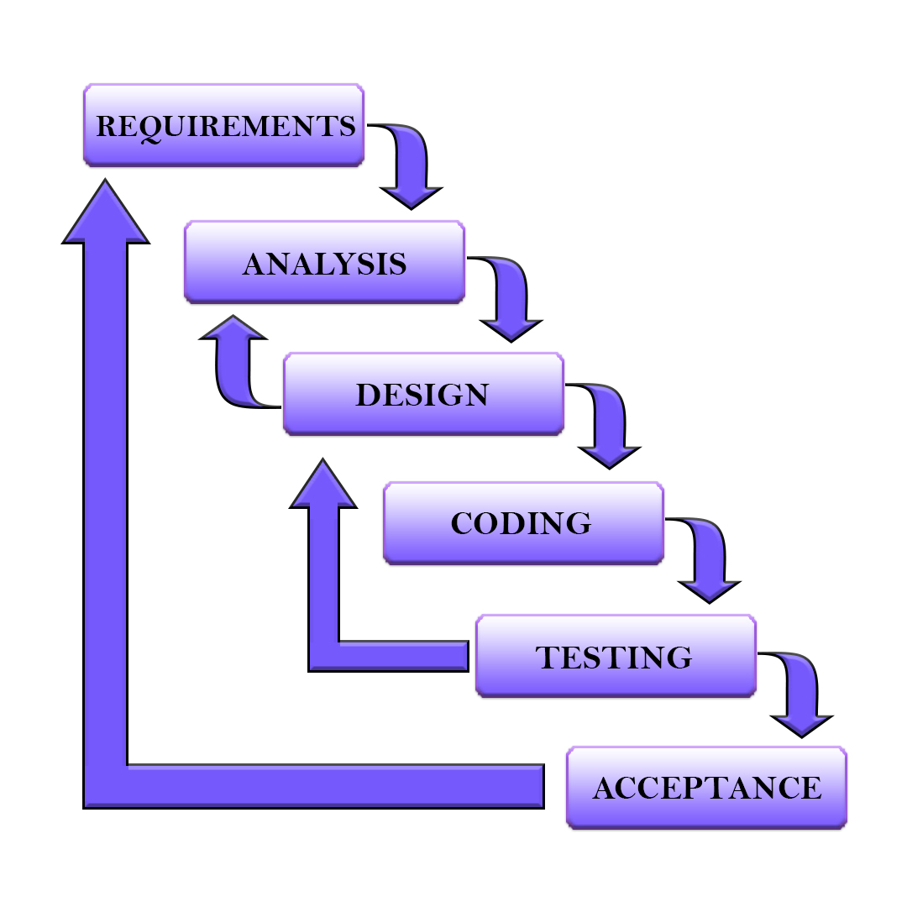

**Figure 8.** Modified Waterfall Model

Retrieved from https://techspirited.com/waterfall-model-diagram

1. **Requirements Phase**

Gharajeh (2019) explains that the requirements phase is a fundamental and essential step in this developmental model that includes both communication and requirement gathering. This phase consists of user requirements, system requirements, and functional requirements that are conveyed by studying the desired software, referring to the database, or collecting answers from questionnaires or interviews.

This first phase is important and involves comprehension of what system is needed to develop. The proponents had a brainstorming about the current circumstances and came up with WFH: Employee Task Monitoring System. In gathering information, the proponents conducted an online interview to an enhanced understanding of the proposed system.

1. **Analysis Phase**

According to JOVACO Solutions (2016), the analysis phase is conducted to assure the proponents understand the vision and purpose of the proposed study. This will help the proponents in decision-making on what features will be used in developing the system.

In the second phase, a topical outline and title proposal have been constructed by the proponents to identify the hardware and software needed in developing the proposed system.

1. **Design Phase**

Ghahrai (2018) stated in this phase, the developers start to discuss the design of the software and the system to deliver the introduced requirements. This process involves problem-solving, defining components that are needed to develop, and selecting the best design approach for the system.

In the third phase, the proponents have come up with the design of the user interface, data flow diagram and entity-relationship model. Also, the proponents performed different documentation such as Chapter 1 to Chapter 3.

1. **Coding Phase**

As explained by Sharma (2019), the coding phase is the application of the software design using any computer language. This should be performed accurately because it is prone to errors. This is an important stage as it relies upon the other phase for proper implementation.

The fourth phase where the proponents have started to develop the proposed system using the stated programming language: all of the given capabilities are being encoded.

1. **Testing Phase**

As written by Lane (2018), this is the phase where written codes come to the scene. During this phase, issues are being identified through automated tests or program testers. This stage will include testing functionality, how well different systems have been integrated, and how these systems are operating.

In the fifth phase, the proponents will test the designed software if there are errors and missing in the coding phase before proceeding to the acceptance phase. The system undergoes different testing such as unit testing, integration testing, system testing, and performance testing. If errors are encountered the software development process should step back to the design phase and re-do the process.

1. **Acceptance Phase**

Kramer (2018) explains the final stage as this is when the process improvement has come together and the application is ready for use. This is the time where the maintenance of the software is being conducted. If an issue or error has been corrected, it is important to ensure the code has been updated in both the development and coded environment.

This is the final phase where the designed system meets the requirements and the satisfaction of the clients. During this process, all documents will be finalized. After the system is released, clients who will use it will receive maintenance support.

**Gantt chart**

As cited in productpla.com (2021), a Gantt chart is a type of bar chart that graphically illustrates a schedule for preparing, arranging, and monitoring specific tasks for a single project. The Gantt chart is a detailed representation of the project timeline that includes projected and actual durations, as well as expected and actual resources.

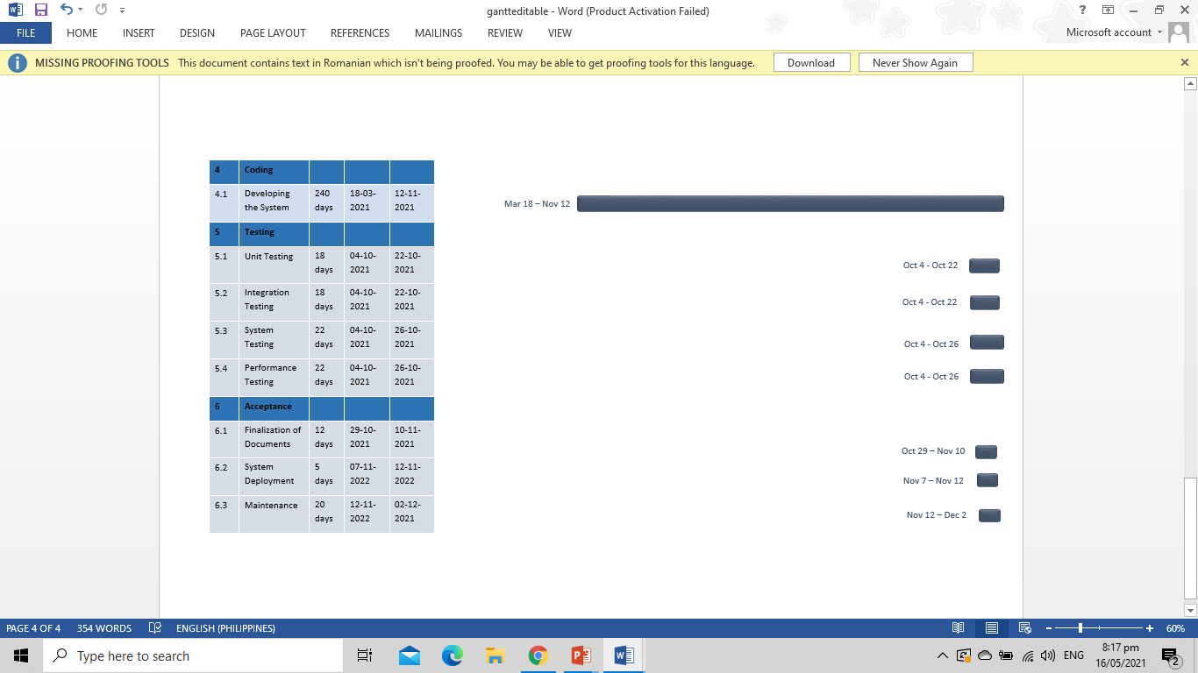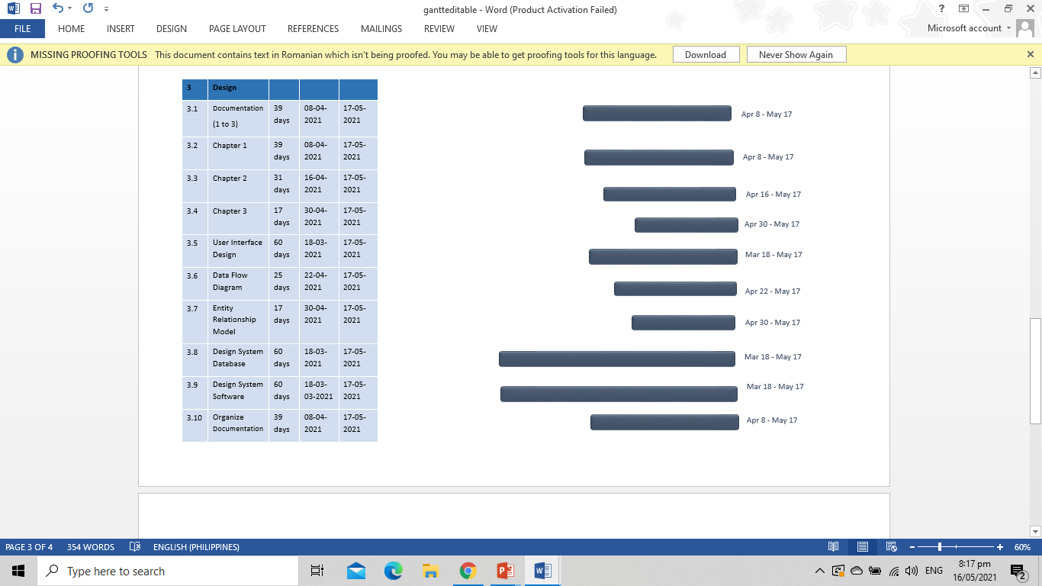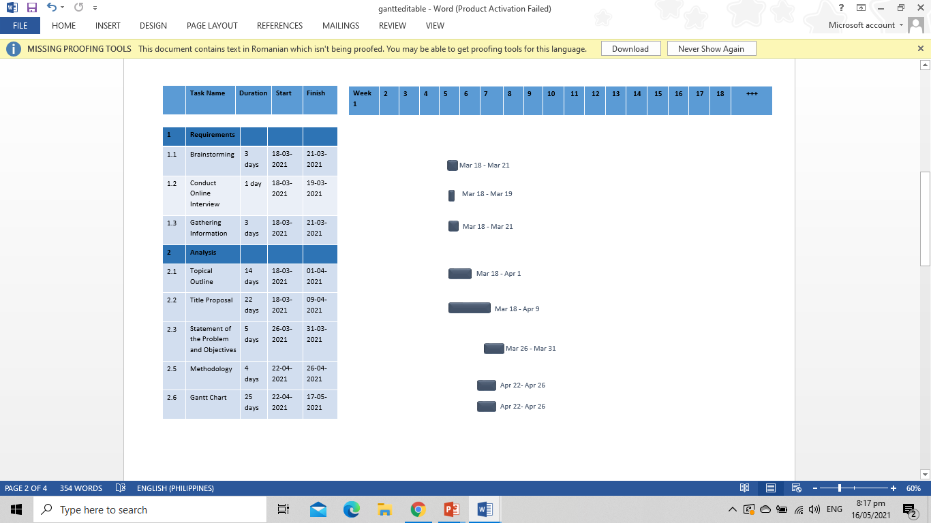

**Figure 9.** Gantt chart

The Gantt chart model of the proposed study is shown in figure 9, it shows the tasks to be completed in each step of the chosen methodology, as well as the number of days it will take to complete each task and the start and finish dates. The development and creation of the proposed system started in March 2021 and will last until December 2021.

**Operational and Testing Procedure**

The operation and testing procedures that the proponents would conduct are discussed in this section. The different testing procedures are also stated such as unit testing, integration testing, system testing, and acceptance testing.

**Operational Procedure**

WFH: Employee Task Monitoring System will discuss the walkthrough of the system to help the users on how to perform a specific action when using the system. The admin needs to log in first to access the system and to register the users. After the admin registration, the created users by the admin will display on the manager’s view and are capable of maintaining all information. Afterward, the manager can create and assign a task to a specific employee.

After the registration, the employee can input the username and password given by the manager to access the system. An employee can view all the tasks using calendar view UI and an employee can decide whether to accept or decline the given task to them. Also, the employee will be able to report if they are doing the task and mark as done if they submitted the output. In addition, the manager will receive the output and can give feedback to the task submitted by the employee to help them to improve their work. Furthermore, in the process of Time Tracking, the employee will provide his/her log-in details to access the system. Every time an employee logs in and logs out, the time is automatically displayed in the manager table to keep track of the employee's working hours.

Technical support will help the employee on the problem they encounter while working. The employee will report the problem first and the technician will assist them to fix the error. In addition, the system allows the employees and manager to have an online video meeting.

**Testing Procedure**

The testing procedures proponents will be using are unit testing, integration testing, system testing and performance testing.

1. **Unit Testing**

Unit testing is software testing used by the developers to test an application such as its functions, procedures, or interfaces. This is used to determine if there are errors or if it is fit to use. It is done to secure the source code written by the developers meets the requirements and conforms to an expected method. As to its goal, it breaks each part of the source code and inspects if it functions accurately, and in every set of input that will be processed, this should come back with an output. (“The Economic Times”, 2021).

The proponents independently checked each module of the WFH: Task Monitoring System to see how well it was working properly and to determine its performance.

1. **Integration Testing**

Choudary (2020) explains integration testing's main goal is to test its connection between modules. This is a software testing that incorporates and assesses individual units to attest if it is functioning effectively when integrated. The units will be combined to comprehend the modules that will function as a single unit to observe how they can work together.

This level of testing aims to find defects in how these software modules work when they are put together. The proponents ensured that all aspects of the device were merged during this process of testing to ensure that all parts were checked and fixed.

1. **System Testing**

As written by Black (2018), this phase focuses on the functionality of the application as it assesses every unit of the application to ensure that they work and incorporate well together. System testing is also called a system-level test or system-integration testing in which a quality assurance team examines how the application connects in the full, integrated system, or application.

The proponents analyze the overall functionality of the established system, as well as the existence of bugs, and each proponent provides guidance to the administrator, manager, and employees.

1. **Performance Testing**

As explained by Narendra & Padmanabhan (2020), performance testing is done on purpose to determine the system's responsiveness, output, reliability, and adaptability under a defined workload. This will be carried out to distinguish how fast the system works under a particular amount of work.

Performance testing was used by the proponents to evaluate the overall performance of the established system. Also, proponents may use performance testing to get the diagnostic details they need to remove constraints.

These testing procedures will utilize the below test script form.

**Table 4.** Test Script Form

|  |  |  |  |
| --- | --- | --- | --- |
| **Date** |  | | |
| **Tested By** |  | | |
| **Test Case Number** |  | | |
| **Test Case Description** |  | | |
| **Test Case Name** |  | | |
| **Item(s) to be Tested** |  | | |
|  |  | | |
| **Procedural Steps** |  | | |
|  |  | | |
| **Specifications** |  | | |
| **Input** | **Expected Output/Result** | **Pass Y/N** | **Actual Result/Output** |
|  |  |  |  |

**Evaluation Procedure**

These are the following activities that the proponents will perform during the evaluation:

1. The proponents will send the URL of the developed website to the user for them to evaluate the system.
2. The proponents will send a video walkthrough of the system to the user.
3. The invited users will allow using the system.
4. The form will be distributed to the invited people through Google survey forms to rate the system based on criteria under ISO 25010.
5. The proponents will answer all the questions of invited people.
6. Afterwards, the result will automatically be collected through Google survey forms and will analyze the data gathered.
7. The proponents will compute the data using the weighted formula.
8. All the data will be interpreted, and the ratings would be based on the Likert’s scale.

**Table 5.** Likert's Scale

|  |  |  |
| --- | --- | --- |
| **Rank** | **Numerical Scale** | **Interpretation** |
| **5** | 4.51 – 5.00 | Excellent |
| **4** | 3.51 – 4.50 | Very Good |
| **3** | 2.51 – 3.50 | Good |
| **2** | 1.51 – 2.50 | Fair |
| **1** | 1.00 – 1.50 | Poor |

**BIBLIOGRAPHY**

**Books**

Brown, E. (2016). *Learning JavaScript: Add Sparkle and Life to Your Web Pages. O’Reilly Media.* Gravenstein Highway North, Sebastopol: O’Reilly Media, Inc.

Harvey, S. (2020). *The Ultimate A-Z of Home Working.* Bonbook.com.

Kahlert, T. &. (2016). *Visual Studio Code Tips & Tricks (1st ed).*

Tatroe, K. &. (2016). *Programming PHP.* Gravenstein Highway North, Sebastopol: O'Reilly Media, Inc. .

**Journals**

Adekotujo, A. O. (2020). A Comparative Study of Operating Systems: Case of Windows, UNIX, Linux, Mac, Android and iOS. *International Journal of Computer Applications*, 16–23.

Alabdulaly, W. (2016). Data Base Management System. *International Journal of Science & Engineering Development Research*, 496.

Argent, M. S. (2016). Best practices for conceptual modelling in environmental planning and management. *Environmental Modelling & Software*, 113-121.

Correia, A. P. (2020). Evaluating videoconferencing systems for the quality of the educational experience. *Distance Education*, 429–452.

Fadhil, H. M. (2016). Design of Computerized Students Grades Database Management System. *International Journal of Scientific Development and Research* , 343-349.

Gharajeh, M. S. (2019). Waterative Model: an Integration of the Waterfall and Iterative Software Development Paradigms. *Database Systems J ournal,* 79*.*

Gladović, P. D. (2020). Video Conferencing and its Application in Education. *JTTTP - JOURNAL OF TRAFFIC AND TRANSPORT THEORY AND PRACTICE*, 45–46.

Layng, J. M. (2016). The Virtual Communication Aspect: A Critical Review of Virtual Studies Over the Last 15 Years. *Journal of Literacy and Technology*, 173-174.

Maus, et al. (2016). Challenges for Business Processes and Task Management. *Journal of Universal Knowledge Management*. Volume 0, Issue 2.

Rathod, D. (2017). WEB BROWSER FORENSICS: GOOGLE CHROME. *International Journal of Advanced Research in Computer Science*, 896.

Yanch, U. &. (2018). Task Assignment Optimization in Photoanalysis Process: Comparative Analysis of Semi-Automated and Manual Task Management. *International Conference on Optimization and Applications* , 336 – 350.

**Theses and** **Dissertations**

Marthouret, E., & Sigvardsson, S. "The effect of quick feedback on employee motivation and performance A qualitative study on how to formulate effective feedback" Bachelors Thesis. Linköping University. 2016

**Electronic Resources**

Adebola, O. (2018). INTRODUCTION TO CSS.

Berezhnoi, R. (2018). *F5 Studio.* Retrieved from F5 Studio: https://f5-studio.com

Black, R. (2018). *System Testing*. Retrieved from <https://searchsoftwarequality.techtarget.com/definition/system-testing>

Bowman, J. D. (2020). *GEORGE LUCAS EDUCATIONAL FOUNDATION.* Retrieved from Edutopia: https://www.edutopia.org/article/getting-students-engage-feedback

Bucki, J. (2019, October 3). *The Balance Small Business*. Retrieved from thebalancesmb.com: https://www.thebalancesmb.com/what-is-a-laptop-computer-2533639

*Career Foundry*. (2020, March 26). Retrieved from careerfoundry.com: https://careerfoundry.com/en/blog/web-development/what-is-bootstrap-a-beginners-guide/

Choudary, A. (2020). *What is Integration Testing? A Simple Guide on How to Perform Integration Testing*. Retrieved from https://www.edureka.co/blog/what-is-integration-testing-a-simple-guide-on- how-to-perform-integration-testing/

Cook, J. (2020). The Ultimate Guide to Working From Home. *Career Advice.* Retrieved from https://www.investopedia.com/personal-finance/work- from-home-guide/

*Computer Hope.* (2018). Retrieved from computerhope.com: https://www.computerhope.com/jargon/m/mysql.htm

*Computer Hope.* (2020, December 31). Retrieved from computerhope.com: https://www.computerhope.com/jargon/b/browser.htm

*Computer Hope*. (2020, November 30). Retrieved from computerhope.com: https://www.computerhope.com/jargon/w/windows.htm

*Definition of Unit Testing*. (2021). The Economic Times. <https://economictimes.indiatimes.com/definition/unit-testing>

Dewitt, K. (2018). *Who is an Employee?* Retrieved from <https://www.patriotsoftware.com/blog/payroll/who-is-an-employee/>

Dwika P., H. (2020, March 4). *Hostinger Tutorials.* Retrieved from hostinger.ph: https://www.hostinger.ph/tutorials/what-is-mysql

Ellis, J. (2020, May 6). *Comms Blog*. Retrieved from https://www.comms-express.com/blog/what-is-a-router-and-how-does-it-work/

Englehardt, N. (2016, September 12). *Platt College*. Retrieved from platt.edu: https://platt.edu/blog/difference-adobe-photoshop-illustrator-indesign/

Fisher, T. (2020). *Life Wire*. Retrieved from lifewire.com: https://www.lifewire.com/what-is-a-router-2618162

Flanagan, S. (2017, Fall). *erformance Management: Giving and Receiving Feedback.* Retrieved from https://hr.psu.edu/sites/hr/files/GivingAndReceivingFeedbackSupervisors

Ghahrai, A. (2018). *Software Development Life Cycle - SDLC.* Retrieved from <https://devqa.io/software-development-life-cycle-sdlc-phases/>

Gorman, S. (2019). *What is Task Management?* Retrieved from <https://www.projectcentral.com/blog/what-is-task-management/>

Guru99. (2020). *Guru99.* Retrieved from Guru99: https://www.guru99.com/what-is-php-first-php-program.html

Heathfield, S. (2016). What is an Employee? *Work/Life Balance.* Retrieved from <https://www.thebalancecareers.com/what-is-an-employee-1918111>

Kramer, M. (2018). Best Practices in Systems Development Lifecycle: An Analyses Based on the Waterfall Model. *Review of Business and Finance Studies*, 77-84.

Lane, A. (2018). *Software Development Life Cycle Phases*. Retrieved from https://www.udacity.com/blog/2018/02/software-development-life-cycle- phases.html

Lauriac, N. (2016). Design and Implement a monitoring system. *What is a monitoring system? What purpose does it serve?,* 7-11.

Latendart, M. (2018). *Work Better.* Retrieved from Blog Open Classrooms: https://blog.openclassrooms.com/

*MDN Web Docs.* (2018, October). Retrieved from https://developer.mozilla.org/: https://developer.mozilla.org/en-US/docs/Web/JavaScript

Microsoft. (2016, April 14). *Visual Studio Code.* Retrieved from Code Visual Studio: https://code.visualstudio.com/docs/editor

Morris, S. (2020, October 13). *Skill Crush*. Retrieved from skillcrush.com: https://skillcrush.com/blog/css/

Murray, J. (2020). Employees: What are they? *Business Law & Taxes.* Retrieved from https://www.thebalancesmb.com/what-is-the-definition-of-an- employee-398246

Padmanabhan, et al. (2020). *Software Performance Testing*. Retrieved from <https://devopedia.org/software-performance-testing>

Peek, S. (2020). *Communication Technology and Inclusion Will Shape The Future of Remote Work.* Retrieved from <https://www.businessnewsdaily.com/8156-future-of-remote-work.html>

Plainer, M. (2020, December). Study of Visual Studio Code.

Raza, M. (2018). *BMC Blogs.* Retrieved from BMC: https://www.bmc.com

Shankel, N. (2020). *Techwalla*. Retrieved from techwalla.com: https://www.techwalla.com/articles/laptop-desktop-similarities-differences

Sharma, M. (2019). *Coding Phase in Software Engineering*. Retrieved from https://www.includehelp.com/basics/coding-phase-in-software- engineering.aspx

*Simbla*. (n.d.). Retrieved from simba.com: https://www.simbla.com/post/what-is-bootstrap

Sonmez, J. (2016). *Simple Programmer.* Retrieved from Simple Programmer: https://simpleprogrammer.com

Staff, W. (2021, February 18). *Webo Pedia*. Retrieved from webopedia.com: https://www.webopedia.com/definitions/adobe-photoshop/

*Tech Target*. (2017). Retrieved from techtarget.com: https://whatis.techtarget.com/definition/bootstrap

*Tech Terms.* (2019). Retrieved from techterms.com: https://techterms.com/definition/web_browser

*Technopedia.* (n.d.). Retrieved from Technopedia: https://www.techopedia.com/definition/9652/task-management

Techopedia. (2019). *Techopedia*. Retrieved from Technopedia.com: https://www.techopedia.com/definition/24406/php-hypertext-preprocessor-php

*The Analysis Phase of a Project: An Important Piece of Any Microsoft Dynamics 365 Implementation.* (2016, February 5) JOVACO Solutions. https://www.erpsoftwareblog.com/2016/02/analysis-phase-project- important-piece-microsoft-dynamics-gp-implementation/

*The importance of having a good monitoring system*. (2017, September 19). Pandorafms.com. https://pandorafms.com/blog/why-you-need-a- monitoring-system/

Vennapoosa, C. (2018). *Importance of Task Management.* Retrieved from http://www.exforsys.com/career-center/task-management/importance-of- task-management.html

Virgillito, D. (2020, April 15). *Oberlo*. Retrieved from oberlo.com.ph: https://www.oberlo.com.ph/blog/how-to-use-photoshop

Wallen, J. (2019, February 8). *Tech Republic.* Retrieved from techrepublic.com: https://www.techrepublic.com/article/how-to-create-tables-and-add-data-to-mysql-database-with-mysql-workbench/

Wiesen, G. (2018). *What is a System Monitor?* Retrieved from https://web.archive.org/web/20101207054610/https://www.wisegeek.com/ what-is-a-system-monitor.htm

APPENDIX A

**TITLE PROPOSAL**

**TITLE PROPOSAL**

**Project Title:** *WFH: Employee Task Monitoring System*

**Summary**

Every company and business require the need for a workforce to perform specific functions. They are called employees if the employer can control the work performed. The employees are the true assets of an organization. They are the ones who contribute to the successful performance of a company. Work from home is difficult to manage and maintain accountability because they are tougher to control and have a higher time commitment than someone who works in an office. However, since the pandemic, there are a lot of employees had the privilege to work from home. Also, the current communication channel of manager and employee is through messenger application which may be a disadvantage because messages from other people are being mixed by the important ones. Given all of the difficulties which have already been found in the current situation, the researchers want to improve the WFH (Work from home): Task Monitoring System to help the employees and managers to evaluate their works to avoid difficulties and to help them manage their time.

**Project Background**

Every company and business require the need for a workforce to perform specific functions. They are called employees if the manager can control the work performed. The employees are the true assets of an organization. They are the ones who contribute to the successful performance of a company. Generally, an employees’ role in the company is the one who meets deadlines of projects or tasks, makes sales, and working on the marketing strategy.

A company employee usually works in an office setting, the company provides everything in the office such as furniture, machines, office supplies, and other essentials needed. They usually have 8hours of working time and include a 1hour office break. Company conduct physical meetings to evaluate and reach their targeted goals. Employees must send activity reports on a regular or weekly basis.

Ever since the pandemic, there are a lot of employees had the privilege to work from home. At present time, the employees use pen and paper to organize the tasks that are needed to be accomplished in a certain time. In order to communicate with their team or coworkers and employers, they use online platforms such as messenger and emails to be able to report on time.

**Current State of Technology**

The manager has two means in assigning a task to their employee and submission of their activities. The traditional setup when the employee personally goes to the company’s office to submit his/her daily task and is called by their manager to give a new task. While, the current setup of giving a new task and submission of daily report is sent via email, messenger, and discord by their manager. The traditional way of giving feedback to submitted reports and documents by the employee is done through face-to-face communication whereas the manager gives comments on his/her task. While the current setup of giving feedback is done online such as Google forms. Besides, the traditional setup of technical support is where the employee called a technician to fix his/her device and the technician will go personally to fix the problem. While the current way of fixing a device is done online using Team Viewer application if the problem is only software. Moreover, the current setup of the communication channel of manager and employee is through messenger, zoom, and Google meet this type of meeting called virtual meeting. While the traditional setup is done in synchronous or face to face meeting, is one where all the participants are physically in the same place.

**Project Problem Statement**

Work from home is difficult to manage and maintain accountability because they are tougher to control and have a higher time commitment than someone who works in an office. This pandemic made all the workers adjust because of the new normal. Work from home has been implemented and there are many disadvantages for the workers, like the teachers sometimes they still need to go school every weekend to submit his/her daily and weekly report but due to limited resources and requirements to acquire for traveling some of them were not able to report on time. The employees usually use pen and paper to organize the daily and weekly tasks being given to them that need to be accomplished in a certain time. Also, the current communication channel of manager and employee is through messenger application which may be a disadvantage because messages from other people are being mixed by the important ones. Given all of the difficulties which have already been found in the current situation, the researchers want to improve the WFH (Work from home): Task Monitoring System to help the employees and managers to evaluate their works to avoid difficulties and to help them manage their time. Moreover, Employees can operate from any location they choose, including their bedrooms, dining rooms, and balconies, as long as they have strong internet access. It is no longer necessary to maintain a very well, having big all day as stating the general problem on the existing operation why the study is conducted.

**Project Assumption**

WFH (Work from home): Task Monitoring System is proposed to help the managers monitor the works of the employees. Since there is a website dedicated to employee transactions, tracking progress and submitting reports is easier. It will help the employees to manage their time and it has technician support if ever there is a problem in the system. The aim of calendar UI is for the employee to view their task easily because some people write it down, others use phone apps, some schedule activities around it, and even others try to remember it all in their minds. Also, there is feedback on tasks for them to communicate well and feedback is knowledge about a task's performance that can be used to enhance the work of employees. In addition, the system has a group meeting through a video call so they can discuss more like face-to-face meetings. Video meetings enable teams to build human relations regardless of their physical location, which improves decision-making and enhances employee abilities.

The following are the benefits that will be gained from the proposed system:

• It will help the company in accessing and editing employees’ information easily and effectively monitoring the employees’ and the managements’ performance; thus, it will found and access easily.

• It will benefit both employees and management, this can help alleviate the distribution of tasks without meeting personally.

• It will not require employees to travel and submit reports personally which can help save money and prevent time-consuming.

• It will make it easier for the employees to find tasks that are needed to be accomplished at a specific time. This can also help in preventing missing tasks.

• It will benefit the employees because they can communicate easily with their managers, follow orders as a result of performance feedback.

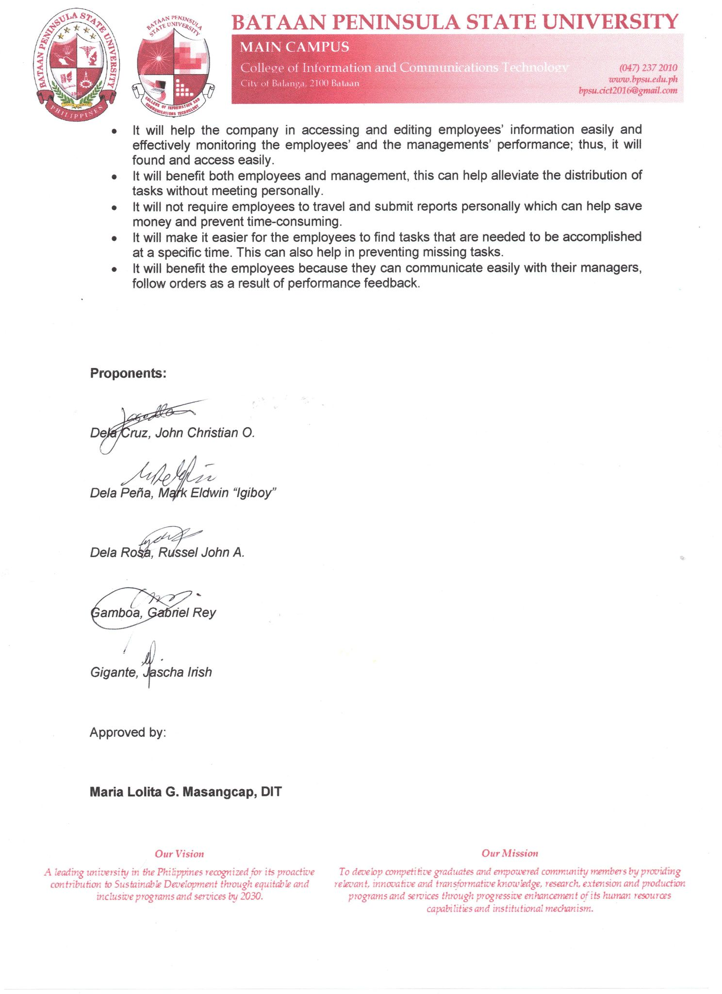

APPENDIX B

**TOPICAL OUTLINE**

**TOPICAL OUTLINE**

Title of the Project Study: **WFH: Employee Task Monitoring System**

**1**. **INTRODUCTION**

* 1. Company Employee
  2. Work from home
  3. Task Monitoring
  4. Monitoring System

**2**. **BASIC** **CONCEPTS**

* 1. Web Development
  2. Database Management System
  3. Video Conferencing
  4. Task Assignment
  5. Feedback Gathering

**3. SIMILAR MACHINES / APPLICATIONS**

* 1. Google Classroom
  2. Google Meet
  3. Time Doctor

**4. DESIGN CONSIDERATIONS / CRITERIA IN TERMS OF RELIABILITY**

* 1. Hardware Requirements

4.1.1 Computer System

4.1.2 Router

* 1. Software Requirements

4.2.1 Visual Studio Code

4.2.2 PHP

4.2.3 HTML

4.2.4 CSS

4.2.5 JavaScript

4.2.6 MySQL

4.2.7 Bootstrap

4.2.8 Web Browser

4.2.9 Windows OS

4.2.10 Adobe Photoshop

**5. EVALUATION SCHEME MODEL**

5.1 ISO 25010

APPENDIX C

**CHILD DIAGRAM**

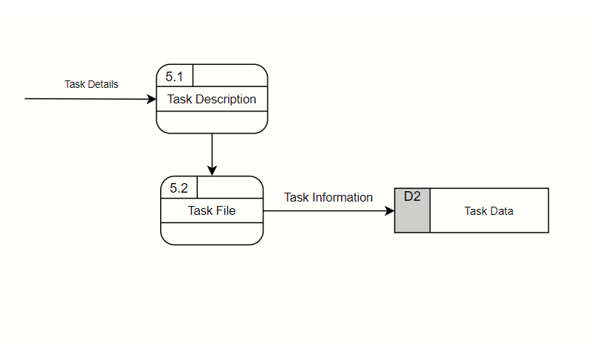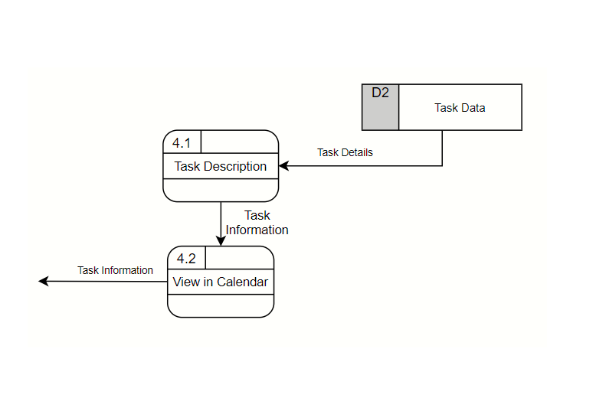

Child Diagram for the Output Submission Process

Child Diagram for the Calendar View Process

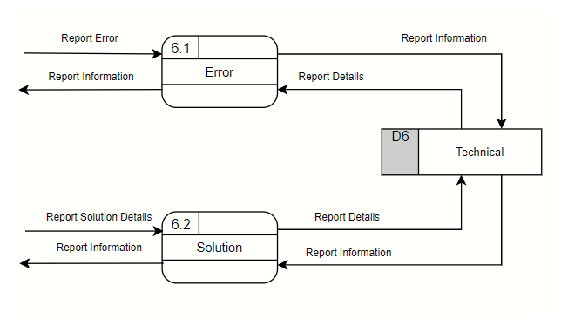

Child Diagram for the Technical Support Process

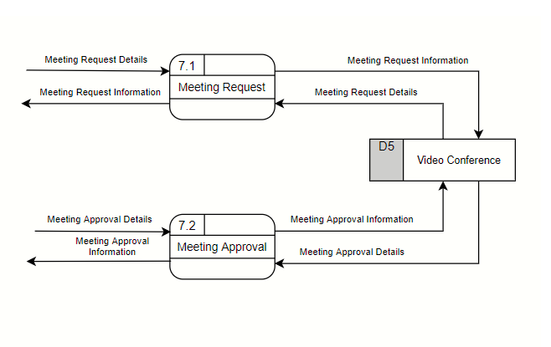

**Figure 13.** Child Diagram for the Video Conferencing Process

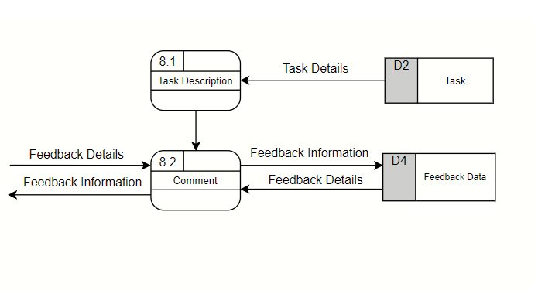

Child Diagram for the Feedback Module Process

APPENDIX D

**DATA DICTIONARY**

Message Table

|  |  |  |  |  |  |  |  |
| --- | --- | --- | --- | --- | --- | --- | --- |
| **Data Dictionary** | | | | | | **Reference Number:** | |
| **Version Number: 1.0** | |
| **System Name:** WFH: Employee Task Monitoring System | | | | | | | |
| **Subject: Message Table** | | | | | | | |
| **PK** | **FK** | **Field Name** | **Data Type** | **Length** | **Nullable** | **Default Value** | **Description** |
| Yes | No | msg_id | int | 20 | No | None | Unique Code for message |
| No | No | Incoming_message_id | int | 255 | No | None | Unique Code for Incoming message |
| No | No | Outgoing_message_id | int | 255 | No | None | Unique Code for Outgoing message |
| No | No | Msg | Varchar | 100 | No | None | Information from messages |

Team_leader Table

|  |  |  |  |  |  |  |  |
| --- | --- | --- | --- | --- | --- | --- | --- |
| **Data Dictionary** | | | | | | **Reference Number:** | |
| **Version Number: 2.0** | |
| **System Name:** WFH: Employee Task Monitoring System | | | | | | | |
| **Subject: Team_leader Table** | | | | | | | |
| PK | FK | Field Name | Data Type | Length | Nullable | Default Value | Description |
| Yes | No | leader_id | int | 55 | No | None | Unique Code for Leader |
| No | No | user_leader | int | 5 | No | None | Unique Code for User Leader |
| No | No | team_id | int | 5 | No | None | Unique Code for Outgoing Team |

User_Team Table

|  |  |  |  |  |  |  |  |
| --- | --- | --- | --- | --- | --- | --- | --- |
| **Data Dictionary** | | | | | | **Reference Number:** | |
| **Version Number: 3.0** | |
| **System Name:** WFH: Employee Task Monitoring System | | | | | | | |
| **Subject: User_Team Table** | | | | | | | |
| PK | FK | Field Name | Data Type | Length | Nullable | Default Value | Description |
| Yes | No | ut_id | int | 5 | No | None | Unique Code for User Team |
| No | No | ut_name | varchar | 255 | No | None | Name of User Team |

User_type Table

|  |  |  |  |  |  |  |  |
| --- | --- | --- | --- | --- | --- | --- | --- |
| **Data Dictionary** | | | | | | **Reference Number:** | |
| **Version Number: 4.0** | |
| **System Name:** WFH: Employee Task Monitoring System | | | | | | | |
| **Subject: User_type Table** | | | | | | | |
| PK | FK | Field Name | Data Type | Length | Nullable | Default Value | Description |
| Yes | No | userType_id | int | 10 | No | None | Unique Code for User Type |
| No | No | userType | varchar | 255 | No | None | Information for User type |

File Table

|  |  |  |  |  |  |  |  |
| --- | --- | --- | --- | --- | --- | --- | --- |
| **Data Dictionary** | | | | | | **Reference Number:** | |
| **Version Number: 9.0** | |
| **System Name:** WFH: Employee Task Monitoring System | | | | | | | |
| **Subject: File Table** | | | | | | | |
| PK | FK | Field Name | Data Type | Length | Nullable | Default Value | Description |
| Yes | No | file_task_id | int | 11 | No | None | Unique Code for File Task |
| No | No | taskId | int | 11 | No | None | Unique Code for Task |
| No | No | Files | varchar | 255 | No | None | Task File |

Output Table

|  |  |  |  |  |  |  |  |
| --- | --- | --- | --- | --- | --- | --- | --- |
| **Data Dictionary** | | | | | | **Reference Number:** | |
| **Version Number: 8.0** | |
| **System Name:** WFH: Employee Task Monitoring System | | | | | | | |
| **Subject: Output Table** | | | | | | | |
| PK | FK | Field Name | Data Type | Length | Nullable | Default Value | Description |
| Yes | No | output_task_id | int | 11 | No | None | Unique Code for Output Task |
| No | No | tbl_task_id | int | 11 | No | None | Unique Code for Task |
| No | No | tbl_emp_id | int | 11 | No | None | Information for Employee |
| No | No | output_file | varchar | 255 | No | None | Output Task |
| No | No | output_comment | Longtext |  | No | None | Output Comment |

Files Table

|  |  |  |  |  |  |  |  |
| --- | --- | --- | --- | --- | --- | --- | --- |
| **Data Dictionary** | | | | | | **Reference Number:** | |
| **Version Number: 10.0** | |
| **System Name:** WFH: Employee Task Monitoring System | | | | | | | |
| **Subject: Files Table** | | | | | | | |
| PK | FK | Field Name | Data Type | Length | Nullable | Default Value | Description |
|  |  |  |  |  |  |  |  |
| Yes | No | file _id | int | 11 | No | None | Unique Code for File |
| No | No | tbl_project_id | int | 11 | No | None | Unique Code for Project |
| No | No | filezz | varchar | 255 | No | None | Task File |

APPENDIX E

**WEEKLY PROGRESS REPORT**

**Weekly Progress Report**

DATE : **March 15 to 19, 2021 (Week 5)**

FROM : **NW3B**

**WFH: Employee Task Monitoring System**

RE : **PROGRESS STATUS REPORT**

**________________________________________________________________**

**SOFTWARE: (0%)**

Date:

Finished Activity:

Description:

Date:

Next Activity:

Description:

**HARDWARE: (100%)**

Date: March 15 to 19, 2021

Finished Activity: Computer System and Router

Description: All hardware requirements are available

Date:

Next Activity:

Description:

**DOCUMENTATION: (0%)**

Date: March 19, 2021

Finished Activity: Brainstorming, Gathering Information, Conduct Online Interview, Topical Outline and Title Proposal

Description: Submission of Topical Outline and Title Proposal

Date: March 22 to 26, 2021

Next Activity: Activity Sheet 2

Description: Statement of the Problems and Objectives

**Weekly Progress Report**

DATE : **March 22 to March 26, 2021 (Week 6)**

FROM : **Group Name**

**NW3B**

**WFH: Employee Task Monitoring System**

RE : **PROGRESS STATUS REPORT**

**________________________________________________________________SOFTWARE: (0%)**

Date:

Finished Activity:

Description:

Date:

Next Activity:

Description:

**HARDWARE: (100%)**

Date:

Finished Activity:

Description:

Date:

Next Activity:

Description:

**DOCUMENTATION: (0%)**

Date: March 26, 2021

Finished Activity: Activity Sheet 2

Description: Statement of the Problems and Objectives

Date: March 29 to April 2, 2021

Next Activity: Topical Outline Version 2 and Topical Outline Version 2

Description: Submission of Topical Outline V2 and Title Proposal V2

**Weekly Progress Report**

DATE : **March 29 to April 2, 2021 (Week 7)**

FROM : **Group Name**

**NW3B**

**WFH: Employee Task Monitoring System**

RE : **PROGRESS STATUS REPORT**

**________________________________________________________________SOFTWARE: (0%)**

Date:

Finished Activity:

Description:

Date:

Next Activity:

Description:

**HARDWARE: (100%)**

Date:

Finished Activity:

Description:

Date:

Next Activity:

Description:

**DOCUMENTATION: (0%)**

Date: April 2, 2021

Finished Activity: Topical Outline Version 2 and Topical Outline Version 2

Description: Submission of Topical Outline V2 and Title Proposal V2

Date: April 5 to April 9, 2021

Next Activity: Chapter 1 and Activity Sheet 3

Description: Submission ofChapter 1 and Activity Sheet 3

**Weekly Progress Report**

DATE : **April 5 to April 9, 2021 (Week 8)**

FROM : **Group Name**

**NW3B**

**WFH: Employee Task Monitoring System**

RE : **PROGRESS STATUS REPORT**

**________________________________________________________________SOFTWARE: (0%)**

Date:

Finished Activity:

Description:

Date:

Next Activity:

Description:

**HARDWARE: (100%)**

Date:

Finished Activity:

Description:

Date:

Next Activity:

Description:

**DOCUMENTATION: (33%)**

Date: April 9, 2021

Finished Activity: Chapter 1 and Activity Sheet 3

Description: Submission ofChapter 1 and Activity Sheet 3

Date: April 12 to April 16, 2021

Next Activity: Title Proposal Version 3 and Chapter 2

Description: Submission of Title Proposal V3 and Chapter 2

**Weekly Progress Report**

DATE : **April 12 to April 16, 2021 (Week 9)**

FROM : **Group Name**

**NW3B**

**WFH: Employee Task Monitoring System**

RE : **PROGRESS STATUS REPORT**

**________________________________________________________________SOFTWARE: (0%)**

Date:

Finished Activity:

Description:

Date:

Next Activity:

Description:

**HARDWARE: (100%)**

Date:

Finished Activity:

Description:

Date:

Next Activity:

Description:

**DOCUMENTATION: (33%)**

Date: April 16, 2021

Finished Activity: Title Proposal Version 3

Description: Submission of Title Proposal V3 and Chapter 2

Date: April 19 to April 23, 2021

Next Activity: Activity Sheet 4, Activity Sheet 5 and Activity Sheet 6

Description: Submission of Activity Sheet 4, Activity

Sheet 5 and ActivitySheet 6

**Weekly Progress Report**

DATE : **April 19 to April 23, 2021 (Week 10)**

FROM : **Group Name**

**NW3B**

**WFH: Employee Task Monitoring System**

RE : **PROGRESS STATUS REPORT**

**________________________________________________________________SOFTWARE: (0%)**

Date:

Finished Activity:

Description:

Date:

Next Activity:

Description:

**HARDWARE: (100%)**

Date:

Finished Activity:

Description:

Date:

Next Activity:

Description:

**DOCUMENTATION: (67%)**

Date: April 23, 2021

Finished Activity: Chapter 2, Activity Sheet 4 and Activity Sheet 5

Description: Submission of Activity Sheet 4, Activity Sheet 5 and Activity Sheet 6

Date: April 26 to April 30, 2021

Next Activity: Weekly Progress Report, Activities & Percentage Computation, Chapter 3 and Week 11 Progress Report

Description: Submission of Weekly Progress Report, Activities & Percentage Computation, Chapter 3 and

Week 11 Progress Report

**Weekly Progress Report**

DATE : **April 26 to April 30, 2021 (Week 11)**

FROM : **Group Name**

**NW3B**

**WFH: Employee Task Monitoring System**

RE : **PROGRESS STATUS REPORT**

**________________________________________________________________**

**SOFTWARE: (0%)**

Date:

Finished Activity:

Description:

Date:

Next Activity:

Description:

**HARDWARE: (100%)**

Date:

Finished Activity:

Description:

Date:

Next Activity:

Description:

**DOCUMENTATION: (67%)**

Date: April 30, 2021

Finished Activity: Activity Sheet 6, Weekly Progress Report and Activities & Percentage Computation

Description: Submission of Weekly Progress Report, Activities & Percentage Computation, Chapter 3 and Week 11 Progress Report

Date: May 3 to May 7, 2021

Next Activity: Chapter 1 V2 and Chapter 2 V2

Description: Submission of Chapter 1 V2 and 2 Version 2

**Weekly Progress Report**

DATE : **May 3 to May 7, 2021 (Week 12)**

FROM : **Group Name**

**NW3B**

**WFH: Employee Task Monitoring System**

RE : **PROGRESS STATUS REPORT**

**________________________________________________________________**

**SOFTWARE: (35%)**

Date: May 3 to May 7, 2021

Finished Activity: Output Submission and Time Tracking

Description: Checking of capabilities

Date: May 10 to May 14, 2021

Next Activity: Maintenance, Task and Technical Support

Description: Checking for Modules

**HARDWARE: (100%)**

Date:

Finished Activity:

Description:

Date:

Next Activity:

Description:

**DOCUMENTATION: (100%)**

Date: May 3 to May 7, 2021

Finished Activity: Chapter 3 and Week 11 Progress Report

Description: Version 1 of Chapter 3 and Week 11 Progress Report

Date: May 10 to May 14, 2021

Next Activity: Complete Chapter 1-3

Description: Include Appendices

**Weekly Progress Report**

DATE : **May 10 to May 14, 2021 (Week 13)**

FROM : **Group Name**

**NW3B**

**WFH: Employee Task Monitoring System**

RE : **PROGRESS STATUS REPORT**

**________________________________________________________________**

**SOFTWARE: (58%)**

Date: May 10 to May 14, 2021

Finished Activity: Maintenance, Task and Technical Support

Description: Checking of Three capabilities

Date: May 17 to May 21, 2021

Next Activity: Feedback Module and Flow of System

Description: Checking for the flow of system and Feedback module

**HARDWARE: (100%)**

Date:

Finished Activity:

Description:

Date:

Next Activity:

Description:

**DOCUMENTATION: (100%)**

Date: May 10 to May 14, 2021

Finished Activity: Chapter 3 and Week 11 Progress Report

Description: Version 1 of Chapter 3 and Week 11 Progress Report

Date: May 17 to May 21, 2021

Next Activity: Complete Docs of Chapter 1-3 with Appendices

Description:

**Weekly Progress Report**

DATE : **May 17 to May 21, 2021 (Week 14)**

FROM : **Group Name**

**NW3B**

**WFH: Employee Task Monitoring System**

RE : **PROGRESS STATUS REPORT**

**________________________________________________________________**

**SOFTWARE: (63%)**

Date: May 10 to May 14, 2021

Finished Activity: Maintenance, Task and Technical Support

Description: Checking for the flow of system and Feedback module

Date: May 17 to May 21, 2021

Next Activity:

Description:

**HARDWARE: (100%)**

Date:

Finished Activity:

Description:

Date:

Next Activity:

Description:

**DOCUMENTATION: (100%)**

Date: May 17 to May 21, 2021

Finished Activity: Complete Docs of Chapter 1-3 with Appendices

Description: Checking of Complete Documents including Appendices

Date:

Next Activity:

Description: