Sample Paper

Alexi N. Author

Metalcasting University of Science and Technology, City, State, Country

Kim R. Person

ST Foundry, Inc., City, State, Country

Copyright 2024 American Foundry Society

abstract

Steel foundries use valuable energy to superheat liquid metal to compensate for the temperature drop during handling and pouring. Improvement in the ladle refractory practice is one of the ways to reduce the superheat required. Alumina and magnesia-based linings can withstand high temperatures and are used for medium and large ladles. However, these ceramics naturally possess high thermal conductivity. Silica sand refractories are traditionally used in steel foundries for smaller volume ladles because silica is a naturally occurring lower conductivity refractory. The addition of one such material, cenospheres, to silica sand was investigated. For this investigation, two types of experimental molds and ladle linings were tested. The performance of regular silica lining was compared with that of the experimental linings containing silica sand and cenospheres. Inverse Computational Fluid Dynamics (CFD) modeling was applied to assess the actual thermal properties of the novel lining.

**Keywords:** energy, steel, ladles, cenospheres, silica refractories, computational fluid dynamics (CFD)

introduction

Energy cost is a key concern for the foundry industry. Total energy efficiency of melting and casting operations in a steel foundry often depend upon ladle practices. The amount of superheat in liquid metal before tapping is directly related to the temperature losses in the ladle. Steel foundries tap at much higher temperatures than integrated steel companies producing similar grades due to ladles with larger surface area to volume ratios, large tap losses and poor preheating. This, when coupled with heat losses

through the ladle linings, results in high tap temperatures. The extensive superheating increases the energy consumption, promotes oxidation of the melt, and increases refractory consumption.1 Ladle practices are modified to reduce the rate of heat losses from the ladle to meet the pouring temperature requirement. Ladle practices can be a combination of multiple factors such as ladle geometry (shape and size), lining materials, initial lining temperature conditions before tap, slag type and thickness, ladle covers, gas stirring and alloy additions. A wide variety of refractory materials are used by metalcasters. A list of commonly used industrial refractory materials is provided in Table 1. Reducing the thermal conductivity of ladle lining materials is vital to reducing and minimizing heat losses from the ladle, thereby, reducing the required superheat for the melt.

Typical foundry ladles experience unsteady-state heat transfer conditions.2 In this condition, the lining accumulates a significant amount of heat. The thermal diffusivity of the refractory, rather than its thermal conductivity, determines the amount of heat lost from the molten steel to the refractory. The thermal diffusivity of a refractory depends on its composition, temperature, porosity, and density. Porosity is important in reducing heat flow through refractories because thermal conductivity and density both decrease with increasing porosity. In a previous publication, increasing melting efficiency through refractory improvements was illustrated by applying a new type of porous alumina castable ceramic lining.3 Ladle inserts were prepared for a 100 lb (45kg) steel capacity ladle. The heat transfer rate during holding was monitored for different lining materials, including regular alumina castable, a low-density magnesia pre-fabricated insert, and porous alumina castable refractory linings.

***Table 1. Typical Refractories Used in Foundry Ladles1,2***

|  |  |  |  |  |
| --- | --- | --- | --- | --- |
| Refractory Types | Chemical Composition | Density, kg/m3 | Melting Temperature F(C) | Thermal Conductivity W/mK |
| Silica | 96 wt% SiO2 | 1600 | 3120F (1715C) | 1.2‒1.5 |
| Fireclay | 50‒90 wt% Al2O3 | 2400 | 3400F (1871C) | 1.4 |
| Magnesia Fiberboard | 90+ wt% MgO | 1400 | 3980F (2193C) | 0.7‒0.9 |
| Alumina | 90+ wt% Al2O3 | 2400 | 3720F (2048C) | 2.2‒2.9 |

A pre-fabricated porous castable alumina lining showed promise due to its low thermal conductivity. However, it was not strong enough (crack formation occurred in the bottom) to withstand the falling melt stream into the ladle during pouring. The idea of increasing the porosity of the alumina-based linings in the previous study was applied for the development of the novel silica-based lining described in this paper.

**NOVEL LINING DESIGN CONCEPT**

Small foundry ladles designed to hold less than 450 kg (1000 lb) of liquid steel have a large surface-to-volume ratio. These ladles are typically used for relatively short holding times (less than 10 minutes) with a minimal amount of aggressive slag. Under these conditions, a lining with a high thermal diffusivity is the driving force of the rapid temperature drop after the melt is tapped into the ladle. Silica sand ladle linings have been used in steel foundries for over 100 years because of the low cost and high chemical purity (above 93% SiO2). In comparison to other polycrystalline ceramics used as traditional refractories, silica has an advantage of a relatively low thermal diffusivity. Figure 1 shows the relationship between density and thermal conductivity of silica sand in comparison to other linings.3 A silica lining has 2.2 to 3.4 times lower thermal conductivity than alumina castable refractories. Silica refractories have a thermal conductivity closer to the magnesia fiber linings used in many foundries. However, magnesia fiber lining cannot be used in the preheated condition because the binder disintegrates when exposed to high temperatures (2732–3092F/1500–1700C) for a long time (preheating and holding time). The goal of this research was to further reduce the thermal conductivity of silica sand-based lining by adding cenospheres to result in a lining that will reduce the necessary tap temperatures at similar hold times (Fig. 1).

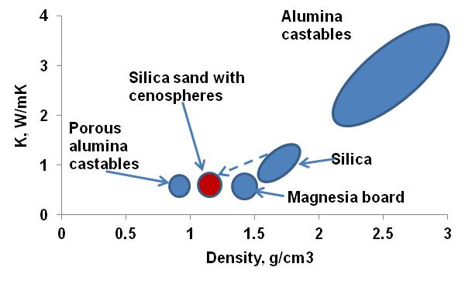

***Figure 1. Room temperature thermal conductivity versus density of different refractory materials3 is shown. (Artwork courtesy of ST Foundry, Inc.)***

Ladle linings are exposed to high temperatures (2732–3092F/1500–1700C); therefore, the effect of elevated temperature on the lining’s thermal properties is very important. At this temperature pore size becomes important. Refractories with smaller pores,lower than the photon mean free path, have lower thermal conductivity values.4 In general, the thermal conductivity of dense refractories decreases with increasing amounts of porosity.5 The relationship between pore size and total porosity on thermal conductivity (k) is shown by the following Equations 1 and 2, respectively.4, 5

**Eqn. 1**

Where: dp = pore size, *n* = refractive index, *e* = reflectivity of the surface, T = absolute temperature and $σ$ = Stefan- Boltzmann constant.

$\frac{k}{k_{0}}=\frac{1+P}{1-nP^{2}}$**Eqn. 2**

Where: k = thermal conductivity of a porous ceramic body, k0 = that of the pore-free ceramic body, P = pore volume fraction and n = constant.

However, there is a limit to the amount of porosity that can be introduced into a refractory lining. High porosity will lead to lower strength. Also, open porosity can lead to problems with melt or slag penetration.6 The suggested concept of a new lining material design is based on two main requirements:

1. Maximization of total porosity to decrease thermal diffusivity (density & thermal conductivity); and
2. avoiding open porosity to prevent melt penetration.

To satisfy these requirements, the addition of hollow cenosphere particles to a traditional silica lining was suggested. Cenospheres are lightweight hollow spheres filled with air or gases and are a byproduct of coal fired power plants. The word, cenosphere, is derived from the Greek words, kenos (hollow) and sphaira (sphere). The properties and composition vary based on the nature of the coal, grinding operation, combustion, and withdrawal in the electricity generation process. They mainly consist of silica and alumina and are inert to chemical reactions. The chemical and physical properties of cenospheres make it a valuable additive to refractory materials. The chemical composition is provided in Table 2. Figure 2 shows the Scanning Electron Microscopic (SEM) image of cenospheres. The physical properties of cenospheres are given in Table 3. Cenospheres have a very low bulk thermal conductivity (0.07 W/mK).

***Table 2. Chemical Composition of Cenospheres (Provided by ST Supplier, Inc.)***

|  |  |  |  |  |  |
| --- | --- | --- | --- | --- | --- |
| **SiO2** | **Al2O3** | **Fe2O3** | **CaO** | **MgO** | **K2O** |
| 50.00‒65.00 | 28.00 min. | 0.50‒5.00 | 0.50‒3.50 | 0.80‒2.00 | 1.00‒4.00 |

The addition of hollow cenospheres to silica sand linings increases total porosity without increasing open porosity.

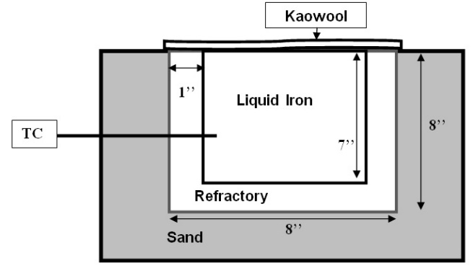

(a)

|  |  |
| --- | --- |
| H:\Paper Prep\Paper 3\0 pct b4 tap.jpg  (b) |  |
| H:\Paper Prep\Paper 3\12 pct mold bfr tap.jpg |  |
| (c) |  |

***Figure 5. These mold designs were used in Experiment 1: View (a)schematic design of the mold; (b) mold insert prepared from silica sand; and (c) mold insert prepared from silica sand containing12 wt% (30 vol%) cenospheres. (Artwork courtesy of ST Foundry, Inc.)***

EXPERIMENTAL TRIALS

Two experiments with liquid iron were performed for comparison of the heat flux from the melt to surrounding lining. In both experiments, a cast iron melt was used instead of liquid steel to increase the time of the lining-melt contact before freezing, due to a lower melting temperature.

Experiment 1

The goal of this experiment was to compare the melt cooling rate in the mold with a regular silica lining to a silica lining containing a 12 wt% (30 vol.%) cenosphere addition. The mold design is shown in Fig. 5. After pouring the open top molds, the tops of the molds were immediately covered (within 5 seconds) with a glass fiber blanket (Kaowool) for thermal insulation. K-type thermocouples (TC) were inserted from the side wall to monitor the melt temperature. The liquid metal was poured into the molds at 2422F (1327C).

Experiment 2

This experiment was performed to compare the heat losses from an experimental ladle lining (silica sand +12 wt % cenospheres) with other typical ladle refractory materials studied previously.3 In the previous work,   
100 lb (45 kg) steel capacity ladle linings were fabricated in steel ladle shell (Fig. 6). Two K-type thermocouples (TC2 and TC3) were embedded into the refractory at 1 in. (2.5 cm) and 2 in. (5.1 cm), respectively, from the inside surface of the ladle.

The liquid metal temperature was measured every minute by a submerged S-type thermocouple (TC1). The temperature measurements were used for inverse modeling to calculate the thermal conductivity of the lining. In the work for this thesis, the experimental refractory, 12 wt% cenospheres mix with silica sand, was fabricated into the same 100 lb (45 kg) capacity ladle. Liquid iron was superheated in an induction furnace to 2912F (1600C) and tapped into the specially designed ladle.

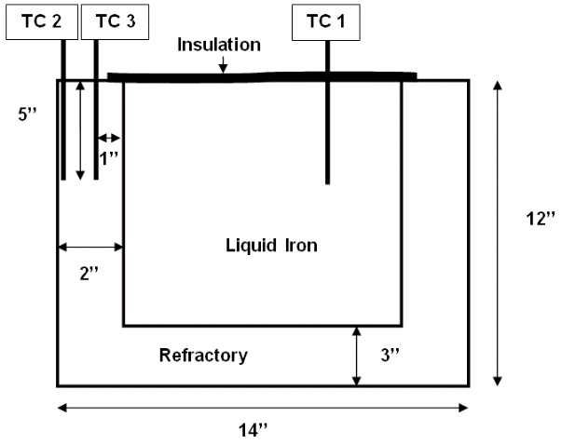

***Figure 6. This is a schematic of the laboratory ladle 100 lb (45 kg) prepared for Experiment 2.3***

**EXPERIMENTAL RESULTS**

BULK PROPERTIES

The physical properties of bulk silica sand and cenospheres as measured are provided in Table 4. The cenospheres are smaller (75–100 μm) compared to the base silica sand particles (200–300 μm). The bulk density of the mix decreases with increasing cenospheres addition. Bulk density was reduced from 1.7 g/cm3 to1.28 g/cm3 (25 % reduction) when 12 wt% cenospheres were added to silica sand without changing the porosity in the bulk mixture (Table 4).

The thermal conductivity of bulk silica sand and cenospheres was found to be 0.23 and 0.08 W/m-K by the hot wire method at room temperature. A 12 wt% addition of cenospheres resulted in a 35% reduction in thermal conductivity. The thermal conductivity of the aggregate/mix was measured as 0.15 W/m-K. Thermal diffusivity of the mix was reduced by 13%.

SIMULATION OF EXPERIMENT 1

For heat transfer calculations, the heat transfer approximation for a thick-walled mold suggested by Poirier was used. It was assumed that all the resistance to heat flow was due to the mold walls (Eqn. 3):

$q_{x=0}=\frac{\sqrt{kρCp}}{\sqrt{πt}}(T_{M}-T_{O})$ $q_{x=0}=\frac{\sqrt{kρCp}}{\sqrt{πt}}(T_{M}-T_{O})$**Eqn. 3**

Where: qx=0 = heat flux into the mold at x = 0; *k* = thermal conductivity; *cp* = heatcapacity; *p* = density; *TM* = metal temperature; *T0* = room temperature and *t* = time.

These calculations were performed for the holding period by dividing the time into smaller time steps (120 sec). The calculation began six minutes after pouring to minimize the effect of the initial drop in temperature (due to the absence of mold preheating). In the simulation, it was assumed that the temperature of the inner surface of the mold was equal to the melt temperature at each time step. The mold wall was assumed to be sufficiently thick so that the outer surface was at room temperature during the experiment. By equating the heat loss from the liquid per unit time to the heat flux through the mold, the temperature change of the liquid metal was calculated by adjusting the thermal conductivity values. The experimental and calculated cooling rates were fitted for:

k = 1.3 W/mK; and

k = 1.0 W/mK for silica sand & lining with cenosphere additions (Fig. 11).

SIMULATION OF EXPERIMENT 2

The temperature measurement data from the second trial were compared with CFD simulation results to determine the overall thermal conductivity of the lining during operation. In inverse modeling, the thermal conductivity value was changed (steps of 0.1 from 0.8 to 1.4) to fit the temperature data of the simulation and the experiment.

The liquid metal temperature obtained from the simulation was compared to the data from the thermocouple TC 1 (Fig. 12). During the experiment, the insulation on top was removed each time the liquid metal temperature was measured. In the model, however, the insulation is assumed to remain in place for the entire time. This could explain the deviation between the two curves after five minutes.

The measured temperature in the lining was also compared to the simulated temperature at the exact position of the thermocouples TC2 and TC3 (Fig. 11).

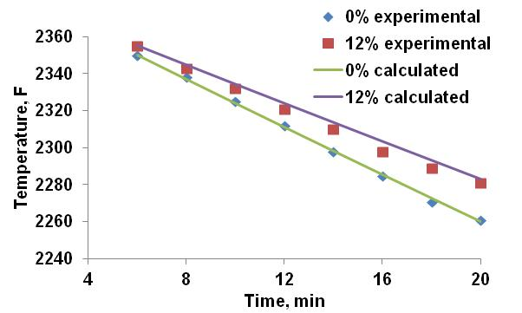

***Figure 11. Graph shows the comparison between the experimental and theoretical temperature drop for experimental molds with the silica sand and the novel refractory (silica + 30 vol. % cenospheres).3***

The difference between the experimental thermocouple measurements and the simulated result is most likely due to the inconsistencies in exact positioning of thermocouples during the experiment and the simulation. But, the trend of the temperature rise was observed to be similar. The average thermal conductivity of the refractory was calculated to be 1 W/mK for this experiment which is 20 to 40 % lower than the regular silica lining (1.2–1.4 W/mK).

The thermal conductivity values for the new lining were found to be 1 W/mK from both the experiments. However, the thermal conductivity measured with the hot wire test differs from the simulation experiments.

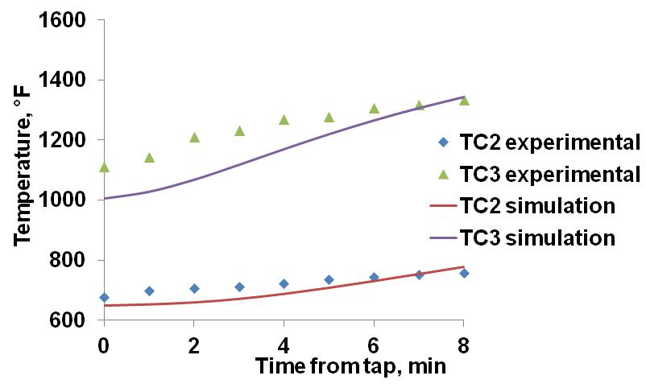

***Figure 12. Graph shows the comparison between experimental and CFD simulated lining temperature for 100 lb (45 kg) ladle lined with the novel refractory (silica + 30 vol. % cenospheres).3***

COMPARISON WITH OTHER LININGS

Figure 13 shows a comparison of the cooling curves for liquid cast iron in the 100 lb (45 kg) ladle with different lining materials. Data for comparison was taken from a previous study.3 The same melt volume and ladle geometry were used for both studies. The time difference for the liquid metal to drop from 2822‒2426F (1550‒1330C) is listed in Table 5 for the four different refractory materials:

1. Preheated silica with cenospheres;
2. Preheated alumina castable;
3. Preheated porous alumina castable and
4. Room temperature magnesia board

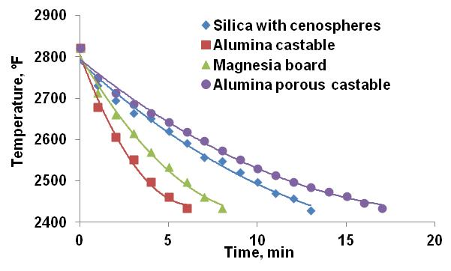

***Figure 13. A graphical comparison of cooling curves for developed and previously studied linings.3***

***Table 5. Holding Times for Melt Temp. to Drop from 2822‒2426F (1550‒1330C) in 100 lb (45 kg) Ladle***

|  |  |  |
| --- | --- | --- |
| Lining | Preheat, F(C) | Time (min) |
| Alumina castable3 | 1290F (700C) | 6 |
| Magnesia board3 | No preheat | 8 |
| Alumina porous castable3 | 1290F (700C) | 17 |
| Silica with cenospheres  (this study) | 1290F (700C) | 13 |

The temperature drop was the highest (six minutes) for the alumina castable because it has the highest thermal conductivity among the four linings. Silica with cenospheres took 13 minutes to reach 2426F (1330C) which is better than the alumina and the magnesia refractories. An important observation was that the silica lining with 30 vol% cenospheres endured the single use with no visible crack formation during or after the trial. This is a promising result, but it will need to be studied over longer campaigns to determine the industrial acceptability of the new lining.

**CONCLUSIONS**

Cenosphere additions to the silica ladle lining has the potential to reduce the heat losses in the ladle for steel foundry operations resulting in lower tap temperatures and reduced melting energy requirements. Effective thermal conductivity measurements during use in the ladle showed a 35% decrease in thermal conductivity for silica with cenospheres when compared to standard silica sand linings. These results were similar to measurements using the hot wire method, which showed a 20–40% decrease in the thermal conductivity. Ladles lined with silica with the addition of cenospheres showed no abnormal wear or evidence of cracks during the experiment which is promising for industrial use. In the 100 lb (45 kg) ladle experiment, the temperature drop for the new silica lining with cenospheres was better than the traditional magnesia or alumina ladle linings. Only the porous alumina was better in terms of temperature drop than the new material. The superheat required before tap could be reduced by 20–50°F (11–28°C) and in the process saving electrical energy consumption by 25–50 KWH/ton. Future trials with the proposed novel lining are suggested for small steel foundry ladles used for a typical multiple-use campaign to determine the ladle life.

**ACKNOWLEDGMENTS**

The author thanks Dr. Jo Walker for his support and supervision and ST Foundry, Inc. for their services.

REFERENCES

1. Heine, H.J., “Reviewing Refractory Practices in Steel Foundries,” *Foundry Management and Technology*, vol. 128 (4), pp. 32 (April 2000).
2. Peaslee, K.D., Lekakh, S., Smith, J., Vibhandik, M. “Increasing Energy Efficiency Through Improvements in Ladle Materials and Practices,” 61st SFSA T & O Conference, Chicago, IL (December 2007).
3. Peaslee, K.D., Lekakh, S., Richards, V., Sander, T., Smith, J., Vibhandik, M., “Improving Melting Efficiency Through the Application of New Refractory Materials,” 60th SFSA T & O Conference, Chicago, IL (December 2006).
4. Nasr, K., Viskanta, R., Ramadhyani, S., “An Experimental Evaluation of the Effective Thermal Conductivities of Packed Beds at High Temperatures,” *Journal of Heat Transfer*, vol. 116 (4), pp. 829‒838 (November 1994).
5. Aivazov, M.I., Domashhev, I.A., “Influence of Porosity on the Conductivity of the Hot-Pressed Titanium Nitride Specimens,” *Poroshkovaya Metallurgiya (Soviet P/M and Metal Ceramics)*, vol. 8(9), pp. 51‒54 (1968).
6. Lee, W.E., Zhang, S., “Melt Corrosion of Oxide and Oxide-Carbon Refractories,” *International Materials Review,* vol. 44(3), pp. 77‒105 (1999).