2025 Author’s Paper Template

(Arial,14 pt, BOLD, Centered)

(Author’s first name, middle initial & last name) (Times New Roman, 12 pt.)

Affiliation, City, State (author’s affiliation & location include country) (Times New Roman, 10 pt.)

(Secondary author(s) first name, middle initial & last name) (Times New Roman, 12 pt.)

Affiliation, City, State (author’s affiliation & location-include Country) (Times New Roman, 10 pt.)

Copyright 2025 American Foundry Society (10 pt. Times New Roman)

**Note:** The acceptable manuscript style has been formatted within this template. A sample paper is also available for you to use when preparing a paper for submission. Please fully edit and proofread your paper before submission to ensure quality. Failure to comply with the submission guidelines may prohibit your manuscript from being published. Do not use headers, footers, page numbers, or linked references and footnotes.

**PAPER TEMPLATE SAMPLES**

abstract (SAMPLE-ABST HEAD-Arial 10BOLD)

The Abstract heading uses **ABSTHEAD** format (**ARIAL 10 BOLD**). The abstract length should be 75 to 150 words. Use “body” text style (Times New Roman 10) and leave a line break between paragraphs. Do not indent paragraphs.Columns should be left-justified.

**Keywords**: Use five to 10 keywords, “body” text style (Times New Roman 10)

introduction (SAMPLE-HEAD1)

The Introduction header uses the style format designated **HEAD1 (ARIAL 10 BOLD).** Leave a line break between paragraphs. Do not indent paragraphs. Use “body” text style (Times New Roman 10). Other subheads within this section should be all uppercase letters HEAD2 (ARIAL 10). Do not leave a line break below subheads.

Sub-subheads should be typed in upper and lowercase letters Head3 (Arial 10, Underline) and Head4 (Arial 10), there is no line break below these subheads. See sample subheads that follow.

DESIGN OF EXPERIMENTS (Sample-head1)

This section may include subheads. Do not indent paragraphs. Use “body” text style for the main text.

experimental (Sample-Head2)

This subhead is identified with a HEAD2 style format and uses “body” text style for the main text.

CHEMISTRY Effect ON PROPERTIES (Sample-HEAD2)

This is another sample of subhead (HEAD2.) There may be several second level subheads within each second level heading. “Body” text style is used for the main text.

Yield Stress (Sample-Head3)

This is a third level subhead (Head3). There may be several third level subheads. “Body” text style is used for the main text.

Predicted Values (Sample Head4)

This is a fourth level sub-subhead (Head4). There may be several fourth level subheads. “Body” text style is used for the main text.

**LISTS / BULLET STYLES**

(Unord list & Ord list)

* **Unordered** bullet, no numbers (Times New Roman 10)
* This unordered list has bullet symbols, no numbers.

1. **Ordered bullet list,** uses numbers (Times New Roman 10)
2. This ordered list contains numbers.

Figures

Figure captions must be a complete sentence, located below each figure, upper and lower (sentence) case, flush left in Caption format (Caption Arial 9 Bold Italic) see example below. The figure should be located after it is cited in the text. Do not use a list of figures at the end of the paper. Do not wrap text around artwork. If artwork spans two columns, see the subhead, OVERSIZE FIGURES & TABLES.

CAPTION NOTE: At the end of each caption, acknowledge the source of any artwork as follows: (Artwork courtesy of ST Foundry, Inc.)

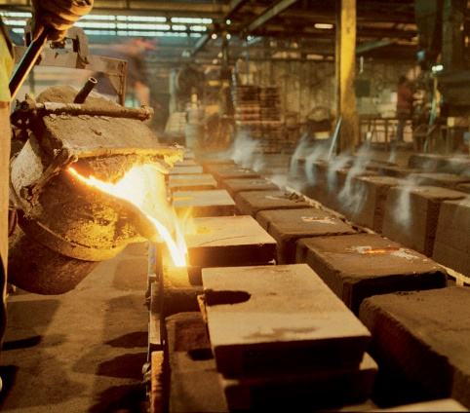

Figure 1. This photo (JPEG file format) was inserted by pulling down the Insert menu on the tool bar and choosing Picture.

Tables

Table captions must be in phrase format, located above each table (centered; see example). Table captions should be upper and lower case (first letter of each word in upper case) in Caption format (Caption Arial 9 Bold Italic). The figure should be located after it is cited in the text. Do not use a list of tables at the end of the paper. Do not wrap text around artwork. If artwork spans two columns, see the subhead, OVERSIZE FIGURES & TABLES.

CAPTION NOTE: At the end of each caption, acknowledge the source of any artwork as follows: (Artwork courtesy of ST Foundry, Inc.)

Create a table with Word, using the Insert, Table option. If artwork spans two columns, see the subhead,**Oversize figures & Tables.** No complex formatting, borders or shading is permitted.

Table 1. Alloy “A” Composition

|  |  |  |  |  |  |
| --- | --- | --- | --- | --- | --- |
| Al | Cu | Zr | Zn | Fe | Cr |
| 1.00 | 2.00 | 3.00 | 4.00 | 5.00 | 6.00 |
| 7.00 | 8.00 | 9.00 | 12.00 | 2.00 | 3.00 |
| 4.00 | 4.00 | 6.00 | 7.00 | 8.00 | 9.00 |

**Temperatures**

Temperatures must be listed in Fahrenheit (F) and Celsius (C). Fahrenheit units must be followed by Celsius units in parentheses [i.e., 32F (0C)].

TEMPERATURE INCREMENT / DIFFERENTIAL

Degree symbols are used only when referring to a temperature differential. [(i.e., the melt temperature increased by 100°F (55.6°C)]

**Mechanical properties**

Mechanical properties should be reported in MPa.

(1 MPa = 0.1450377 Ksi).

**Metric & English Units**

Metric and English units are both used in the text. Metric should be converted to English and vice versa.

Inches & feet

Use abbreviations for inches and feet (in., ft.), not symbols.

**Equations**

Create equations in *Equation Editor* (found under the Insert/Equation tab) and number equations consecutively. Left align the equation and right align the equation number as follows:

a + b = c Eqn. 1

Conclusion (conc HEad)

This section head uses the style format designated **CONC HEAD** (**ARIAL 10 BOLD**). Leave a line break between paragraphs, no paragraph indent. Use “body” text style for the main text (Times New Roman 10).

**Oversize Figures and TableS**

Examples of an acceptable figure and table that span the full-page width is shown on the next page. To flow text from left-to-right, top-to-bottom across two columns (when figures span two columns) the text should be inserted before or after the text or embedded within the text in such a way that retains the flow as desired above.

NOTE ON ARTWORK

All artwork that is not the property of the author must be acknowledged in the caption i.e., (***Artwork courtesy of ABC Foundry, Inc***.).

***NOTE****: It is the author(s)’ responsibility to obtain permission to use any artwork, video, table, figure, photo, etc. or that is not their property***.**

**Oversize figures & Tables**

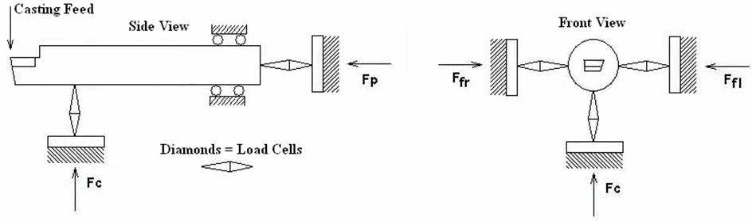

***Figure 2. A schematic of a tool force measurement system is illustrated above. (Artwork courtesy of ST Foundry, Inc.)***

Table 1. Chemical Analysis Results for the Aging Effect on Tool Force

A completed digital ***AFS Author’s/Speaker’s Copyright & Publication Agreement***form is required from each author and must be included with your paper submission for your paper to be considered for publication. [**Copyright Agreement**](https://afsinc.s3.us-east-1.amazonaws.com/Technical/Authors%20Guide/2025%20Author-Speaker%20Copyright%20Publication%20Agreement-st%20Final%20%283%29.docx)

acknowledgments (head1)

The Acknowledgment section is an optional section that uses a **head1** style **(ARIAL 10 BOLD),** and “body” text style is used for the main text.

**Note:** The submission of content created by AI, language models, machine learning, or similar technologies are prohibited unless it is a part of the formal research design/experimental analysis. It is not permitted without a clear description of the content created and the name of the manufacturer/model/version must be included.

If AI tools are used to create content or assist with manuscript preparation, authors must take responsibility for the integrity of the content generated by these tools. Authors must report the use of AI technology to create content in the manuscript submission in the Acknowledgments section. View the full *AFS Policy on Authorship & Use of AI Technology* at:

[AFS Policy on Authorship Criteria](https://afsinc.s3.us-east-1.amazonaws.com/Technical/Authors%20Guide/AFS%20Policy%20on%20Authorship%20Criteria-1st%20policy%20update%2005-21-24.docx)

REFERENCES (REFER HEAD)

The Reference section uses the REFER HEAD (**ARIAL** 10 BOLD). Reference text uses Ref Text (Times New Roman 10). Use superscript numbers in the text for noting references (i.e., The air quality data was compared to works by Scholz.1). References must be listed in numerical order within the text and in the **REFERENCE** section at the end of the paper.

**REFERENCES**

1. Gundlach, Richard, “Heat Treatments to Develop High Strength Ferritic Ductile Iron,” *AFS Transactions*, Paper #19-036, American Foundry Society (2019).
2. Prucha, T., “Generative AI,” From the Editor, *AFS International Journal of Metalcasting, (IJMC)* 17, 589-591 (2023). [**https://rdcu.be/dcheH**](https://rdcu.be/dcheH)(Link last accessed 05-14-2024).
3. Schorn, Ted J., “Process Control for Engineers,” American Foundry Society, Schaumburg, IL (2023).
4. Bohra, H., Ramrattan, S.N., Joyce, M.K., Fleming, P.D., III, Ikonomov, P., “Patternless Sand Mold and Core Formation for Rapid Casting,” U.S. Patent No. US9901977B2 (2013).

additional reading

Any pertinent books, research articles, etc., that the author(s) feel may be of interest to their readers but are not used as reference in the submitted paper, may be listed in **ADDITIONAL READING** (**ARIAL** 10 BOLD) and “body” text style is used for the main text. This subhead should be listed after the **REFERENCE** listings, as an unordered list (Times New Roman 10pt, align left).