1. Given the provided data, what are three conclusions we can draw about Kickstarter campaigns?
2. Kickstarters related to music has highest success rate.
3. Such campaigns as journalism, food, games and technology have very high failure and cancelling rate.
4. Number of successful campaigns decline toward the end of the year.
5. What are some limitations of this dataset?

Dataset does not contain such information as cities, populations, etc. Therefore, it is not easy to grasp the cause of failure.

1. What are some other possible tables and/or graphs that we could create?

Correlation between success, failure, or cancellation and duration of the project will give some insights.

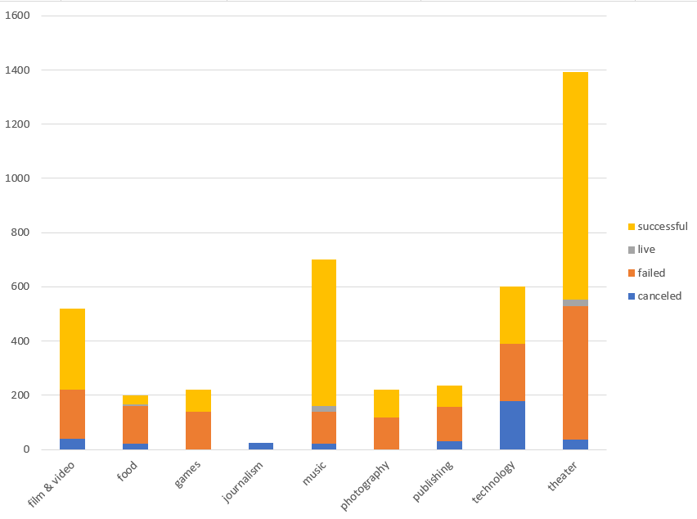

Figure 1:

