Shannon Kueneke
2/2/2026
Assignment 4.2

- Display all users in the collection
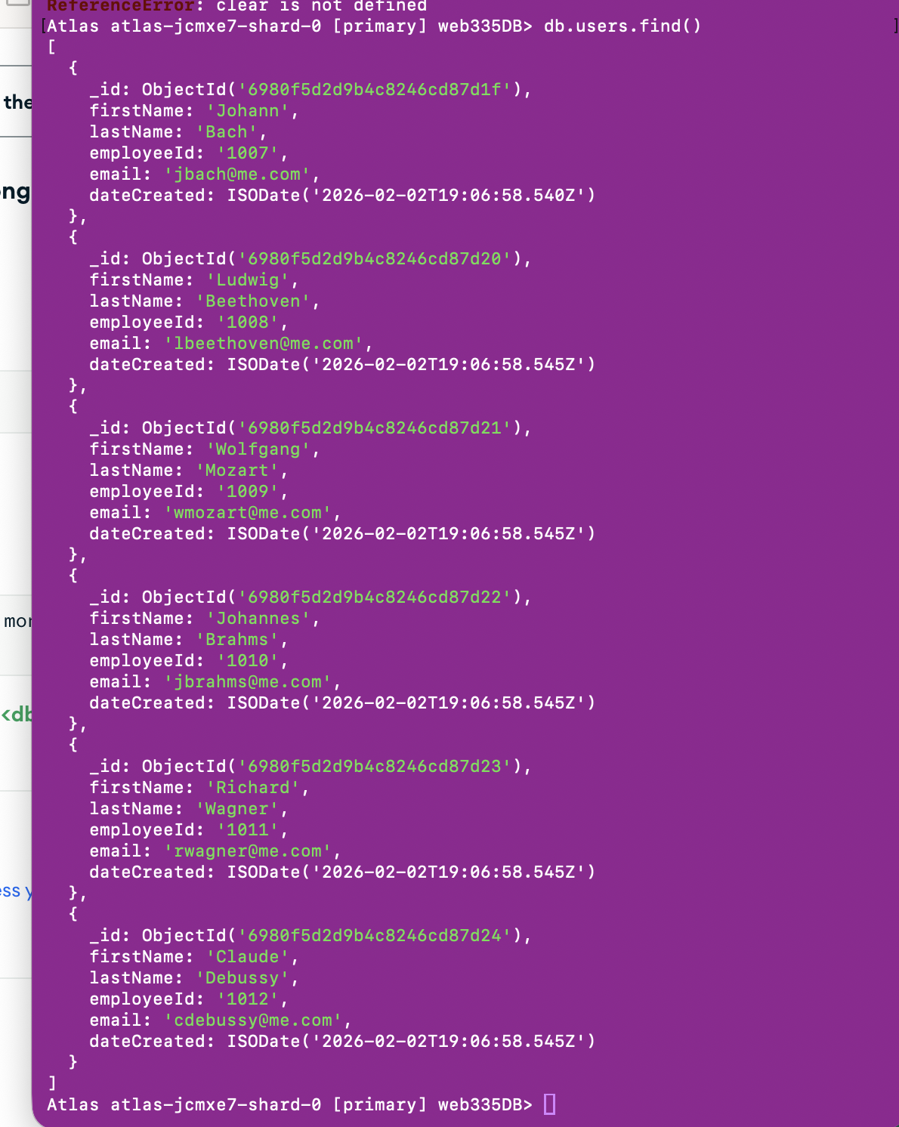

- Display the user with the email address: jbach@me.com
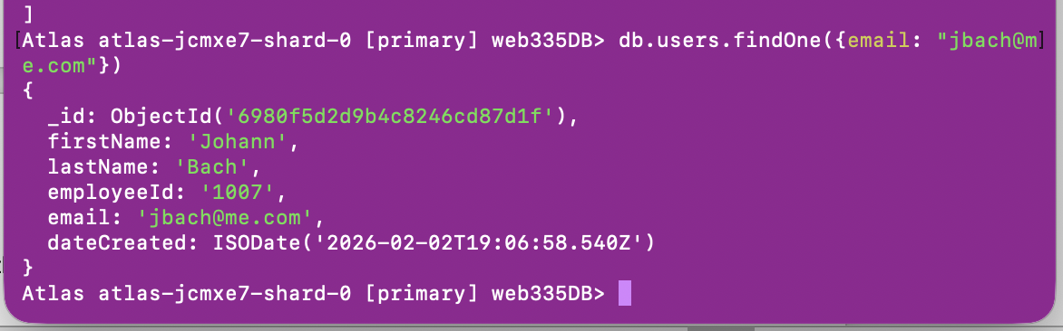

- Display the user with the last name Mozart.
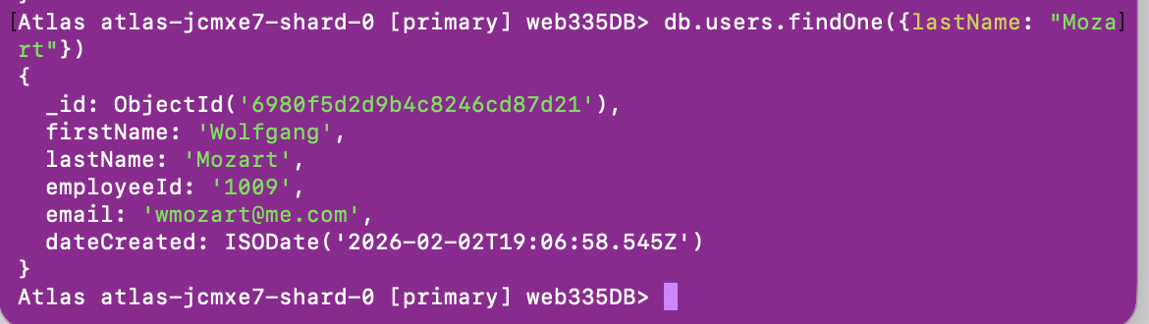

- Display the user with the first name Richard.
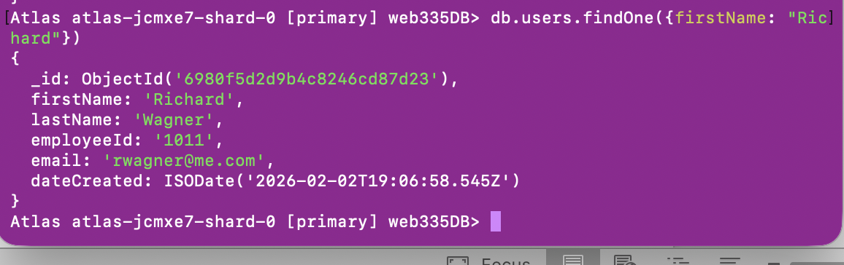

- Display the user with employeeId 1010
