

COMMUNITY COLLEGE OF CITY UNIVERSITY

DIVISION OF APPLIED SCIENCE AND TECHNOLOGY

AST20613 Computer System Development

2014-2015

V. Calendar

(Voice Calendar)

PROJECT PLAN

by

Group:ISD02

WONG, Ho Long(53587834)*

LI, Sing Lun (53612386)

SIN, Sin Chung(53587350)

WONG, Chun Kit(53581516)

Supervised by

Dr. Timothy Kwong

**Project Environment**

Name of Project: V. Calendar

Type of product: Web Development

Course Code: AST20613

Course Name: Computer System Development

Supervisor: Dr.Timothy Kwong

Group Number: ISD02

Group Leader: WONG, Ho Long (53587834)

Group Members: LI, Sing Lun (53612386)

SIN, Sin Chung (53587350)

WONG, Chun Kit (53581516)

# **ACKNOWLEDGEMENTS**

We have taken efforts in this project, it would not have been possible without the kind help and support of many individuals and organizations. We would like to take this chance to extend our sincere thanks of all of them.

We are very thankful to our supervisor, Dr.Timothy Kwong, the guide of the project that help us to solve many problems throughout the project. Also, we are highly indebted for his guidance and constant supervision as well as for providing necessary information regarding the project and also for his support in completing the project. Moreover, his kind concern provides much power to our team to finish the project successfully.

We would also like to express our special gratitude and thanks to the teachers who have taught us in these two years. The knowledge they have taught us is very useful in this project and it helps to fix lots of issues.

The teachers that we owe a great many thanks are: (Names are listed in alphabetical order)

Dr. Desmond Tsoi

Mr. Frank Lau

Mr. Jackie Kwong

Dr. Kenny Ma

Dr. Timothy Kwong

We would also like to thank you all of our groupmates, with all the help and support for doing the development of the project.

Thank you.

Yours sincerely,

Wong Ho Long, Li Sing Lun, Chan Kin Chung, Sin Sin Chung, Wong Chun Kit

FYP ISD-02 V. Calendar

**Table of Contents**

**Acknowledgements**

**Abstract**

**1. Introduction**

1.1 Background

1.2 Objective

1.3 Scope

1.4 Reason of developing this application

1.5 Assumptions

1.6 Limitation of existing application

1.7 Target user

1.8 Report outline

**2. System function**

2.1 Overview

2.2 Client side

2.3 Server side

**3. System development**

**4. Responsibilities and Management**

4.1 Organ**i**zational Chart

4.2 Responsibilities

4.3 Project Deliverables

**5. Resources and Budget**

5.1 Hardware

5.2 Software

5.3 Budget

**6. Risk Management**

6.1 Technique Risk

6.2 Schedule Risk

6.3 Assumption Risk

**7. References**

**GANTT table**

**ABSTRACT**

The population of portable device is growing gradually especially throughout these year, portable device may become replaced position of Computer or laptops, Not only the student studied in IT field, but also other streams of students usually use portable device in their daily life. Therefore the aim of our project is developing tools for useful managing their life by portable device friendly. Perhaps our project will try to use CSS3 and HTML5 for designing the layout of website, CSS3 and HTML5 are the too use for development.

These tools most update function included flexible property and also animation function, slider function etc, with database application for development such as MySQL. Our group is confident that our development tools will cater all requirements of portable device users indeed.

By ISD02 in 2014-2015

**1.1. Background**

Nowadays, we can see lots of Hong Kong people using their smart devices such as smart phones, tablets at any time. With the great popularity of smart products, those devices have become part of their live and they cannot live with it. The aim of those smart products is to facilitate people live and make their life become convenient. People can finish their jobs or obtain the specific information easily in a short period of time by using those smart devices and so the number of people using smart products is increasing sharply in recent years.

Besides, why those smart devices can improve people’s life or get the job done easily? First of all, smart devices are portable. People can bring it outside and use it in any places with a light affords, they can put it on their bags or just take it by hand. With the compare of traditional desktop computer or notebook, smart devices are smaller in size and lighter in weight. Also, the design of smart devices fits human’s hand so people can hold it easily and use it for a long time. Secondly, with the aid of physical size of portable devices, people can obtain information or complete a specific job easily at outdoor. For example, people can search the nearby restaurants, the review of the restaurants, the address of shops or sending emails at anywhere by using smart devices. People can obtain what they want in a simple gesture of finger. Thirdly, the functions provided by apps in smart devices can bring a bunch of useful tools that can get the job done easily. Usually, there is a bunch of specific functions in a specific app and it helps a specific task. People can install a number of apps and help them to do a list of jobs. Therefore, with the trend of smart devices, more and more company develops apps for their brand as it is a way to help to earn money. In general, the apps that require paying can provide the functions that other apps do not have or it provides a specific function in an abundant way.

However, although there is a lot of app in the market, most of the apps cannot provide a complete function for a high scope of users. Some of the user may need a specific function from the app and the app does not have it. In a serious situation, there are no apps that provide those specific functions to satisfy the specific group of people’s needs. Moreover, some of the famous applications only provide a brunch of basic functions and they do not have the functions that are used for the people who are disabled or some special situations. With the issue mentioned above, we would like to complete some of the functions missed in a specific app to make the app more perfect. The details of the project will be discussed in the later section.

**1.2. Objective**

In general, we would like to focus on making a webpage called Voice Calendar. The project would introduce Voice Recognition engine to obtain users’ input and output the information from the calendar. We hope our target users can use Voice Calendar to help them provide reminder to remember the things by using voice input and output.

In general, this project has three objectives and they are listed below.

1. To facilitate the use for visually-impaired people.
2. To provide a better function based on Google calendar
3. A more user-friendly and configurable UI should be used.

We have seen that the calendar provided by Google cannot satisfy some of the needs of users in daily life. In general, we see that people will face the problems on viewing the calendar when their hands are not “free”. The Voice Recognition engine can enhance the situation they meet. Also, the system can provide a more convenient way to check the schedule on users’ calendar. In the side of UI design, we should provide more settings to users to configure the application and make it more user-friendly.

# **1.3 SCOPE**

As we all know, people use the Google Calendar frequently but they need to use their eyes and hands to control it. They cannot use Google Calendar when they are doing others things. It causes inconvenience. For example, people cannot view their calendar during driving or working at the same time.

In order to make the Google Calendar to be more convenient and cater to universal usability, the following listed out some of the features that we aim to include in GV Calendar to solve the problems and inconvenience that those target users encounter.

**1.3.1 Voice output system**

Using voice commands to input event in users’ schedule, for cater to users with color blindness and the users who are busy.

->Function only implemented with today schedule

->AI could read aloud the detail, schedule date detail, Venue, Remark accordingly.

**1.3.1.1 Read the timetable in the current time**

The system could automate operated the timetable with current time only, as well as the event start in today could read aloud by the AI system only.

**1.3.2 Voice Input Function**

The voice command could be used for input the context and information instead of direct hand input, this method could aids the visual problem patients easily input the information besides from the traditional method.

**1.3.3 Voice Control Function**

The users could control their calendar by voice easily, such as given the command for register the account, the system could provide different guidelines for the users especially true for visual patients for control their calendar by voices.

**1.3.4 Setting the Calendar into different dimensions**

For favor with different people style, the calendar provides two types of calendars for user chosen which on is suitable for them, which are Day Schedule and Month Schedule.

**1.3.5 Responsive Website Design**

The website could function responsively, whatever the users are using mobile, laptop computer or Ipad, the users could easily check the information by the system setting and monitors size accordingly in different cases.

**1.3.6 Low Memory required**

Most users from out targets are mainly mobile users and portable device users, therefore design should be aims at low memory required, hence made the efficiency of the website maximize.

**1.3.7 High Security Maintenance**

**1.3.7.1. Hashed Password**

The password for users could hash for increased sense of security as well as for highly protected the security of users and protected their privacy in the highest security ways.

**1.3.7.2. Session for storing the datum instead of cookies**

System implemented with the session instead of cookies, which are text file for storing the datum memory for login. Compared to cookies, session has a higher security protection of datum and prevents data get loss by spyware.

**1.3.8. Administration Function**

The administrator could have the right for control and edit the record of accounts for all the users, if the users have problems for their accounts, they might contact their administrators or coordinators.

**1.4 Reasons of Developing this Application**

As most of the people will use calendar to check or mark their schedule frequently, or even use it daily, a user-friendly and complete functions should be included in the calendar. If more useful functions are included in the calendar, more users will use it instead of using traditional paper calendar and thus it can saves the user of paper.

Moreover, there is no solution for the blindness or some specific situations in using calendar. The project can provide some of the solutions to improve and fix the problems in different situations and scope of people.

Therefore, we decide to introduce more functions for the existing Google calendar that can improve the life of different users and help them to finish the job in a easier and comfortable way.

**1.5 Assumptions**

A few assumptions have been made during developing this application.

1. Every user who uses this web application has a computer or smartphone with browser
2. Every user who uses this web application has a network connection
3. Every user who uses this web application has Google account
4. Every user who uses this web application is using Google Chrome browser to browse the website.
5. Every visually impaired user can browse website to use this web application
6. Add friends function’s target is//Only this web application users can add friends

**1.6 Limitations of Existing Application**

**1.6.1 Google Calendar**

An application for Google Calendar is widespread, it seems become the most popular calendar among the competitor. However, there are many functions had gave a high rating from users. However, there are certain of functions may be more user friendly and adapt much better for cater universal usability to all users.

The priority arrangement for nowadays Google Calendar could make color blindness patient frustrates while used it, although the color chosen is full of diversity for people chosen for set the importance of among works. However the users cannot see the color arrangement, the users may define wrong and it made make a big trouble for users.

But also the second distinctive advantage maybe the crowed users may feel frustrated for reading the timetable around chaos, therefore Google Calendar cannot satisfy the requirement of those users.

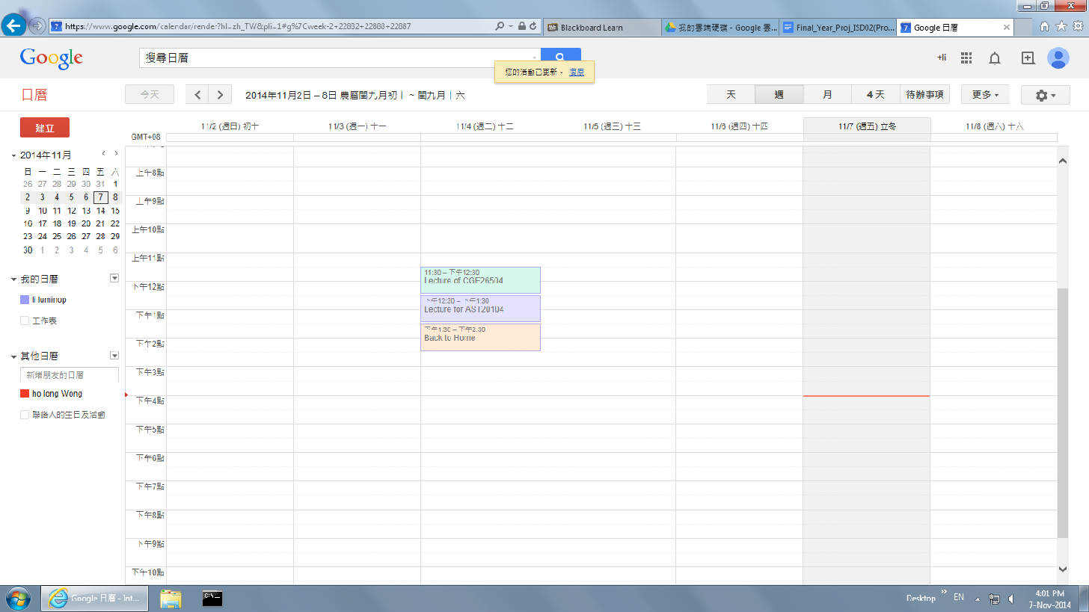

**Figure 1.1** Google Calendar’s user interface and priority of things provided and arranged, the color blindness patients quite difficult for determine the colors effectively

**1.6.2 Voice Calendar**

Voice Calendar is an application of Google Play. It is an calendar with voice input functions. Users can add schedules in their own calendar.

**Figure 1.2**

**Voice Calendar UI**

There are few limitations of Voice Calendar.

First, it is platform independent. Voice Calendar only can be used in Android OS mobile. Other Operation Systems (OS) devices cannot use this application.

Second, It only provide voice input function (add calendar). It without calendar speaks out function. It is not take care of visually impaired people at all.

Third, in this application’s voice input function, users can speak out what they want. The system will generate the schedule form with information automatically, but users still need to press “done” button. It is not good for visually impaired user.

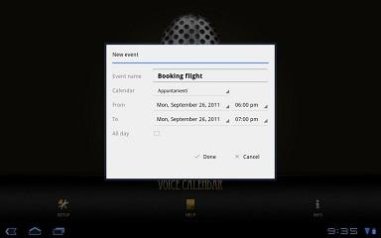

**Figure 1.3 Voice Calendar UI of adding event**

Fourth, this application needs to be paid by users for using. Not all people can use this application.

Lastly, this application has no import or out port calendar file (.ics extension file). It is not high portability in iCalendar. Users are hard to add existing iCalendar into their application. Users are also hard to add it calendar into other iCalendar.

**1.7 Target Users**

Users of Google Calendar and visually impaired people are the main target users of this application.

**1.7.1 Google Calendar’s users**

Google Calendar’s users can use browser access to this web application in order to make use of Google Calendar in their life easier. They can use the function of Google Calendar more efficiency and comfortable. It can save them some time and more willing to use the system.

This application can help them accessing to Google Calendar.

This application is an interface between users and Google Calendar. Users can use all functions of Google Calendar, such as display Calendar information, add friends calendar, add event into calendar. And additional function can be used, such as voice system, user can add or browse event in their Google Calendar. These functions can reduce user time to see calendar, quickly achieve users’ goal. Users no need to look their Google Calendar schedule, but they can still get the information that they want. User can browse their timetable when they are driving or not convenient to see their calendar.

**1.7.2 Visually impaired people**

Google Calendar is designed for normal people to use. Google Calendar cannot take care of people that having visual impaired. Visually impaired people have a right to use electronic calendar. Google Calendar required users have visual ability. It is not cater to universal usability enough.

For visual impaired people, some of them using a large print calendar, some of them using voice recorder to record their schedule and some of them need relatives to remind them. This application can change their daily life. Visually impaired user can use iCalendar smoothly.

**1.8 Report Outline**

In the next chapter, it is the overview of the features that GV Calendar will be given. This chapter is mainly divided into two parts, which describe about the features provided by the web page and the feature of the server that help the web page to store the data or information for the users.

In Chapter 3, reasons of choosing which version of operating system we choose and reasons of CS6 we chosen rather than others such CS5 or CS4. This chapter also listed out the tools we need to use for developing this web application project. Moreover, it will give brief information on the project team’s organization and their responsibilities.

For the Chapter 4, the resources, the hardware and the software we need to use for this project will be listed out. Also, the budgets of this project will be also given out.

For the final chapter, it will mention all the risks what we will face and the solutions how to solve it on doing this project.

**2 SYSTEM FUNCTION**

**2.1 Overview**

While developing the web application, it can be divided into two parts, which are web page side and server side. For the web page side, it will mainly focus on the displaying the features provided by the web application; while the server side will store and handle the information of user and the data of database.

**System Context Diagram (SCD)**

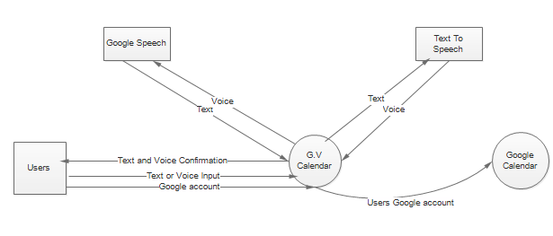

**2.2 Client Side**

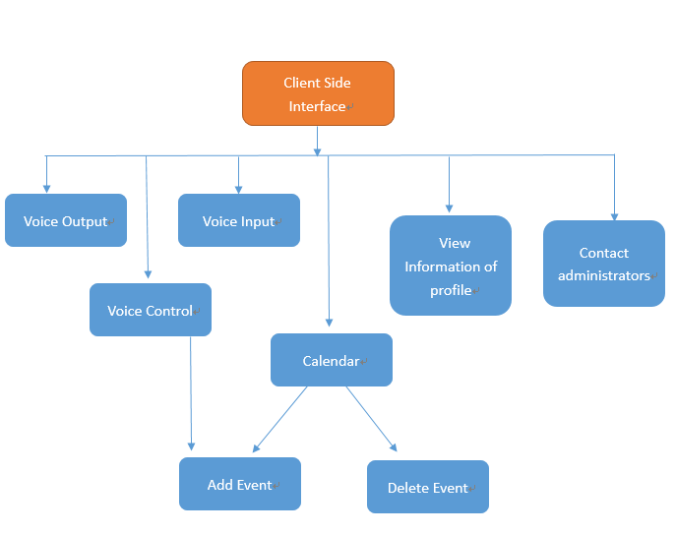

**Figure 2.1: The figure illustrate the main web page function planned**

**Features Description**

The application includes many features, the following listed out features that can help user increase the efficiency and convenience of using calendar.

**A.AI Speaking Aloud Function**

**Voice output function(Client Side)**

Voice output function is mainly for converting the text to speech file, for cater different users usage that who are busy and in the crowded situation that might not check interface immediately. From these, user through this output function for listen schedule rather than read. Moreover, the users may be have visual problems for reading the timetable such as color blindness, which their sensitive of color are not sharp and strong, then they may detected wrong the color and it might formed big troubles at all. Just imagine that the users are businessman with colorblindness, the wrong detection of color may lead them missed a priority for grouping things. Therefore, It’s compulsory for setting listening AI function for users listening the tapes they could like to listen.

**Voice Input Function(Client Side)**

User could just simply click the small mic button,it could automatically related to the google webkit recognition server,for allow you just speaking what you want to say and generate the word input.

**Voice Control Add Calendar**

It ‘s a function just combined the function of voice input and click button,through these,the user could just simply given an command by voice,then webkit recognition machine could generate the user commands into actions,such as clicking the buttons or login function,

Voice Add Calendar Function combined the function of voice input and voice control functions,while the system detected the users want to input their events,the system could generate a series of automatics login flows,the users required to follow the guideline given by AI,then input an appropriate commands and their things want to input,for the event add function.

**Contact Administrators**

The function allows the user for asking the requests for the administrators as their add calendar bugs or other problems facing.For sending the email to the administrators,the administrators could receive the form from automatics system,which report the requests for the users in the standard form.

**View Information of profile**

The users have right for check their profile manually and seen their personal information since they registered.

**2.3 Server Side**

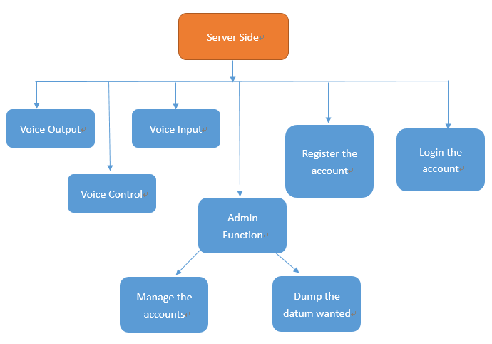

**Figure 2.4: The figure illustrate the main server function planned**

**Create and Login Account**

User need to create an account in server side for Identity. In this process, this account will save many things, included voice message, the content of event.Likewise,the users required to input their name and password for login.

**Input Event(Server Side)**

User and decide to input their event by inputting text or voice. For input by text, server will transfer those text and input to client’s calendar. For input by voice, the voice file will save at our server, the title of event will input to calendar and the link of that sound file will save in content side.

**Output Event(Server Side)**

There have two ways to output event. First one is output the event in calendar according by UI design. Other one is output by voice. For the event inputted by text, server will get those events from user and send back those texts to client side for display. For event input by voice, when users are on click of that event or want to get all schedules by voice, the request will send to server. For text schedule, server will convert the text to voice and send the sound file back. For voice schedule, server will get the sound file from database and send it to client side.

**Voice Control(Server Side)**

Voice Control function is one of the features of voice calendar in the server side. Since calendar will give out a voice to talk about the command on current page, users will know all the command. Voice Control function is to let users give the command to the calendar. Based on the command, the server will help users to go to the related page. It can help users to go to next page easier.

**Admin Function**

The admin users have right for delete or edit the user information which maintain the system consistency,the allowance for the admin to edits are user name and user mail yet the password because for protect the privacy issues of clients.

**Dump the datum**

The admin could also have the right for dump the datum as well as for the backup,the backup content could mainly contented the user ‘s calendar event and SQL Data Structure.

3 System Development

Operation Environment of project maybe as follow illustrated, and hopefully development method would follow these style as possible:

|  |  |
| --- | --- |
| Operating System | Web base system design |
| Hardware Requirement | Vostro 3900 PC  Android Mobile Phone |
| Operation Software | PHP  CSS3  JavaScript  MySQL  C++(May not be helpful for developing)  C#(May not be helpful for developing)  Visual Studio 2013 Professional (May not be helpful for developing) |
| Server | MySQL |
| Platform for performance | Dreamweaver developed by Adobe Company for CSS/CSS3,HTML,HTML5 |

System Relation and Explanation

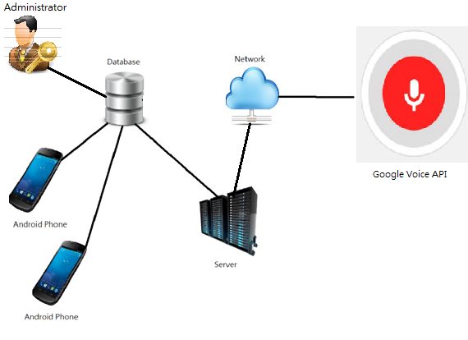**Figure 3.1: The graph had illustrates the relation between servers, users, administrators and database**

The graph had illustrate the relation for procedure rundown, it consist of server, user and database. Server is a place for placing the hardware and tools with standard, however the database is used for storing certain datum with arrangement, when the client required for the information, the database then could transmitted the information that user indeed respectively.

Administrators have a role for controlling and administering the Database’s data flow and information respectively.

Development tool and Comparison:

**Microsoft Speech Platform – Software Development Kit**



It is a useful software for converting the text file to sound files with standard quality, With nearest Version 5.1, there could have full of diversity of voice and language for chosen, Compare with other TTS Console Application in the market share, Microsoft Speech Platform still kept pioneered with competitor.

The second charming from Speech SDK may come from the text to speech tool could have a grammatical correction function, by which reducing the opportunity for getting the errors. Likewise, it‘s a user friendly behavior

[PromptBuilder](http://msdn.microsoft.com/en-us/library/microsoft.speech.synthesis.promptbuilder(v=office.14).aspx) class is easily for control the class speech output, [Speech Synthesis Markup Language (SSML)](http://go.microsoft.com/fwlink/?LinkId=201763), files containing text or SSML markup, and prerecorded audio files. [PromptBuilder](http://msdn.microsoft.com/en-us/library/microsoft.speech.synthesis.promptbuilder(v=office.14).aspx) also given an opportunity that for choosing voice that you like and also rate and volume. For author content much better, SSML-compliant XML, which provides a full range of authoring technique and also allows you to select and control speaking voices.

The competitor of Speech SDK come from different aspects, Ultra Hal TTS Reader, naturalReader are also common tools for input the voice, however these tools only supporting the language with specific types(NO Chinese and Cantonese for chosen). Therefore, it makes Microsoft stood out from various of choices.



Java (Eclispe)

A Programming tools that support for Java Development Toolkit (JDK) environment, useful for development a function for Java, java application such useful for programming task in web development



C# (Visual Studio Professional)

Visual Studio Professional 2013 is a programming tool for supporting C# environment, useful for development a function for TTS Application specially.

MySQL Enterprise edition



Used for database programming, the tools is useful for manipulating data and managing data with SQL Code. However, due to for commercial use (development of project) rather than Individual use, some may consumed.

MySQL Cost and our recommendation using development software:

|  |  |  |  |
| --- | --- | --- | --- |
| Name of function | MySQL Enterprise Edition | MySQL Standard Edition | MySQL Cluster Carrier Grade Edition |
| MySQL Cost | Medium | Lowest | Highest |
| MySQL Database Server |  |  |  |
| MySQL Security and Encryption (Important for developloging system) |  |  |  |
| Storage Engine: NDB(Not Useful) |  |  |  |
| Overall Prefer Version |  |  |  |

Dreamweaver CS6 Version



Dreamweaver is a tool for manipulating the Web layout design such as CSS and Html, design tool throughout the websites. The CS6 could also support the CSS3, PHP and HTML5 Function.

Why choosing HTML CS6 rather than other CS5/4/3/2/1:

|  |  |
| --- | --- |
| Advantage |  |
| 1. CSS3 and HTML5 don ‘t need using plugin anymore in CS6 | 5.Design mode could modified to more and more portable device oriented design |
| 2.Live View are much faster and reduced procedures | 6. UI Design for giving the people easily for selection. |
| 3.Business Catalysis Connective |  |
| 4.Better Integration for adapt in Dreamweaver by Photoshop or Illustration technique |  |

It’s, Therefore, its force us from develop the tools by using CS6 rather than other development language through advantage as below illustrated.

Google Chrome



It’s a portable web browser for support diverse of authority language such as CSS3, Html5 and also support with different properties of web designs. such as flex properties for portable devices.

Opera Browser



Opera Browser mainly functionally dependence on Google, but the advantage of opera not only use less memory required while computer ran browser.

Market share of Browsers

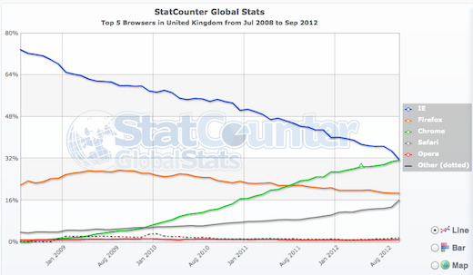

Fig3.2. The figure show the comparison on the usage of 5 browser from British.

The figure had provided the comparison of Window Browser for computer Users in British during 2008 to 2012, variety of browsers namely IE, Firefox, Chrome, Safari, Opera and Other respectively.

It‘s obvious observed from diagram that the expenditure for using IE declined gradually, yet usage of Chrome risen continuously, it’s interested to noticed that proportion of usage of IE and Chrome overlooked at Sep 2012.

IE kept dominant at the beginning, an exponentially plunged had observed between June 2009 and July 2009, While the proportion of usage declined gradually between June 2010 and Sep 2012, the number of Google Chrome users kept continuously increased.

Firefox, Safari and Opera, meanwhile, kept remain kept constant from period provided. It‘s forecast that the proportion of Chrome would increase in the future yet IE would decreased.

**4 Responsibilities and Management**

**4.1. Organizational Chart**

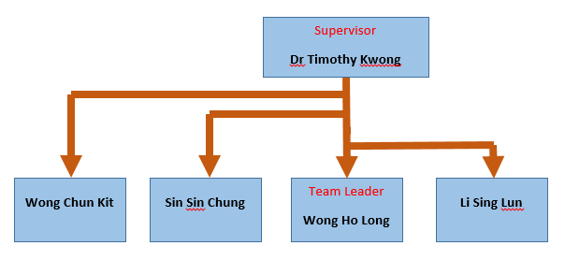

**Figure 3.4.**Organizational chart of the developing team

The above figure showed the organization of the group which is developing the voice system timetable. As shown above, Dr Timothy Kwong is our supervisor and Wong Ho Long is our team leader.

**4.2. Responsibilities**

The following table listed out the responsibilities of each member.

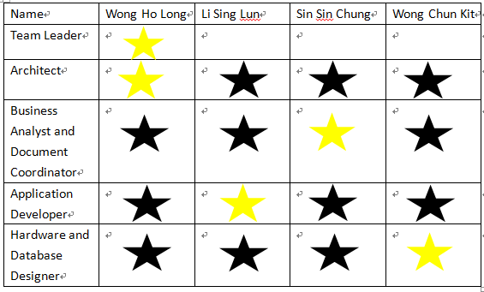

Remark: Yellow Star is refer for in charge person, black star is represent deputy in charge person

**4.3. Project Deliverables**

The table below showed the date of submission of the required items that needed to be delivered.

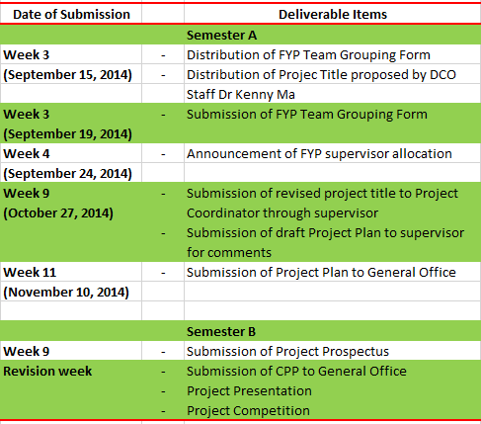

**Figure** Chart that listed out the deliverables for the project

**5 Resources and Budget**

**5.1 Hardware**

|  |  |
| --- | --- |
| **Model** | *Vostro 3900 by Dell Computer*  *(i5 4460 processor,4GB DDR3 MEMORY)* |
| **Operating System** | *Microsoft Server 2008 R2 Standard* |
| **Price** | HK$ 4288 |

Vostro 3900 by Dell Computer is chosen as the server for the project and it is used to storing the necessary data and process a specific task for users. It has an i5 CPU, 4GB DDR3 memory and it should be powerful enough to process the main tasks of the project and handle a high volume of traffic data.

**5.2 Software**

|  |  |
| --- | --- |
| **Name** | *Eclipse* |
| **Purpose** | Program Coding |
| **Price** | HK$ 0 |

Eclipse is used for coding and it is a famous coding software among the market as it is easy to use. The cost of Eclipse is completely free of charge and it is a open-source software.

|  |  |
| --- | --- |
| **Name** | *Visual Studio 2013 Professional* |
| **Purpose** | Program Coding |
| **Price** | HK$ 4506 |

Visual Studio 2013 Professional is chosen for the coding of C++ language as it provide more abundant functions and UI. The cost is HK$ 4506 for buying a copy of professional license.

|  |  |
| --- | --- |
| **Name** | *MySQL Enterprise Edition* |
| **Purpose** | Database System |
| **Price** | HK$ 15511 |

MySQL Enterprise Edition is used for the data system and it is used to manage the database in the server. The cost is HK$ 15511 for buying a copy of Enterprise license.

|  |  |
| --- | --- |
| **Name** | *Dreamweaver CS6 Version* |
| **Purpose** | Web Language coding |
| **Price** | HK$ 3730 |

For the part of web language coding (HTML5, CSS), Dreamweaver CS6 Version is chosen. As Dreamweaver is the famous software that used in organizing the web page and coding the web language, it will be used. The cost of buying the license of it is HK$ 3730.

|  |  |
| --- | --- |
| **Name** | *Google Chrome Explorer + Opera Explorer* |
| **Purpose** | Testing |
| **Price** | HK$ 0 |

As we have to test the project, browsers are needed. Google Chrome and Opera will be used for testing. Google Chrome is one of the most famous browsers for users so we will test on it. In contrast, Opera Explorer has fewer users and there is some issues in displaying content of webpage so we also test on it. The cost of both is HK$ 0, we just download it from the Internet.

|  |  |
| --- | --- |
| **Name** | *Microsoft Server 2008 R2 Standard* |
| **Purpose** | Operating System of Server |
| **Price** | HK$ 6438 |

Microsoft Server 2008 R2 Standard will be installed in the server as the operating system. The cost of it is HK$ 6438 in buying the license of it.

**5.3 Budget**

|  |  |
| --- | --- |
| **Item** | **Cost (HKD)** |
| *Eclipse* | $0 |
| *Visual Studio 2013 Professional* | $4506 |
| *MySQL Enterprise Edition* | $15511 |
| *Dreamweaver CS6 Version* | $3730 |
| *Vostro 3900 by Dell Computer*  *(i5 4460 processor,4GB DDR3 MEMORY)* | $4288 |
| *Google Chrome Explorer* | $0 |
| *Microsoft Server 2008 R2 Standard* | $6348 |
| *Opera Explorer(Prepare Use)* | $0 |
| *Total* | $34383 HKD |

The above table shows the total cost for developing this application.

The total cost for developing this application is HK$20,232.

**6. Risk Management**

**6.1 Technique Risk**

1. **Unfamiliarity of web applications**

Our group members are not familiar with web applications.

Available Solution

Some of the team members took a JavaScript and JQuery Summer Workshop that taught by Mr Jackie Kwong, so they can teach other team members some of the basic concepts of the JavaScript and JQuery library. Furthermore, we will borrow or buy some books to read to help us understanding web programming more.

6.2 Schedule Risk

1. **Keeping up with the schedule and progress**

This is the first time for our group to work on a big scale of project, our group is worried that we may not follow the schedule and progress because we have lots of other matters their tasks can give a helping hand by alleviating the workload.

Available Solution

We have divided our responsibilities equally and everyone knows their responsibilities. If there are problems appeared, other members who have finished their task can help to solve problems and share the workload.

1. **Making up time for meeting**

Every member of our group has different timetable. We are hard to find time to have meetings with supervisor. Also, we are hard to find other time to have meeting to talk about the project every week.

Available Solution

We use whatsapp to create a group and communicate with each other. Everyone sends the timetable in the group chatting room. All of us can know others’ timetable clearly. When one of our members want to make a meeting, he can see others’ timetable and provide available time to ask us to join the meeting.

6.3 Assumption Risk

1. **Failure of recognition**

There may be a chance that the Speech SDK may fail to recognize the voice command from the users what they want to do.

Available Solution

After users using the voice to input command, the system will output the words or commands that it recognized to the screen. It provides a chance for user to check the command is correct or not. Then, users can correct it by themselves or redo to input the voice again for the command once a time.

**7. Reference:**

1. SSL Table Show the market share of Window server.

*“The certificates in the July 2013 Netcraft SSL survey served over an SSL connection with a stapled OCSP response, split by operating system.” Retrieved November 5, 2014,*

*from http://news.netcraft.com/archives/2013/07/19/microsoft-achieves-world-domination-in-ocsp-stapling.html*

2. Stat Count Top Five Counter Web Browser in the UK. *Retrieved November 5, 2014, from* http://trak.in/wp-content/uploads/2010/08/BrowserMarketShare.jpg

3. Sound quality compared with MP3 and WAV. *Retrieved November 5, 2014, from* <http://www.noiseaddicts.com/2010/04/sound-test-difference-between-wav-vs-mp3/>

4. Comparison of Window Server 2008. *Retrieved November 5, 2014, from*

<http://powerwindows.files.wordpress.com/2010/07/07-26-10-exchange2010comparison.png>

[5.](http://powerwindows.files.wordpress.com/2010/07/07-26-10-exchange2010comparison.png) Voice Calendar - Google Play. *Retrieved November 5, 2014, from*

<https://play.google.com/store/apps/details?id=it.forbesluke.calendariovocale>

6. MySQL Link and Official Page. *Retrieved November 5, 2014, from*

<http://www.mysql.com/>

7. The Lame Project Official Page. *Retrieved November 5, 2014, from*

http://lame.sourceforge.net/

8. Dreamweaver CS6 Official Webpage. *Retrieved November 5, 2014, from*

<http://www.adobe.com/cfusion/tdrc/index.cfm?product=dreamweaver&loc=cn>

9. ASP.NET Official Webpage. *Retrieved November 5, 2014, from*

[http://www.asp.net/](http://www.adobe.com/cfusion/tdrc/index.cfm?product=dreamweaver&loc=cn)

10. Eclipse Official Page. *Retrieved November 5, 2014, from*

<https://www.eclipse.org/>

11. Chrome Official Webpage. *Retrieved November 5, 2014, from*

<https://www.google.com/chrome/browser/>

12. Microsoft Speech SDK Version 5.1. *Retrieved November 5, 2014, from*

<http://www.microsoft.com/en-us/download/details.aspx?id=10121>

13. Opera Browser Official Webpage. *Retrieved November 5, 2014, from*

<http://www.opera.com/>

14. Windows Server Official Site. *Retrieved November 5, 2014, from*

<http://www.microsoft.com/en-us/server-cloud/products/windows-server-2012-r2/default.aspx>

**GANTT TABLE**

In order to make the whole project more efficient, the project is divided into few parts. The following Gantt table shows the details of the tasks.

