**COMP3315 PreLab6: Recursion**

**Number and Name:**

**Object**: Recursion

**Procedure**:

**Iterative add function**:

Write and run a MIPS algorithm that takes 2 integer input and finds sum value between these inputs. Use procedure that takes two integers and returns sum value.

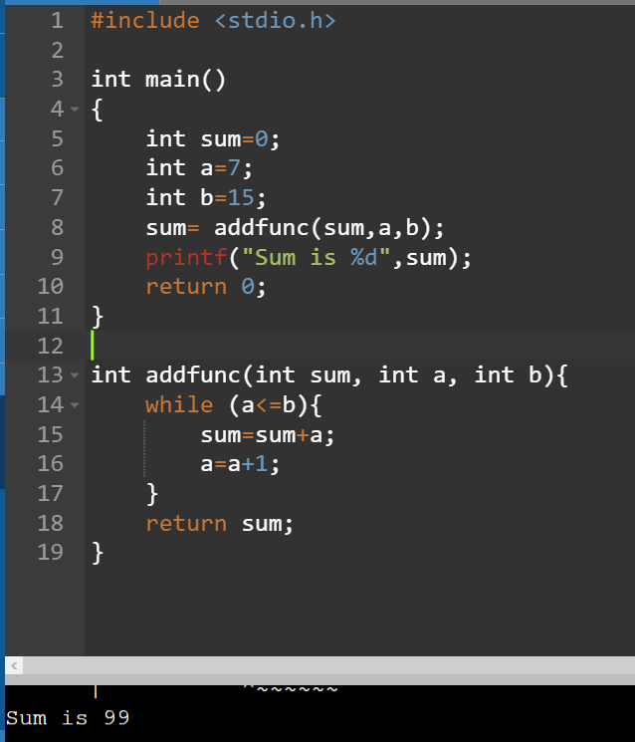

**Recursive add function**:

Write and run a MIPS algorithm that takes 2 integer inputs from user and finds sum value between these inputs. Use a recursive procedure that takes three integers (sum,lower integer,higher integer)and returns sum value. You need to call functions recursively and store call address and sum value in stack in order the implement recursion.

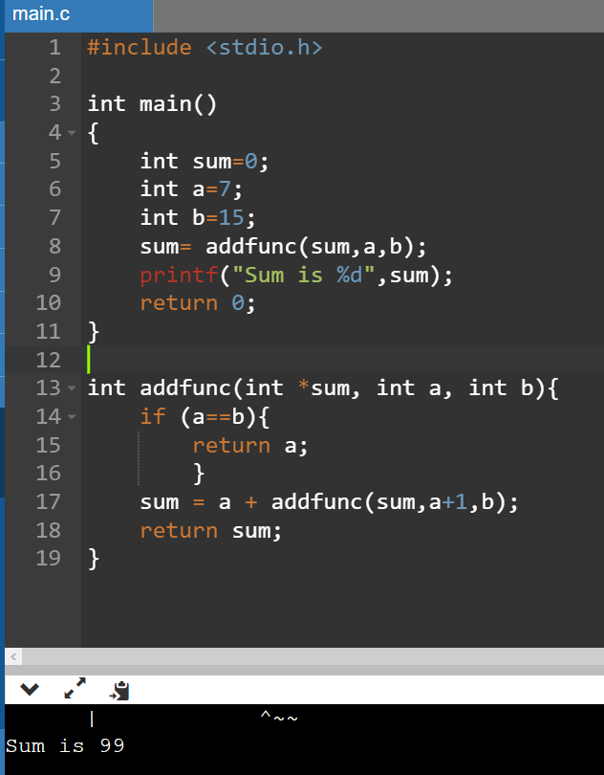

You are expected to implement given C codes to MIPS code. Use necessary code and register conventions. Use Stack for return addresses in recursive code. Upload 2 different “.asm” files for iterative and recursive prelab.