**Question 1**

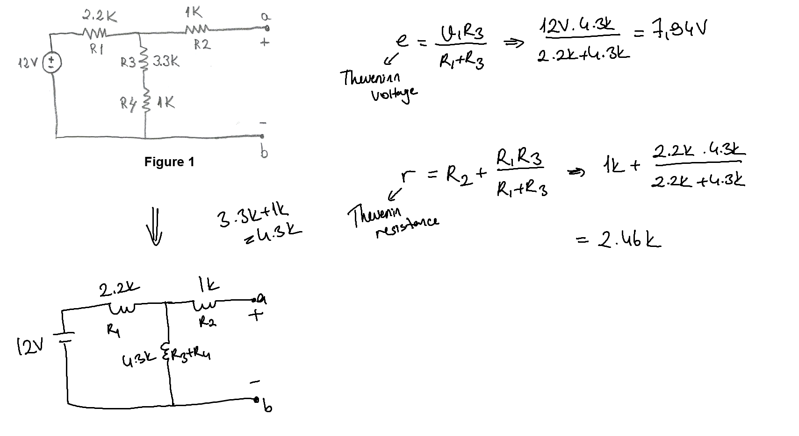

**Question 2.a)**

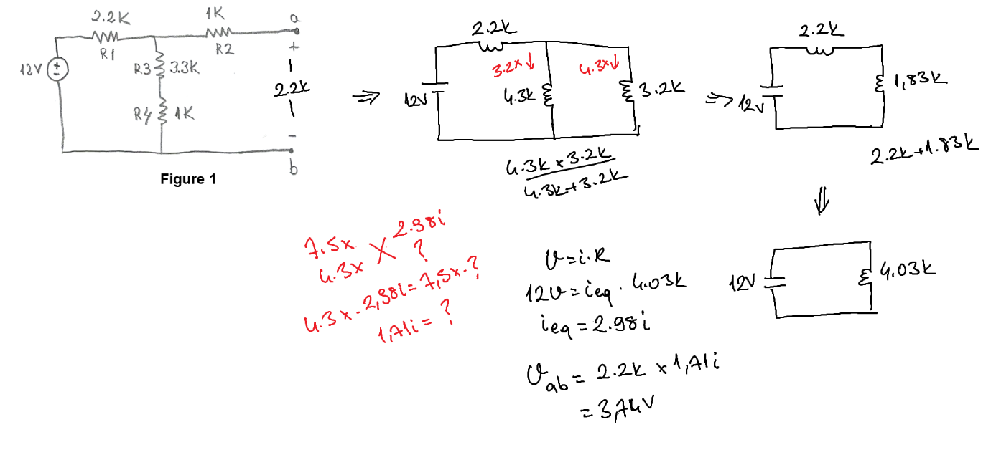

**Question 2.b)**

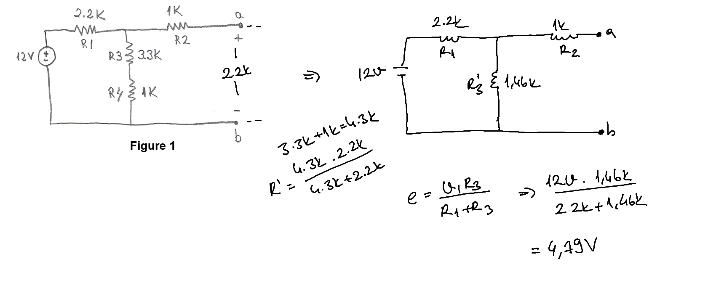

**Question 2.c)** Vab are different from eachother in each calculation. I don’t know what makes the difference. Maybe it’s because that merge 2.2k and 4.3k.

**Question 3.a.b)**

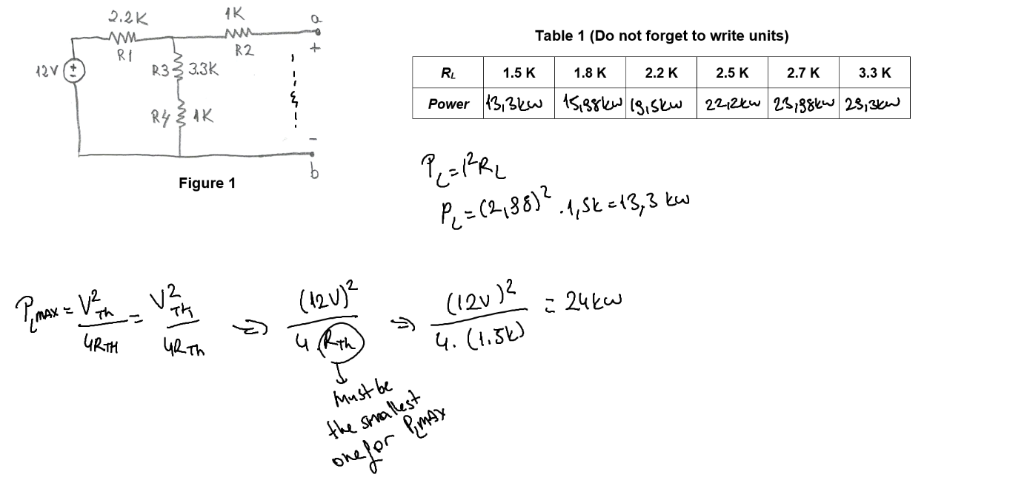

**Conclusion:**

**a)** They are a bit different because of resistors tolerances.

**b)** Because of the maxpower formula, we need 1/Rth, that means if Rth is less then power increases.

**c)** 