**PART 1**

**Q1.a)**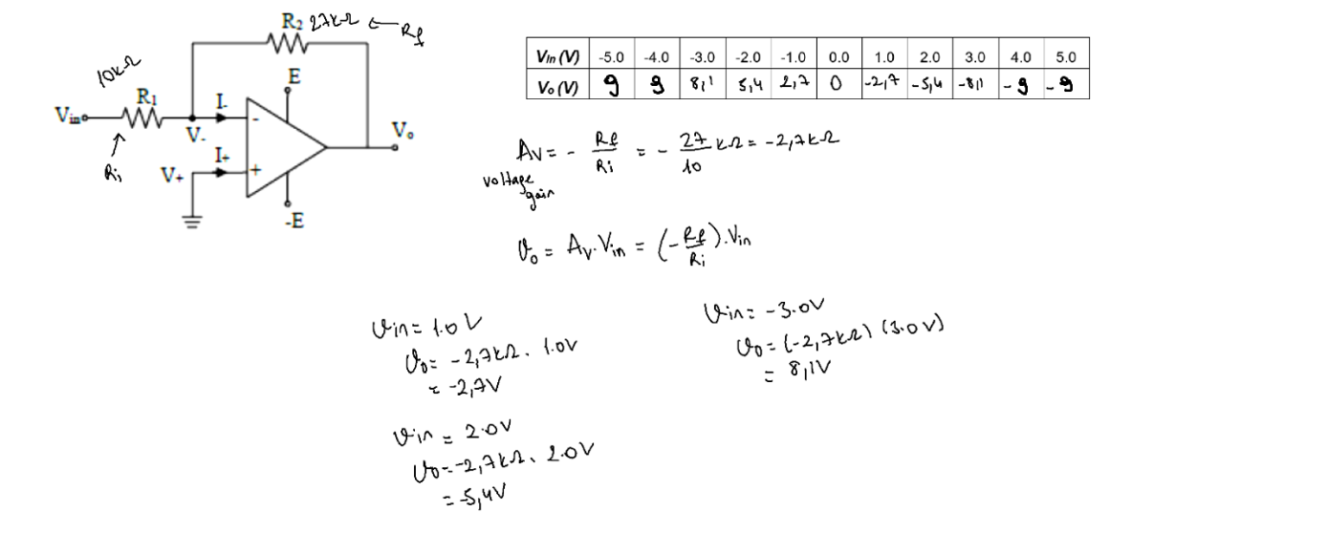

**Q1.b)**

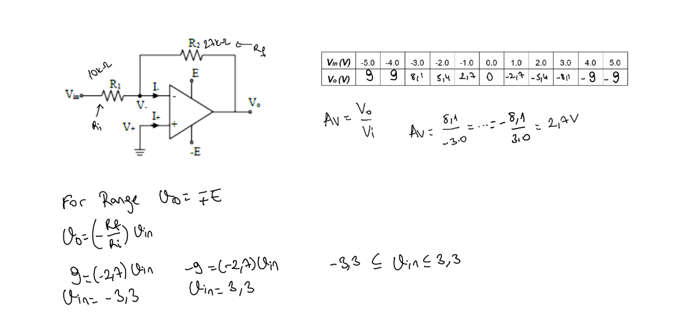

**Q2.a)** 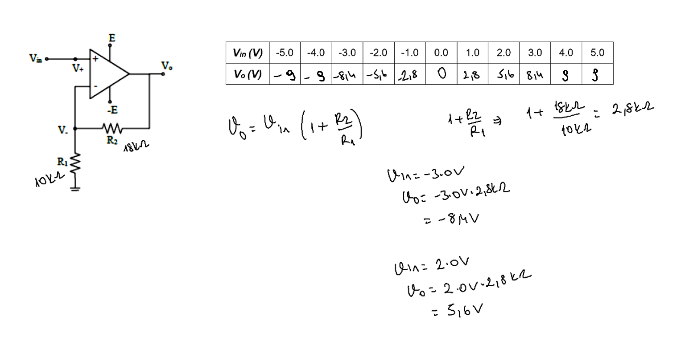

**Q2.b)**

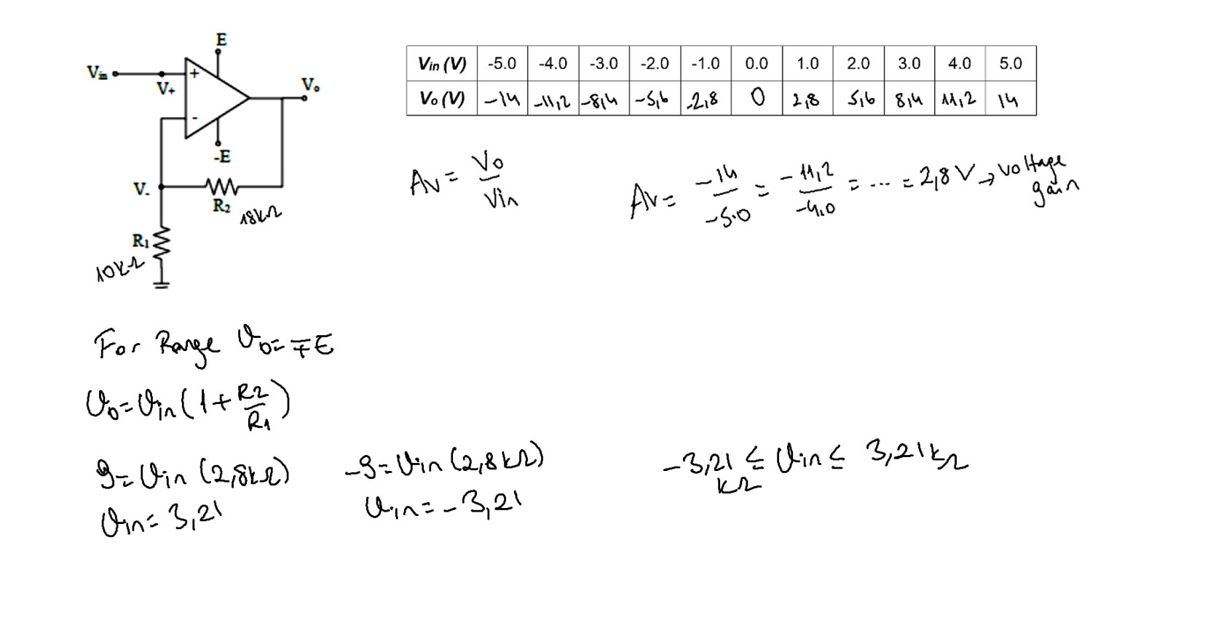

**PART 2:**

**1)**

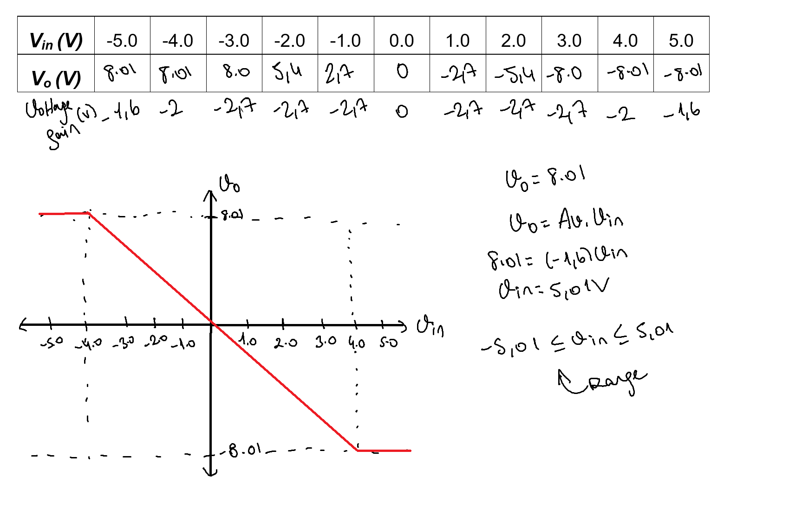

Opamp limits the voltage, values are same except (-4.0,-5.0,4.0,5.0)

**2)**

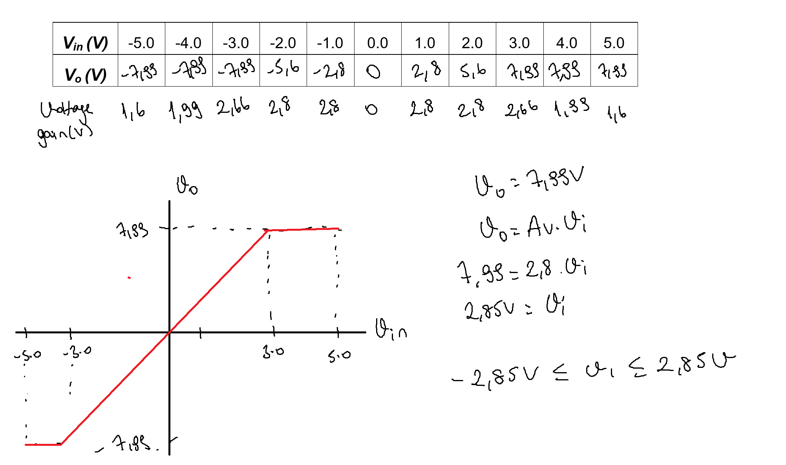

Opamp limits the voltage, values are nearly same except (-4.0,-5.0,4.0,5.0)

(Difference caused by significant figures)

