**Question 1**

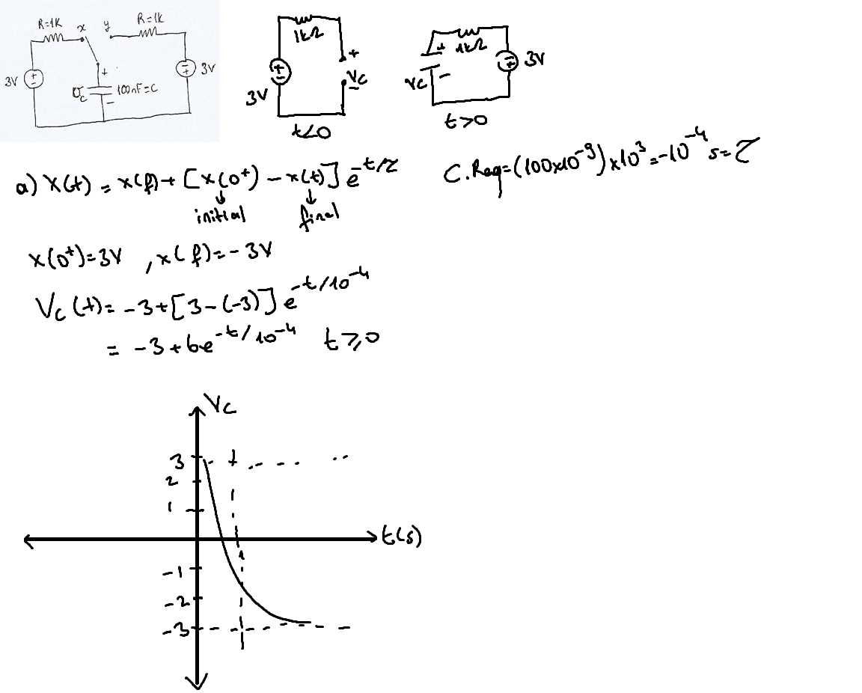

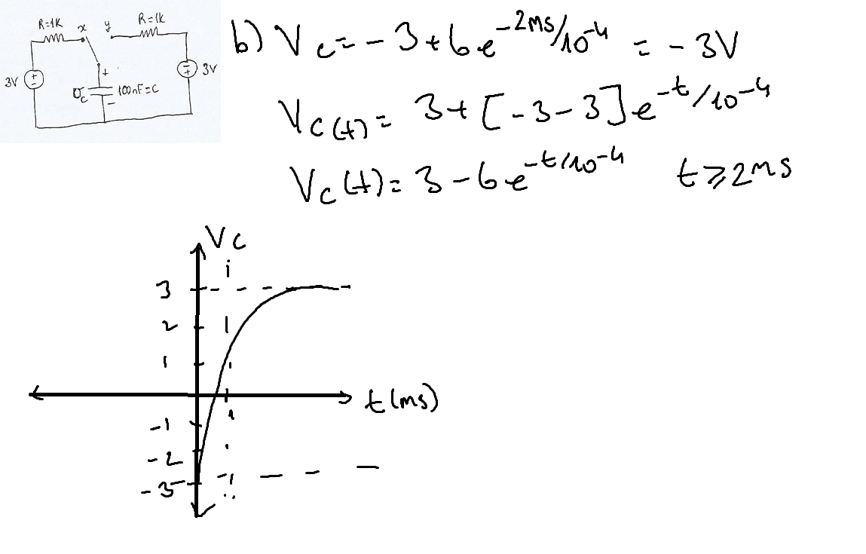

**Question2**

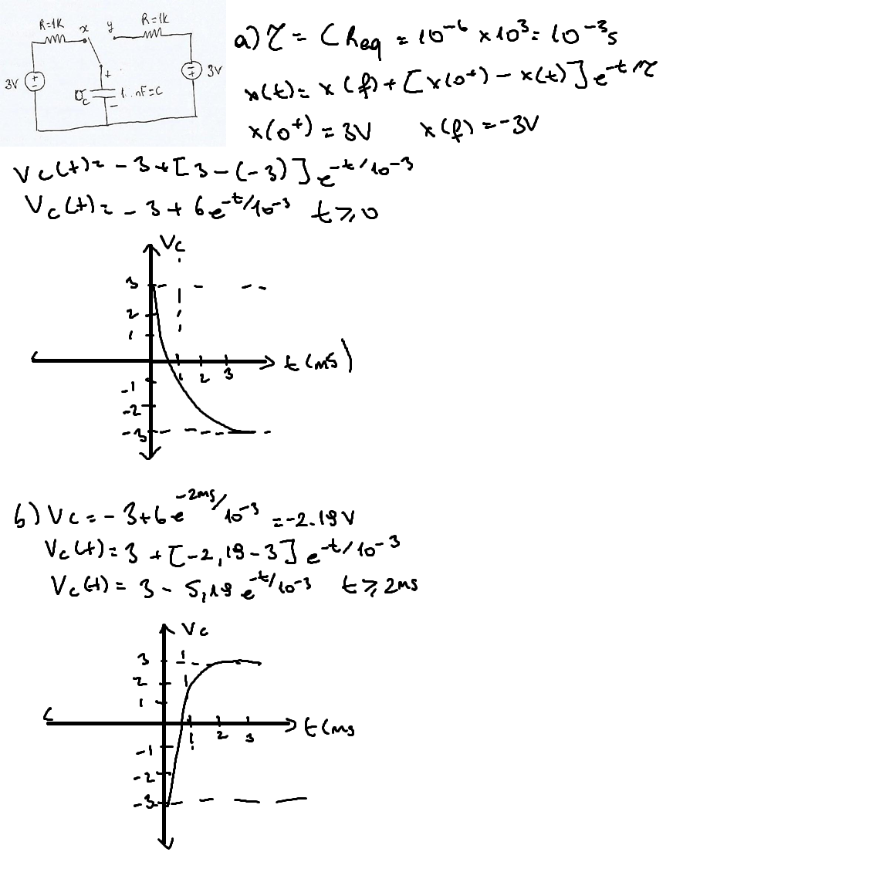

**Question 3)**

1. Only difference is amplitude. 1uFs amplitude less than 100Nf. Wavelength’s seems similar and didn’t see any difference between them.
2. Switch’s role is filling or discharging the capacitor. X fills the capacitor and Y discharges the capacitor.   
   Square wave help us to see even the smallest changes in our voltage waves.

