**PART I  
Question 1**

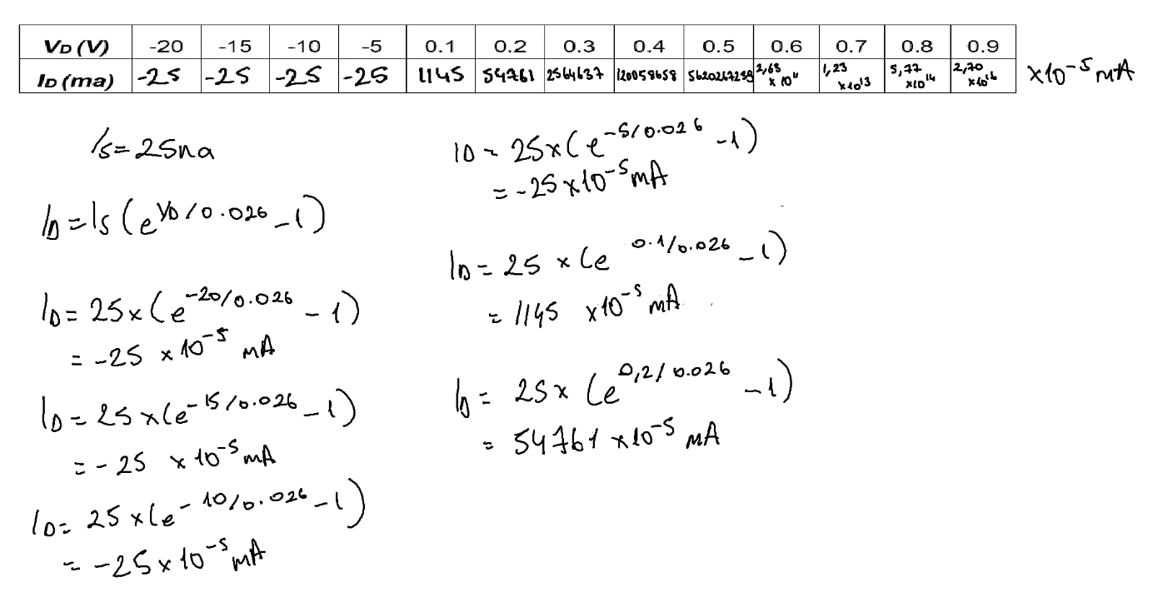

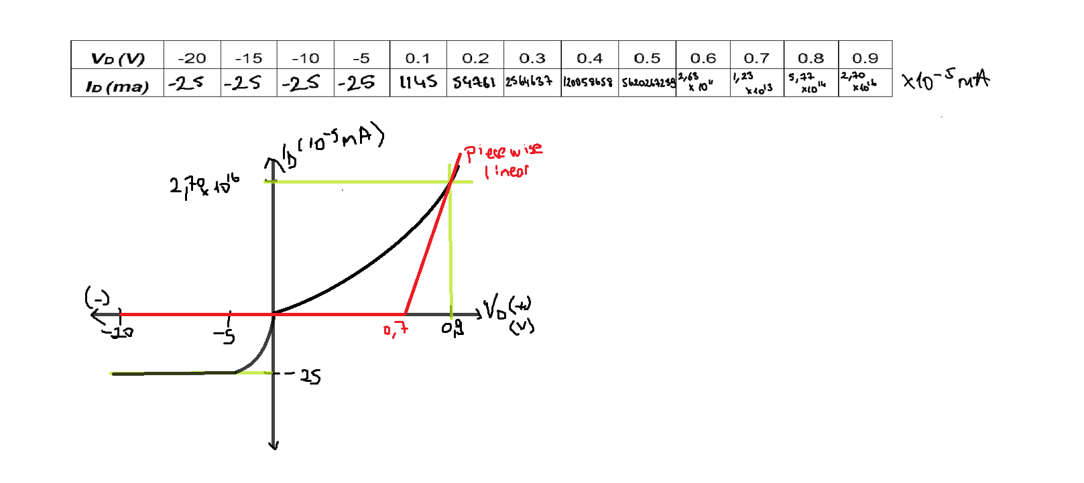

**PART II**

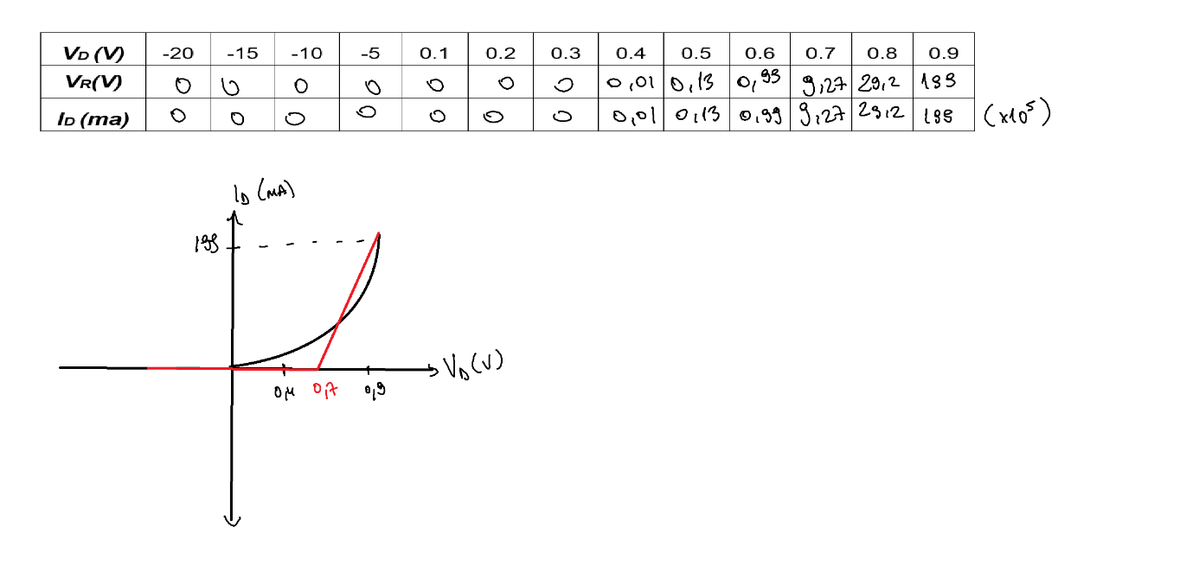

**Question 2)**

1. Because of the simulation enviroment, there are a bit different. But exponential increase is the same. In theoretic, change begins 0.1 V but in simulation, change begins 0.04 V
2. Piecewise linear is used to the diode characteristic curve as a series of linear segments. That means, it’s the same and nothing different.

