**Question 1**

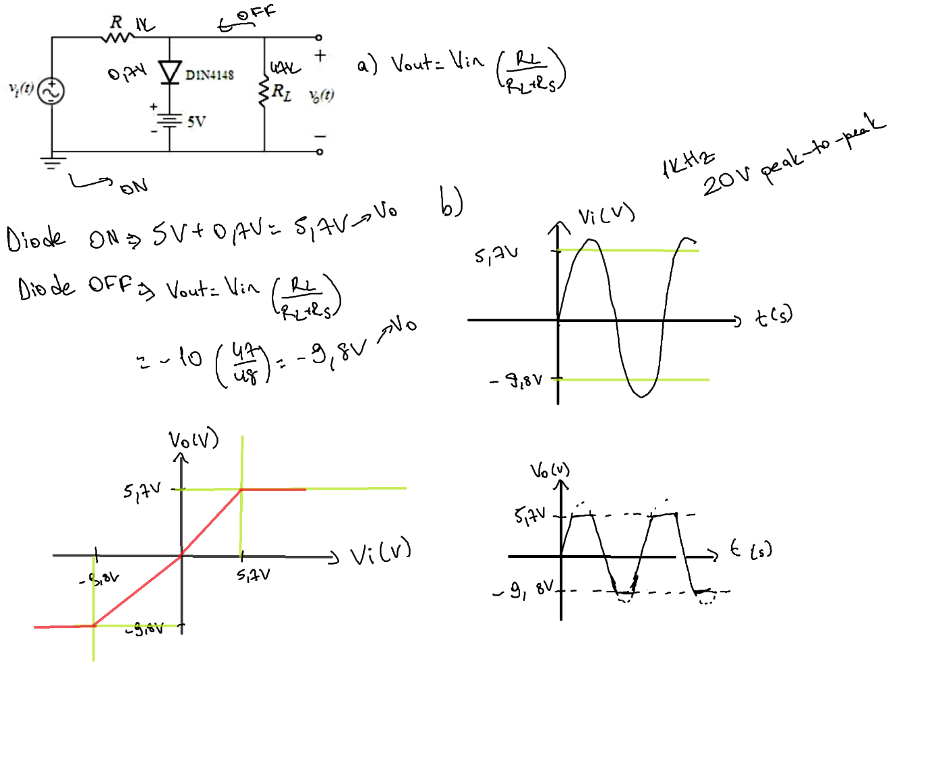

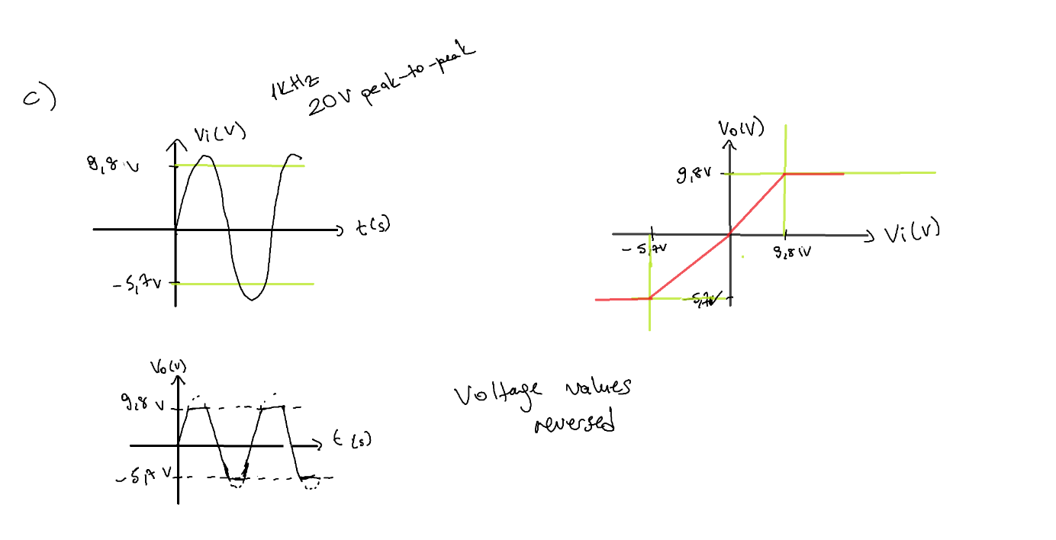

**Question2**

1. Negative clamper,

Positive half, capacitor charged to peak value Vm. The diode is forward biased and conducts.

Negative half, the diode gets reverse biased and gets open circuited. At this moment;

Vo=Vi+Vm

Signal changes according to the changes in the input, and shifts according to charge on the capacitor, it adds in the input voltage.

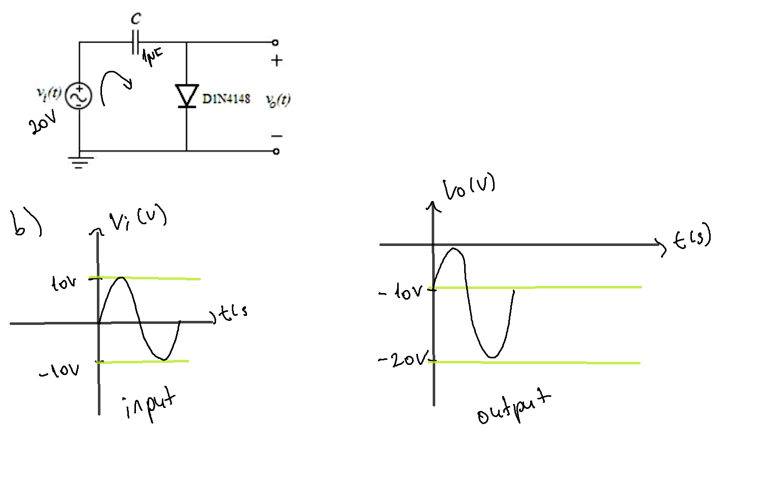

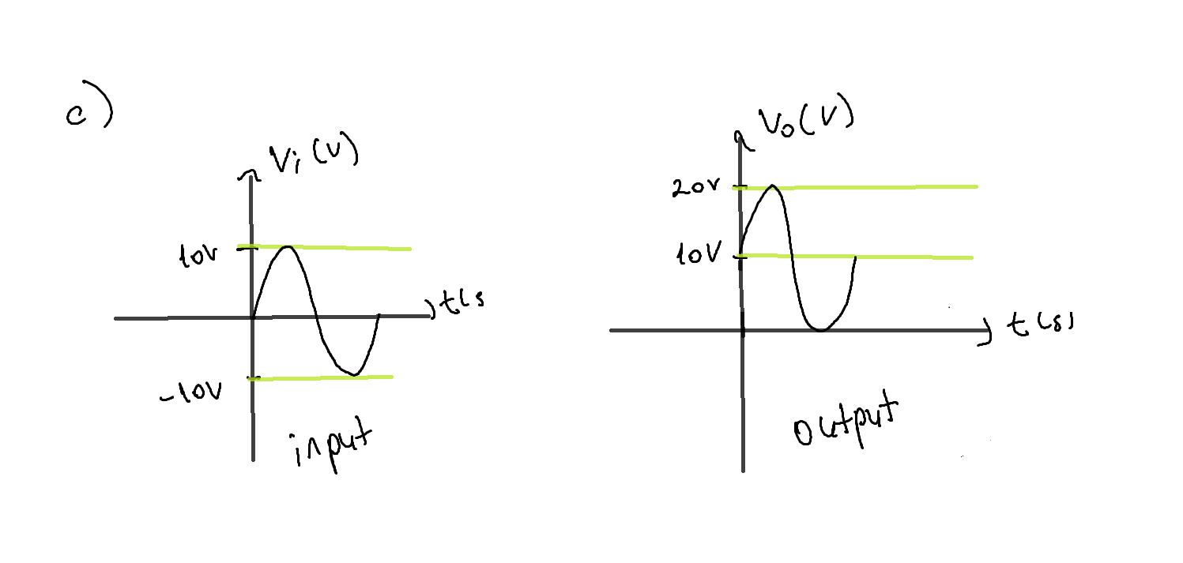

**Part II)**

There is no difference between simulations and calculated graphs.

