YAŞAR UNIVERSITY

THE FACULTY OF ENGINEERING

DEPARTMENT OF ELECTRICAL AND ELECTRONICS ENGINEERING

EEE 2274 FUNDAMENTALS OF ELECTRONICS
Fall 2022

Experiment 1: Basics of Measurement

OBJECTIVE:
1. To demonstrate the basics of laboratory equipment and components.
2. To measure voltage and current using digital multimeter.

PRELAB WORK
Please upload your files according to following rules:
• Upload your work (derivations, calculations, explanations) for Part I and Part III, as a single a .docx or .pdf file.
• Upload your simulations in Part II, as .pdsprj files.
The simulation files uploaded as draft or screenshots could not be evaluated; also simulation work of different types of file extensions such as png, jpg, .docx, .pdf, etc. will not be evaluated. In all these cases you will get “0” for your simulation work.

PART I : Theory
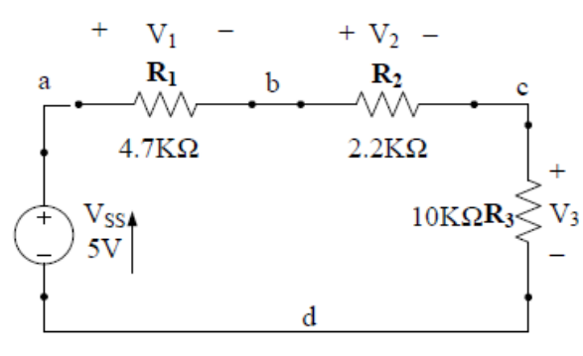
Question 1
For the circuit given on the right, calculate the voltage across each resistor and the corresponding current.

Question 2
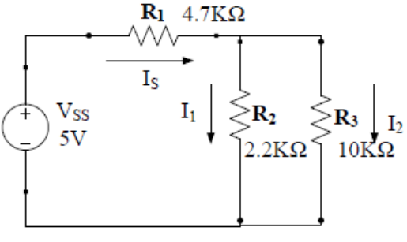
For the circuit given on the right, calculate the current through each resistor and the corresponding voltage.

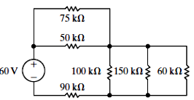
Question 3 :
a. Calculate the current through the voltage source.
b. Calculate the current through 60 KΩ resistor.
c. Verify that the total power developed equals the total power dissipated.

Question 4
Read the Appendix. Answer the following questions by your own words. Do not copy and paste.
a. .What is a breadboard? How does it work? Explain briefly.
b. What is a DC power source?
c What is a multi-meter? By using this device, which quantities can be measured, indicate the units and ranges.
d. What is tolerance of a resistor? Why does it occur?

PART II : Simulation
For Question 1 and Question 2 in Part I,
a. Construct the circuit in Proteus and place appropriate instruments to measure the values you have calculated in Part I.
b. Simulate the circuit and upload your simulation as a .pdsprj file.

PART III : Conclusion
For the each circuit, compare the results you have found by calculations with your Proteus simulations outputs.
Comment on the differences you observe.

 | Student’s number | Name
1
2

EEE 2274 - Experiment 1
LAB REPORT

LAB WORK
1. Fill in the following table, for the three resistors of the circuit given in Figure 1.1.
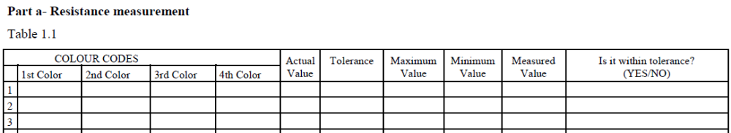

2. a. Set up the circuit in Figure 1.1.
b. Measure the current and the voltage of all resistors by using multimeter and record them on Table 1.1.
c. Calculate the power of all resistors by using measured voltage values. Fill the values to Table 1.1.
d. Control the power balance in the circuit.

Figure 1.1

Table 1.1 (Do not forget to write units!!!)
Values | Calculation | Simulation | Measurement
I_{R1}
I_{R2}
I_{R3}
V_{R1}
V_{R2}
V_{R3}
P_{R1} |  |  | *
P_{R2} |  |  | *
P_{R3} |  |  | *

3. Repeat step 2- for the circuit given in Figure 1.2.

Figure 1.2

Table 1.2 (Do not forget to write units!!!)
Values | Calculation | Simulation | Measurement
I_{R1}
I_{R2}
I_{R3}
V_{R1}
V_{R2}
V_{R3}
P_{R1} |  |  | *
P_{R2} |  |  | *
P_{R3} |  |  | *

4. For the each circuit, compare the results you have found by calculations, your Proteus simulations outputs and above measurements.
Comment on the differences you observe.

APPENDIX

A. Resistors:
Components that are specifically designed to have a certain amount of resistance are called resistors. The principle applications of resistors are to limit current and divide voltage. The unit for resistance value is the OHM and it is symbolized by the Greek letter omega (Ω). To represent higher resistance values "K" (kilo-ohms) and “M” (mega ohms) are used. For example, 470,000 Ω is represented as 470KΩ, while 4,700,000 Ω is represented as 4.7MΩ.
There are two classes of resistors; fixed resistors and the variable resistors.

Fixed Resistors:
Fixed resistors have large selection of resistance values that are set during manufacturing and cannot be changed easily. The symbol for a fixed resistor is shown in the Fig. 1.1.
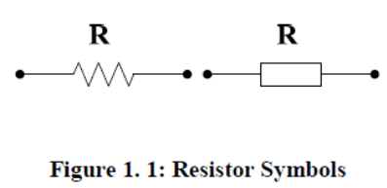
Fixed resistors are constructed using various methods and materials. Fig. 1.2 shows common types of fixed resistances as carbon consumption type, wire wound, chip resistors and resistor networks.
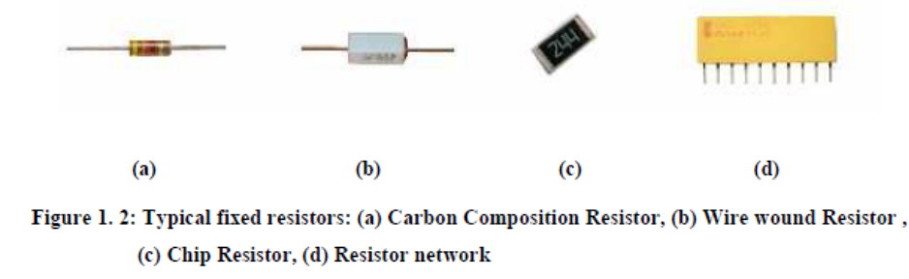
Resistor value is normally shown by a series of colored bands on the resistor itself. These colors as indicated in Fig. 1.3 are read starting with the band nearest an end. Most resistors have four bands but some resistors have five bands. For four bands resistors;
* The first two bands give the significant figures.
* The third band gives the power of ten which is multiplied the figures by to get the correct resistance value.
* The fourth band gives the tolerance or accuracy of the value
For example; a resistor whose bands are "brown black red gold” is 10 x 100, or 1k ohms, at 5% tolerance. For five bands resistors first three bands give the significant figures. The fourth gives a power of ten which is multiplied the figures by to get the correct resistance. The fifth band gives the tolerance or accuracy of the value. For example; a resistor whose bands "yellow violet black orange brown" would be 470 x 1000, or 470k ohms, at 1% tolerance.
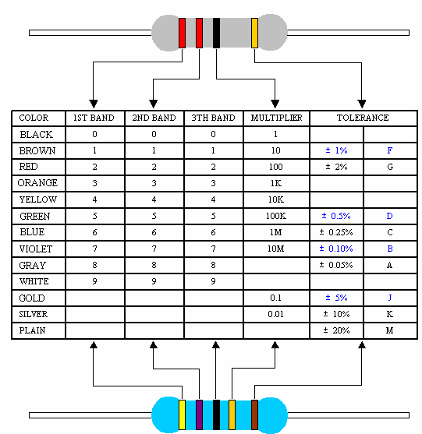

Figure 1.3: Resistance Codes

All resistors have a wattage rating that is the power it can dissipate over a long period of time. When a current flowing through a resistor increases, resistor heats up, and if the temperature exceeds a certain critical value, it can be damaged. In this sense, therefore wattage rating is important. Most commonly used resistors in circuit have a 1/4 Watt or 1/2 Watt wattage rate.

Variable Resistors:
Variable resistors are types of resistors that their resistance values can be changed easily with a manual or an automatic adjustment. Two basic uses for variable resistors are to divide voltage and to control current. The variable resistor used to divide voltage is called a potentiometer. The variable resistor used to control current is called a rheostat. Schematic symbols for these types are shown in Fig. 1.4.
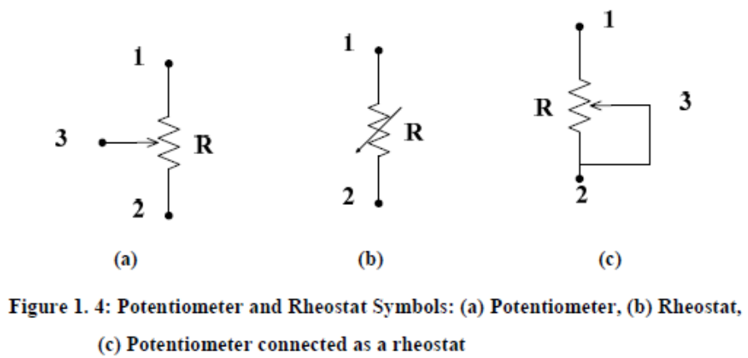
The potentiometer referred to also as a “pot”, is a three terminal device, as shown part (a) in Fig. 1.4. There is a fixed resistance which is the total resistance between terminals 1and 2. The resistance between 1 and 3 or between 2 and 3 can be varied by moving the contact. In part (b) the rheostat is shown as a two terminal variable resistor. Part (c) shows usage of potentiometer as a rheostat by connecting terminal 3 to either terminal 1 and terminal 2.
The internal construction of a potentiometer is shown in Fig. 1.5.
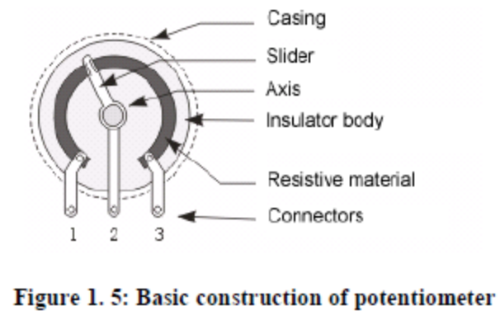
Potentiometers and rheostats can be classified as linear and tapered (usually logarithmic). In linear types the resistance between both terminal and the moving contact varies linearly with the position of the moving contact. In the tapered types, the resistance varies nonlinearly with the position of the moving contact. Typical potentiometers are shown in Fig. 1.6.

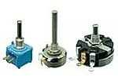
Figure 1. 6: Typical Potentiometers

PTC (positive temperature coefficient) resistor and NTC (negative temperature coefficient) resistor are variable resistors that are temperature sensitive. When the temperature increases, resistance of the PTC increases and resistance of the NTC decreases. They are also called thermistor that is a temperature sensor, because of its resistance changing by temperature.

B. Multimeter:
Multimeter is electricity measurement device to measure voltage, current, resistor values. Multimeters can be grouped as analog and digital multimeters. An analog multimeter displays results by moving a pointer across a printed scale. The movement of the pointer helps to show gradual changes, but is less precise than its digital counterpart. A digital multimeter (DMM) displays the exact measurement on a numeric LCD or LED readout.
We will use CHY-21C Multimeter in our experiments.
This multimeter has features that:
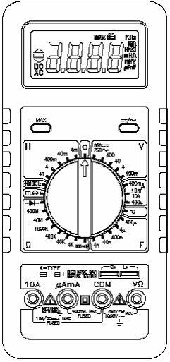
- DC voltage measurement up to 1000V,
- AC voltage measurement up to 750V,
- DC current measurement up to 10A,
- AC current measurement up to 10A,
- Capacitance measurement from 1pF to 400µ F
- Inductance measurement from 1µ H to 40 mH
- Resistance measurement from 0.1Ω to 400MΩ,
- Diode test and audible continuity check function,
- Logic test function,
- Temperature measurement function

FFigure 1.7 CHY-21 Multimeter
Breadboard :
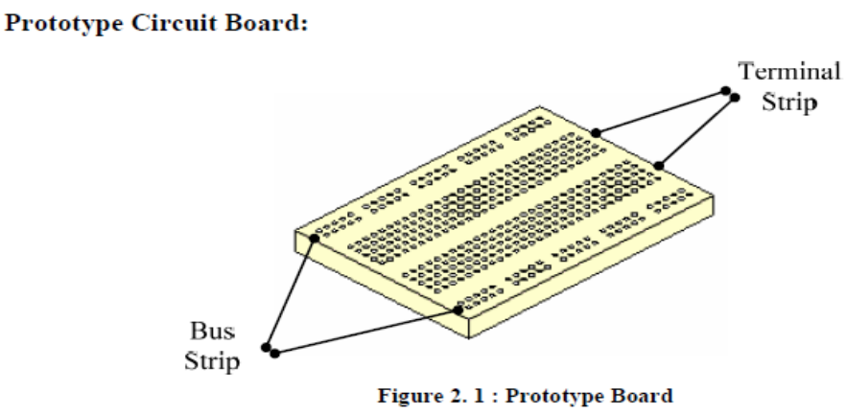
Breadboard is used to build temporary circuits, without any soldering process. In general, a board has two terminal strips and two bus strips as shown in the above figure. Each bus strip has two rows of contacts. Each of the two rows of contacts on the bus strips are a node. That is every contact along a row on a bus strip is connected together inside the board. Bus strips are used primarily for power supply connections but are also used for any node requiring a large number of connections. Each terminal strip has 60 rows and columns of contacts on each side of the center gap. Each row of 5 contacts is a node. Components and wire links can be pushed into any of the holes.
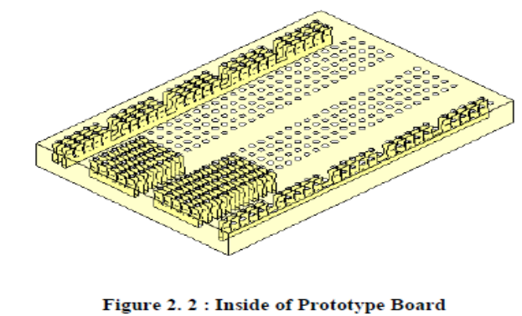

DC POWER SOURCE:
DC power source has two probes (positive and negative). When setting up the circuit:
- Push the POWER button, to turn the power source ON.
- Push the OUTPUT button to arrange the voltage and current ( if there is a short circuit in the system, current led is ON)
- Adjust the voltage (voltage range is 0 to 30V) or the current (range is 0 to 3A).
- Connect the probes properly into the circuit.

