YAŞAR UNIVERSITY

THE FACULTY OF ENGINEERING

DEPARTMENT OF ELECTRICAL AND ELECTRONICS ENGINEERING

EEE 2274 FUNDAMENTALS OF ELECTRONICS
Fall 2022

Experiment 2: Resistive Circuits

OBJECTIVE:
To analyze and to test resistive circuits.

PRELAB WORK
Please upload your files according to following rules:
• Upload your work (derivations, calculations, explanations) for Part I and Part III, as a single a .docx or .pdf file.
• Upload your simulations in Part II, as .pdsprj files.
The simulation files uploaded as draft or screenshots could not be evaluated; also simulation work of different types of file extensions such as png, jpg, .docx, .pdf, etc. will not be evaluated. In all these cases you will get “0” for your simulation work.

PART I : Theory
Question 1 : For the circuit given in Fig 1, calculate the voltage, current and power of each resistor and record in Table 1.
You should not use node voltage method or mesh current method.
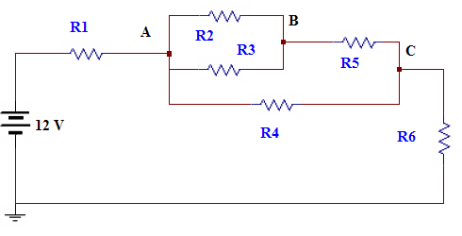

R₁= 2.2 kΩ, R₂= 3.3 kΩ, R₃= 3.3 kΩ,
R₄= 4.7 kΩ, R₅= 1.0 kΩ R₆= 5.6 kΩ

Figure 1
Table 1 (Do not forget to write units)

Values | Theory | Simulation
V_{R1}
V_{R2}
V_{R3}
V_{R4}
V_{R5}
V_{R6}
I_{R1}
I_{R2}
I_{R3}
I_{R4}
I_{R5}
I_{R6}
P_{R1}
P_{R2}
P_{R3}
P_{R4}
P_{R5}
P_{R6}

PART II : Simulation
For Question 1 in Part I,
a. Construct the circuit in Proteus and place appropriate instruments to measure/ calculate all the values in Table I.
b. Simulate the circuit and upload your simulation as a .pdsprj file.
c. Record all the measured and calculated values in Table 1 above.

PART III : Conclusion
Compare the results you have found by calculations with your Proteus simulations outputs and indicate all the deviations .
Comment on the reasons for the deviations you have observed.

 | Student’s number | Name
1
2

EEE 2274 - Experiment 2
LAB REPORT

LAB WORK
1. Set up the circuit in Figure 1 on breadboard.
a. Measure the voltage of each resistor by using a multi-meter and record them in Table 1.
b. Calculate the current and power of each resistor by using measured voltage values at Step a. Record the values in Table 1.
c. Write also the values you obtained in Prelab Work in Table 1.

R₁= 2.2 kΩ, R₂= 3.3 kΩ, R₃= 3.3 kΩ,
R₄= 4.7 kΩ, R₅= 1.0 kΩ R₆= 5.6 kΩ
Figure 1.

Quantity | Theory | Simulation | Lab work
V_{R1}
V_{R2}
V_{R3}
V_{R4}
V_{R5}
V_{R6}
I_{R1}
I_{R2}
I_{R3}
I_{R4}
I_{R5}
I_{R6}
P_{R1}
P_{R2}
P_{R3}
P_{R4}
P_{R5}
P_{R6}

Table 1 (Do not forget to write units)

2. Check the power balance in the circuit.

3. Compare the results you have found by calculations, your Proteus simulations outputs and by lab measurements/calculations and indicate all the deviations.
Comment on the reasons for the deviations you have observed.

4. Verify and write the Kirchhoff current and voltage law equations in the given circuit KVL for (R1, R4, R6) loop and KCL for node A. Comment on the reasons for the deviations you have observed.

