Freight rate prediction assessment
The selected CatBoost model achieved a mean absolute error of $128.88 on the September-October 2025 holdout, compared with $229.10 for an equipment-based rate-per-mile baseline. This is a 43.74% reduction in MAE. After evaluation, the selected settings were refitted on all 48,000 labeled loads to produce the 12,000 required predictions and the fixed December chart.

Data and exploration
The target is posted_rate in US dollars per load. The labeled file, data/train-test.csv, covers January 1 through October 31, 2025. The final prediction file, data/validation.csv, contains 12,000 loads from November 1 through December 31 and has no target prices. Its name does not make it a labeled evaluation set.
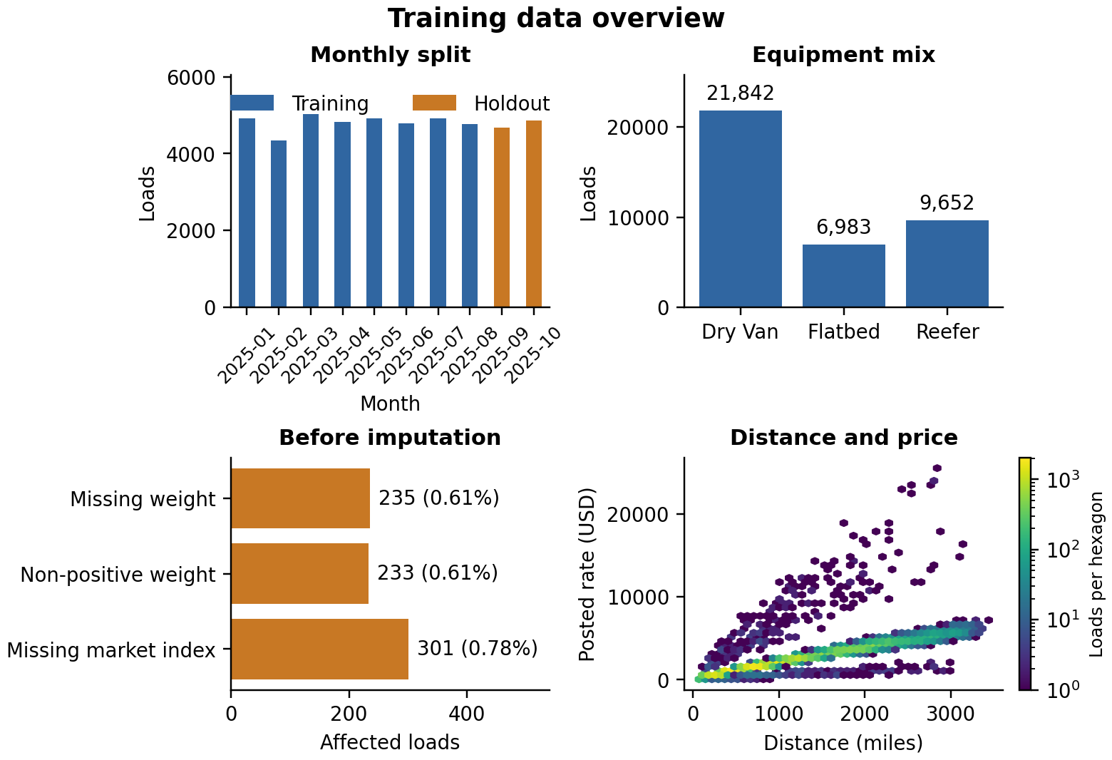
Figure 1 Overview generated from the preparation step.
Within the training portion, 235 weights are originally missing, 233 are non-positive, and 301 market-index values are missing. These counts differ from the complete-file audit on the next page. High prices remain in the data and in the plotted range.
The labeled data contains 27,202 Dry Van loads, 12,045 Reefer loads, and 8,753 Flatbed loads. Median distance is 953.3 miles. Median posted price is $2,030.76, while the maximum is $25,533.00. The Spearman correlation between distance and posted price is 0.976 across the labeled file, supporting mileage as a useful starting point for the baseline.

Data quality and chronological validation
The audit below covers all 48,000 labeled loads and the 12,000 final loads. Preprocessing values are fitted separately within each training partition.
Issue | Labeled loads | Final loads | Treatment
Missing weight | 300 | 165 | Fill with the positive-weight median fitted on training rows.
Non-positive weight | 292 | 145 | Treat as missing and retain an invalid-weight indicator.
Missing market_index | 374 | 249 | Exclude market_index from the CatBoost feature set.
Duplicate load IDs | 0 | 0 | Require unique, non-missing IDs before prediction.
Invalid or missing dates | 0 | 0 | Parse dates strictly and reject invalid inputs.

There are no missing target prices in the labeled file, and all distances and labeled prices are positive and finite. No labeled rows or large observed prices were removed. Missing-weight flags also identify values that became missing after invalid-weight cleaning.
The labeled file contains 64 cities; the final file contains 72. In the final file, 1,447 loads (12.06%) include at least one city absent from the labeled data. Supplied coordinates provide geographic inputs for those loads. The counts on this page describe the complete files; fitted preprocessing and model selection use the chronological partitions described next.

Validation split
The evaluation setup mirrors prediction of future loads. January-August supplies 38,477 development rows; September-October supplies a later holdout of 9,523 rows. A random split would mix earlier and later observations and would not reproduce this forecasting task. The holdout is excluded from model fitting, hyperparameter selection, and early stopping.
Model selection uses three expanding training windows within January-August. Each fold trains on all earlier months and validates on the next two months. Date boundaries are exclusive at the start of the following period.
Training months | Validation months | Training rows | Validation rows
January-February | March-April | 9,255 | 9,855
January-April | May-June | 19,110 | 9,696
January-June | July-August | 28,806 | 9,671

Equipment baseline
The baseline multiplies distance by the training median price per mile for each equipment type. Its learned rates are $2.0447 for Dry Van, $2.2132 for Flatbed, and $2.3103 for Reefer. Missing or unseen equipment uses the overall training median rate per mile.
prepare_data.py fills missing weight and market_index using training-only medians, but the baseline itself uses only equipment and distance. CatBoost fits its own feature preprocessing in every fold. The baseline summary figure is saved as outputs/baseline/figures/baseline_summary.png.

Model selection and features
Both depth 6 and depth 8 use MAE loss, a learning rate of 0.05, L2 leaf regularization of 3, seed 42, and four CPU threads. Each fold permits up to 1,200 trees and stops after 80 rounds without validation improvement. Candidate MAE is averaged across folds using validation row counts as weights. Pooled CV RMSE is calculated from the weighted squared fold RMSE values.
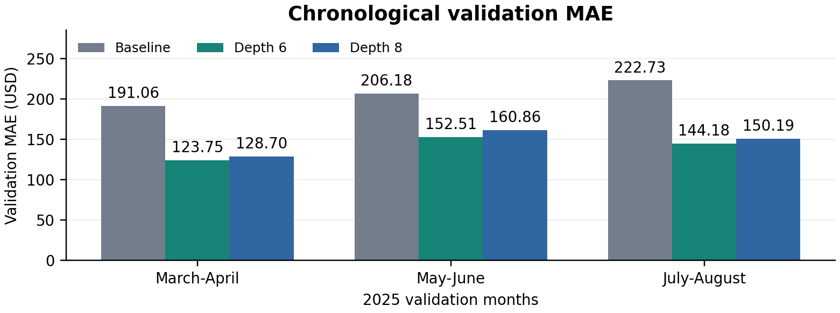
Figure 2 Baseline and CatBoost MAE in the three chronological validation folds.
Depth | CV MAE in USD | CV RMSE in USD | Selected tree count
6 | 140.06 | 606.35 | 503
8 | 146.48 | 609.48 | 358

Depth 6 has the lower CV MAE. Its best fold tree counts are 503, 902, and 117; their median, 503, is used for the fixed refit. The evaluation model is then fitted on all January-August rows without passing the September-October holdout as an evaluation set. CV scores are used for selection; the later holdout provides the separate reported evaluation.

Features and model rationale
CatBoost was chosen for the mixture of categorical route information and numeric load attributes. Pickup city, delivery city, equipment, and directional lane are categorical features. Numeric inputs include distance, log1p distance, cleaned weight and quality flags, coordinates, coordinate differences, and calendar features. The target is predicted directly in dollars. MAE is the selection metric because it measures the average absolute dollar error; RMSE is also reported to expose large errors.
For every fold, FreightFeatures.fit learns the weight median and city-coordinate lookup from that fold's training rows only. FreightFeatures.transform uses supplied coordinates first and fills absent coordinates from the learned lookup. This also supports the reduced December input schema. An unknown city without supplied coordinates retains missing numeric coordinates.
load_id and posted_rate are not predictors. quote_signal is excluded because its rank correlation with price per mile changes within development data: +0.9625 in January, -0.9634 in April, and -0.0224 in August. market_index is excluded so that one model can use the supplied December inputs, which omit this field. Predictions are floored at $0.01.

Holdout results
The following results use the January-August evaluation model on the 9,523 September-October loads. Metrics are calculated from unrounded predictions in US dollars. The final all-data model is a separate refit and is not the model evaluated in these tables.
Model | MAE in USD | RMSE in USD
Equipment rate-per-mile baseline | 229.10 | 670.66
Selected CatBoost model | 128.88 | 641.44

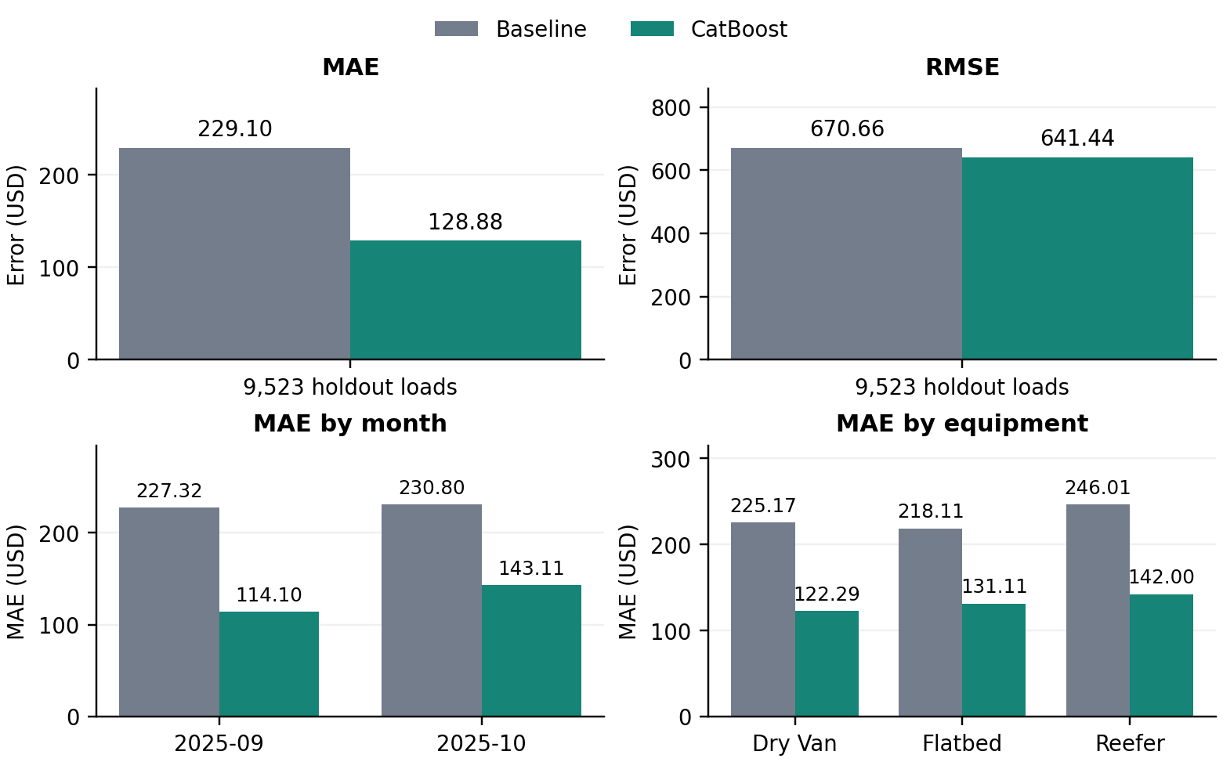
Figure 3 Baseline and CatBoost on the same 9,523 holdout loads. The upper panels show overall MAE and RMSE; the lower panels show MAE by month and equipment.
CatBoost reduces MAE by 43.74% and RMSE by 4.36% relative to the baseline. The smaller RMSE reduction means that the gain in average absolute error does not translate into a similarly large reduction in the influence of extreme errors.
CatBoost breakdowns are listed below. Month and equipment groups summarize the same holdout population and overlap.
Holdout group | Rows | MAE in USD | RMSE in USD
September 2025 | 4,670 | 114.10 | 619.64
October 2025 | 4,853 | 143.11 | 661.74
Dry Van | 5,360 | 122.29 | 661.61
Flatbed | 1,770 | 131.11 | 517.16
Reefer | 2,393 | 142.00 | 677.55

Error analysis and limitations
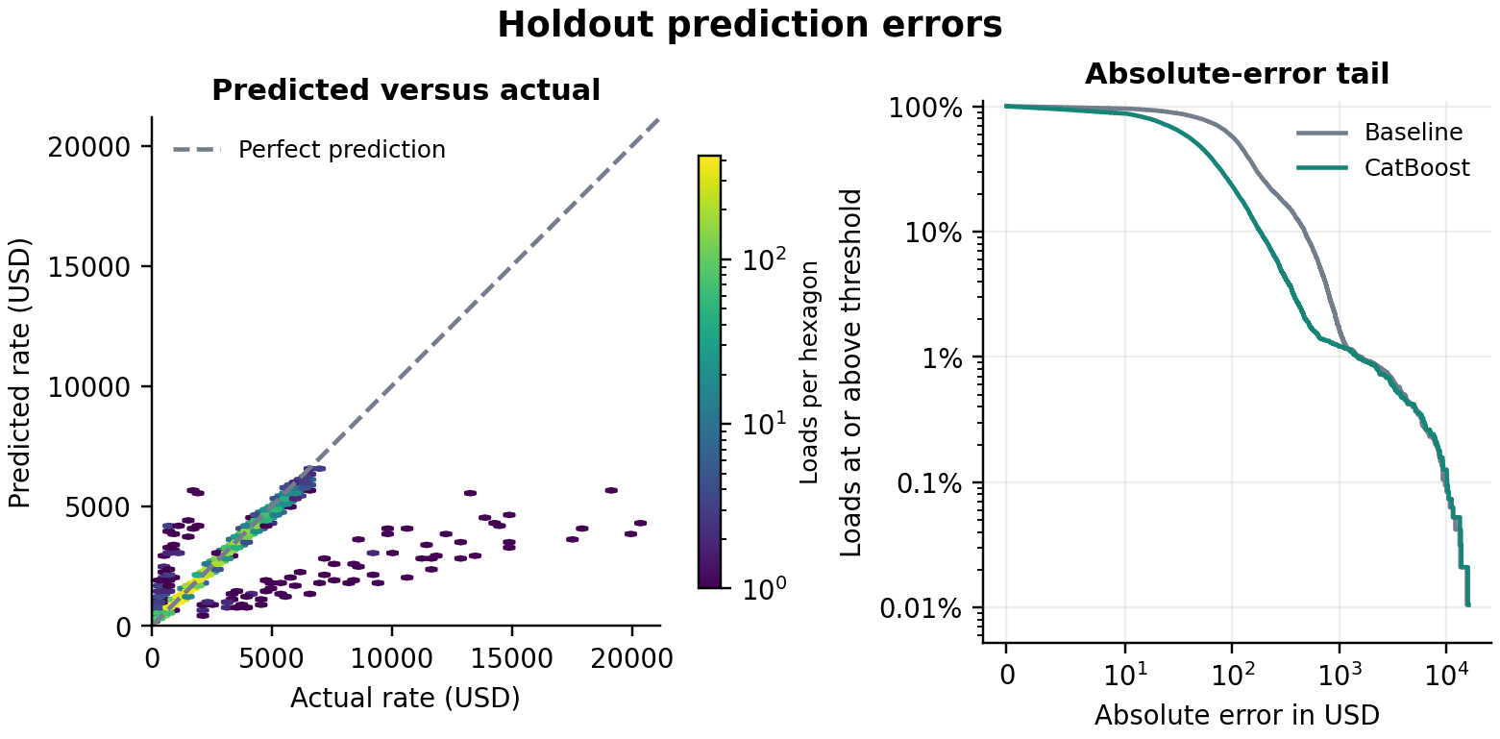
Figure 4 All holdout errors are retained. The left panel uses a logarithmic count color scale. On the right, percentages are logarithmic; error thresholds are linear up to $10, then logarithmic. Lower curves indicate fewer errors at or above each threshold.
The median absolute error is $47.42, the 95th percentile is $284.01, and the 99th percentile is $1,490.74. There are 116 errors above $1,000, and the largest absolute error is $16,307.15. The largest 96 errors, approximately 1% of the holdout, account for 95.77% of total squared error. These values explain why RMSE remains much larger than MAE.
October MAE is higher than September MAE. The two-month holdout therefore should not be treated as a guarantee of November-December accuracy. It measures prediction of later dates and is not a city-disjoint test. Performance on the 1,447 final loads involving an unseen city cannot be measured without their labels.
The experiment uses one random seed, two CatBoost depths, and a simple baseline. It does not quantify variation across seeds or establish superiority over other model families. No accuracy metric is available for the 12,000 final loads because their true prices are not supplied.

Feature importance
In the January-August fitted model, distance accounts for 47.21 of the 100 normalized importance points and log_distance for 42.05. Equipment contributes 3.28 and longitude_change 2.68. These scores describe how this model uses its features. Correlated variables can share importance; the scores do not establish causal effects.
The complete feature-importance chart and the baseline summary are available with the other four generated figures under docs/figures/ in the repository. The report charts use the same saved results with text and dimensions adjusted for printing.

Final predictions and December chart
After selection and holdout evaluation, make_submission.py refits the feature builder and the fixed depth-6, 503-tree model on all 48,000 January-October loads. It checks the training-data hash and saved selection, then predicts every November-December load. Prices are matched to the template by load_id and rounded to cents.
For the December chart, pickup is Lexington, delivery is Fort Wayne, distance is 360 miles, equipment is Dry Van, and weight is 32,000 lb. Only the date changes across December 1-31, 2025. The same final model is used, with coordinates supplied by its training-fitted city lookup.
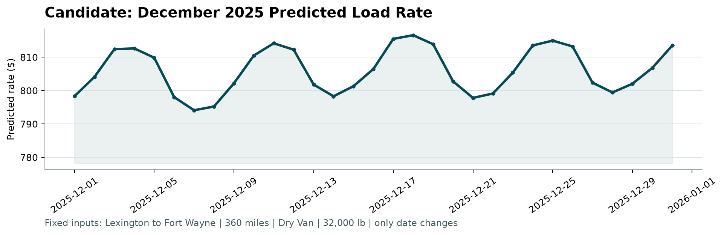
Figure 5 Fixed December predictions from the supplied score.py.
The predicted rate ranges from $794.10 on December 7 to $816.59 on December 18. The changes come from the model's calendar inputs for this fixed load. The chart contains predictions only; there are no observed December prices against which to assess the curve.

Submission checks and reproducibility
The supplied scorer accepted exactly 12,000 unique final load IDs, finite positive prices, and all 31 required December rows with their fixed inputs preserved. Reloading the saved model and preprocessing state reproduced the rounded prediction files exactly. The scorer validates output structure and creates the chart; Spotter calculates final accuracy after submission.
From the repository root, a complete run uses the commands below. The preparation, baseline, and CatBoost steps now save figures automatically; make_submission.py runs the supplied scorer.
python -m pip install -r requirements-catboost.txt
python prepare_data.py
python baseline.py
python train_catboost.py
python make_submission.py
With completed baseline and CatBoost results already saved, refresh all six evaluation figures without retraining:
python prepare_data.py
python plot_results.py
PNG figures are under outputs/preparation/figures/, outputs/baseline/figures/, and outputs/catboost/figures/. CSV/JSON results remain available. Required final outputs are validation_predictions.csv, submission/december_predictions.csv, and scorer_results/candidate_december.png.
Repository code and predictions at commit 0bfa5e713bb1
Reference evaluation environment: Python 3.12.14, CatBoost 1.2.8, pandas 2.2.3, NumPy 2.3.5. Evaluation records: outputs/catboost/metrics.json and cv_results.csv. Final fit details and checks: submission/run_summary.json.

