Susan Marshall TE2006

CREATIVE PROGRAMMING

Ajax and Structured Data

Table of Contents

XML, JSON AND JSONP – THE BASICS 3

1.1. JavaScript Object Notation (JSON) 3

1.2. JavaScript Object Notation with Padding (JSONP) 3

1.3. eXtensible Markup Language (XML) 3

JSON 4

1.4. JavaScript Object Notation 4

1.5. What does JSON do? 4

JSONP 5

1.6. Data Types 5

1.7. What does JSONP (JSON with Padding) do? 5

XML 6

1.8. Data Types 6

1.9. What does XML do? 6

HOW AJAX WORKS 7

TABLE 8

Conclusion 9

References 10

# XML, JSON AND JSONP – THE BASICS

## JavaScript Object Notation (JSON)

JavaScript Object Notation (JSON) is standard format that is readable by humans and machines; is used to transmit data server to server. Allows new data to be retrieved without the whole webpage needing to be reloaded again. Language Independent (Lynda.com - from LinkedIn, 2017).

## JavaScript Object Notation with Padding (JSONP)

JavaScript Object Notation with Padding (JSONP) is the same format as JSON but is able to transmit information to another domain. Allows new data to be retrieved without the whole webpage needing to be reloaded again. Language Independent (Lynda.com - from LinkedIn, 2017.

## eXtensible Markup Language (XML)

eXtensible Markup Language (XML) designed to store and transport data it is both machine and human readable. Language Independent (Lynda.com - from LinkedIn, 2017).

# JSON

## JavaScript Object Notation

Javascript Object with data in it using key value pairs:

My own example data is below:

“Properties” : “Values”

**{“name” : “Susan”,**

**“colour” : “green”**

**} no comma after last line of code in the JavaScript Object**

## What does JSON do?

JSON is a way of representing Objects. JSON data starts with a curly bracket and ends with a curly bracket, strings must be written in double quotes. You can access the object values by using dot (.) notation

* access the object values by using bracket ([]) notation
* loop through object properties by using the for-in loop

Values in a JSON object can be another JSON object this is called nesting (W3schools.com, 2017).

# JSONP

## Data Types

Valid Data Types: JSON values must be one of the following data types:

* a string
* a number
* an object (JSON object)
* an array
* a Boolean (true or false)
* null

JSON values cannotbe one of the following data types:

* a function
* a date
* undefined

(W3schools.com, 2017)

## What does JSONP (JSON with Padding) do?

All the same functions as JSON but in addition JSONP is used to transmit data from a remote server to your application. You can tie in to other services to request different types of data (Lynda.com - from LinkedIn, 2017).

JSONP is used to call data from a dynamic source i.e. the data on the server could be different each time the function is called.

# XML

## Data Types

The tags < and > are not in a defined standard, that is the user defines what the tags are. These invented tags are created by the author of the XML document. XML simplifies data sharing and data transport (W3schools.com, 2017).

XML can contain

* text
* attributes
* other elements
* or a combination of the above

(W3schools.com, 2017)

## What does XML do?

The XMLHttpRequest object is used to request data from a web server. XML allows data to both request and receive data after the web page has loaded. According to W3schools (W3schools.com, 2017) website:

AJAX allows web pages to be updated asynchronously by exchanging data with a web server behind the scenes. This means that it is possible to update parts of a web page, without reloading the whole page.

Ajax allows the transportation of data between the server and the HTML page. The advantage of XML is the simplification of data sharing, data transport, platform changes and data availability (W3schools.com, 2017).

# HOW AJAX WORKS

(w3Schools, 2017)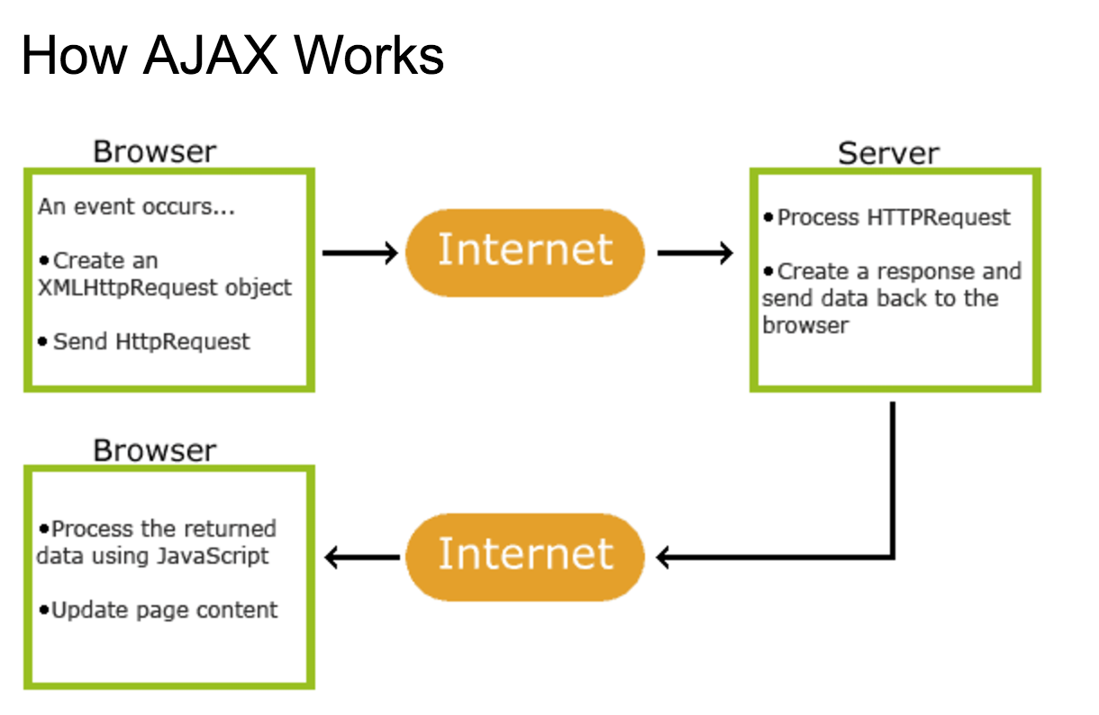

# TABLE

(Prayaga, 2017)

|  |  |
| --- | --- |
| JSON | XML |
| JSON objects are type | XML data is typeless |
| JSON types:string, number, array and oolean | XML data are all string |
| Data is easily accessible as JSON object | XML data needs to be parsed |
| Retrieving value is easy | Retrieving value is difficult |
| JSON is supported across all browers | Cross browser XML parsing can be difficult |
| Simple API | Complex API |
| Supported by Multiple Ajax toolkit | Not fully supported by AJAX toolkit |
| Fast object de-serialization in JavaScript | Slower de-serialization in JavaScript |
| Fully automated way of desterilizing/serializing JavaScript Objects | Developers have to write JavaScript code to serialize/de-serialize to/from XML |

# Conclusion

According to Emil Tullstedt (Tulllstedt, 2017) JSON is used in web development today:

due to it’s simplicity’ and the “fact that is easily parseable by e.g. JavaScript makes it smooth and easy to use.

The fact that JSON can translate between different programs makes its implementation smoother than XML and “less prone to errors than XML”.

Pradyumna, (Pradyumna, 2017) puts it in a simpler way “most of the programming languages have some kind of interpreter to understand what the JSON data is trying to tell. It is through Javascript that it has got very popular”.

Allowing webpages to retrieve data ‘on the fly’ and according to Pradyumna, (Pradyumna, 2017) very less bandwidth usage and in an effective way. It is easy to see from these opinions why it has become popular with today’s web developers.

While XML is still useful, the fact that JSON can perform the same tasks as XML but in a lighter fashion has meant that XML is used much less widely than previously. XML is no longer the first choice of web developers. In addition to this, it needs an XML parser whereas JSON can easily be parsed by JavaScript.

# References

Lynda.com - from LinkedIn. (2017). *JavaScript and JSON*. [online] Available at: https://www.lynda.com/JavaScript-tutorials/JavaScript-JSON/114901-2.html [Accessed 9 Mar. 2017].

Lynda.com - from LinkedIn. (2017). *JSON and JSONP*. [online] Available at: https://www.lynda.com/Ajax-tutorials/JSON-JSONP/150163/155369-4.html#tab [Accessed 9 Mar. 2017].

Lynda.com - from LinkedIn. (2017). *Learn API Documentation with JSON and XML*. [online] Available at: https://www.lynda.com/Software-Development-tutorials/Learning-API-Documentation/540498-2.html?srchtrk=index%3a1%0alinktypeid%3a2%0aq%3aXML%0apage%3a1%0as%3arelevance%0asa%3atrue%0aproducttypeid%3a2 [Accessed 9 Mar. 2017].

Lynda.com - from LinkedIn. (2017). *Welcome*. [online] Available at: https://www.lynda.com/CSS-tutorials/Welcome/133326/145976-4.html?srchtrk=index%3a9%0alinktypeid%3a2%0aq%3aXML%0apage%3a2%0as%3arelevance%0asa%3atrue%0aproducttypeid%3a2 [Accessed 9 Mar. 2017].

Lynda.com - from LinkedIn. (2017). *XML basics*. [online] Available at: https://www.lynda.com/Software-Development-tutorials/XML-basics/540498/581666-4.html [Accessed 27 Feb. 2017].

Lynda.com - from LinkedIn. (2017). *XML Essential Training*. [online] Available at: https://www.lynda.com/XML-tutorials/XML-Essential-Training/145930-2.html?srchtrk=index%3a13%0alinktypeid%3a2%0aq%3aXML%0apage%3a1%0as%3arelevance%0asa%3atrue%0aproducttypeid%3a2 [Accessed 9 Mar. 2017].

Nurelm.com. (2017). *Bring Flickr to Your Website Using JSON and jQuery – NuRelm*. [online] Available at: http://nurelm.com/bring-flickr-to-your-website-using-json-and-jquery/ [Accessed 12 Mar. 2017].

Pradyumna, C. (2017). [online] Available at: https://www.quora.com/What-is-JSON-and-why-is-it-important [Accessed 12 Mar. 2017].

Prayaga, (2017). *Json*. [online] Slideshare.net. Available at: https://www.slideshare.net/sprayaga/json-1775249/2 [Accessed 9 Mar. 2017].

Technotip.com. (2017). Reading XML File Using jQuery AJAX Method. [online] Available at: http://technotip.com/2199/reading-xml-file-using-jquery-ajax-method/ [Accessed 15 Mar. 2017].

Tulllstedt, E. (2017). [online] Available at: https://www.quora.com/What-is-JSON-and-why-is-it-important [Accessed 12 Mar. 2017].

W3schools.com. (2017). *AJAX Introduction*. [online] Available at: https://www.w3schools.com/xml/ajax_intro.asp [Accessed 14 Mar. 2017].

W3schools.com. (2017). *Google API Tutorial*. [online] Available at: https://www.w3schools.com/graphics/google_maps_intro.asp [Accessed 10 Mar. 2017].

W3schools.com. (2017). *JSON Introduction*. [online] Available at: https://www.w3schools.com/js/js_json_intro.asp [Accessed 10 Mar. 2017].

W3schools.com. (2017). *XML Tutorial*. [online] Available at: https://www.w3schools.com/xml/ [Accessed 10 Mar. 2017].

YouTube. (2017). *JSON and AJAX Tutorial: With Real Examples*. [online] Available at: https://www.youtube.com/watch?v=rJesac0_Ftw&t=1568s [Accessed 27 Feb. 2017].