This report will analyze and evaluate a framework and a library that would normally be used to speed up the development process of a website. The library chosen is fabric.js and the framework chosen is Twitter Bootstrap.

The main difference between a Library and a framework is when you call a method from a Library the developer is in control. When you use a framework the framework calls the developer.

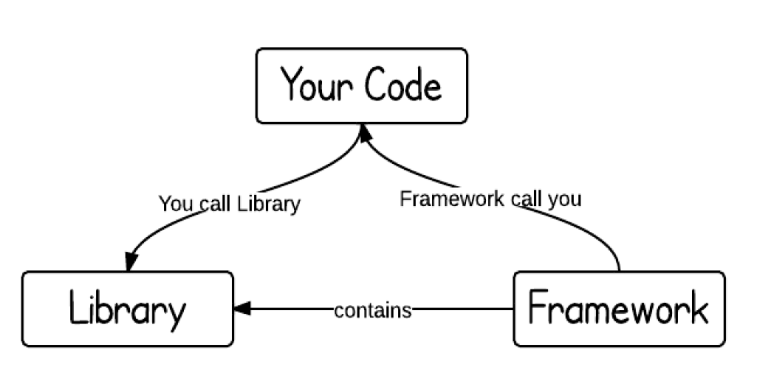The framework contains the library and it decides when it is appropriate to call your code. When using a Library, the developer decides when it is appropriate for the code to be called.

**Library**

**Who created Fabric?**

Juriy Zaytsev created Fabric; it is an interactive design editor, ‘Fabric provides a missing object model for canvas, as well as an SVG parser, layer of interactivity, and a whole suite of other indispensable tools’ (Fabricjs.com, 2017).

**Why did they create it?**

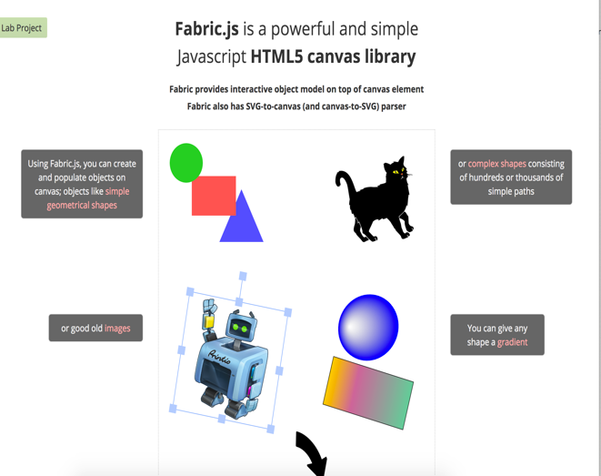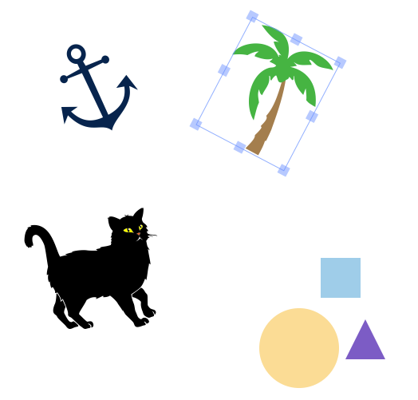Zaytsev started developing Fabric after discovering the pains of working with native canvas Application Programming Interface (API). He had a start-up business printio.ru that allows users to design their own clothing. The kind of interactivity the website needed existed in Flash apps, however, the level of interactivity the design process needed was not achievable using existing products. At the time of writing few other products can achieve what is possible with Fabric. Fabric includes an SVG to canvas parser, i.e. it can convert an SVG image into JavaScript that can be inserted within the <canvas> element and vice-versa (Fabricjs.com, 2017).

(Introduction to Fabric.js. Part 1., 2017) (Fabricjs.com, 2017)

**Who uses the Fabric.js library?**

The library is utilized by developers across many different spectrums from online design and print, creating your own children’s storybook online to designing and tracking the growth of your garden plants (Gatha, 2017).

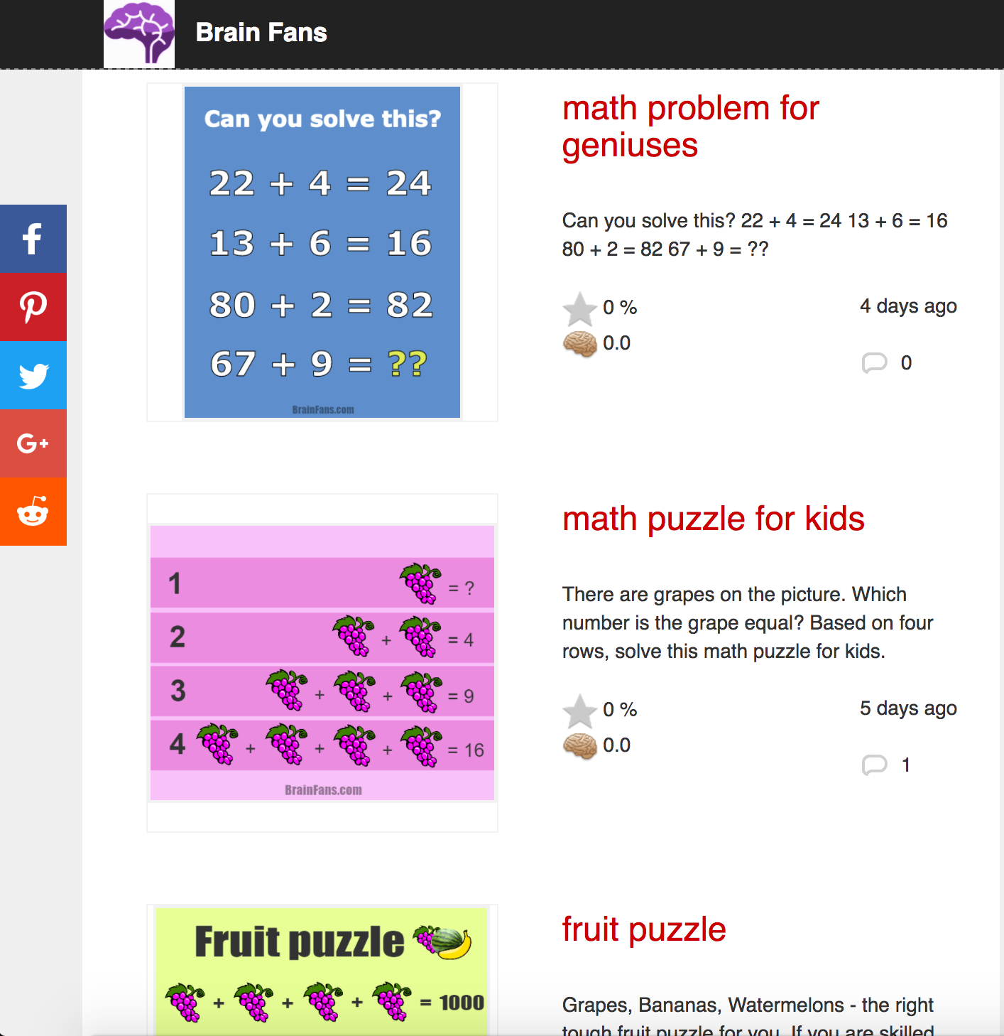Fabric.js is used widely across a variety of sites. For example, Brain.Fans.com has used the library to allow users to create their own brain teasers and puzzles (Brainfans.com, 2017).

(math problem for geniuses, 2017) (math puzzle for kids, 2017)

**What have they built with it?**

The website designsoftware.ninja uses Fabric.js in its software (Design Software, 2017). It gives a fast, responsive user experience that allows them to manipulate their design directly in the browser. The user can customize their chosen product in a variety of ways; and can upload images and clipart from their local device or from social media sites to add to the product. Users can use drag, rotate, flip, resize and customize their images in multiple ways. This ability to customize the product directly in the browser is purely because of the Fabric.js library.

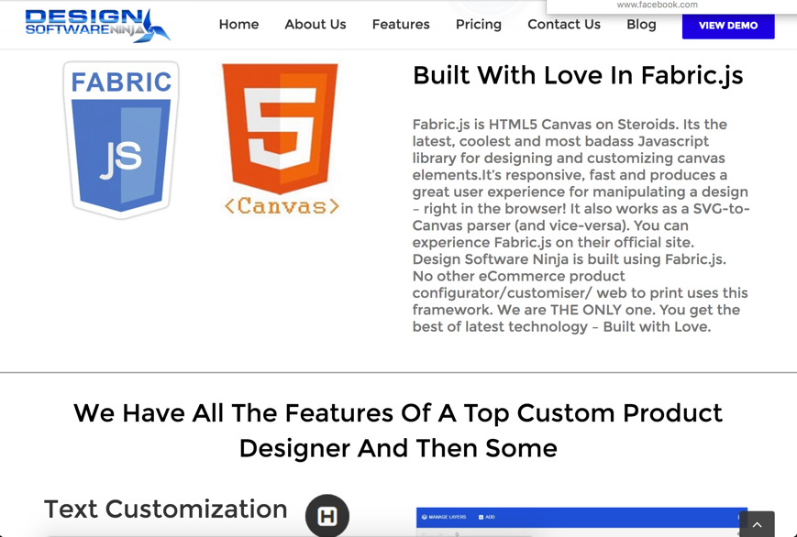

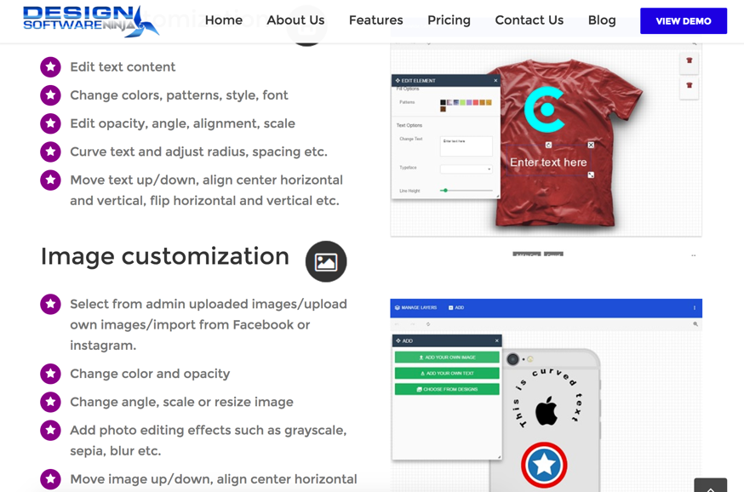

(Fabric.js, 2017)

What are its main features?

The native canvas method allows basic shapes to be drawn using the canvas tag, however, it gives little control over changing images or drawing more complex shapes. Fabric provides a simple but powerful object model on top of native methods. Native methods operate on context, an object representing an entire canvas bitmap. Fabric operates directly on objects. This object model takes care of canvas state and rendering allowing the developer to work with objects directly. Fabric aids in the development and display of graphics, it can create animation, plotting, motion and SVG. It provides easier access to JavaScript events (Fabricjs.com, 2017).

**Why has it become popular?**

The built in shape objects create shapes directly on the canvas, objects can be grouped and manipulated together. The Fabric library makes creating and coding shapes more simple. As Fabric operates directly on objects the canvas objects are easily manipulated and have far more functionality than using the HTML5 Canvas tag alone.

**How long would it take you to learn it to a point where you could build a system for a client with it?**

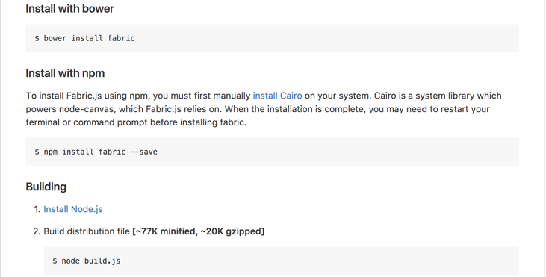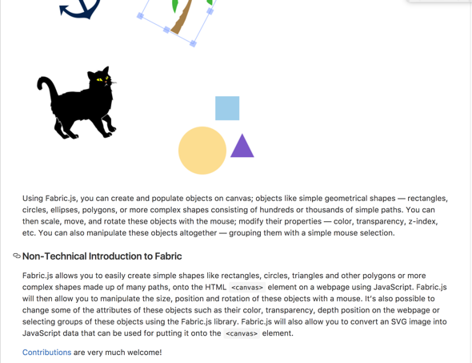The user guides provided are excellent and include a four-part demonstration on how the code is used and how it works. The developer has included guides and examples

of the differences between using the Fabric library with the HTML5 <canvas> tag. The read me guide is comprehensive and includes instructions on how to install and deploy the library within your code. I believe it would take a short amount of time to learn how to use the library effectively and support for Fabric appears to be active on external sites such as stackoverflow.com.(Zaytsev,2017)

**What are the risks of using it from the point of view as a coder or developer?**

The risks associated with using any library are how invested the original creator is in keeping the code updated and how the code is developed. Will future developments render the developers current use of the library unfeasible? Will any bugs in the code be found and rectified quickly? Fabric.js is well maintained and regularly updated. It is active within the community and is regularly forked. At the time of writing there are one hundred and forty-one contributors to the repository and had been updated within the last seven days. As the library is collaborative, with over a hundred contributors, it is more future proof than having a single or a limited number of contributors. The library is fully responsive and has a good user experience. The browser support is good and the following are supported:

* Firefox 2+
* Safari 3+
* Opera 9.64+
* Chrome (all versions)
* IE9, IE10, IE11, Edge

**Framework**

**Twitter Bootstrap**

**Who created the framework?**

Bootstrap, originally named Twitter Blueprint, was developed by Mark Otto and Jacob Thornton at Twitter

**Why did they create it?**

Bootstrap was originally developed for the Twitter application. It was created as a framework to encourage consistency across internal tools. It was created in mid 2010 and released on August 19th 2011. It was developed by Twitter’s designers and developers. Then it was released for open-source.

**Who uses it?**

Mainly used by front end developers to create stylish, responsive webpages. Bootstrap is a collection of free tools developers can use to create websites and web applications.

**What have they built with it?**

Fully responsive websites that work across multiple devices, including mobile devices. The JQuery website is built using Bootstrap. The beauty of Bootstrap is that the developer gets a lot of the website components automatically from the Bootstrap template.

**What are its main features?**

Bootstrap is a front-end web framework that contains HTML and CSS based design templates. These include forms, buttons, navigation and typography as well as optional JavaScript extensions. It is easy to get started with good instructions. It has a good grid system that makes the template fully responsive and is fully customizable. There is an extensive list of components and bundled JavaScript plugins.

It uses pre-defined class names for the webpage elements that are styled automatically through Bootstrap. Using Bootstrap negates the need for the developer to write their own CSS code and it saves time when designing webpages. Using Bootstrap’s 12 column system, and when utilized correctly, it makes mobile ready, responsive websites. In its basic form it is a webs designer’s template. What makes Bootstrap great is that the developer or designer can customize the code and create a totally unique website. They can pick and choose the parts of the code that they want to include in their website, they don’t have to include all the code in the template, only the code that they need.

**Why has it become popular?**

Bootstrap allows front end developers and designers to quickly build fully responsive websites. Bootstrap is also developed to support both CSS and HTML5. Browser compatibility issues are handled by the Framework. The developer can prototype a website in a matter of minutes and if the developer also knows Less, a CSS pre- processor, and Sass, a CSS extension language, it can be customized to create a unique design. Bootstrap, importantly, has an active community and regular updates.

**How long would it take you to learn it to a point where you could build a system for a client with it?**

I downloaded the Bootstrap application and built a basic web template in just a few minutes following the Bootstrap set-up tutorial (Banas, 2017). I think to fully utilize the Bootstrap Framework I would have to complete more in-depth research and watch more tutorials. To learn how to fully customize the template I would have to up-skill my CSS. However, for front end developers this is a good open-source tool to learn. As I have researched further it has peaked my interest in further expanding my coding skills.

**What are the risks of using it from the point of view as a coder or developer?**

As with all open-source products there is always the risk of the project falling out of favour as new products come to the market. However, Bootstrap is well established with an active community and frequent updates. The risk is quite low to developers but it always pays to keep up to date with new open-source products and keeping your skills as up to date as possible.

In conclusion the use of Libraries and Frameworks by front end developers is a positive development. Providing the developer researches the potential Library or Framework, checking that it has been recently updated, improved and the community using the code is active and bugs or issues are sorted quickly, there is no reason for developers to write all their code from scratch. It makes sense from a development and efficiency point of view to use the code that has been written already if it fulfills the developer’s requirements.

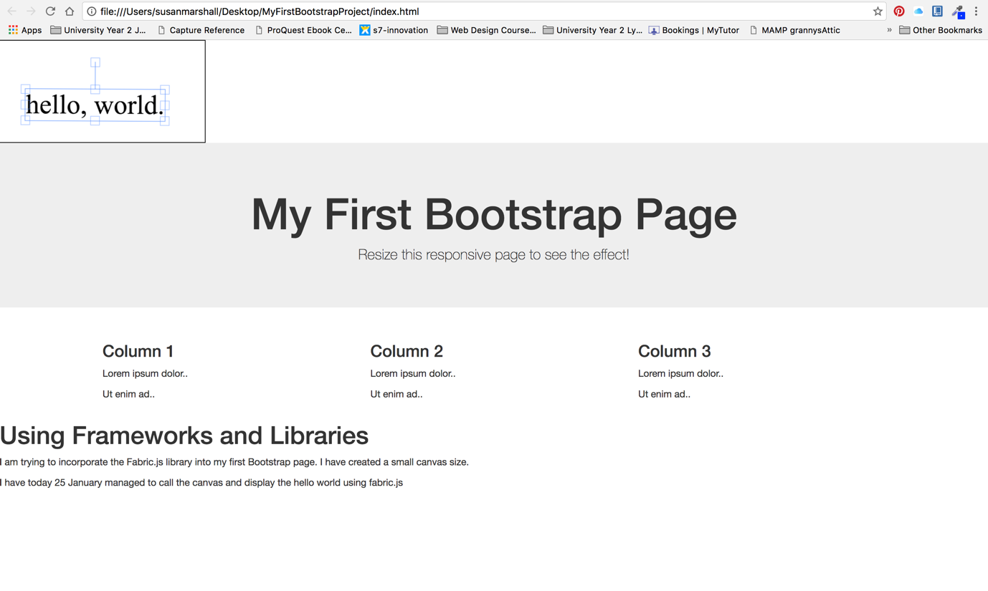Above is the fabric.js library used with the Bootstrap framework. I have managed to call the fabric.js library within the framework and display simple text (Campbell, 2017).

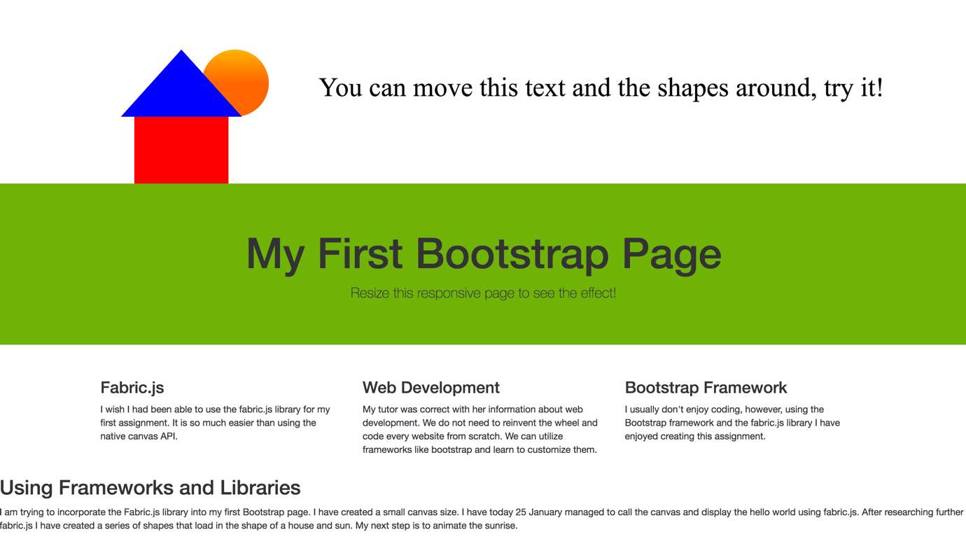I customized the CSS to change the container colour and added further shapes using the fabric.js library. I added a gradient to the sun and set the co-ordinates of the other shapes to create the house. The user can move, rotate and drag the shapes on the canvas; when the page reloads they return to their original positions.